ELSKY IPC400U Industrial Computer Specifications
―――――――――――――――――――――――――――――――――――――――――――――――――――――――
PC size diagram
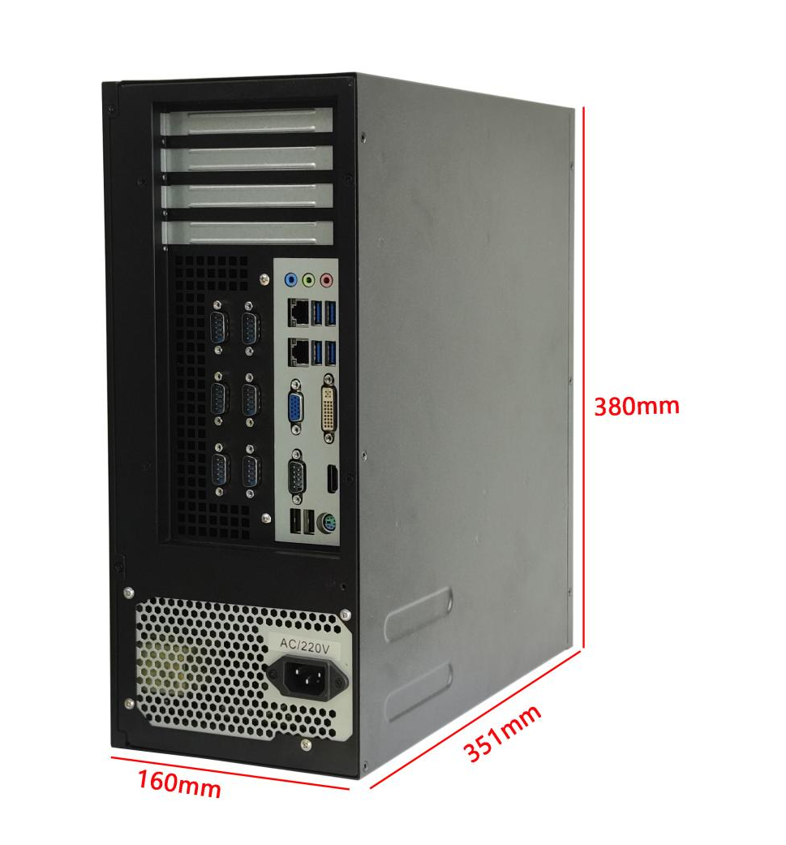
―――――――――――――――――――――――――――――――――――――――――――――――――――――――
Rear DVI interface diagram
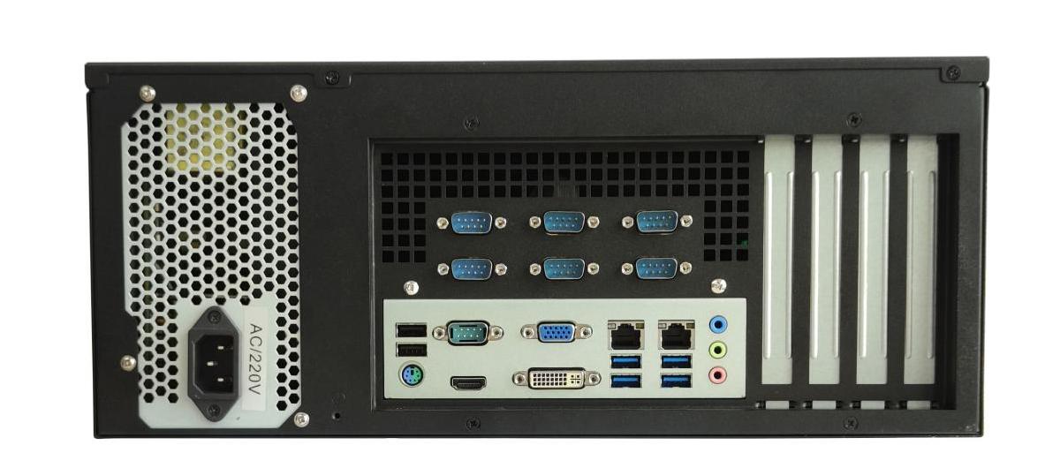
―――――――――――――――――――――――――――――――――――――――――――――――――――――――
―――――――――――――――――――――――――――――――――――――――――――――――――――――――
Diagram of connecting the PC to the graphics card
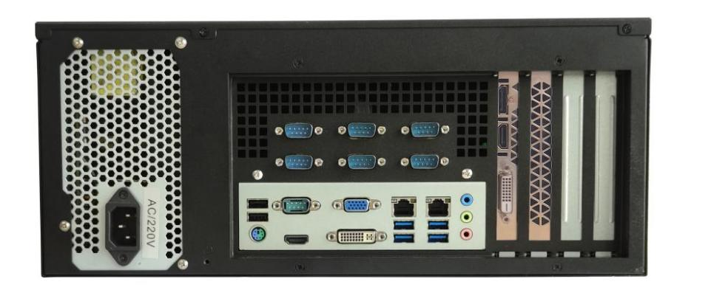
―――――――――――――――――――――――――――――――――――――――――――――――――――――――
Rear interface diagram with network port in the middle and small audio port.
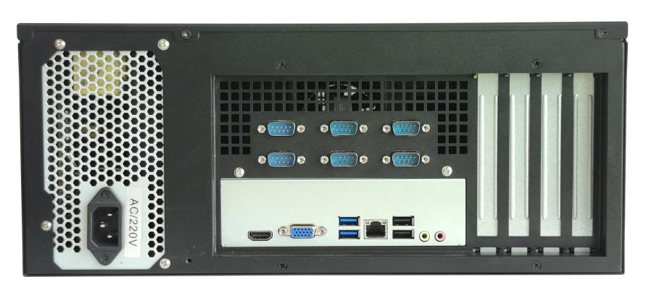
―――――――――――――――――――――――――――――――――――――――――――――――――――――――
Rear interface side view of network port + large audio port diagram
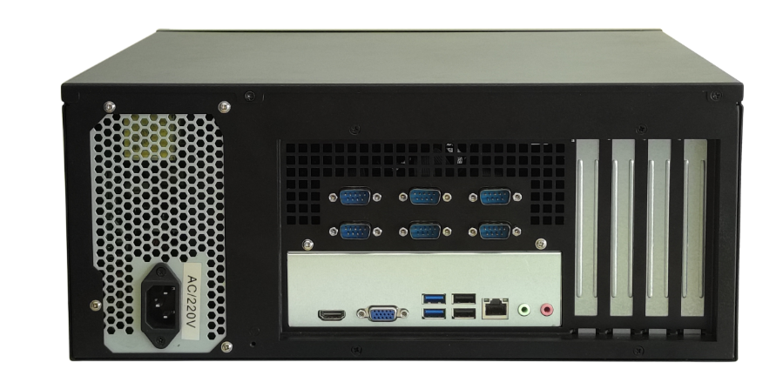
―――――――――――――――――――――――――――――――――――――――――――――――――――――――
Front Interface Diagram
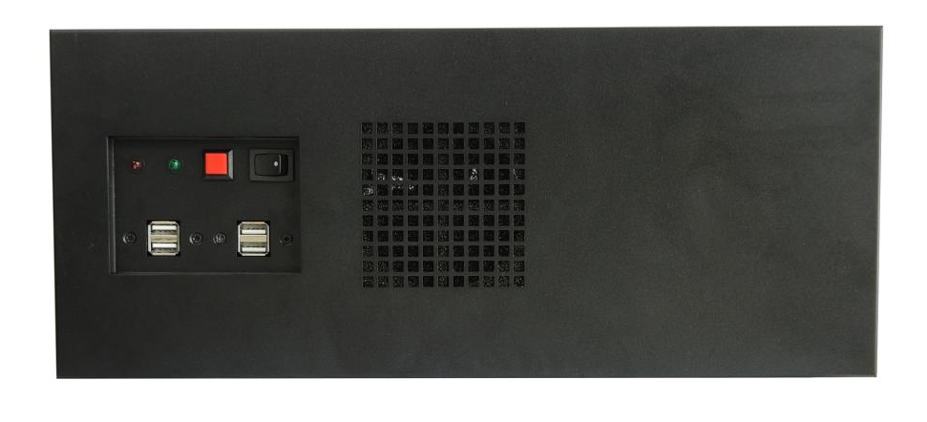
―――――――――――――――――――――――――――――――――――――――――――――――――――――――
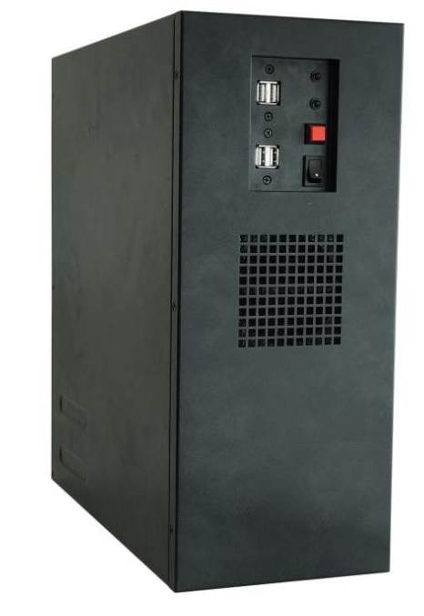
―――――――――――――――――――――――――――――――――――――――――――――――――――――――
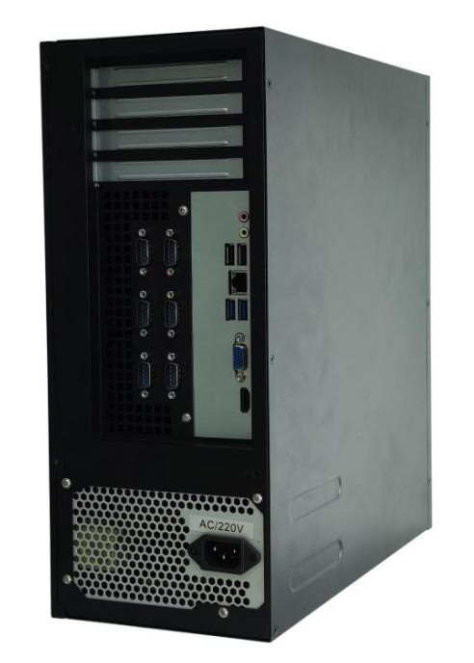
―――――――――――――――――――――――――――――――――――――――――――――――――――――――
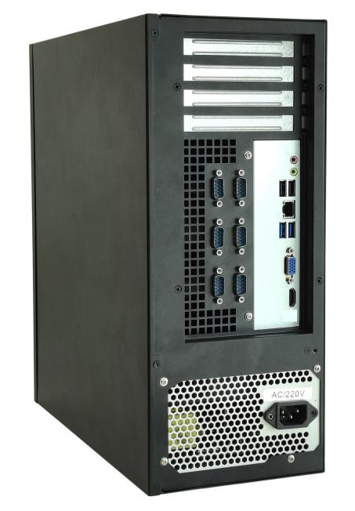
―――――――――――――――――――――――――――――――――――――――――――――――――――――――
PC size diagram
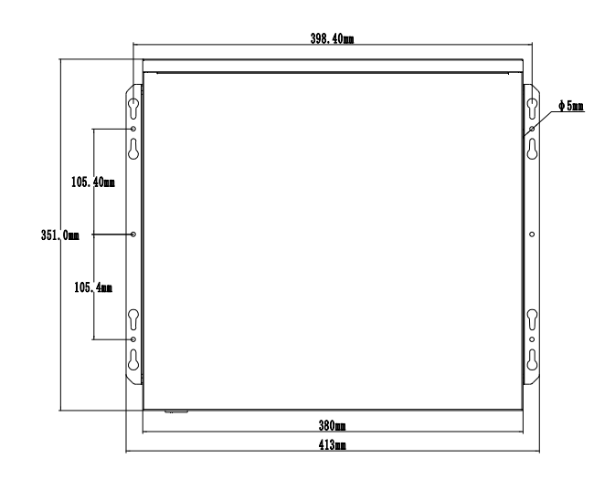
―――――――――――――――――――――――――――――――――――――――――――――――――――――――
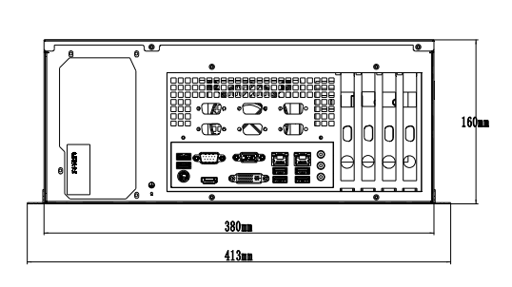
―――――――――――――――――――――――――――――――――――――――――――――――――――――――
The pictures are for reference only. Please refer to the actual product.
※※※※※※※※※※※※※※※※※※※※※※※※※※※※※※※※※※※※※※※※※※※※※※※※※
HDMI | VGA |  | LAN | USB 2.0 |  | USB 3.0 | COM | SSD | Memory | Power
2K 60Hz | 2K 60Hz |  | 1 | 7 |  | 1 | / | 1*MSATA  1 x 2.5-inch SSD/HDD | 1*NB-DDR3  MAX 8G | 200W  The above power supply
 |  |  |  |  |  |  | 1 | 1*MSATA  1 x 2.5-inch SSD/HDD | 1*NB-DDR3  MAX 8G | 200W  The above power supply
 |  |  |  |  |  |  | 2 | 1*MSATA  1 x 2.5-inch SSD/HDD | 1*NB-DDR3  MAX 8G | 200W  The above power supply
 |  |  |  |  |  |  | 6 | 1*MSATA  1 x 2.5-inch SSD/HDD | 1*NB-DDR3  MAX 8G | 200W  The above power supply
PC model |  | IPC400U-J1900 series
PC size |  | 380mm(L)*351mm(W)*160mm(H)
Cooling system |  | With ventilation holes, fanless or silent fan cooling
Color |  | black
Compatible motherboard models |  | M218F, M219F, M218H, M219H, M284F, M284FC, M284FN, M294F, M294FC, M294FN, M284H, M294H, QM1800E, QM1800L, QM1900E, QM1900L
Power supply |  | ATX power supply |  |  | Supports 12V, a power supply of 200W or higher is recommended.
CPU |  | Intel Celeron J1800 Dual-Core 2.41GHz, Turbo Boost 2.58GHz;  Intel Celeron J1900 Quad-core 1.99GHz, Turbo Boost 2.4GHz;  Intel Pentium J2900 Quad-core 2.41GHz, Turbo Boost 2.66GHz;  Intel Celeron N2840 dual-core 2.16GHz, turbo boost 2.58GHz;  Intel Celeron N2930 Quad-core 1.83GHz, Turbo Boost 2.16GHz;  Intel Celeron N2940 Quad-core 1.83GHz, Turbo Boost 2.25GHz;
Chipset |  | Intel Bay Trail SOC
Memory |  | 1*NB-DDR3 memory, supports 1.35V, supports 1600MHz memory, maximum support 8GB
Network function |  | 1*RJ45 LAN interface |  |  | Integrated Realtek 8111H Gigabit Ethernet adapter or Realtek 810 6E 100Mbps Ethernet adapter optional.  Supports network power on/off and network PXE functionality.
 |  | Supports optional WIFI/4G/Bluetooth, supports 2*WIFI antenna masts
Display function |  | Intel HD Graphics graphics controller, supports single display, dual display duplication, and dual display expansion.
 |  | 1*VGA DB15 interface |  |  | Supports resolution 1920*1080@60Hz
 |  | 1 HDMI 1.4 port |  |  | Supports resolution 1920*1080@60Hz
USB function |  | 1 USB 3.0 port |  |  | The blue group of USB ports is for USB 3.0 (the blue group, the ones on the bottom of the case are USB 3.0).
 |  | 7 USB 2.0 ports |  |  | The black group of USB ports is USB 2.0 (the blue group, the ones on the top of the case, are USB 2.0).
Sound function |  | Integrated Cmedia HS_100B USB audio chip  Alternatively, it can integrate a Realtek ALC 662/897 HD digital audio decoder and a 6-channel high-fidelity audio controller.
 |  | 1*SPK interface |  |  | Supports audio output
 |  | 1*MIC interface |  |  | Microphone input supported
 |  | The HDMI interface supports HDMI audio output.
Hard drive function |  | 1 x mSATA drive; 1 x 2.5-inch SSD or HDD hard drive
On/off function |  | POWER button |  |  | switch button
Other I/O |  | 6*COM interface |  |  | Supports RS232 (RS485 support can be customized).
M218FN/M219FN/M284FN/M294FN have no COM port; M218FC/M219FC/M284FC/M294FC support 1 COM port; QM1800E/QM1800L/QM1900E/QM1900L support 2 COM ports.
M218F/M219F/M219H/218H/M284H/M294H/M284F/M294F supports 6*COM;
Operating environment |  | Operating temperature: -10℃ to 60℃; Operating humidity: 5% to 95% relative humidity, non-condensing.  Storage temperature: -20℃ to 70℃;
BIOS |  | AMI BIOS supports power-on, scheduled power-on, and remote power-on/off.
Watch Dog |  | Watchdog programming with support for hardware reset function (256 levels, 0~255 seconds).
Operating system |  | Windows 10, Windows 8, Windows 7, Linux, etc.
※※※※※※※※※※※※※※※※※※※※※※※※※※※※※※※※※※※※※※※※※※※※※※※※※

※※※※※※※※※※※※※※※※※※※※※※※※※※※※※※※※※※※※※※※※※※※※※※※※※
HDMI | VGA |  | LAN | USB 2.0 |  | USB 3.0 | COM | SSD | Memory | Power
2K 60Hz | 2K 60Hz |  | 1 | 6 |  | 2 | 2 | 1*MSATA  1 x 2.5-inch SSD/HDD | 1*NB-DDR3  MAX 8G | 200W  The above power supply
 |  |  |  |  |  |  | 6 | 1*MSATA  1 x 2.5-inch SSD/HDD | 1*NB-DDR3  MAX 8G | 200W  The above power supply
PC model |  | IPC400U-M316F series
PC size |  | 380mm(L)*351mm(W)*160mm(H)
Cooling system |  | With ventilation holes, fanless or silent fan cooling
color |  | black
Compatible motherboard models |  | M316F
power supply |  | ATX power supply |  |  | It is recommended to use a power supply of 200W or higher.
CPU |  | Intel Celeron N3150 Quad-core 1.6GHz, Turbo Boost 2.08GHz;  Intel Celeron N3160 Quad-core 1.6GHz, Turbo Boost 2.24GHz;  Intel Celeron N3700 Quad-core 1.6GHz, Turbo Boost 2.40GHz;
Chipset |  | Intel Bay Trail SOC
Memory |  | 1*NB-DDR3 memory, supports 1.35V, supports 1600MHz memory, maximum support 8GB
Network function |  | 1 RJ45 LAN interface |  |  | Integrated Realtek 8111H Gigabit Ethernet NIC  Supports network power on/off and network PXE functionality.
 |  | Supports optional WIFI/4G/Bluetooth, supports 2*WIFI antenna masts
Display function |  | Intel HD Graphics graphics controller, supports single display, dual display duplication, and dual display expansion.
 |  | 1*VGA DB15 interface |  |  | Supports resolution 1920*1080@60Hz
 |  | 1 HDMI 1.4 port |  |  | Supports resolution 1920*1080@60Hz
USB function |  | 2 USB 3.0 ports |  |  | The blue group of USB ports is USB 3.0.
 |  | 6 USB 2.0 ports |  |  | The black USB connector is USB 2.0.
sound function |  | Integrated Realtek ALC 662 HD digital audio decoder, 6-channel high-fidelity audio controller
 |  | 1*SPK interface |  |  | Supports audio output
 |  | 1*MIC interface |  |  | Microphone input supported
 |  | The HDMI interface supports HDMI audio output.
Hard drive function |  | 1*MSATA drive;  1 x 2.5-inch SSD or HDD
On/off function |  | POWER button |  |  | switch button
Other I/O |  | 2/6*COM interface |  |  | Supports RS232 (RS485 support can be customized).
Operating environment |  | Operating temperature: -10℃ to 60℃;  Operating humidity: 5% to 95% relative humidity, non-condensing.  Storage temperature: -20℃ to 70℃;
BIOS |  | AMI BIOS supports power-on, scheduled power-on, and remote power-on/off.
Watch Dog |  | Watchdog programming with support for hardware reset function (256 levels, 0~255 seconds).
operating system |  | Windows 10, Windows 8, Windows 7, Linux, etc.
※※※※※※※※※※※※※※※※※※※※※※※※※※※※※※※※※※※※※※※※※※※※※※※※※

※※※※※※※※※※※※※※※※※※※※※※※※※※※※※※※※※※※※※※※※※※※※※※※※※
HDMI | VGA |  | LAN | USB 2.0 |  | USB 3.0 | COM | SSD | Memory | Power
4K 30Hz | 2K 60Hz |  | 1 | 6 |  | 2 | 2 | 1*M.2  1*MSATA  1 x 2.5-inch SSD/HDD | 1*NB-DDR3  MAX 8G | 200W  The above power supply
 |  |  |  |  |  |  | 6 | 1*M.2  1*MSATA  1 x 2.5-inch SSD/HDD | 1*NB-DDR3  MAX 8G | 200W  The above power supply
PC model |  | IPC400U-J3355 series
PC size |  | 380mm(L)*351mm(W)*160mm(H)
Cooling system |  | With ventilation holes, fanless or silent fan cooling
color |  | black
Compatible motherboard models |  | M335F
power supply |  | ATX power supply |  |  | A power supply of 200W or higher is recommended.
CPU |  | Intel Celeron J3355, dual-core 2.0GHz, turbo boost 2.5GHz;  Intel Celeron J3455 Quad-core 1.5GHz, Turbo Boost 2.3GHz;  Intel Pentium N4200 Quad-core 1.1GHz, Turbo Boost 2.5GHz;
Chipset |  | Intel Apollo Lake SOC
Memory |  | 1*NB-DDR3 memory, supports 1.35V, supports 1600MHz memory, maximum support 8GB
Network function |  | 1 RJ45 LAN interface |  |  | Integrated Realtek 8111H Gigabit Ethernet controller; supports network power on/off and network PXE functionality.
 |  | Supports optional WIFI/4G/Bluetooth, supports 2*WIFI antenna masts
Display function |  | Intel HD Graphics 500/505 graphics controller, supporting single display, dual display duplication, and dual display expansion.
 |  | 1*VGA DB15 interface |  |  | Supports resolution 1920*1080@60Hz
 |  | 1 HDMI 1.4 port |  |  | Supports 4K resolution 4096/3840*2160@30Hz
USB function |  | 2 USB 3.0 ports |  |  | The blue group of USB ports is USB 3.0.
 |  | 6 USB 2.0 ports |  |  | The black USB connector is USB 2.0.
sound function |  | Integrated Realtek ALC 662/897 HD digital audio decoder, 6-channel high-fidelity audio controller  Or integrate Shunxin ES8336 audio chip
 |  | 1*SPK interface |  |  | Supports audio output
 |  | 1*MIC interface |  |  | Microphone input supported
 |  | The HDMI interface supports HDMI audio output.
Hard drive function |  | 1*M.2;  1*MSATA drive;  1 x 2.5-inch SSD or HDD
On/off function |  | POWER button |  |  | switch button
Other I/O |  | 2/6*COM interface |  |  | Supports RS232 (RS485 support can be customized).
Operating environment |  | Operating temperature: -10℃ to 60℃;  Operating humidity: 5% to 95% relative humidity, non-condensing.  Storage temperature: -20℃ to 70℃;
BIOS |  | AMI BIOS supports power-on, scheduled power-on, and remote power-on/off.
Watch Dog |  | Watchdog programming with support for hardware reset function (256 levels, 0~255 seconds).
operating system |  | Windows 10, Windows 8, Windows 7, Linux, etc.
※※※※※※※※※※※※※※※※※※※※※※※※※※※※※※※※※※※※※※※※※※※※※※※※※

※※※※※※※※※※※※※※※※※※※※※※※※※※※※※※※※※※※※※※※※※※※※※※※※※
HDMI | VGA |  | LAN | USB 2.0 |  | USB 3.0 | COM | SSD | Memory | Power
4K 60Hz | VGA  2K 60Hz |  | 1 | 6 |  | 2 | 2 | 1*MSATA  1 x 2.5-inch SSD/HDD | 1*NB-DDR4  MAX 16G | 200W  The above power supply
 |  |  |  |  |  |  | 6 | 1*MSATA  1 x 2.5-inch SSD/HDD | 1*NB-DDR4  MAX 16G | 200W  The above power supply
PC model |  | IPC400U-J4125 series
PC size |  | 380mm(L)*351mm(W)*160mm(H)
Cooling system |  | With ventilation holes, fanless or silent fan cooling
color |  | black
Compatible motherboard models |  | M415F
power supply |  | ATX power supply |  |  | A power supply of 200W or higher is recommended.
CPU |  | Intel Celeron J4025 dual-core 2.0GHz, turbo boost 2.9GHz;  Intel Celeron J4125 Quad-core 2.0GHz, Turbo Boost 2.7GHz;  Intel Celeron N4020 dual-core 1.1GHz, turbo boost up to 2.8GHz;  Intel Celeron N4120 Quad-core 1.1GHz, Turbo Boost 2.6GHz;  Intel Pentium N5030 Quad-core 1.1GHz, Turbo Boost 3.1GHz;  Intel Pentium J5040 Quad-core 2.0GHz, Turbo Boost 3.2GHz;
Memory |  | 1*NB-DDR4 memory, supports 1.2V, supports 2400MHz memory, maximum support 16GB
Network function |  | 1*RJ45 LAN interface |  |  | Integrated Realtek 8111H Gigabit Ethernet adapter or Realtek 810 6E 100Mbps Ethernet adapter optional.  Supports network power on/off and network PXE functionality.
 |  | Supports optional WIFI/4G/Bluetooth, supports 2*WIFI antenna masts
Display function |  | The Intel HD Graphics 600 graphics controller supports single display, dual display duplication, and dual display expansion.
 |  | 1*VGA DB15 interface |  |  | Supports resolution 1920*1080@60Hz
 |  | 1 HDMI 2.0 port |  |  | Supports 4K resolution 4096/3840*2160@60Hz
USB function |  | 2 USB 3.0 ports |  |  | The blue group of USB ports is USB 3.0.
 |  | 6 USB 2.0 ports |  |  | The black USB connector is USB 2.0.
sound function |  | Integrated Cmedia HS_100B USB audio chip  Alternatively, it can integrate a Realtek ALC 662/897 HD digital audio decoder and a 6-channel high-fidelity audio controller.
 |  | 1*SPK interface |  |  | Supports audio output
 |  | 1*MIC interface |  |  | Microphone input supported
 |  | The HDMI interface supports HDMI audio output.
Hard drive function |  | 1*MSATA drive;  1 x 2.5-inch SSD or HDD
On/off function |  | POWER button |  |  | switch button
Other I/O |  | 2/6*COM interface |  |  | Supports RS232 (RS485 support can be customized).
Operating environment |  | Operating temperature: -10℃ to 60℃;  Operating humidity: 5% to 95% relative humidity, non-condensing.  Storage temperature: -20℃ to 70℃;
BIOS |  | AMI BIOS supports power-on, scheduled power-on, and remote power-on/off.
Watch Dog |  | Watchdog programming with support for hardware reset function (256 levels, 0~255 seconds).
operating system |  | Windows 11, Windows 10, Linux, etc.
※※※※※※※※※※※※※※※※※※※※※※※※※※※※※※※※※※※※※※※※※※※※※※※※※

※※※※※※※※※※※※※※※※※※※※※※※※※※※※※※※※※※※※※※※※※※※※※※※※※
HDMI | VGA |  | LAN | USB 2.0 |  | USB 3.1 | COM | SSD | Memory | Power
4K 60Hz | VGA  2K 60Hz |  | 1 | 6 |  | 2 | 2 | 1*M.2  1 x 2.5-inch SSD/HDD | 1*NB-DDR4  MAX 32G | 200W  The above power supply
 |  |  |  |  |  |  | 6 | 1*M.2  1 x 2.5-inch SSD/HDD | 1*NB-DDR4  MAX 32G | 200W  The above power supply
PC model |  | IPC400U-J6412 series
PC size |  | 380mm(L)*351mm(W)*160mm(H)
Cooling system |  | With ventilation holes, fanless or silent fan cooling
color |  | black
Compatible motherboard models |  | M612F
power supply |  | ATX power supply |  |  | It is recommended to use a power supply of 200W or higher.
CPU |  | Intel Celeron J6412 Quad-core 2.0GHz, Turbo Boost 2.6GHz;  Intel Celeron J6413 Quad-core 1.8GHz, Turbo Boost 3.0GHz;  Intel Celeron N6210 dual-core 1.2GHz, turbo boost 2.6GHz;  Intel Celeron N6211 dual-core 1.2GHz, turbo boost 3.0GHz;  Intel Pentium J6426 Quad-core 2.0GHz, Turbo Boost 3.0GHz;  Intel Pentium N6415 Quad-core 1.2GHz, Turbo Boost 3.0GHz;
Memory |  | 1*NB-DDR4 memory, supports 1.2V, supports 3200MHz memory, maximum support 32GB
Network function |  | 1*RJ45 LAN interface |  |  | Integrated Realtek 8111H Gigabit Ethernet adapter or Realtek 810 6E 100Mbps Ethernet adapter optional.  Supports network power on/off and network PXE functionality.
 |  | Supports optional WIFI/4G/Bluetooth, supports 2*WIFI antenna masts
Display function |  | Intel UHD Graphics controller, supporting single display, dual display duplication, and dual display expansion.
 |  | 1*VGA DB15 interface |  |  | Supports resolution 1920*1080@60Hz
 |  | 1 HDMI 2.0 port |  |  | Supports 4K resolution 4096/3840*2160@60Hz
USB function |  | 2 USB 3.1 ports |  |  | The blue group of USB ports is USB 3.1 Gen1.
 |  | 6 USB 2.0 ports |  |  | The black USB connector is USB 2.0.
sound function |  | Integrated Realtek ALC 662/897 HD digital audio decoder, 6-channel high-fidelity audio controller
 |  | 1*SPK interface |  |  | Supports audio output
 |  | 1*MIC interface |  |  | Microphone input supported
 |  | The HDMI interface supports HDMI audio output.
Hard drive function |  | 1*M.2;  1 x 2.5-inch SSD or HDD
On/off function |  | POWER button |  |  | switch button
Other I/O |  | 2/6*COM interface |  |  | Supports RS232 (RS485 support can be customized).
Operating environment |  | Operating temperature: -10℃ to 60℃;  Operating humidity: 5% to 95% relative humidity, non-condensing.  Storage temperature: -20℃ to 70℃;
BIOS |  | AMI BIOS supports power-on, scheduled power-on, and remote power-on/off.
Watch Dog |  | Watchdog programming with support for hardware reset function (256 levels, 0~255 seconds).
operating system |  | Windows 11, Windows 10, Linux, etc.
※※※※※※※※※※※※※※※※※※※※※※※※※※※※※※※※※※※※※※※※※※※※※※※※※

※※※※※※※※※※※※※※※※※※※※※※※※※※※※※※※※※※※※※※※※※※※※※※※※※
HDMI | VGA |  | LAN | USB 2.0 |  | USB 3.0 | COM | SSD | Memory | Power
2K 60Hz | VGA  2K 60Hz |  | 1 | 6 |  | 2 | 2 | 1*MSATA  1 x 2.5-inch SSD/HDD | 1*NB-DDR3  MAX 8G | 200W  The above power supply
 |  |  |  |  |  |  | 6 | 1*MSATA  1 x 2.5-inch SSD/HDD | 1*NB-DDR3  MAX 8G | 200W  The above power supply
PC model |  | IPC400U-1037 series
PC size |  | 380mm(L)*351mm(W)*160mm(H)
Cooling system |  | With ventilation holes and silent fan cooling
color |  | black
Compatible motherboard models |  | 1007F, 1037F, 2117F
power supply |  | ATX power supply |  |  | It is recommended to use a power supply of 200W or higher.
CPU |  | Intel Celeron 1007U Dual-Core 1.5GHz;  Intel Celeron 1037U Dual-Core 1.8GHz;  Intel Pentium 2117U Dual-Core 1.8GHz;
Chipset |  | Intel 6 series chipsets: HM65, HM67, QM67  Intel 7 series chipsets: NM70, HM70, HM75, HM76, HM77, QM77
Memory |  | 1*NB-DDR3 memory, supports 1.35V/1.5V, supports 1333/1600MHz memory, maximum support 8GB
Network function |  | 1*RJ45 LAN interface |  |  | Integrated Realtek 8111H Gigabit Ethernet adapter or Realtek 810 6E 100Mbps Ethernet adapter optional.  Supports network power on/off and network PXE functionality.
 |  | Supports optional WIFI/4G/Bluetooth, supports 2*WIFI antenna masts
Display function |  | Intel HD Graphics 4000 graphics controller, supports single display, dual display duplication, and dual display expansion.
 |  | 1*VGA DB15 interface |  |  | Supports resolution 1920*1080@60Hz
 |  | 1 HDMI 1.4 port |  |  | Supports resolution 1920*1080@60Hz
USB function |  | 2 USB 3.0 ports |  |  | The blue group of USB ports is USB 3.0.
 |  | 6 USB 2.0 ports |  |  | The black USB connector is USB 2.0.
sound function |  | Integrated Cmedia HS_100B USB audio chip  Alternatively, it can integrate a Realtek ALC 662/897 HD digital audio decoder and a 6-channel high-fidelity audio controller.
 |  | 1*SPK interface |  |  | Supports audio output
 |  | 1*MIC interface |  |  | Microphone input supported
 |  | The HDMI interface supports HDMI audio output.
Hard drive function |  | 1*MSATA drive;  1 x 2.5-inch SSD or HDD
On/off function |  | POWER button |  |  | switch button
Other I/O |  | 2/6*COM interface |  |  | Supports RS232; COM2 can optionally support RS485/RS422, which can be configured via BIOS.
Operating environment |  | Operating temperature: -10℃ to 60℃; Operating humidity: 5% to 95% relative humidity, non-condensing.  Storage temperature: -20℃ to 70℃;
BIOS |  | AMI BIOS supports power-on, scheduled power-on, and remote power-on/off.
Watch Dog |  | Watchdog programming with support for hardware reset function (256 levels, 0~255 seconds).
operating system |  | Windows 10, Windows 8, Windows 7, Windows XP, Linux, etc.
※※※※※※※※※※※※※※※※※※※※※※※※※※※※※※※※※※※※※※※※※※※※※※※※※

※※※※※※※※※※※※※※※※※※※※※※※※※※※※※※※※※※※※※※※※※※※※※※※※※
HDMI | VGA |  | LAN | USB2.0 |  | USB3.0 | COM | SSD | Memory | Power
2K 60Hz | VGA  2K 60Hz |  | 1 | 6 |  | 2 | 2 | 1*MSATA  1*2.5 inch SSD/HDD | 1*NB-DDR3  MAX 8G | 200W  The above power supply
 |  |  |  |  |  |  | 6 | 1*MSATA  1*2.5 inch SSD/HDD | 1*NB-DDR3  MAX 8G | 200W  The above power supply
PC model |  | IPC400U-2nd Generation Series
PC size |  | 380mm(L)*351mm(W)*160mm(H)
Cooling system |  | With ventilation holes and silent fan cooling
color |  | black
Compatible motherboard models |  | QM6600, QM6637, QM6616, QM2360
power supply |  | ATX power supply |  |  | It is recommended to use a power supply of 200W or higher.
Second-generation CPU |  | Intel Core i3-2310M Dual-core 2.1GHz; Intel Core i3-2330M Dual-core 2.2GHz;  Intel Core i3-2350M Dual-core 2.3GHz; Intel Core i3-2370M Dual-core 2.4GHz;  Intel Core i5-2410M dual-core 2.3GHz, turbo boost 2.9GHz; Core i5-2430M dual-core 2.4GHz, turbo boost 3.0GHz;  Intel Core i5-2520M dual-core 2.5GHz, turbo boost 3.2GHz; Core i5-2540M dual-core 2.6GHz, turbo boost 3.3GHz;  Intel Core i7-2620M dual-core 2.7GHz, turbo boost 3.4GHz; Core i7-2640M dual-core 2.8GHz, turbo boost 3.5GHz;
Chipset |  | Intel 6 series chipsets: HM65, HM67, QM67  Intel 7 series chipsets: NM70, HM70, HM75, HM76, HM77, QM77
Memory |  | 1*NB-DDR3 memory, supports 1.35V/1.5V, supports 1333/1600MHz memory, maximum support 8GB
Network function |  | 1*RJ45 LAN interface |  |  | Integrated Realtek 8111H Gigabit Ethernet adapter or Realtek 810 6E 100Mbps Ethernet adapter optional.  Supports network power on/off and network PXE functionality.
 |  | Supports optional WIFI/4G/Bluetooth, supports 2*WIFI antenna masts
Display function |  | Intel HD Graphics 3000 graphics controller, supports single display, dual display duplication, and dual display expansion.
 |  | 1*VGA DB15 interface |  |  | Supports resolution 1920*1080@60Hz
 |  | 1 HDMI 1.4 port |  |  | Supports resolution 1920*1080@60Hz
USB function |  | 2 USB 3.0 ports |  |  | The blue group of USB ports is USB 3.0.
 |  | 6 USB 2.0 ports |  |  | The black USB connector is USB 2.0.
sound function |  | Integrated Cmedia HS_100B USB audio chip  Alternatively, it can integrate a Realtek ALC 662/897 HD digital audio decoder and a 6-channel high-fidelity audio controller.
 |  | 1*SPK interface |  |  | Supports audio output
 |  | 1*MIC interface |  |  | Microphone input supported
 |  | The HDMI interface supports HDMI audio output.
Hard drive function |  | 1*MSATA drive;  1 x 2.5-inch SSD or HDD
On/off function |  | POWER button |  |  | switch button
Other I/O |  | 2/6*COM interface |  |  | Supports RS232 (RS485 support can be customized).
Operating environment |  | Operating temperature: -10℃ to 60℃; Operating humidity: 5% to 95% relative humidity, non-condensing.  Storage temperature: -20℃ to 70℃;
BIOS |  | AMI BIOS supports power-on, scheduled power-on, and remote power-on/off.
Watch Dog |  | Watchdog programming with support for hardware reset function (256 levels, 0~255 seconds).
operating system |  | Windows 10, Windows 8, Windows 7, Windows XP, Linux, etc.
※※※※※※※※※※※※※※※※※※※※※※※※※※※※※※※※※※※※※※※※※※※※※※※※※

※※※※※※※※※※※※※※※※※※※※※※※※※※※※※※※※※※※※※※※※※※※※※※※※※
HDMI | VGA |  | LAN | USB 2.0 |  | USB 3.0 | COM | SSD | Memory | Power
2K 60Hz | VGA  2K 60Hz |  | 1 | 6 |  | 2 | 2 | 1*MSATA  1 x 2.5-inch SSD/HDD | 1*NB-DDR3  MAX 8G | 200W  The above power supply
 |  |  |  |  |  |  | 6 | 1*MSATA  1 x 2.5-inch SSD/HDD | 1*NB-DDR3  MAX 8G | 200W  The above power supply
PC model |  | IPC400U-3rd Generation Series
PC size |  | 380mm(L)*351mm(W)*160mm(H)
Cooling system |  | With ventilation holes and silent fan cooling
color |  | black
Compatible motherboard models |  | i3HGP, i5HGP, i7HGP, QM6600, QM6637, QM6616, QM2360
power supply |  | ATX power supply |  |  | The DC connector has an inner diameter of 2.5mm and supports 12V.  For the U series, a 12V 5A or higher power supply is recommended; for the M series, a 12V 7A or higher power supply is recommended.
Third generation CPU |  | Intel Celeron 1037U Dual-Core 1.8GHz; Intel Pentium 2117U Dual-Core 1.8GHz;  Intel Core i3-3217U Dual-core 1.8GHz; Intel Core i3-3227U Dual-core 1.9GHz;  Intel Core i5-3317U dual-core 1.7GHz, turbo boost 2.6GHz; Intel Core i5-3337U dual-core 1.8GHz, turbo boost 2.7GHz; Intel Core i5-3427U dual-core 1.8GHz, turbo boost 2.8GHz; Intel Core i5-3437U dual-core 1.9GHz, turbo boost 2.9GHz;  Intel Core i7-3517U dual-core 1.9GHz, turbo boost 3.0GHz; Intel Core i7-3537U dual-core 2.0GHz, turbo boost 3.1GHz; Intel Core i7-3667U dual-core 2.0GHz, turbo boost 3.2GHz; Intel Core i7-3687U dual-core 2.1GHz, turbo boost 3.3GHz;  Intel Core i3-31 10M dual-core 2.4GHz; Intel Core i3-312 0M dual-core 2.5GHz;  Intel Core i5-3210M dual-core 2.5GHz, turbo boost 3.1GHz; Core i5-3230M dual-core 2.6GHz, turbo boost 3.2GHz;  Intel Core i5-3320M dual-core 2.6GHz, turbo boost 3.3GHz; Core i5-3340M dual-core 2.7GHz, turbo boost 3.4GHz;  Intel Core i5-3360M dual-core 2.8GHz, turbo boost 3.5GHz; Core i5-3380M dual-core 2.9GHz, turbo boost 3.6GHz;  Intel Core i7-3520M dual-core 2.9GHz, turbo boost 3.6GHz; Core i7-3540M dual-core 3.0GHz, turbo boost 3.7GHz;
Chipset |  | Intel 6 series chipsets: HM65, HM67, QM67  Intel 7 series chipsets: NM70, HM70, HM75, HM76, HM77, QM77
Memory |  | 1*NB-DDR3 memory, supports 1.35V/1.5V, supports 1333/1600MHz memory, maximum support 8GB
Network function |  | 1*RJ45 LAN interface |  |  | Integrated Realtek 8111H Gigabit Ethernet adapter or Realtek 810 6E 100Mbps Ethernet adapter optional.  Supports network power on/off and network PXE functionality.
 |  | Supports optional WIFI/4G/Bluetooth, supports 2*WIFI antenna masts
Display function |  | Intel HD Graphics 4000 graphics controller, supports single display, dual display duplication, and dual display expansion.
 |  | 1*VGA DB15 interface |  |  | Supports resolution 1920*1080@60Hz
 |  | 1 HDMI 1.4 port |  |  | Supports resolution 1920*1080@60Hz
USB function |  | 2 USB 3.0 ports |  |  | The blue group of USB ports is USB 3.0.
 |  | 6 USB 2.0 ports |  |  | The black USB connector is USB 2.0.
sound function |  | Integrated Cmedia HS_100B USB audio chip  Alternatively, it can integrate a Realtek ALC 662/897 HD digital audio decoder and a 6-channel high-fidelity audio controller.
 |  | 1*SPK interface |  |  | Supports audio output
 |  | 1*MIC interface |  |  | Microphone input supported
 |  | The HDMI interface supports HDMI audio output.
Hard drive function |  | 1 x mSATA drive; 1 x 2.5-inch SSD or HDD hard drive
On/off function |  | POWER button |  |  | switch button
Other I/O |  | 2/6*COM interface |  |  | Supports RS232 (RS485 support can be customized).
Operating environment |  | Operating temperature: -10℃ to 60℃;  Operating humidity: 5% to 95% relative humidity, non-condensing.  Storage temperature: -20℃ to 70℃;
BIOS |  | AMI BIOS supports power-on, scheduled power-on, and remote power-on/off.
Watch Dog |  | Watchdog programming with support for hardware reset function (256 levels, 0~255 seconds).
operating system |  | Windows 10, Windows 8, Windows 7, Windows XP, Linux, etc.
※※※※※※※※※※※※※※※※※※※※※※※※※※※※※※※※※※※※※※※※※※※※※※※※※

※※※※※※※※※※※※※※※※※※※※※※※※※※※※※※※※※※※※※※※※※※※※※※※※※
HDMI | VGA |  | LAN |  | USB 2.0 |  | USB 3.0 | COM | SSD | Memory | Power
4K 30Hz | VGA  2K 60Hz |  | 1 |  | 6 |  | 2 | 2 | 1*MSATA  1 x 2.5-inch SSD/HDD | 1*NB-DDR3  MAX 8G | 200W  The above power supply
 |  |  |  |  |  |  |  | 6 | 1*MSATA  1 x 2.5-inch SSD/HDD | 1*NB-DDR3  MAX 8G | 200W  The above power supply
PC model |  | IPC400U-4th Generation Series
PC size |  | 380mm(L)*351mm(W)*160mm(H)
Cooling system |  | With ventilation holes and silent fan cooling
color |  | black
Compatible motherboard models |  | QM9400, QM9400H, QM9400L, QM9400E, QM9450, QM9360
power supply |  | ATX power supply |  | A power supply of 200W or higher is recommended.
Fourth generation CPU |  | Intel Core i3-4005U Dual-core 1.7GHz; Core i3-4010U Dual-core 1.7GHz;  Intel Core i3-4025U Dual-core 1.9GHz; Core i3-4030U Dual-core 1.9GHz;  Intel Core i3-4100U Dual-Core 1.8GHz;  Intel Core i5-4200U dual-core 1.6GHz, turbo boost 2.6GHz; Core i5-4210U dual-core 1.7GHz, turbo boost 2.7GHz;  Intel Core i5-4250U dual-core 1.3GHz, turbo boost 2.6GHz; Core i5-4278U dual-core 2.6GHz, turbo boost 3.1GHz;  Intel Core i5-4300U dual-core 1.9GHz, turbo boost 2.9GHz; Core i5-4308U dual-core 2.8GHz, turbo boost 3.3GHz;  Intel Core i5-4310U dual-core 2.0GHz, turbo boost 3.0GHz; Core i7-4500U dual-core 1.8GHz, turbo boost 3.0GHz;  Intel Core i7-4510U dual-core 2.0GHz, turbo boost 3.1GHz; Core i7-4550U dual-core 1.5GHz, turbo boost 3.0GHz;  Intel Core i7-4558U dual-core 2.8GHz, turbo boost 3.3GHz; Core i7-4578U dual-core 3.0GHz, turbo boost 3.5GHz;  Intel Core i7-4600U dual-core 2.1GHz, turbo boost 3.3GHz; Core i7-4650U dual-core 1.7GHz, turbo boost 3.0GHz;
Chipset |  | Haswell-U
Memory |  | 1*NB-DDR3 memory, supports 1.35V, supports 1333/1600MHz memory, maximum support 8GB
Network function |  | 1*RJ45 LAN interface |  |  |  | Integrated Realtek 8111H/8111F Gigabit Ethernet adapter or Realtek 810 6E /8105E 100Mbps Ethernet adapter optional.  Supports network power on/off and network PXE functionality.
 |  | Supports optional WIFI/4G/Bluetooth, supports 2*WIFI antenna masts
Display function |  | M series: Intel HD Graphics 4600 graphics controller, supporting single display, dual display duplication, and dual display expansion.  U-series: Intel HD Graphics 4400 graphics controller, supporting single display, dual display duplication, and dual display expansion.
 |  | 1*VGA DB15 interface |  |  |  | Supports resolution 1920*1080@60Hz
 |  | 1 HDMI 1.4 port |  |  |  | Supports 4K resolution 4096/3840*2160@30Hz
USB function |  | 2 USB 3.0 ports |  |  |  | The blue group of USB ports is USB 3.0.
 |  | 6 USB 2.0 ports |  |  |  | The black USB connector is USB 2.0.
sound function |  | Integrated Cmedia HS_100B USB audio chip  Alternatively, it can integrate a Realtek ALC 662/897 HD digital audio decoder and a 6-channel high-fidelity audio controller.
 |  | 1*SPK interface |  |  |  | Supports audio output
 |  | 1*MIC interface |  |  |  | Microphone input supported
 |  | The HDMI interface supports HDMI audio output.
Hard drive function |  | 1 x mSATA drive; 1 x 2.5-inch SSD or HDD hard drive
On/off function |  | POWER button |  |  |  | switch button
Other I/O |  | 2/6*COM interface |  |  |  | Supports RS232 (RS485 support can be customized).
Operating environment |  | Operating temperature: -10℃ to 60℃;  Operating humidity: 5% to 95% relative humidity, non-condensing.  Storage temperature: -20℃ to 70℃;
BIOS |  | AMI BIOS supports power-on, scheduled power-on, and remote power-on/off.
Watch Dog |  | Watchdog programming with support for hardware reset function (256 levels, 0~255 seconds).
operating system |  | Windows 10, Windows 8, Windows 7, Linux, etc.
※※※※※※※※※※※※※※※※※※※※※※※※※※※※※※※※※※※※※※※※※※※※※※※※※

※※※※※※※※※※※※※※※※※※※※※※※※※※※※※※※※※※※※※※※※※※※※※※※※※
HDMI | VGA |  | LAN | USB2.0 |  | USB3.0 | COM | SSD | Memory | Power
4K 30Hz | VGA  2K 60Hz |  | 1 | 6 |  | 2 | 2 | 1*MSATA  1*2.5 inch SSD/HDD | 1*NB-DDR3  MAX 8G | 200W  The above power supply
 |  |  |  |  |  |  | 6 | 1*MSATA  1*2.5 inch SSD/HDD | 1*NB-DDR3  MAX 8G | 200W  The above power supply
PC model |  | IPC400U-5th Generation Series
PC size |  | 380mm(L)*351mm(W)*160mm(H)
Cooling system |  | With ventilation holes and silent fan cooling
color |  | black
Compatible motherboard models |  | QM9500, QM9500H, QM9500L, QM9500E, QM9550, QM9360
power supply |  | ATX power supply |  |  | A power supply of 200W or higher is recommended.
Fifth generation CPU |  | Intel Core i3-5005U Dual-core 2.0GHz; Core i3-5010U Dual-core 2.1GHz;  Intel Core i3-5015U dual-core 2.1GHz; Core i3-5020U dual-core 2.2GHz;  Intel Core i5-5200U dual-core 2.2GHz, turbo boost 2.7GHz; Core i5-5250U dual-core 1.6GHz, turbo boost 2.7GHz;  Intel Core i5-5257U dual-core 2.7GHz, turbo boost 3.1GHz; Core i5-5287U dual-core 2.9GHz, turbo boost 3.3GHz;  Intel Core i5-5300U dual-core 2.3GHz, turbo boost 2.9GHz; Core i5-5350U dual-core 1.8GHz, turbo boost 2.9GHz;  Intel Core i7-5500U dual-core 2.4GHz, turbo boost 3.0GHz; Core i7-5550U dual-core 2.0GHz, turbo boost 3.0GHz;  Intel Core i7-5557U dual-core 3.1GHz, turbo boost 3.4GHz; Core i7-5600U dual-core 2.6GHz, turbo boost 3.2GHz;  Intel Core i7-5650U dual-core 2.2GHz, turbo boost 3.1GHz;
Chipset |  | Broadwell-U
Memory |  | 1*NB-DDR3 memory, supports 1.35V, supports 1333/1600MHz memory, maximum support 8GB
Network function |  | 1 RJ45 LAN interface |  |  | Integrated Realtek 8111H/8111F Gigabit Ethernet adapter or Realtek 810 6E /8105E 100Mbps Ethernet adapter optional.  Supports network power on/off and network PXE functionality.
 |  | Supports optional WIFI/4G/Bluetooth, supports 2*WIFI antenna masts
Display function |  | The Intel HD Graphics 5500 graphics controller supports single display, dual display duplication, and dual display expansion.
 |  | 1*VGA DB15 interface |  |  | Supports resolution 1920*1080@60Hz
 |  | 1 HDMI 1.4 port |  |  | Supports 4K resolution 4096/3840*2160@30Hz
USB function |  | 2 USB 3.0 ports |  |  | The blue group of USB ports is USB 3.0.
 |  | 6 USB 2.0 ports |  |  | The black USB connector is USB 2.0.
sound function |  | Integrated Cmedia HS_100B USB audio chip  Alternatively, it can integrate a Realtek ALC 662/897 HD digital audio decoder and a 6-channel high-fidelity audio controller.
 |  | 1*SPK interface |  |  | Supports audio output
 |  | 1*MIC interface |  |  | Microphone input supported
 |  | The HDMI interface supports HDMI audio output.
Hard drive function |  | 1 x mSATA drive; 1 x 2.5-inch SSD or HDD hard drive
On/off function |  | POWER button |  |  | switch button
Other I/O |  | 2/6*COM interface |  |  | Supports RS232 (RS485 support can be customized).
Operating environment |  | Operating temperature: -10℃ to 60℃;  Operating humidity: 5% to 95% relative humidity, non-condensing.  Storage temperature: -20℃ to 70℃;
BIOS |  | AMI BIOS supports power-on, scheduled power-on, and remote power-on/off.
Watch Dog |  | Watchdog programming with support for hardware reset function (256 levels, 0~255 seconds).
operating system |  | Windows 10, Windows 8, Windows 7, Linux, etc.
※※※※※※※※※※※※※※※※※※※※※※※※※※※※※※※※※※※※※※※※※※※※※※※※※

※※※※※※※※※※※※※※※※※※※※※※※※※※※※※※※※※※※※※※※※※※※※※※※※※
HDMI | VGA |  | LAN | USB 2.0 |  | USB 3.0 | COM | SSD | Memory | Power
4K 30Hz | VGA  2K 60Hz |  | 1 | 6 |  | 2 | 2 | 1*MSATA  1 x 2.5-inch SSD/HDD | 2*NB-DDR3  MAX 16G | 200W  The above power supply
 |  |  |  |  |  |  | 6 | 1*MSATA  1 x 2.5-inch SSD/HDD | 2*NB-DDR3  MAX 16G | 200W  The above power supply
PC model |  | IPC400U-6th Generation Series
PC size |  | 380mm(L)*351mm(W)*160mm(H)
Cooling system |  | With ventilation holes and silent fan cooling
color |  | black
Compatible motherboard models |  | QM9600, QM9600H
power supply |  | ATX power supply |  |  | A power supply of 200W or higher is recommended.
6th generation CPU |  | Intel Celeron 3855U Dual-Core 1.6GHz; Celeron 3955U Dual-Core 2.0GHz;  Intel Core i3-6006U Dual-core 2.0GHz; Core i3-6100U Dual-core 2.3GHz;  Intel Core i3-6157U Dual-core 2.4GHz; Core i3-6167U Dual-core 2.7GHz;  Intel Core i5-6200U dual-core 2.3GHz, turbo boost 2.8GHz; Core i5-6300U dual-core 2.4GHz, turbo boost 3.0GHz;  Intel Core i5-6260U dual-core 1.8GHz, turbo boost 2.9GHz; Core i5-6267U dual-core 2.9GHz, turbo boost 3.3GHz;  Intel Core i5-6287U dual-core 3.1GHz, turbo boost 3.5GHz; Core i5-6360U dual-core 2.0GHz, turbo boost 3.1GHz;  Intel Core i7-6500U dual-core 2.5GHz, turbo boost 3.1GHz; Core i7-6600U dual-core 2.6GHz, turbo boost 3.4GHz;  Intel Core i7-6560U dual-core 2.2GHz, turbo boost 3.2GHz; Core i7-6567U dual-core 3.3GHz, turbo boost 3.6GHz;  Intel Core i7-6650U dual-core 2.2GHz, turbo boost 3.4GHz; Core i7-6660U dual-core 2.4GHz, turbo boost 3.4GHz;
Chipset |  | Skylake
Memory |  | 2*NB-DDR3 memory modules, supporting 1.35V, 1333/1600MHz memory, maximum support 16GB.
Network function |  | 1 RJ45 LAN interface |  |  | Integrated Realtek 8111H/8111F Gigabit Ethernet adapter or Realtek 810 6E /8105E 100Mbps Ethernet adapter optional.  Supports network power on/off and network PXE functionality.
 |  | Supports optional WIFI/4G/Bluetooth, supports 2*WIFI antenna masts
Display function |  | Intel HD Graphics 510/520 graphics controller, supporting single display, dual display duplication, and dual display expansion.
 |  | 1*VGA DB15 interface |  |  | Supports resolution 1920*1080@60Hz
 |  | 1 HDMI 1.4 port |  |  | Supports 4K resolution 4096/3840*2160@30Hz
USB function |  | 2 USB 3.0 ports |  |  | The blue group of USB ports is USB 3.0.
 |  | 6 USB 2.0 ports |  |  | The black USB connector is USB 2.0.
sound function |  | Integrated Cmedia HS_100B USB audio chip  Alternatively, it can integrate a Realtek ALC 662/897 HD digital audio decoder and a 6-channel high-fidelity audio controller.
 |  | 1*SPK interface |  |  | Supports audio output
 |  | 1*MIC interface |  |  | Microphone input supported
 |  | The HDMI interface supports HDMI audio output.
Hard drive function |  | 1 x mSATA drive; 1 x 2.5-inch SSD or HDD hard drive
On/off function |  | POWER button |  |  | switch button
Other I/O |  | 2/6*COM interface |  |  | Supports RS232 (RS485 support can be customized).
Operating environment |  | Operating temperature: -10℃ to 60℃;  Operating humidity: 5% to 95% relative humidity, non-condensing.  Storage temperature: -20℃ to 70℃;
BIOS |  | AMI BIOS supports power-on, scheduled power-on, and remote power-on/off.
Watch Dog |  | Watchdog programming with support for hardware reset function (256 levels, 0~255 seconds).
operating system |  | Windows 10, Windows 8, Windows 7, Linux, etc.
※※※※※※※※※※※※※※※※※※※※※※※※※※※※※※※※※※※※※※※※※※※※※※※※※

※※※※※※※※※※※※※※※※※※※※※※※※※※※※※※※※※※※※※※※※※※※※※※※※※
HDMI | VGA |  | LAN | USB 2.0 |  | USB 3.0 | COM | SSD | Memory | Power
4K 30Hz | VGA  2K 60Hz |  | 1 | 6 |  | 2 | 2 | 1*M.2  1 x 2.5-inch SSD/HDD  Optional 1*MSATA | 2*NB-DDR4  MAX 32G | 200W  The above power supply
 |  |  |  |  |  |  | 6 | 1*M.2  1 x 2.5-inch SSD/HDD  Optional 1*MSATA | 2*NB-DDR4  MAX 32G | 200W  The above power supply
PC model |  | IPC400U-QM9650
PC size |  | 380mm(L)*351mm(W)*160mm(H)
Cooling system |  | With ventilation holes and silent fan cooling
color |  | black
Compatible motherboard models |  | QM9650
power supply |  | ATX power supply |  |  | A power supply of 200W or higher is recommended.
6th generation CPU |  | Intel Celeron 3855U Dual-Core 1.6GHz; Celeron 3955U Dual-Core 2.0GHz;  Intel Core i3-6006U Dual-core 2.0GHz; Core i3-6100U Dual-core 2.3GHz;  Intel Core i3-6157U Dual-core 2.4GHz; Core i3-6167U Dual-core 2.7GHz;  Intel Core i5-6200U dual-core 2.3GHz, turbo boost 2.8GHz; Core i5-6300U dual-core 2.4GHz, turbo boost 3.0GHz;  Intel Core i5-6260U dual-core 1.8GHz, turbo boost 2.9GHz; Core i5-6267U dual-core 2.9GHz, turbo boost 3.3GHz;  Intel Core i5-6287U dual-core 3.1GHz, turbo boost 3.5GHz; Core i5-6360U dual-core 2.0GHz, turbo boost 3.1GHz;  Intel Core i7-6500U dual-core 2.5GHz, turbo boost 3.1GHz; Core i7-6600U dual-core 2.6GHz, turbo boost 3.4GHz;  Intel Core i7-6560U dual-core 2.2GHz, turbo boost 3.2GHz; Core i7-6567U dual-core 3.3GHz, turbo boost 3.6GHz;  Intel Core i7-6650U dual-core 2.2GHz, turbo boost 3.4GHz; Core i7-6660U dual-core 2.4GHz, turbo boost 3.4GHz;
Chipset |  | Skylake
Memory |  | 2*NB-DDR4 memory, supports 1.2V, supports 2133/2400MHz memory, maximum support 32GB
Network function |  | 1*RJ45 LAN interface |  |  | Integrated Realtek 8111H Gigabit Ethernet adapter or Realtek 810 6E 100Mbps Ethernet adapter optional.  Supports network power on/off and network PXE functionality.
 |  | Supports optional WIFI/4G/Bluetooth, supports 2*WIFI antenna masts
Display function |  | Intel HD Graphics 510/520 graphics controller, supporting single display, dual display duplication, and dual display expansion.
 |  | 1*VGA DB15 interface |  |  | Supports resolution 1920*1080@60Hz
 |  | 1 HDMI 1.4 port |  |  | Supports 4K resolution 4096/3840*2160@30Hz
USB function |  | 2 USB 3.0 ports |  |  | The blue group of USB ports is USB 3.0.
 |  | 6 USB 2.0 ports |  |  | The black USB connector is USB 2.0.
sound function |  | Integrated Realtek ALC 662/897 HD digital audio decoder, 6-channel high-fidelity audio controller
 |  | 1*SPK interface |  |  | Supports audio output
 |  | 1*MIC interface |  |  | Microphone input supported
 |  | The HDMI interface supports HDMI audio output.
Hard drive function |  | 1*M.2; 1*2.5-inch SSD or HDD (1*MSATA optional)
On/off function |  | POWER button |  |  | switch button
Other I/O |  | 2/6*COM interface |  |  | Supports RS232 (RS485 support can be customized).
Operating environment |  | Operating temperature: -10℃ to 60℃;  Operating humidity: 5% to 95% relative humidity, non-condensing.  Storage temperature: -20℃ to 70℃;
BIOS |  | AMI BIOS supports power-on, scheduled power-on, and remote power-on/off.
Watch Dog |  | Watchdog programming with support for hardware reset function (256 levels, 0~255 seconds).
operating system |  | Windows 10,Windows 8,Windows 7,Linux etc.
※※※※※※※※※※※※※※※※※※※※※※※※※※※※※※※※※※※※※※※※※※※※※※※※※

※※※※※※※※※※※※※※※※※※※※※※※※※※※※※※※※※※※※※※※※※※※※※※※※※
HDMI | VGA |  | LAN | USB2.0 |  | USB3.0 | COM | SSD | Memory | Power
4K 30Hz | VGA  2K 60Hz |  | 1 | 6 |  | 2 | 2 | 1*MSATA  1*2.5 inch SSD/HDD | 2*NB-DDR3  MAX 16G | 200W  The above power supply
 |  |  |  |  |  |  | 6 | 1*MSATA  1*2.5 inch SSD/HDD | 2*NB-DDR3  MAX 16G | 200W  The above power supply
PC model |  | IPC400U-7th Generation Series
PC size |  | 380mm(L)*351mm(W)*160mm(H)
Cooling system |  | With ventilation holes and silent fan cooling
color |  | black
Compatible motherboard models |  | QM9700, QM9700H
power supply |  | ATX power supply |  |  | A power supply of 200W or higher is recommended.
7th generation CPU |  | Intel Celeron 3865U Dual-Core 1.8GHz; Celeron 3965U Dual-Core 2.2GHz;  Intel Core i3-7020U Dual-core 2.3GHz; Core i3-7100U Dual-core 2.4GHz;  Intel Core i3-7130U dual-core 2.7GHz;  Intel Core i5-7200U dual-core 2.5GHz, turbo boost 3.1GHz; Core i5-7260U dual-core 2.2GHz, turbo boost 3.4GHz;  Intel Core i5-7267U dual-core 3.1GHz, turbo boost 3.5GHz; Core i5-7287U dual-core 3.3GHz, turbo boost 3.7GHz;  Intel Core i5-7300U dual-core 2.6GHz, turbo boost 3.5GHz; Core i5-7360U dual-core 2.3GHz, turbo boost 3.6GHz;  Intel Core i7-7500U dual-core 2.7GHz, turbo boost 3.5GHz; Core i7-7560U dual-core 2.4GHz, turbo boost 3.8GHz;  Intel Core i7-7567U dual-core 3.5GHz, turbo boost 4.0GHz; Core i7-7660U dual-core 2.5GHz, turbo boost 4.0GHz;  Intel Core i7-7600U dual-core 2.8GHz, turbo boost up to 3.9GHz;
Chipset |  | Kabylake
Memory |  | 2*NB-DDR3 memory modules, supporting 1.35V, 1333/1600MHz memory, maximum support 16GB.
Network function |  | 1*RJ45 LAN interface |  |  | Integrated Realtek 8111H/8111F Gigabit Ethernet adapter or Realtek 810 6E /8105E 100Mbps Ethernet adapter optional.  Supports network power on/off and network PXE functionality.
 |  | Supports optional WIFI/4G/Bluetooth, supports 2*WIFI antenna masts
Display function |  | Intel HD Graphics 610/620 graphics controller, supporting single display, dual display duplication, and dual display expansion.
 |  | 1*VGA DB15 interface |  |  | Supports resolution 1920*1080@60Hz
 |  | 1 HDMI 1.4 port |  |  | Supports 4K resolution 4096/3840*2160@30Hz
USB function |  | 2 USB 3.0 ports |  |  | The blue group of USB ports is USB 3.0.
 |  | 6 USB 2.0 ports |  |  | The black USB connector is USB 2.0.
sound function |  | Integrated Cmedia HS_100B USB audio chip  Alternatively, it can integrate a Realtek ALC 662/897 HD digital audio decoder and a 6-channel high-fidelity audio controller.
 |  | 1*SPK interface |  |  | Supports audio output
 |  | 1*MIC interface |  |  | Microphone input supported
 |  | The HDMI interface supports HDMI audio output.
Hard drive function |  | 1 x mSATA drive; 1 x 2.5-inch SSD or HDD hard drive
On/off function |  | POWER button |  |  | switch button
Other I/O |  | 2/6*COM interface |  |  | Supports RS232 (RS485 support can be customized).
Operating environment |  | Operating temperature: -10℃ to 60℃;  Operating humidity: 5% to 95% relative humidity, non-condensing.  Storage temperature: -20℃ to 70℃;
BIOS |  | AMI BIOS supports power-on, scheduled power-on, and remote power-on/off.
Watch Dog |  | Watchdog programming with support for hardware reset function (256 levels, 0~255 seconds).
operating system |  | Windows 10, Windows 8, Windows 7, Linux, etc.
※※※※※※※※※※※※※※※※※※※※※※※※※※※※※※※※※※※※※※※※※※※※※※※※※

※※※※※※※※※※※※※※※※※※※※※※※※※※※※※※※※※※※※※※※※※※※※※※※※※
HDMI | VGA |  | LAN | USB 2.0 |  | USB 3.0 | COM | SSD | Memory | Power
4K 30Hz | VGA  2K 60Hz |  | 1 | 6 |  | 2 | 2 | 1*M.2  1 x 2.5-inch SSD/HDD  Optional 1*MSATA | 2*NB-DDR4  MAX 32G | 200W  The above power supply
 |  |  |  |  |  |  | 6 | 1*M.2  1 x 2.5-inch SSD/HDD  Optional 1*MSATA | 2*NB-DDR4  MAX 32G | 200W  The above power supply
PC model |  | IPC400U-QM9750
PC size |  | 380mm(L)*351mm(W)*160mm(H)
Cooling system |  | With ventilation holes and silent fan cooling
color |  | black
Compatible motherboard models |  | QM9750
power supply |  | ATX power supply |  |  | It is recommended to use a power supply of 200W or higher.
7th generation CPU |  | Intel Celeron 3865U Dual-Core 1.8GHz; Celeron 3965U Dual-Core 2.2GHz;  Intel Core i3-7020U dual-core 2.3GHz; Core i3-7100U dual-core 2.4GHz;  Intel Core i3-7130U dual-core 2.7GHz;  Intel Core i5-7200U dual-core 2.5GHz, turbo boost 3.1GHz; Core i5-7260U dual-core 2.2GHz, turbo boost 3.4GHz;  Intel Core i5-7267U dual-core 3.1GHz, turbo boost 3.5GHz; Core i5-7287U dual-core 3.3GHz, turbo boost 3.7GHz;  Intel Core i5-7300U dual-core 2.6GHz, turbo boost 3.5GHz; Core i5-7360U dual-core 2.3GHz, turbo boost 3.6GHz;  Intel Core i7-7500U dual-core 2.7GHz, turbo boost 3.5GHz; Core i7-7560U dual-core 2.4GHz, turbo boost 3.8GHz;  Intel Core i7-7567U dual-core 3.5GHz, turbo boost 4.0GHz; Core i7-7660U dual-core 2.5GHz, turbo boost 4.0GHz;  Intel Core i7-7600U dual-core 2.8GHz, turbo boost up to 3.9GHz;
Chipset |  | Kabylake
Memory |  | 2*NB-DDR4 memory, supports 1.2V, supports 2133/2400MHz memory, maximum support 32GB
Network function |  | 1*RJ45 LAN interface |  |  | Integrated Realtek 8111H Gigabit Ethernet adapter or Realtek 810 6E 100Mbps Ethernet adapter optional.  Supports network power on/off and network PXE functionality.
 |  | Supports optional WIFI/4G/Bluetooth, supports 2*WIFI antenna masts
Display function |  | Intel HD Graphics 610/620 graphics controller, supporting single display, dual display duplication, and dual display expansion.
 |  | 1*VGA DB15 interface |  |  | Supports resolution 1920*1080@60Hz
 |  | 1 HDMI 1.4 port |  |  | Supports 4K resolution 4096/3840*2160@30Hz
USB function |  | 2 USB 3.0 ports |  |  | The blue group of USB ports is USB 3.0.
 |  | 6 USB 2.0 ports |  |  | The black USB connector is USB 2.0.
sound function |  | Integrated Realtek ALC 662/897 HD digital audio decoder, 6-channel high-fidelity audio controller
 |  | 1*SPK interface |  |  | Supports audio output
 |  | 1*MIC interface |  |  | Microphone input supported
 |  | The HDMI interface supports HDMI audio output.
Hard drive function |  | 1*M.2; (Optional 1*MSATA)  1 x 2.5-inch SSD or HDD
On/off function |  | POWER button |  |  | switch button
Other I/O |  | 2/6*COM interface |  |  | Supports RS232 (RS485 support can be customized).
Operating environment |  | Operating temperature: -10℃ to 60℃;  Operating humidity: 5% to 95% relative humidity, non-condensing.  Storage temperature: -20℃ to 70℃;
BIOS |  | AMI BIOS supports power-on, scheduled power-on, and remote power-on/off.
Watch Dog |  | Watchdog programming with support for hardware reset function (256 levels, 0~255 seconds).
operating system |  | Windows 10, Windows 8, Windows 7, Linux, etc.
※※※※※※※※※※※※※※※※※※※※※※※※※※※※※※※※※※※※※※※※※※※※※※※※※

※※※※※※※※※※※※※※※※※※※※※※※※※※※※※※※※※※※※※※※※※※※※※※※※※
HDMI | VGA |  | LAN | USB 2.0 |  | USB 3.2 | COM | SSD | Memory | Power
4K 30Hz | VGA  2K 60Hz |  | 1 | 5 |  | 2 | 2 | 1*M.2  1 x 2.5-inch SSD/HDD  Optional 1*MSATA | 2*NB-DDR4  MAX 64G | 200W  The above power supply
 |  |  |  |  |  |  | 6 | 1*M.2  1 x 2.5-inch SSD/HDD  Optional 1*MSATA | 2*NB-DDR4  MAX 64G | 200W  The above power supply
PC model |  | IPC400U - 8th and 10th Generation Series
PC size |  | 380mm(L)*351mm(W)*160mm(H)
Cooling system |  | With ventilation holes and silent fan cooling
color |  | black
Compatible motherboard models |  | QM9850, QM8U, QM10U, QM8H, QM9H, QM10H
power supply |  | ATX power supply |  |  | A power supply of 200W or higher is recommended.
8th generation CPU |  | QM9850: Kaby Lake R: Intel Core i3-8130U dual-core 2.2GHz, turbo boost 3.4GHz;  Intel Core i5-8250U quad-core 1.6GHz, turbo boost 3.4GHz; Core i5-8350U quad-core 1.7GHz, turbo boost 3.6GHz;  Intel Core i7-8550U quad-core 1.8GHz, turbo boost 4.0GHz; Core i7-8650U quad-core 1.9GHz, turbo boost 4.2GHz;  QM8U/QM8H: Whiskey Lake: Intel Core i3-8145U dual-core 2.1GHz, turbo boost 3.9GHz;  Intel Core i5-8265U quad-core 1.6GHz, turbo boost 3.9GHz; Core i5-8365U quad-core 1.6GHz, turbo boost 4.1GHz;  Intel Core i7-8565U quad-core 1.8GHz, turbo boost 4.6GHz; Core i7-8665U quad-core 1.9GHz, turbo boost 4.8GHz;  QM9H: Coffee Lake  Intel Core i3-8109U dual-core 3.0GHz, turbo boost 3.6GHz; Core i3-8140U dual-core 2.1GHz, turbo boost 3.9GHz;  Intel Core i5-8259U quad-core 2.3GHz, turbo boost 3.8GHz; Core i5-8269U quad-core 2.6GHz, turbo boost 4.2GHz;  Intel Core i5-8279U quad-core 2.4GHz, turbo boost 4.1GHz; Core i5-8257U quad-core 1.4GHz, turbo boost 3.9GHz;  Intel Core i5-8260U quad-core 1.6GHz, turbo boost 3.9GHz; Core i7-8559U quad-core 2.7GHz, turbo boost 4.5GHz;  Intel Core i7-8569U quad-core 2.8GHz, turbo boost 4.7GHz; Core i7-8557U quad-core 1.7GHz, turbo boost 4.5GHz;
10th generation CPU |  | Comet Lake: Intel Core i3-10110U dual-core 2.1GHz, turbo boost 4.1GHz;  Intel Core i5-10210U quad-core 1.6GHz, turbo boost 4.2GHz; Core i5-10310U quad-core 1.7GHz, turbo boost 4.4GHz;  Intel Core i7-10510U quad-core 1.8GHz, turbo boost 4.9GHz; Core i7-10610U quad-core 1.8GHz, turbo boost 4.9GHz;  Intel Core i7-10710U: 6 cores, 1.1GHz, turbo boost up to 4.7GHz; Core i7-10810U: 6 cores, 1.1GHz, turbo boost up to 4.9GHz;
Memory |  | 2*NB-DDR4 memory, supports 1.2V, supports 2133/2400/2666MHz memory, maximum support 64GB
Network function |  | 1*RJ45 LAN interface |  |  | Integrated Realtek 8111H/8111G Gigabit Ethernet controller; supports network power on/off and network PXE functionality.
 |  | Supports optional WIFI/4G/Bluetooth, and supports 2*WIFI antenna masts (optional support for M.2-5G).
Display function |  | Intel HD Graphics 610/620 graphics controller, supporting single display, dual display duplication, and dual display expansion.
 |  | 1*VGA DB15 interface |  |  | Supports resolution 1920*1080@60Hz
 |  | 1 HDMI 1.4 port |  |  | Supports 4K resolution 4096/3840*2160@30Hz
USB function |  | 2 USB 3.2 ports |  |  | The blue group of USB ports is USB 3.2 Gen1.
 |  | 6 USB 2.0 ports |  |  | The black USB connector is USB 2.0.
sound function |  | Integrated Realtek ALC 662/897 HD digital audio decoder, 6-channel high-fidelity audio controller  Alternatively, it can integrate the Cmedia HS_100B USB audio chip; (BBH621 USB sound card is optional)
 |  | 1*SPK interface |  |  | Supports audio output
 |  | 1*MIC interface |  |  | Microphone input supported
 |  | The HDMI interface supports HDMI audio output.
Hard drive function |  | 1*M.2; (Optional 1*MSATA)  1 x 2.5-inch SSD or HDD
On/off function |  | POWER button |  |  | switch button
Other I/O |  | 2/6*COM interface |  |  | Supports RS232 ( RS485 support can be customized).
Operating environment |  | Operating temperature: -10℃ to 60℃; Operating humidity: 5% to 95% relative humidity, non-condensing.  Storage temperature: -20℃ to 70℃;
BIOS |  | AMI BIOS supports power-on, scheduled power-on, and remote power-on/off.
Watch Dog |  | Watchdog programming with support for hardware reset function (256 levels, 0~255 seconds).
operating system |  | Windows 11, Windows 10, Linux, etc.

※※※※※※※※※※※※※※※※※※※※※※※※※※※※※※※※※※※※※※※※※※※※※※※※※
HDMI | VGA |  | LAN | USB 2.0 |  | USB 3.2 | COM | SSD | Memory | Power
4K 30Hz | VGA  2K 60Hz |  | 1 | 5 |  | 2 | 2 | 1*M.2  1*MSATA  1 x 2.5-inch SSD/HDD | 2*NB-DDR4  MAX 64G | 200W  The above power supply
 |  |  |  |  |  |  | 6 | 1*M.2  1*MSATA  1 x 2.5-inch SSD/HDD | 2*NB-DDR4  MAX 64G | 200W  The above power supply
PC model |  | IPC400U-QM8900 series
PC size |  | 380mm(L)*351mm(W)*160mm(H)
Cooling system |  | With ventilation holes and silent fan cooling
color |  | black
Compatible motherboard models |  | QM8900, QM8900H
power supply |  | ATX power supply |  |  | A power supply of 200W or higher is recommended.
8th generation CPU |  | Intel Core i3-8100H Quad-core 3.0GHz;  Intel Core i5-8300H quad-core 2.3GHz, turbo boost 4.0GHz; Core i5-8400H quad-core 2.5GHz, turbo boost 4.2GHz;  Intel Core i7-8750H: Six-core, 2.2GHz, turbo boost up to 4.1GHz; Core i7-8850H: Six-core, 2.6GHz, turbo boost up to 4.3GHz;  Intel Core i9-8950HK: Six-core, 2.9GHz, turbo boost up to 4.6GHz;
9th generation CPU |  | Intel Core i5-9300H quad-core 2.4GHz, turbo boost 4.1GHz; Core i5-9400H quad-core 2.5GHz, turbo boost 4.3GHz;  Intel Core i7-9750H: Six-core, 2.6GHz, turbo boost up to 4.5GHz; Core i7-9850H: Six-core, 2.6GHz, turbo boost up to 4.6GHz;  Intel Core i9-9880H: Eight-core, 2.3GHz, turbo boost up to 4.8GHz; Core i9-9980HK: Eight-core, 2.4GHz, turbo boost up to 5.0GHz;
10th generation CPU |  | QM8900H: Intel Core i5-10200H quad-core 2.4GHz, turbo boost up to 4.1GHz;  Intel Core i5-10300H: Quad-core 2.5GHz, turbo boost 4.5GHz; Core i5-10500H: Hexa-core 2.5GHz, turbo boost 4.5GHz;  Intel Core i7-10750H: 6 cores, 2.6GHz, turbo boost up to 5.0GHz; Core i7-10870H: 8 cores, 2.2GHz, turbo boost up to 5.0GHz;  Intel Core i9-10980HK, eight cores, 2.4GHz, turbo boost up to 5.3GHz;
Memory |  | 2*NB-DDR4 memory, supports 1.2V, supports 2133/2400/2666MHz memory, maximum support 64GB
Network function |  | 1*RJ45 LAN interface |  |  | Integrated Realtek 8111H Gigabit Ethernet controller; supports network power on/off and network PXE functionality.
 |  | Supports optional WIFI/4G/Bluetooth, and supports 2*WIFI antenna masts (optional support for M.2-5G).
Display function |  | Intel HD Graphics 630 graphics controller, supports single display, dual display duplication, and dual display expansion.
 |  | 1*VGA DB15 interface |  |  | Supports resolution 1920*1080@60Hz
 |  | 1 HDMI 1.4 port |  |  | Supports 4K resolution 4096/3840*2160@30Hz
USB function |  | 2 USB 3.2 ports |  |  | The blue group of USB ports is USB 3.2 Gen1.
 |  | 5 USB 2.0 ports |  |  | The black USB connector is USB 2.0.
sound function |  | Integrated Cmedia HS_100B USB audio chip
 |  | 1*SPK interface |  |  | Supports audio output
 |  | 1*MIC interface |  |  | Microphone input supported
 |  | The HDMI interface supports HDMI audio output.
Hard drive function |  | 1*M.2; 1*MSATA  1 x 2.5-inch SSD or HDD
On/off function |  | POWER button |  |  | switch button
Other I/O |  | 6*COM interface |  |  | Supports RS232 ( RS485 support can be customized).
Operating environment |  | Operating temperature: -10℃ to 60℃; Operating humidity: 5% to 95% relative humidity, non-condensing.  Storage temperature: -20℃ to 70℃;
BIOS |  | AMI BIOS supports power-on, scheduled power-on, and remote power-on/off.
Watch Dog |  | Watchdog programming with support for hardware reset function (256 levels, 0~255 seconds).
operating system |  | Windows 11, Windows 10, Linux, etc.
※※※※※※※※※※※※※※※※※※※※※※※※※※※※※※※※※※※※※※※※※※※※※※※※※

※※※※※※※※※※※※※※※※※※※※※※※※※※※※※※※※※※※※※※※※※※※※※※※※※
HDMI | VGA |  | LAN | USB 2.0 |  | USB 3.2 | COM | SSD | Memory | Power
4K 60Hz | VGA  2K 60Hz |  | 1 | 6 |  | 2 | 2 | 1*M.2  1 x 2.5-inch SSD/HDD  Optional 1*MSATA | 2*NB-DDR4  MAX 64G | 200W  The above power supply
 |  |  |  |  |  |  | 6 | 1*M.2  1 x 2.5-inch SSD/HDD  Optional 1*MSATA | 2*NB-DDR4  MAX 64G | 200W  The above power supply
PC model |  | IPC400U-11th Generation Series
PC size |  | 380mm(L)*351mm(W)*160mm(H)
Cooling system |  | With ventilation holes and silent fan cooling
color |  | black
Compatible motherboard models |  | QM11U
power supply |  | ATX power supply |  |  | A power supply of 200W or higher is recommended.
11th generation CPU |  | Intel Core i3-1115G4E dual-core 2.2GHz, turbo boost 3.9GHz; Core i3-1115GRE dual-core 2.2GHz, turbo boost 3.9GHz;  Intel Core i3-1115G4 dual-core 3.0GHz, turbo boost 4.1GHz; Core i3-1125G4 quad-core 2.0GHz, turbo boost 3.7GHz;  Intel Core i5-1145G7E Quad-core 1.5GHz, Turbo Boost 4.1GHz; Core i5-1145GRE Quad-core 1.5GHz, Turbo Boost 4.1GHz;  Intel Core i5-1145G7 Quad-core 2.6GHz, Turbo Boost 4.4GHz; Core i5-1135G7 Quad-core 2.4GHz, Turbo Boost 4.2GHz;  Intel Core i5-1155G7 Quad-core 2.5GHz, Turbo Boost 4.5GHz; Core i7-1185GRE Quad-core 1.8GHz, Turbo Boost 4.4GHz;  Intel Core i5-1185G7E Quad-core 1.8GHz, Turbo Boost 4.4GHz; Core i5-1185G7 Quad-core 3.0GHz, Turbo Boost 4.8GHz;  Intel Core i5-1165G7 Quad-core 2.8GHz, Turbo Boost 4.7GHz; Core i5-1195G7 Quad-core 2.9GHz, Turbo Boost 5.0GHz;
Memory |  | 2*NB-DDR4 memory, supports 1.2V, supports 2133/2400/2666/3200MHz memory, maximum support 64GB
Network function |  | 1*RJ45 LAN interface |  |  | Single-network Intel WG I219V Gigabit Ethernet controller; Dual-network Intel WG I219V + Realtek 8111H Gigabit Ethernet controller  Supports network power on/off and network PXE functionality.
 |  | Supports optional WIFI/4G/Bluetooth, supports 2*WIFI antenna masts
Display function |  | Intel UHD/Iris Xe Graphics controller, supporting single display, dual display duplication, and dual display expansion.
 |  | 1*VGA DB15 interface |  |  | Supports resolution 1920*1080@60Hz
 |  | 1 HDMI 2.0 port |  |  | Supports 4K resolution 4096/3840*2160@60Hz
USB function |  | 2 USB 3.2 ports |  |  | The blue group of USB ports is USB 3.2 Gen1.
 |  | 6 USB 2.0 ports |  |  | The black USB connector is USB 2.0.
sound function |  | Integrated Realtek ALC 662/897 HD digital audio decoder, 6-channel high-fidelity audio controller;  Alternatively, it can integrate a Cmedia HS_100B USB audio chip;
 |  | 1*SPK interface |  |  | Supports audio output
 |  | 1*MIC interface |  |  | Microphone input supported
 |  | The HDMI interface supports HDMI audio output.
Hard drive function |  | 1*M.2; (Optional 1*MSATA)  1 x 2.5-inch SSD or HDD
On/off function |  | POWER button |  |  | switch button
Other I/O |  | 2/6*COM interface |  |  | Supports RS232 (2*RS485 support can be customized).
Operating environment |  | Operating temperature: -10℃ to 60℃; Operating humidity: 5% to 95% relative humidity, non-condensing.  Storage temperature: -20℃ to 70℃;
BIOS |  | AMI BIOS supports power-on, scheduled power-on, and remote power-on/off.
Watch Dog |  | Watchdog programming with support for hardware reset function (256 levels, 0~255 seconds).
operating system |  | Windows 11, Windows 10, Linux, etc.
※※※※※※※※※※※※※※※※※※※※※※※※※※※※※※※※※※※※※※※※※※※※※※※※※

※※※※※※※※※※※※※※※※※※※※※※※※※※※※※※※※※※※※※※※※※※※※※※※※※
HDMI | VGA |  | LAN |  | USB 2.0 |  | USB 3.2 | COM | SSD | Memory | Power
4K 60Hz | VGA  2K 60Hz |  | 1 |  | 6 |  | 2 | 2 | 1*M.2  1 x 2.5-inch SSD/HDD | 2*NB-DDR4  MAX 64G | 200W  The above power supply
 |  |  |  |  |  |  |  | 6 | 1*M.2  1 x 2.5-inch SSD/HDD | 2*NB-DDR4  MAX 64G | 200W  The above power supply
PC model |  | IPC400U-12th and 13th generation series
PC size |  | 380mm(L)*351mm(W)*160mm(H)
Cooling system |  | With ventilation holes and silent fan cooling
color |  | black
Compatible motherboard models |  | QM12U, QM13U, QM12P, QM13P, QM12H, QM13H
power supply |  | ATX power supply |  | It is recommended to use a power supply of 200W or higher.
CPU |  | Supports Intel Alder Lake 12th generation U, P, H series i3, i5, i7, i9  Supports Intel Raptor Lake 13th generation U, P, and H series i3, i5, i7, and i9 processors.  (See the next page for a complete CPU list)
Memory |  | 2*NB-DDR4 memory, supports 1.2V, supports 2133/2400/2666/2933/3200MHz memory, maximum support 64GB
Network function |  | 1*RJ45 LAN interface |  |  |  | Single-network Intel I219V Gigabit Ethernet adapter; Dual-network Intel I219V + Realtek 8111H Gigabit Ethernet adapter  Supports network power on/off and network PXE functionality.
 |  | Supports M.2 Wi-Fi/Bluetooth optional, supports M.2-5G, optional M.2-4G, supports 2*Wi-Fi antenna mounts
Display function |  | Intel UHD/Iris Xe Graphics controller, supporting single display, dual display duplication, and dual display expansion.
 |  | 1*VGA DB15 interface |  |  |  | Supports resolution 1920*1080@60Hz
 |  | 1 HDMI 2.0 port |  |  |  | Supports 4K resolution 4096/3840*2160@60Hz
USB function |  | 2 USB 3.2 ports |  |  |  | The blue group of USB ports is USB 3.2 Gen1.
 |  | 6 USB 2.0 ports |  |  |  | The black USB connector is USB 2.0.
sound function |  | Integrated Realtek ALC 662/897 HD digital audio decoder, 6-channel high-fidelity audio controller;
 |  | 1*SPK interface |  |  |  | Supports audio output
 |  | 1*MIC interface |  |  |  | Microphone input supported
 |  | The HDMI interface supports HDMI audio output.
Hard drive function |  | 1*M.2;  1 x 2.5-inch SSD or HDD
On/off function |  | POWER button |  |  |  | switch button
Other I/O |  | 2/6*COM interface |  |  |  | Supports RS232 ( 2*RS485 support can be customized).
Operating environment |  | Operating temperature: -10℃ to 60℃; Operating humidity: 5% to 95% relative humidity, non-condensing.  Storage temperature: -20℃ to 70℃;
BIOS |  | AMI BIOS supports power-on, scheduled power-on, and remote power-on/off.
Watch Dog |  | Watchdog programming with support for hardware reset function (256 levels, 0~255 seconds).
operating system |  | Windows 11, Windows 10, Linux, etc.
※※※※※※※※※※※※※※※※※※※※※※※※※※※※※※※※※※※※※※※※※※※※※※※※※

List of 12th and 13th generation CPUs
Motherboard Model | CPU Specifications | CPU Brand | CPU model | kernel/thread | clock speed | Turbo Boost
QM12U | 12th Gen i3 | Core | 1215U | Six cores and eight threads | 1.2G | 4.4G
QM12U | 12th Gen i3 | Core | 1210U | Six cores and eight threads | 1.0G | 4.4G
QM12U | 12th Gen i5 | Core | 1235U | Ten cores and twelve threads | 1.3G | 4.4G
QM12U | 12th Gen i5 | Core | 1240U | Ten cores and twelve threads | 1.1G | 4.4G
QM12U | 12th Gen i5 | Core | 1230U | Ten cores and twelve threads | 1.0G | 4.4G
QM12U | 12th Gen i5 | Core | 1245U | Ten cores and twelve threads | 1.6G | 4.4G
QM12U | 12th Gen i7 | Core | 1250U | Ten cores and twelve threads | 1.1G | 4.7G
QM12U | 12th Gen i7 | Core | 1260U | Twelve cores and sixteen threads | 1.1G | 4.7G
QM12U | 12th Gen i7 | Core | 1265U | Ten cores and twelve threads | 1.8G | 4.8G
QM12U | 12th Gen i7 | Core | 1255U | Ten cores and twelve threads | 1.7G | 4.7G
QM13U | 13th Gen i3 | Core | 1305U | Five cores and six threads | 1.6G | 4.5G
QM13U | 13th Gen i3 | Core | 1315U | Six cores and eight threads | 1.2G | 4.5G
QM13U | 13th Gen i5 | Core | 1334U | Ten cores and twelve threads | 1.3G | 4.6G
QM13U | 13th Gen i5 | Core | 1335U | Ten cores and twelve threads | 1.3G | 4.6G
QM13U | 13th Gen i5 | Core | 1345U | Ten cores and twelve threads | 1.6G | 4.7G
QM13U | 13th Gen i7 | Core | 1355U | Ten cores and twelve threads | 1.7G | 5.0G
QM13U | 13th Gen i7 | Core | 1365U | Ten cores and twelve threads | 1.8G | 5.2G
QM12P | 12th Gen i3 | Core | 1220P | Ten cores and twelve threads | 1.5G | 4.4G
QM12P | 12th Gen i5 | Core | 1240P | Twelve cores and sixteen threads | 1.7G | 4.4G
QM12P | 12th Gen i5 | Core | 1250P | Twelve cores and sixteen threads | 1.7G | 4.4G
QM12P | 12th Gen i7 | Core | 1280P | Fourteen cores and twenty threads | 1.8G | 4.8G
QM12P | 12th Gen i7 | Core | 1260P | Twelve cores and sixteen threads | 2.1G | 4.7G
QM12P | 12th Gen i7 | Core | 1270P | Twelve cores and sixteen threads | 2.2G | 4.8G
QM13P | 13th Gen i5 | Core | 1340P | Twelve cores and sixteen threads | 1.8G | 4.6G
QM13P | 13th Gen i5 | Core | 1350P | Twelve cores and sixteen threads | 1.9G | 4.7G
QM13P | 13th Gen i7 | Core | 1360P | Twelve cores and sixteen threads | 2.2G | 5.0G
QM13P | 13th Gen i7 | Core | 1370P | Fourteen cores and twenty threads | 1.9G | 5.2G
QM12H | 12th Gen i5 | Core | 12450H | Eight cores and twelve threads | 1.5G | 4.4G
QM12H | 12th Gen i5 | Core | 12500H | Twelve cores and sixteen threads | 1.8G | 4.5G
QM12H | 12th Gen i7 | Core | 12800H | Fourteen cores and twenty threads | 1.8G | 4.8G
QM12H | 12th Gen i7 | Core | 12700H | Fourteen cores and twenty threads | 1.7G | 4.7G
QM12H | 12th Gen i7 | Core | 12650H | Ten cores and sixteen threads | 1.7G | 4.7G
QM12H | 12th Gen i7 | Core | 12600H | Twelve cores and sixteen threads | 2.0G | 4.5G
QM12H | 12th Gen i9 | Core | 12900H | Fourteen cores and twenty threads | 1.8G | 5.0G
QM13H | 13th Gen i5 | Core | 13420H | Eight cores and twelve threads | 2.1G | 4.60G
QM13H | 13th Gen i5 | Core | 13500H | Twelve cores and sixteen threads | 2.6G | 4.70G
QM13H | 13th Gen i5 | Core | 13505H | Twelve cores and sixteen threads | 2.6G | 4.70G
QM13H | 13th Gen i5 | Core | 13600H | Twelve cores and sixteen threads | 2.8G | 4.80G
QM13H | 13th Gen i7 | Core | 13620H | Ten cores and sixteen threads | 2.4G | 4.90G
QM13H | 13th Gen i7 | Core | 13700H | Fourteen cores and twenty threads | 2.4G | 5.00G
QM13H | 13th Gen i7 | Core | 13705H | Fourteen cores and twenty threads | 2.4G | 5.00G
QM13H | 13th Gen i7 | Core | 13800H | Fourteen cores and twenty threads | 2.5G | 5.20G
QM13H | 13th generation i9 | Core | 13900H | Fourteen cores and twenty threads | 2.6G | 5.40G

※※※※※※※※※※※※※※※※※※※※※※※※※※※※※※※※※※※※※※※※※※※※※※※※※
HDMI | VGA |  | LAN |  | USB 2.0 |  | USB 3.0 | COM | SSD | Memory | Power
4K 30Hz | VGA  2K 60Hz |  | 1 |  | 6 |  | 2 | 2 | 1*M.2  1 x 2.5-inch SSD/HDD | 2*NB-DDR4  MAX 64G | 200W  The above power supply
 |  |  |  |  |  |  |  | 6 | 1*M.2  1 x 2.5-inch SSD/HDD | 2*NB-DDR4  MAX 64G | 200W  The above power supply
PC model |  | IPC400U-Zhaoxin KC6000
PC size |  | 380mm(L)*351mm(W)*160mm(H)
Cooling system |  | With ventilation holes and silent fan cooling
color |  | black
Compatible motherboard models |  | KC6000
power supply |  | ATX power supply |  | A power supply of 200W or higher is recommended.
CPU |  | Supports the entire series of domestic Zhaoxin KX6000 16NM surface-mount CPUs.  KX 6640MA Quad-core 2.2GHz, Turbo Boost 2.6GHz;  KX 6640A Quad-core 2.6GHz  KX U6580 Octa-core 2.5GHz  KX U6780A Octa-core 2.7GHz  KX U6780 Octa-core 2.7GHz
Memory |  | 2*NB-DDR4 memory slots, supporting 2133/2400/2666 MHz memory, maximum support 64 GB.
Network function |  | 1*RJ45 LAN interface |  |  |  | Integrated Realtek 8111H Gigabit Ethernet NIC  Supports network power on/off and network PXE functionality.
 |  | Supports optional WIFI/4G/Bluetooth, supports 2*WIFI antenna masts
Display function |  | Integrated ZX C960 DX11 super graphics card, supporting single display, dual display duplication, and dual display expansion.
 |  | 1*VGA DB15 interface |  |  |  | Supports resolution 1920*1080@60Hz
 |  | 1 HDMI 1.4 port |  |  |  | Supports 4K resolution 4096/3840*2160@30Hz
USB function |  | 2 USB 3.0 ports |  |  |  | The blue group of USB ports is USB 3.0.
 |  | 6 USB 2.0 ports |  |  |  | The black USB connector is USB 2.0.
sound function |  | Integrated CJC6811A high-fidelity USB audio chip;  Alternatively, it can integrate a Realtek ALC 662/897 HD digital audio decoder and a 6-channel high-fidelity audio controller;
 |  | 1*SPK interface |  |  |  | Supports audio output
 |  | 1*MIC interface |  |  |  | Microphone input supported
 |  | The HDMI interface supports HDMI audio output.
Hard drive function |  | 1*MSATA;  1 x 2.5-inch SSD or HDD
On/off function |  | POWER button |  |  |  | switch button
Other I/O |  | 2/6*COM interface |  |  |  | Supports RS232 ( 2*RS485 support can be customized).
Operating environment |  | Operating temperature: -10℃ to 60℃; Operating humidity: 5% to 95% relative humidity, non-condensing.  Storage temperature: -20℃ to 70℃;
BIOS |  | Supports power-on upon startup, scheduled power-on, and remote power-on/off.
Watch Dog |  | Watchdog programming with support for hardware reset function (256 levels, 0~255 seconds).
operating system |  | Windows 10, Windows 7, Kylin OS, UnionTech OS, Linux, etc.
※※※※※※※※※※※※※※※※※※※※※※※※※※※※※※※※※※※※※※※※※※※※※※※※※

※※※※※※※※※※※※※※※※※※※※※※※※※※※※※※※※※※※※※※※※※※※※※※※※※
HDMI | VGA |  | LAN |  | USB 2.0 |  | USB 3.2 | COM | SSD | Memory | Power
4K 30Hz | VGA  2K 60Hz |  | 1 |  | 6 |  | 2 | 2 | 1*M.2  1 x 2.5-inch SSD/HDD with 1 x MSATA option | 2*NB-DDR4  MAX 64G | 200W  The above power supply
GPU X100 4G video memory |  |  |  |  |  |  | 2 | 6 | 1*M.2  1 x 2.5-inch SSD/HDD with 1 x MSATA option | 2*NB-DDR4  MAX 64G | 200W  The above power supply
PC model |  | IPC400U-Feiteng ET2000
PC size |  | 380mm(L)*351mm(W)*160mm(H)
Cooling system |  | With ventilation holes and silent fan cooling
color |  | black
Compatible motherboard models |  | ET2000
power supply |  | ATX power supply |  | It is recommended to use a power supply of 200W or higher.
CPU |  | Supports domestic Phytium Tengrui D2000 octa-core 2.3GHz processor.
Memory |  | 2*NB-DDR4 memory slots, supporting 2133/2400/2666 MHz memory, maximum support 64 GB.
Network function |  | 1*RJ45 LAN interface |  |  |  | Integrated Realtek 8111H Gigabit Ethernet Adapter or YT8521SC/YT6801  Supports network power on/off and network PXE functionality.
 |  | Supports optional WIFI/4G/Bluetooth, supports 2*WIFI antenna masts
Display function |  | Integrated X100 super graphics card with 4GB of video memory, supporting single display, dual display duplication, and dual display expansion.
 |  | 1*VGA DB15 interface |  |  |  | Supports resolution 1920*1080@60Hz
 |  | 1 HDMI 1.4 port |  |  |  | Supports 4K resolution 4096/3840*2160@30Hz
USB function |  | 2 USB 3.2 ports |  |  |  | The blue group of USB ports is USB 3.2 Gen1.
 |  | 6 USB 2.0 ports |  |  |  | The black USB connector is USB 2.0.
sound function |  | Integrated Realtek ALC 662/897 HD digital audio decoder, 6-channel high-fidelity audio controller;
 |  | 1*SPK interface |  |  |  | Supports audio output
 |  | 1*MIC interface |  |  |  | Microphone input supported
 |  | The HDMI interface supports HDMI audio output.
Hard drive function |  | 1*M.2;  1 x 2.5-inch SSD or HDD  Optional support for 1*MSATA
On/off function |  | POWER button |  |  |  | switch button
Other I/O |  | 6*COM interface |  |  |  | Supports RS232
Operating environment |  | Operating temperature: 0℃~60℃; Operating humidity: 5%~95% relative humidity, non-condensing.  Storage temperature: 0℃~70℃;
BIOS |  | Supports power-on upon startup, scheduled power-on, and remote power-on/off.
Watch Dog |  | Watchdog programming with support for hardware reset function (256 levels, 0~255 seconds).
operating system |  | Kylin OS, UnionTech OS, Linux, etc. (must support X100 version)
※※※※※※※※※※※※※※※※※※※※※※※※※※※※※※※※※※※※※※※※※※※※※※※※※

※※※※※※※※※※※※※※※※※※※※※※※※※※※※※※※※※※※※※※※※※※※※※※※※※
HDMI | VGA |  | LAN |  | USB 2.0 |  | USB 3.2 | COM | SSD | Memory | Power
4K 30Hz | 2K 60Hz |  | 1 |  | 6 |  | 2 | 2 | 1*MSATA  1 x 2.5-inch SSD/HDD | 1*NB-DDR3  MAX 8G | 200W  The above power supply
 |  |  |  |  |  |  |  | 6 | 1*MSATA  1 x 2.5-inch SSD/HDD | 1*NB-DDR3  MAX 8G | 200W  The above power supply
PC model |  | IPC400U-4th Generation Independent CPU Series
PC size |  | 380mm(L)*351mm(W)*160mm(H)
Cooling system |  | With ventilation holes and silent fan cooling
color |  | black
Compatible motherboard models |  | QM8680, QM8680L
power supply |  | ATX power supply |  | It is recommended to use a power supply of 200W or higher.
CPU |  | Intel PGA946 socket 4th generation M series laptop dedicated CPU  Intel Core i3-4000M Dual-core 2.4GHz; Core i3-4100M Dual-core 2.5GHz;  Intel Core i3-4110M Dual-core 2.6GHz;  Intel Core i5-4200M dual-core 2.5GHz, turbo boost 3.1GHz; Core i5-4210M dual-core 2.6GHz, turbo boost 3.2GHz;  Intel Core i5-4300M dual-core 2.6GHz, turbo boost 3.3GHz; Core i5-4310M dual-core 2.7GHz, turbo boost 3.4GHz;  Intel Core i5-4330M dual-core 2.8GHz, turbo boost 3.5GHz; Core i5-4340M dual-core 2.9GHz, turbo boost 3.6GHz;  Intel Core i7-4600M dual-core 2.9GHz, turbo boost 3.6GHz; Core i7-4610M dual-core 3.0GHz, turbo boost 3.7GHz;
Memory |  | 1*NB-DDR3 memory, supports 1.2V, supports 2133/2400/2666/2933/3200MHz memory, maximum support 8GB
Network function |  | 1*RJ45 LAN interface |  |  |  | Integrated with Realtek 8111H Gigabit Ethernet Adapter or Realtek 8106E 100Mbps Ethernet Adapter  Supports network power on/off and network PXE functionality.
 |  | Supports optional Wi-Fi/Bluetooth, supports 2*Wi-Fi antenna masts
Display function |  | The Intel HD Graphics 4600 graphics controller supports single display, dual display duplication, and dual display expansion.
 |  | 1*VGA DB15 interface |  |  |  | Supports resolution 1920*1080@60Hz
 |  | 1 HDMI 1.4 port |  |  |  | Supports 4K resolution 4096/3840*2160@30Hz
USB function |  | 2 USB 3.2 ports |  |  |  | The blue group of USB ports is USB 3.2 Gen1.
 |  | 6 USB 2.0 ports |  |  |  | The black USB connector is USB 2.0.
sound function |  | Integrated Cmedia HS-100B high-fidelity USB audio chip;  Alternatively, it can integrate a Realtek ALC 662/897 HD digital audio decoder and a 6-channel high-fidelity audio controller;
 |  | 1*SPK interface |  |  |  | Supports audio output
 |  | 1*MIC interface |  |  |  | Microphone input supported
 |  | The HDMI interface supports HDMI audio output.
Hard drive function |  | 1*MSATA;  1 x 2.5-inch SSD or HDD
On/off function |  | POWER button |  |  |  | switch button
Other I/O |  | 2/6*COM interface |  |  |  | Supports RS232 ( 2*RS485 support can be customized).
Operating environment |  | Operating temperature: -10℃ to 60℃; Operating humidity: 5% to 95% relative humidity, non-condensing.  Storage temperature: -20℃ to 70℃;
BIOS |  | AMI BIOS supports power-on, scheduled power-on, and remote power-on/off.
Watch Dog |  | Watchdog programming with support for hardware reset function (256 levels, 0~255 seconds).
operating system |  | Windows 10, Windows 7, Linux, etc.
※※※※※※※※※※※※※※※※※※※※※※※※※※※※※※※※※※※※※※※※※※※※※※※※※

※※※※※※※※※※※※※※※※※※※※※※※※※※※※※※※※※※※※※※※※※※※※※※※※※
HDMI | VGA |  | LAN |  | USB 2.0 |  | USB 3.2 | COM | SSD | Memory | Power
4K 30Hz | 2K 60Hz |  | 1 |  | 3 |  | 4 | 2 | 1*M.2  1 x 2.5-inch SSD/HDD  Optional 1*MSATA | 1*NB-DDR4  MAX 16G | 200W  The above power supply
 |  |  |  |  |  |  |  | 6 | 1*M.2  1 x 2.5-inch SSD/HDD  Optional 1*MSATA | 1*NB-DDR4  MAX 16G | 200W  The above power supply
PC model |  | IPC400U-6th/7th Generation Dedicated CPU Series
PC size |  | 380mm(L)*351mm(W)*160mm(H)
Cooling system |  | With ventilation holes and silent fan cooling
color |  | black
Compatible motherboard models |  | QM1100C, QM1100, QM3600
power supply |  | ATX power supply |  | It is recommended to use a power supply of 200W or higher.
CPU |  | 1151-pin 6th generation CPU for standalone desktop PCs:  Intel Core i3-6100 Dual-Core 3.7GHz; Core i3-6300 Dual-Core 3.8GHz;  Intel Core i3-6320 dual-core 3.9GHz;  Intel Core i5-6400 Quad-core 2.7GHz, Turbo Boost 3.3GHz; Core i5-6500 Quad-core 3.2GHz, Turbo Boost 3.6GHz;  Intel Core i5-6600 Quad-core 3.3GHz, Turbo Boost 3.9GHz;  Intel Core i7-6700 Quad-core 3.4GHz, Turbo Boost 4.0GHz;  7th generation 1151-pin CPU for standalone desktop PCs:  Intel Core i3-7100 Dual-Core 3.9GHz; Core i3-7300 Dual-Core 4.0GHz;  Intel Core i3-7320 dual-core 4.1GHz;  Intel Core i5-7400 Quad-core 3.0GHz, Turbo Boost 3.5GHz; Core i5-7500 Quad-core 3.4GHz, Turbo Boost 3.8GHz;  Intel Core i5-7600 Quad-core 3.5GHz, Turbo Boost 4.1GHz;  Intel Core i7-7700 Quad-core 3.6GHz, Turbo Boost 4.2GHz;
Memory |  | 1*NB-DDR4 memory, supports 1.2V, supports 2133/2400MHz memory, maximum support 16GB
 |  | The QM3600 supports 2*NB-DDR4 memory, supporting 2133/2400/2600MHz memory, with a maximum support of 32GB.
Network function |  | 1*RJ45 LAN interface |  |  |  | Integrated with Realtek 8111F Gigabit Ethernet controller, supporting network power on/off and PXE network functionality.
 |  | Supports optional Wi-Fi/Bluetooth, supports 2*Wi-Fi antenna masts
Display function |  | Intel HD Graphics 530/630 graphics controller, supporting single display, dual display duplication, and dual display expansion.
 |  | 1*VGA DB15 interface |  |  |  | Supports resolution 1920*1080@60Hz
 |  | 1 HDMI 1.4 port |  |  |  | Supports 4K resolution 4096/3840*2160@30Hz
USB function |  | 4 USB 3.2 ports |  |  |  | The blue group of USB ports is USB 3.2 Gen1.
 |  | 3 USB 2.0 ports |  |  |  | The black USB connector is USB 2.0.
sound function |  | Integrated Cmedia HS-100B high-fidelity USB audio chip;
 |  | 1*SPK interface |  |  |  | Supports audio output
 |  | 1*MIC interface |  |  |  | Microphone input supported
 |  | The HDMI interface supports HDMI audio output.
Hard drive function |  | 1*M.2;  One 2.5-inch SSD or HDD hard drive;  Optional 1*MSATA drive;
On/off function |  | POWER button |  |  |  | switch button
Other I/O |  | 2/6*COM interface |  |  |  | Supports RS232 ( 2*RS485 support can be customized).
Operating environment |  | Operating temperature: -10℃ to 60℃; Operating humidity: 5% to 95% relative humidity, non-condensing.  Storage temperature: -20℃ to 70℃;
BIOS |  | AMI BIOS supports power-on, scheduled power-on, and remote power-on/off.
Watch Dog |  | Watchdog programming with support for hardware reset function (256 levels, 0~255 seconds).
operating system |  | Windows 10, Windows 8, Windows 7, Linux, etc.
※※※※※※※※※※※※※※※※※※※※※※※※※※※※※※※※※※※※※※※※※※※※※※※※※

※※※※※※※※※※※※※※※※※※※※※※※※※※※※※※※※※※※※※※※※※※※※※※※※※
HDMI | VGA |  | LAN |  | USB 2.0 |  | USB 3.2 | COM | SSD | Memory | Power
4K 30Hz | 2K 60Hz |  | 1 |  | 3 |  | 4 | 2 | 1*M.2  1 x 2.5-inch SSD/HDD  Optional 1*MSATA | 2*NB-DDR4  MAX 32G | 200W  The above power supply
 |  |  |  |  |  |  |  | 6 | 1*M.2  1 x 2.5-inch SSD/HDD  Optional 1*MSATA | 2*NB-DDR4  MAX 32G | 200W  The above power supply
PC model |  | IPC400U-8th/9th Generation Dedicated CPU Series
PC size |  | 380mm(L)*351mm(W)*160mm(H)
Cooling system |  | With ventilation holes and silent fan cooling
color |  | black
Compatible motherboard models |  | QM3100, QM3600
power supply |  | ATX power supply |  | A power supply of 200W or higher is recommended.
CPU |  | 8th generation 1151-pin CPU for standalone desktop PCs:  Intel Core i3-8100 Quad-core 3.6GHz; Core i3-8300 Quad-core 3.7GHz;  Intel Core i5-8400: Six-core, 2.8GHz, turbo boost up to 4.0GHz; Core i5-8500: Six-core, 3.0GHz, turbo boost up to 4.1GHz;  Intel Core i5-8600, six cores, 3.2GHz, turbo boost up to 4.3GHz;  Intel Core i7-8700, six cores, 3.2GHz, turbo boost up to 4.6GHz;  9th generation 1151-pin CPU for standalone desktop PCs:  Intel Core i3-9100 Quad-core 3.6GHz, Turbo Boost 4.2GHz; Core i3-9300 Quad-core 3.7GHz, Turbo Boost 4.2GHz;  Intel Core i5-9400: Six-core, 2.9GHz, turbo boost up to 4.1GHz; Core i5-9500: Six-core, 3.0GHz, turbo boost up to 4.4GHz;  Intel Core i5-9600, six cores, 3.1GHz, turbo boost up to 4.6GHz;  Intel Core i7-9700, eight cores, 3.0GHz, turbo boost up to 4.7GHz;  Intel Core i9-9900, eight cores, 3.1GHz, turbo boost up to 5.0GHz;
Memory |  | 2*NB-DDR4 memory, supports 1.2V, supports 2133/2400/2666MHz memory, maximum support 32GB
Network function |  | 1*RJ45 LAN interface |  |  |  | Integrated with Realtek 8111F Gigabit Ethernet controller, supporting network power on/off and PXE network functionality.
 |  | Supports optional Wi-Fi/Bluetooth, supports 2*Wi-Fi antenna masts
Display function |  | Intel HD Graphics 530/630 graphics controller, supporting single display, dual display duplication, and dual display expansion.
 |  | 1*VGA DB15 interface |  |  |  | Supports resolution 1920*1080@60Hz
 |  | 1 HDMI 1.4 port |  |  |  | Supports 4K resolution 4096/3840*2160@30Hz
USB function |  | 4 USB 3.2 ports |  |  |  | The blue group of USB ports is USB 3.2 Gen1.
 |  | 3 USB 2.0 ports |  |  |  | The black USB connector is USB 2.0.
sound function |  | Integrated Cmedia HS-100B high-fidelity USB audio chip;
 |  | 1*SPK interface |  |  |  | Supports audio output
 |  | 1*MIC interface |  |  |  | Microphone input supported
 |  | The HDMI interface supports HDMI audio output.
Hard drive function |  | 1*M.2;  One 2.5-inch SSD or HDD hard drive;  Optional 1*MSATA drive;
On/off function |  | POWER button |  |  |  | switch button
Other I/O |  | 2/6*COM interface |  |  |  | Supports RS232 ( 2*RS485 support can be customized).
Operating environment |  | Operating temperature: -10℃ to 60℃; Operating humidity: 5% to 95% relative humidity, non-condensing.  Storage temperature: -20℃ to 70℃;
BIOS |  | AMI BIOS supports power-on, scheduled power-on, and remote power-on/off.
Watch Dog |  | Watchdog programming with support for hardware reset function (256 levels, 0~255 seconds).
operating system |  | Windows 10, Windows 8, Windows 7, Linux, etc.
※※※※※※※※※※※※※※※※※※※※※※※※※※※※※※※※※※※※※※※※※※※※※※※※※

※※※※※※※※※※※※※※※※※※※※※※※※※※※※※※※※※※※※※※※※※※※※※※※※※
HDMI | VGA |  | DVI-I | LAN | USB 2.0 |  | USB 3.0 | COM | SSD | Memory | Power
4K 30Hz | 2K 60Hz |  | 2K 60Hz | 2 | 6 |  | 4 | 6 | 1*M.2  1 x 2.5-inch SSD/HDD | 2*PC-DDR4  MAX 64G | 200W  The above power supply
PC model |  | IPC400U-GK6900 series
PC size |  | 428mm (L)*350mm (W)*88mm (H)
Cooling system |  | With ventilation holes and silent fan cooling
color |  | black
Compatible motherboard models |  | GK6900
power supply |  | ATX power supply |  |  |  | It is recommended to use a power supply of 200W or higher.
CPU |  | Supports Intel 6th/7th/8th/9th generation desktop platform 1151-pin i3, i5, i7, and i9 discrete CPUs (see next page for CPU list details).
Chipset |  | Intel H310C Chipset
Memory |  | 2*PC-DDR4 memory , supports 2133/2400/2666MHz memory, maximum support 64GB
Network function |  | 2 RJ45 LAN ports |  |  |  | Supports dual Gigabit Ethernet controllers (Intel I219V + Intel I225-LM), supports network power on/off, and network PXE functionality.
Display function |  | Intel HD Graphics 530/630 integrated graphics, supporting single display, dual display duplication, and dual display expansion; single display under DOS.
 |  | 1*VGA DB15 interface |  |  |  | Supports resolution 1920*1080@60Hz
 |  | 1 HDMI 1.4 port |  |  |  | Supports resolution 1920*1080@60Hz
 |  | 1*DVI-I interface |  |  |  | Supports resolution 1920*1080@60Hz
 |  | 1 PCI-E x16 interface |  |  |  | A standard PCI-E x16 slot allows for the connection of external devices such as discrete graphics cards.
USB function |  | 6 USB 3.0 ports |  |  |  | The blue group of USB ports is USB 3.2 Gen1.
 |  | 4 USB 2.0 ports |  |  |  | The black USB connector is USB 2.0.
sound function |  | Integrated Realtek ALC 897 HD digital audio decoder, 6-channel high-fidelity audio controller
 |  | 1*LINE_IN |  |  |  | Supports line input (blue)
 |  | 1*LINE_OUT interface |  |  |  | Supports audio output (green)
 |  | 1*MIC_IN interface |  |  |  | Microphone input is supported (red).
 |  | The HDMI interface supports HDMI audio output.
Hard drive function |  | 1*M.2 disk;  1 x 2.5-inch SSD or HDD
On/off function |  | POWER button |  |  |  | switch button
Other I/O |  | 6*COM interface |  |  |  | Supports RS232 ( RS485 support can be customized).
 |  | 1 PS/2 interface |  |  |  | Standard PS/2 1-to-2 interface, supports PS/2 keyboard/mouse
Operating environment |  | Operating temperature: -10℃ to 60℃; Operating humidity: 5% to 95% relative humidity, non-condensing.  Storage temperature: -20℃ to 70℃;
BIOS |  | AMI BIOS supports power-on, scheduled power-on, and remote power-on/off.
Watch Dog |  | Watchdog programming with support for hardware reset function (256 levels, 0~255 seconds).
operating system |  | Windows 11, Windows 10, Windows 8, Windows 7, Linux, etc.
※※※※※※※※※※※※※※※※※※※※※※※※※※※※※※※※※※※※※※※※※※※※※※※※※

Information on Intel 6th/7th/8th/9th generation desktop platform 1151-pin discrete CPUs:
CPU Specifications | CPU Brand | CPU model | clock speed | Turbo Boost | CPU power consumption is approximately (W) | CPU full load power consumption (W)
6th generation i3 | Intel  Core | 6100 | Dual-core 3.7G |  | 65 | 90
6th generation i3 | Intel  Core | 6300 | Dual-core 3.8G |  | 65 | 90
6th generation i3 | Intel  Core | 6320 | Dual-core 3.9G |  | 65 | 90
6th generation i5 | Intel  Core | 6400 | Quad-core 2.7GHz | 3.3G | 65 | 90
6th generation i5 | Intel  Core | 6500 | Quad-core 3.2GHz | 3.6G | 65 | 90
6th generation i5 | Intel  Core | 6600 | Quad-core 3.3GHz | 3.9G | 65 | 90
6th generation i7 | Intel Core | 6700 | Quad-core 3.4GHz | 4.0G | 65 | 90
7th generation i3 | Intel  Core | 7100 | Dual-core 3.9G |  | 65 | 90
7th generation i3 | Intel  Core | 7300 | Dual-core 4.0G |  | 65 | 90
7th generation i3 | Intel  Core | 7320 | Dual-core 4.1G |  | 65 | 90
7th Gen i5 | Intel  Core | 7400 | Quad-core 3.0GHz | 3.5G | 65 | 90
7th Gen i5 | Intel  Core | 7500 | Quad-core 3.4GHz | 3.8G | 65 | 90
7th Gen i5 | Intel  Core | 7600 | Quad-core 3.5GHz | 4.1G | 65 | 90
7th generation i7 | Intel Core | 7700 | Quad-core 3.6GHz | 4.2G | 65 | 90
8th generation i3 | Intel  Core | 8100 | Quad-core 3.6GHz |  | 65 | 90
8th generation i3 | Intel  Core | 8300 | Quad-core 3.7GHz |  | 65 | 90
8th Gen i5 | Intel  Core | 8400 | Six-core 2.8GHz | 4.0G | 65 | 90
8th Gen i5 | Intel  Core | 8500 | Six-core 3.0GHz | 4.1G | 65 | 90
8th Gen i5 | Intel  Core | 8600 | Six-core 3.2GHz | 4.3G | 65 | 90
8th Gen i7 | Intel Core | 8700 | Six-core 3.2GHz | 4.6G | 65 | 90
9th generation i3 | Intel Core | 9100 | Quad-core 3.6GHz | 4.2G | 65 | 90
9th generation i3 | Intel Core | 9300 | Quad-core 3.7GHz | 4.2G | 65 | 90
9th Gen i5 | Intel  Core | 9400 | Six-core 2.9GHz | 4.1G | 65 | 90
9th Gen i5 | Intel  Core | 9500 | Six-core 3.0GHz | 4.4G | 65 | 90
9th Gen i5 | Intel  Core | 9600 | Six-core 3.1GHz | 4.6G | 65 | 90
9th Gen i7 | Intel Core | 9700 | Octa-core 3.0G | 4.7G | 65 | 90
9th generation I9 | Intel Core | 9900 | Octa-core 3.1GHz | 5.0G | 65 | 90

※※※※※※※※※※※※※※※※※※※※※※※※※※※※※※※※※※※※※※※※※※※※※※※※※
HDMI | VGA |  | LAN |  | USB 2.0 |  | USB 3.2 | COM | SSD | Memory | Power
4K 30Hz | 2K 60Hz |  | 1 |  | 6 |  | 2 | 2 | 1*MSATA  1 x 2.5-inch SSD/HDD | 2*NB-DDR4  MAX 64G | 200W  The above power supply
 |  |  |  |  |  |  |  | 6 | 1*MSATA  1 x 2.5-inch SSD/HDD | 2*NB-DDR4  MAX 64G | 200W  The above power supply
PC model |  | IPC400U-10th/11th Generation Dedicated CPU Series
PC size |  | 380mm(L)*351mm(W)*160mm(H)
Cooling system |  | With ventilation holes and silent fan cooling
color |  | black
Compatible motherboard models |  | QM5100
power supply |  | ATX power supply |  | A power supply of 200W or higher is recommended.
CPU |  | 1200-pin 10th generation CPU for standalone desktop PC:  Intel Core i3-10100 Quad-core 3.6GHz, Turbo Boost 4.3GHz; Core i3-10105 Quad-core 3.7GHz, Turbo Boost 4.4GHz;  Intel Core i3-10300 Quad-core 3.7GHz, Turbo Boost 4.4GHz; Core i3-10305 Quad-core 3.8GHz, Turbo Boost 4.5GHz;  Intel Core i3-10320 Quad-core 3.8GHz, Turbo Boost 4.6GHz; Core i3-10325 Quad-core 3.9GHz, Turbo Boost 4.7GHz;  Intel Core i5-10400: 6 cores, 2.9GHz, turbo boost up to 4.3GHz; Core i5-10505: 6 cores, 3.2GHz, turbo boost up to 4.6GHz;  Intel Core i5-10500: 6 cores, 3.1GHz, turbo boost up to 4.5GHz; Intel Core i5-10600: 6 cores, 3.3GHz, turbo boost up to 4.8GHz;  Intel Core i7-10700, eight cores, 2.9GHz, turbo boost up to 4.8GHz;  Intel Core i9-10900: 10 cores, 2.8GHz, turbo boost up to 5.2GHz;  1200-pin 11th generation CPU for standalone desktop PCs:  Intel Core i5-11400: 6 cores, 2.6GHz, turbo boost up to 4.4GHz; Core i5-11500: 6 cores, 2.6GHz, turbo boost up to 4.6GHz;  Intel Core i5-11600, six cores, 2.8GHz, turbo boost up to 4.8GHz;  Intel Core i7-11700, eight cores, 2.5GHz, turbo boost up to 4.9GHz;  Intel Core i9-11900, eight cores, 2.5GHz, turbo boost up to 5.2GHz;
Memory |  | 2*NB-DDR4 memory, supports 1.2V, supports 2133/2400/2666/2933MHz memory, maximum support 64GB
Network function |  | 1*RJ45 LAN interface |  |  |  | Integrated with Realtek 8111H Gigabit Ethernet controller, supporting network power on/off and PXE network functionality.
 |  | Supports optional Wi-Fi/Bluetooth, supports 2*Wi-Fi antenna masts
Display function |  | Intel HD Graphics 630/730/750 graphics controller, supporting single display, dual display duplication, and dual display expansion.
 |  | 1*VGA DB15 interface |  |  |  | Supports resolution 1920*1080@60Hz
 |  | 1 HDMI 1.4 port |  |  |  | Supports 4K resolution 4096/3840*2160@30Hz
 |  | 10th generation CPUs support 4K at 30Hz; 11th generation CPUs support 4K at 60Hz.
USB function |  | 2 USB 3.2 ports |  |  |  | The blue group of USB ports is USB 3.2 Gen1.
 |  | 6 USB 2.0 ports |  |  |  | The black USB connector is USB 2.0.
sound function |  | Integrated Realtek ALC 662/897 HD digital audio decoder, 6-channel high-fidelity audio controller;  Alternatively, it can integrate the Cmedia HS-100B high-fidelity USB audio chip;
 |  | 1*SPK interface |  |  |  | Supports audio output
 |  | 1*MIC interface |  |  |  | Microphone input supported
 |  | The HDMI interface supports HDMI audio output.
Hard drive function |  | 1*MSATA drive; 1*2.5-inch SSD or HDD hard drive;
On/off function |  | POWER button |  |  |  | switch button
Other I/O |  | 2/6*COM interface |  |  |  | Supports RS232 ( 2*RS485 support can be customized).
Operating environment |  | Operating temperature: -10℃ to 60℃; Operating humidity: 5% to 95% relative humidity, non-condensing.  Storage temperature: -20℃ to 70℃;
BIOS |  | AMI BIOS supports power-on, scheduled power-on, and remote power-on/off.
Watch Dog |  | Watchdog programming with support for hardware reset function (256 levels, 0~255 seconds).
operating system |  | Windows 11, Windows 10, Linux, etc.
※※※※※※※※※※※※※※※※※※※※※※※※※※※※※※※※※※※※※※※※※※※※※※※※※
※※※※※※※※※※※※※※※※※※※※※※※※※※※※※※※※※※※※※※※※※※※※※※※※※
HDMI | VGA |  | LAN |  | USB 2.0 |  | USB 3.2 | COM | SSD | Memory | Power
4K 30Hz | 2K 60Hz |  | 1 |  | 6 |  | 2 | 2 | 1*M.2  1 x 2.5-inch SSD/HDD | 2*NB-DDR4  MAX 64G | 200W  The above power supply
 |  |  |  |  |  |  |  | 6 | 1*M.2  1 x 2.5-inch SSD/HDD | 2*NB-DDR4  MAX 64G | 200W  The above power supply
PC model |  | IPC400U-12th/13th Generation Dedicated CPU Series
PC size |  | 380mm(L)*351mm(W)*160mm(H)
Cooling system |  | With ventilation holes and silent fan cooling
color |  | black
Compatible motherboard models |  | QM6300, QM6100
power supply |  | ATX power supply |  | A power supply of 200W or higher is recommended.
CPU |  | 12th generation 1700-pin CPU for standalone desktop PCs:  Intel Core i3-12100 Quad-core 3.3GHz, Turbo Boost 4.3GHz; Core i3-12300 Quad-core 3.5GHz, Turbo Boost 4.4GHz;  Intel Core i5-12400: 6 cores, 2.5GHz, turbo boost up to 4.4GHz; Core i5-12500: 6 cores, 3.0GHz, turbo boost up to 4.6GHz;  Intel Core i5-12600, six cores, 3.3GHz, turbo boost up to 4.8GHz;  Intel Core i7-12700, 12 cores, 2.1GHz, turbo boost up to 4.9GHz;  Intel Core i9-12900, 16 cores, 2.4GHz, turbo boost up to 5.1GHz;  13th generation 1700-pin CPU for standalone desktop PCs:  Intel Core i5-13100 Quad-core 3.4GHz, Turbo Boost 4.5GHz;  Intel Core i5-13400: 10 cores, 2.5GHz, turbo boost up to 4.6GHz; Core i5-13500: 14 cores, 2.5GHz, turbo boost up to 4.8GHz;  Intel Core i5-13600, 14 cores, 2.7GHz, turbo boost up to 5.3GHz;  Intel Core i7-13700, 16 cores, 2.1GHz, turbo boost up to 5.2GHz;  Intel Core i9-13900, 24 cores, 2.3GHz, turbo boost up to 5.6GHz;
Memory |  | 2*NB-DDR4 memory, supports 1.2V, supports 2133/2400/2666/2933/3200MHz memory, maximum support 128GB
Network function |  | 1*RJ45 LAN interface |  |  |  | Integrated with Realtek 8111H Gigabit Ethernet controller, supporting network power on/off and PXE network functionality.
 |  | Supports M.2 Wi-Fi/Bluetooth optional, supports 2*Wi-Fi antenna masts
Display function |  | Intel HD Graphics 730/770 graphics controller, supporting single display, dual display duplication, and dual display expansion.
 |  | 1*VGA DB15 interface |  |  |  | Supports resolution 1920*1080@60Hz
 |  | 1 HDMI 1.4 port |  |  |  | Supports 4K resolution 4096/3840*2160@30Hz
 |  | 10th generation CPUs support 4K at 30Hz; 11th generation CPUs support 4K at 60Hz.
USB function |  | 4 USB 3.2 ports |  |  |  | The blue group of USB ports is USB 3.2 Gen1.
 |  | 4 USB 2.0 ports |  |  |  | The black USB connector is USB 2.0.
sound function |  | Integrated Realtek ALC897 HD digital audio decoder, 6-channel high-fidelity audio controller;
 |  | 1*SPK interface |  |  |  | Supports audio output
 |  | 1*MIC interface |  |  |  | Microphone input supported
 |  | The HDMI interface supports HDMI audio output.
Hard drive function |  | 1*M.2 drive; 1*2.5-inch SSD or HDD hard drive;
On/off function |  | POWER button |  |  |  | switch button
Other I/O |  | 2/6*COM interface |  |  |  | Supports RS232 ( 2*RS485 support can be customized).
Operating environment |  | Operating temperature: -10℃ to 60℃; Operating humidity: 5% to 95% relative humidity, non-condensing.  Storage temperature: -20℃ to 70℃;
BIOS |  | AMI BIOS supports power-on, scheduled power-on, and remote power-on/off.
Watch Dog |  | Watchdog programming with support for hardware reset function (256 levels, 0~255 seconds).
operating system |  | Windows 11, Windows 10, Linux, etc.
※※※※※※※※※※※※※※※※※※※※※※※※※※※※※※※※※※※※※※※※※※※※※※※※※

※※※※※※※※※※※※※※※※※※※※※※※※※※※※※※※※※※※※※※※※※※※※※※※※※
HDMI | VGA |  | LAN |  | USB 2.0 |  | USB 3.2 | COM | SSD | Memory | Power
4K 30Hz | 2K 60Hz |  | 1 |  | 6 |  | 2 | 2 | 1*M.2  1 x 2.5-inch SSD/HDD | 2*NB-DDR4  MAX 64G | 200W  The above power supply
PC model |  | IPC400U-14th Generation Dedicated CPU Series
PC size |  | 380mm(L)*351mm(W)*160mm(H)
Cooling system |  | With ventilation holes and silent fan cooling
color |  | black
Compatible motherboard models |  | QM6100
power supply |  | ATX power supply |  | It is recommended to use a power supply of 200W or higher.
CPU |  | 14th generation 1700-pin CPU for standalone desktop PCs:  Intel Core i3-14100 Quad-core 3.5GHz, Turbo Boost 4.7GHz;  Intel Core i5-14400: 10 cores, 2.5GHz, turbo boost up to 4.7GHz; Core i5-14500: 14 cores, 2.6GHz, turbo boost up to 5.0GHz;  Intel Core i5-14600, 14 cores, 2.7GHz, turbo boost up to 5.2GHz;  Intel Core i7-14700, 20 cores, 2.1GHz, turbo boost up to 5.4GHz;  Intel Core i9-14900, 24 cores, 2.0GHz, turbo boost up to 5.8GHz;
Memory |  | 2*NB-DDR4 memory, supports 1.2V, supports 2133/2400/2666/2933/3200MHz memory, maximum support 128GB
Network function |  | 1*RJ45 LAN interface |  |  |  | Integrated with Realtek 8111H Gigabit Ethernet controller, supporting network power on/off and PXE network functionality.
 |  | Supports M.2 Wi-Fi/Bluetooth optional, supports 2*Wi-Fi antenna masts
Display function |  | Intel HD Graphics 730/770 graphics controller, supporting single display, dual display duplication, and dual display expansion.
 |  | 1*VGA DB15 interface |  |  |  | Supports resolution 1920*1080@60Hz
 |  | 1 HDMI 1.4 port |  |  |  | Supports 4K resolution 4096/3840*2160@30Hz
 |  | 10th generation CPUs support 4K at 30Hz; 11th generation CPUs support 4K at 60Hz.
USB function |  | 4 USB 3.2 ports |  |  |  | The blue group of USB ports is USB 3.2 Gen1.
 |  | 4 USB 2.0 ports |  |  |  | The black USB connector is USB 2.0.
sound function |  | Integrated Realtek ALC897 HD digital audio decoder, 6-channel high-fidelity audio controller;
 |  | 1*SPK interface |  |  |  | Supports audio output
 |  | 1*MIC interface |  |  |  | Microphone input supported
 |  | The HDMI interface supports HDMI audio output.
Hard drive function |  | 1*MSATA drive; 1*2.5-inch SSD or HDD hard drive;
On/off function |  | POWER button |  |  |  | switch button
Other I/O |  | 2/6*COM interface |  |  |  | Supports RS232 ( 2*RS485 support can be customized).
Operating environment |  | Operating temperature: -10℃ to 60℃; Operating humidity: 5% to 95% relative humidity, non-condensing.  Storage temperature: -20℃ to 70℃;
BIOS |  | AMI BIOS supports power-on, scheduled power-on, and remote power-on/off.
Watch Dog |  | Watchdog programming with support for hardware reset function (256 levels, 0~255 seconds).
operating system |  | Windows 11, Windows 10, Linux, etc.
※※※※※※※※※※※※※※※※※※※※※※※※※※※※※※※※※※※※※※※※※※※※※※※※※

