ELSKY ET3000 V1.2A Motherboard Specification
――――――――――――――――――――――――――――――――――――――――――――――――――――――
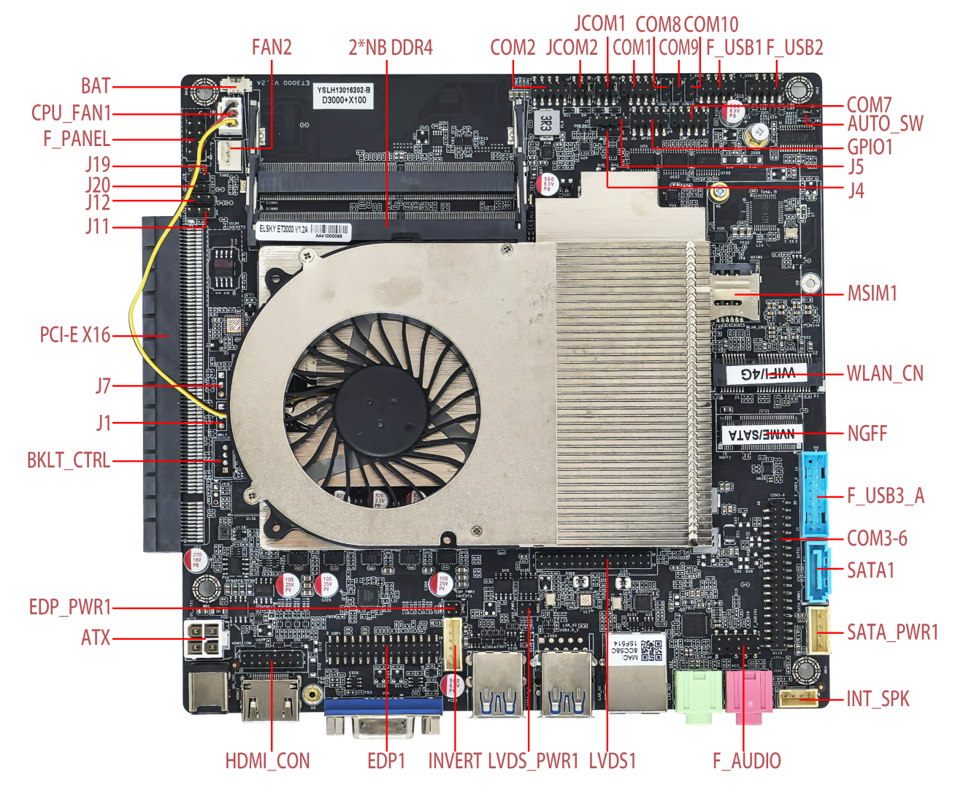
――――――――――――――――――――――――――――――――――――――――――――――――――――――
Motherboard single network interface diagram ↓
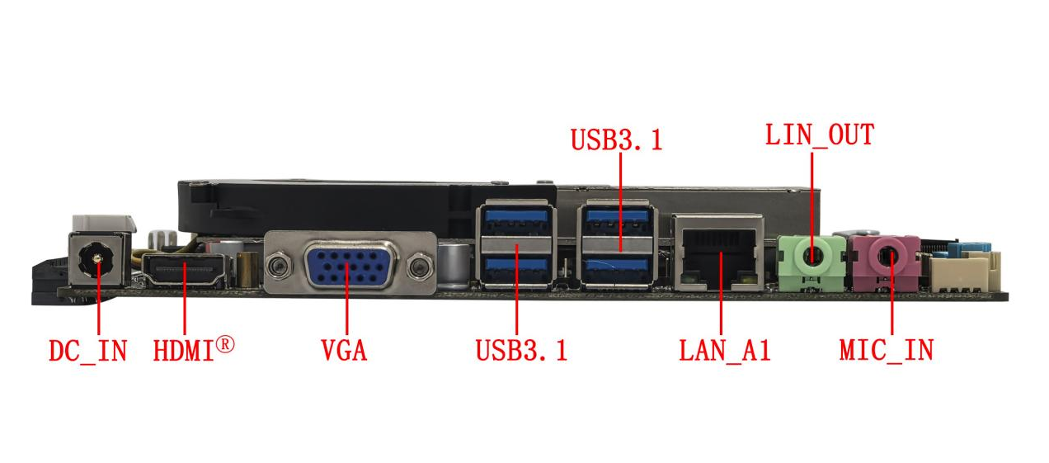
――――――――――――――――――――――――――――――――――――――――――――――――――――――

――――――――――――――――――――――――――――――――――――――――――――――――――――――
Motherboard dual network interface diagram ↓
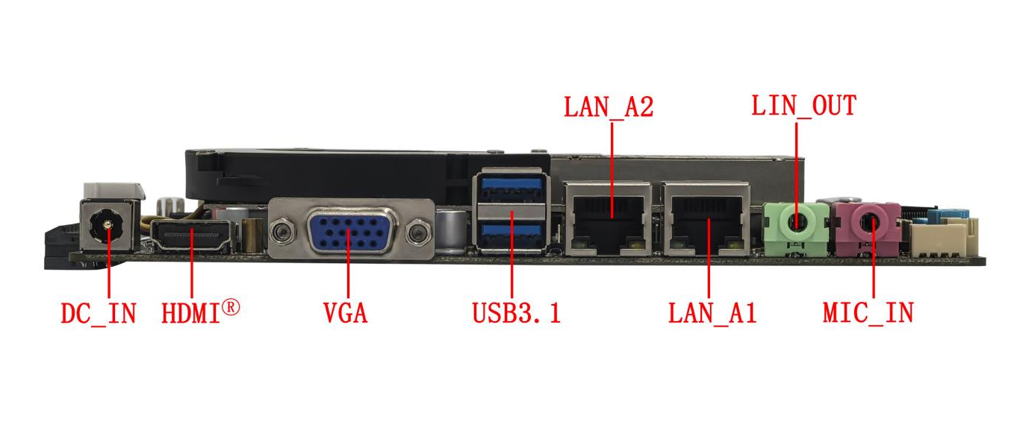
――――――――――――――――――――――――――――――――――――――――――――――――――――――

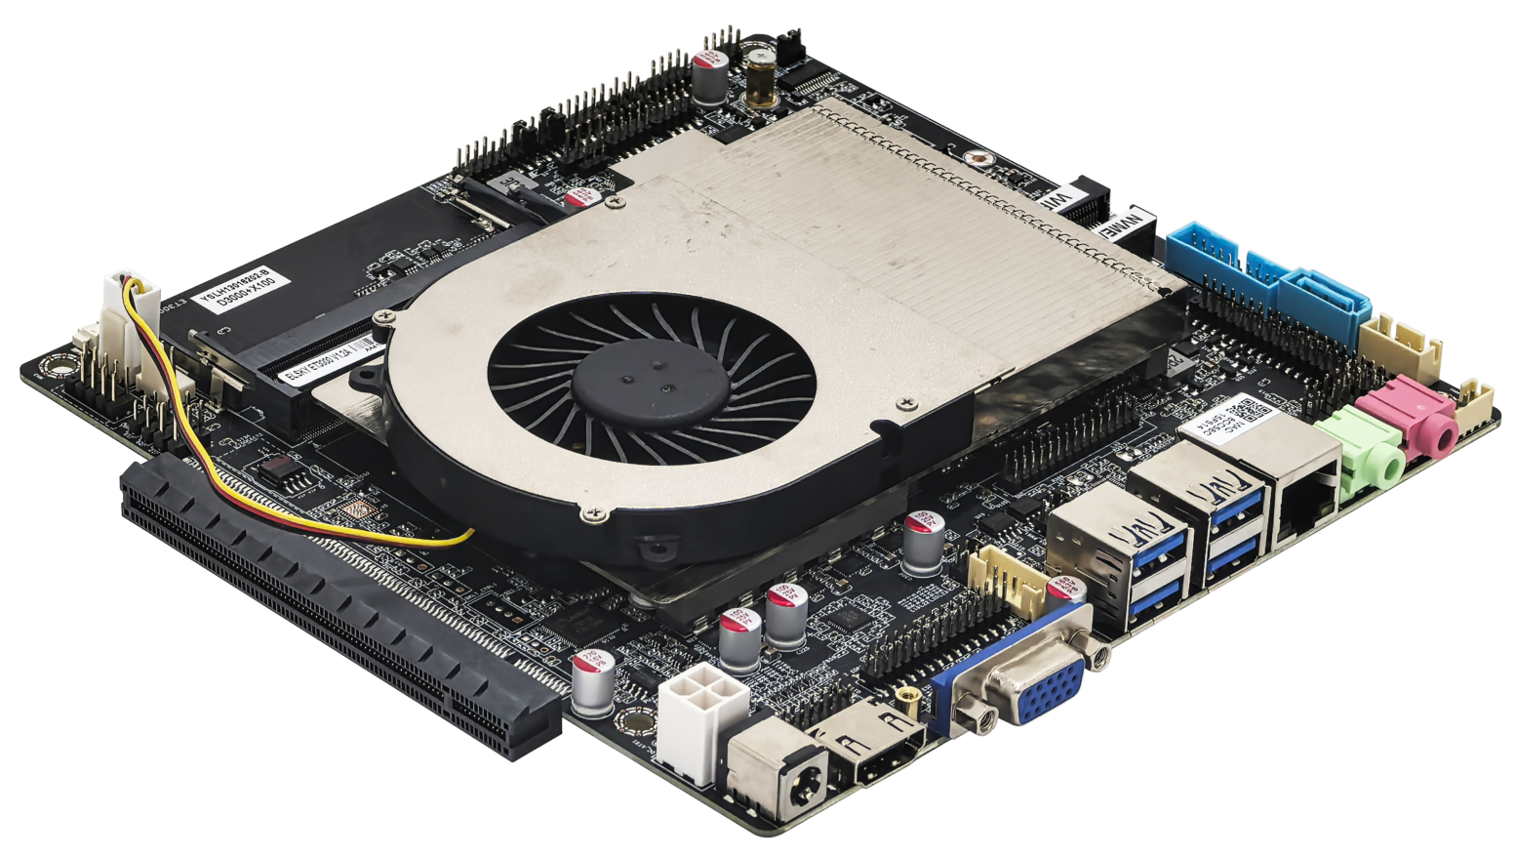
――――――――――――――――――――――――――――――――――――――――――――――――――――――

――――――――――――――――――――――――――――――――――――――――――――――――――――――
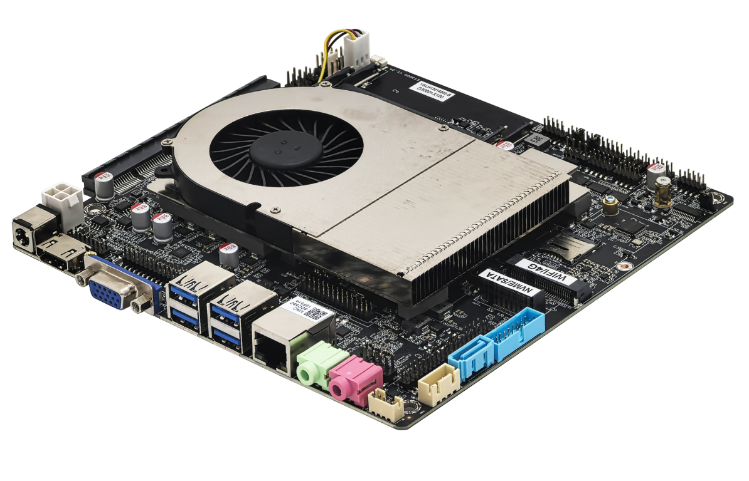
――――――――――――――――――――――――――――――――――――――――――――――――――――――
Motherboard back view ↓
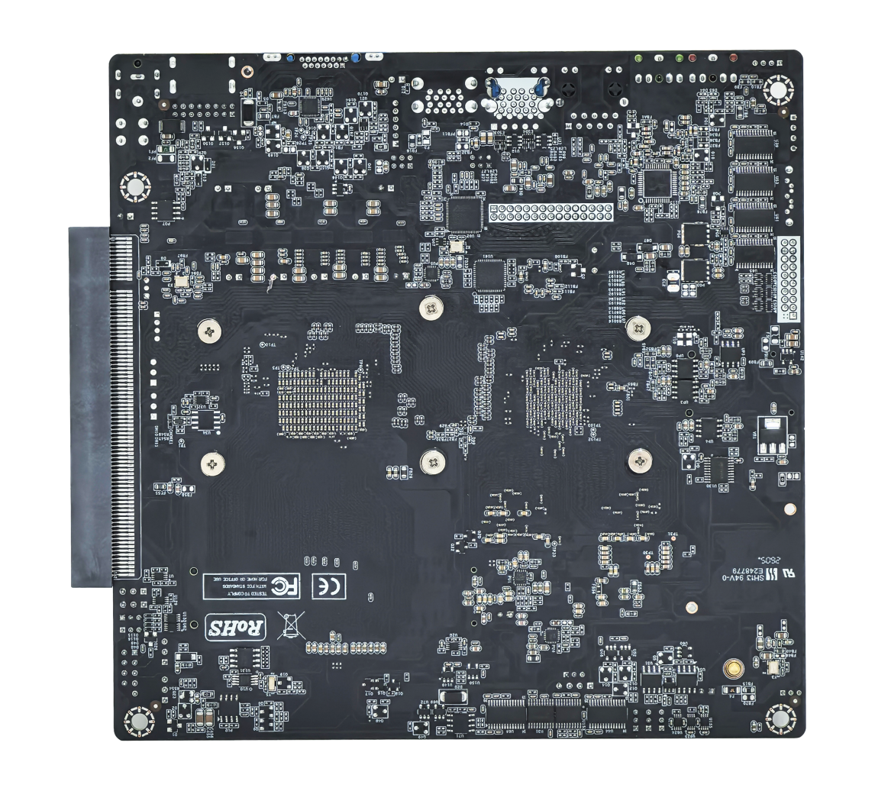
――――――――――――――――――――――――――――――――――――――――――――――――――――――
The images above are for reference only; please refer to the actual product for details.
Product model ordering and configuration options:
Product model | CPU | GPU | LAN | USB 2.0 | USB 3.1 | Memory | SSD | Power
ET3000 | Support domestic Phytium  Tengrui D3000 | Onboard X100  4G/8G dedicated graphics card  Optional | 1 | 4 | 5 | 2*NB-DDR4  64G (MAX) | 1*M.2  1*SATA  Optional 1*MSATA | +12V/19V
ET3000 | Support domestic Phytium  Tengrui D3000 | Onboard X100  4G/8G dedicated graphics card  Optional | 2 | 4 | 3 | 2*NB-DDR4  64G (MAX) | 1*M.2  1*SATA  Optional 1*MSATA | +12V/19V
Model configuration specifications: ET3000-2C/6C/10C-P (with PCI-E X16 graphics card slot), ET3000-2C/6C/10C (without PCI-E X16 graphics card slot)
Important Note:
Power supply interface:
The motherboard's DC power connector is 5.5*2.5mm; it supports one ATX 4-pin power connector.
The motherboard power supply supports 12V or 19V; the full load power consumption is about 70W, and it is recommended to use a power supply with 12V 7A or 19V 5A or higher .
CPU:
The motherboard supports the domestic Phytium Tengrui D3000 eight-core 2.5G;
Display interface:
- The motherboard features an onboard X100 4G/8G dedicated graphics card, with options available.
- The motherboard's VGA, HDMI® 2.0 , and HDMI_CON signals are the same, supporting single display, dual /triple display duplication , and dual display expansion ( expansion requires motherboard modification ) ;
- External HDMI® 2.0 interface /HDMI_CON header/VGA interface + LVDS1/EDP1 can support dual display expansion by default;
- The motherboard can choose between LVDS1 and EDP1. LVDS1 is supported by default, but hardware can be modified to support EDP1 using an EDP-C 30-pin backlight integrated screen cable.
- The motherboard's HDMI® 2.0 / HDMI_CON and VGA ports can be modified to support extended display, but this requires hardware modification. After modification, LVDS1/EDP1 will have no signal, and VGA will occupy the LVDS1/EDP1 signal; after modification, VGA will not support hot-swapping.
- The motherboard's HDMI® 2.0 interface supports 4K resolution 4096/3840*2160@30Hz, and the built-in HDMI_CON header supports 2K@60Hz ;
- The motherboard can be equipped with one PCI-E X16 slot supporting PCIE 4.0 x8 signals, supporting discrete graphics cards and PCI-E X16 devices ; after connecting a discrete graphics card, the display interfaces on the motherboard (VGA/HDMI® / LVDS/EDP1) will have no signal output ;
Mini-PCIe:
- The motherboard's WLAN_CN ( Mini - PCIE ) interface supports PCIE 3.0 x1 & USB signals , and supports WIFI, Bluetooth/4G modules by default ; the PCIE signal can be changed to a SATA signal, and after the change, it supports mSATA drives;
- The motherboard's WLAN_CN ( Mini - PCIE ) interface has two USB signal options: the USB signal from the 11-19 pins of the F_UAB3_A connector. By default, the WLAN_CN ( Mini - PCIE ) interface has a USB signal.
M.2:
The motherboard NGFF supports Key-M interface M.2 2280 NVME PCIe 4.0 x4 / SATA dual-protocol adaptive standard SSDs;
USB interface:
The single-network motherboard supports 9 USB ports by default (5 USB 3.1 Gen1, 4 USB 2.0).
By default, pins 11-19 of the motherboard's F_USB3_A connector are inactive; pins 1-9 are usable.
The external USB ports and internal USB headers on the motherboard are powered by S (no power when the computer is off) by default, but can be changed to A (power when the computer is off).
COM port:
1. The motherboard supports 10/ 6/2*COM options; COM1 can be selected to support RS232/422/485, and COM2 can be selected to support RS232/RS485, with 1*RS422 or 2*RS485, which can be set in the BIOS .
2. The 2/6COM motherboard supports RS232 by default;
3. The 10COM motherboard's COM1~COM7 ports support RS232 by default, while COM8/9/10 support TTL by default.
4. When a discrete graphics card is connected to the motherboard, COM1 and COM2 support RS232 by default, but do not support RS422/RS485; a dedicated BIOS needs to be flashed to use RS422/RS485.
5. COM1/2 can be configured to output 0V/5V/12V on pin 9 via the JCOM1/2 jumper cap; the default is 0V .
Network card:
Single network: Default is YT6801 Gigabit Ethernet adapter; optional is Realtek 8111H Gigabit Ethernet adapter;
Dual network: YT6801+YT6801 or Realtek 8111H+Realtek 8111H are optional, PoE power supply cannot be changed ;
Sound card:
The motherboard supports the Senary SN6186 sound card by default, but can be modified to support the Realtek ALC897 sound card ;

illustrate
Except for the accessories listed that come with the product, the contents of this manual do not represent a commitment by the company, and the company reserves the right to make changes to this manual without prior notice.
We are not responsible for any direct, indirect, intentional or unintentional damage or potential hazards caused by improper installation or use.
Before ordering a product, please consult with the distributor to understand in detail whether the product performance meets your needs.
The contents of this manual are protected by copyright. All rights reserved. No part of this manual may be reproduced in any mechanical, electronic or other manner without permission.
The final interpretation right of this instruction manual belongs to SHENZHEN ELSKY TECHNOLOGY CO.,LTD.
The above ordering information is for reference only. Please contact our sales department for details. Tel: 0755-82260150
Motherboard driver download: https://pan.baidu.com/s/1ie7qi5NutS53ipPecRSYtw
Access password: cbn5

CPU information
CPU Brand | CPU Specifications | CPU model | clock speed | Turbo Boost | CPU power consumption (W) | Full load power consumption is approximately (W)
Phytium | Tengrui D3000 | D3000 | Octa-core 2.5GHz | / | 43 | 70

BIOS function keys
BIOS function keys | Function Description
Press F8 during startup | Enter BIOS function interface
Press F2 when powering on | You can choose to boot from the BIOS or enter the BIOS interface.
← → | Use the left and right arrow keys to select an item.
↑ ↓ | Use the up and down arrows to select items
Enter | Select the item and enter the submenu.
+/- | Change the selection, or add or subtract values.
F9 | Factory reset
F10 | Save changes
Esc | quit

Chapter 1, Product Specifications
Motherboard size | 170mm (L) *170mm (W) * 24mm (H)
CPU | Supports domestic Phytium Tengrui D3000 octa-core 2.5GHz processor.
Chipset | Phytium X100
Power supply | 1*DC_ IN |  | The DC connector has an inner diameter of 2.5mm and supports 12V /19V.  The motherboard consumes approximately 70W under full load; a 12V 7A or 19V 5A or higher power supply is recommended.
Power supply | 1* ATX (4-pin)
Memory | 2*SO DIMM slots |  | NB-DDR4 memory , supporting a maximum frequency of 3200 MHz and a maximum capacity of 64 GB.
Network function | 1 / 2 * LAN interface | Single Gigabit Ethernet adapter: Default is YT6801; optional is Realtek 8111H; supports Wake-on-LAN and PXE functionality ;  Dual Gigabit Ethernet Adapters: YT6801 + YT6801 or Realtek 8111H + Realtek 8111H (optional)
Network function | 1*WLAN_CN interface |  | Supports PCIe 3.0 x1 & USB signals , and supports WIFI, Bluetooth/4G modules; can be modified to support mSATA hard drives.
Display function | graphics card |  | Supports onboard X100 4G/8G dedicated graphics card, supporting single display, dual display expansion, and dual/triple display duplication.
Display function | External HDMI® interface /HDMI® header /VGA interface + LVDS/EDP can support dual display expansion, requiring a newer system version;  HDMI® / HDMI_CON and VGA support single display, dual/triple display replication, and dual display expansion (see important notes for details) .
Display function | 1*VGA DB15 interface |  | Supports resolution 1920*1080@60Hz
Display function | 1*HDMI® 2.0 port |  | Supports 4K resolution 4096/3840*2160@60Hz
Display function | 1*HDMI_CON pins |  |  | Supports 2K resolution 1920*1080@60Hz (16Pin, 2*8Pin, 2.0mm)
Display function | VGA and HDMI® / HDMI_CON For the same signal, it supports simultaneous display. Hardware can be modified to support different displays. After modification, LVDS1/EDP1 will have no signal, and VGA will not support hot-swapping.
Display function | 1*LVDS 1 pin |  | Supports resolution 1920*1080@60Hz ( 30Pin, 2*15Pin, 2.0mm)
Display function | 1*EDP1 pin |  | EDP-C screen cable, supports resolution 1920*1080@ 60Hz  (30Pin, 2*15Pin, 2.0mm)
Display function | LVDS1 and EDP1 signals are selectable, with independent pins. EDP uses an EDP-C screen cable.
Display function | 1*EDP_PWR 1 pin |  | EDP working voltage control pin (6-pin, 2*3-pin, 2.0mm)
Display function | 1*LVDS_PWR 1 pin |  | LVDS operating voltage control pin (6-pin, 2*3-pin, 2.0mm)
Display function | 1*INVERT pin |  | LVDS backlight control pins (6-pin, 1*6-pin, 2.0mm)
Display function | 1*BKLT_CTRL pin |  | LVDS brightness adjustment pins (not included by default)  ( 4 Pin, 1* 4 Pin, 2.0mm)
Display function | 1 PCI-E X16 slot |  | Optional 1 PCI-E x16 slot supports PCIe 4.0 x8 signal , can be used to connect discrete graphics cards and PCI-E devices.
USB function | 4 USB 3.1 ports |  | Rear-mounted standard USB 3.1 Gen1 port with a maximum bandwidth of 5Gbps.
USB function | 1*F_USB 1- pin connector |  | Front-mounted USB 2.0 header, one set has 2 USB 2.0 ports.  (9-pin, 2*5-pin, 2.0 mm )
USB function | 1*F_USB2 pin |  | Front-mounted USB 2.0 header, one set has 2 USB 2.0 ports.  (9-pin, 2*5-pin, 2.0 mm )
USB function | 1*F_USB3_A connector |  | Front-mounted USB 3.1 Gen1 header, one set includes 1 USB 3.1 Gen1  (19 - pin, 2 x 10-pin, 2.0mm) .
USB function | The motherboard's WLAN_CN ( Mini - PCIE ) interface has two USB signals: one for the USB signal and the other for the USB 2.0 signal on pins 11-19 of the F_UAB3_A connector. By default, pins 11-19 of the F_UAB3_A connector do not have a USB 2.0 signal.
Sound function | The Senary SN6186 sound card is supported by default.  It can be modified to support integrated Realtek ALC 897 HD digital audio decoder and 6-channel high-fidelity audio controller.
Sound function | 1*LINE_OUT interface |  | Supports audio output (green)
Sound function | 1*MIC_IN interface |  | Microphone input is supported (red).
Sound function | 1* INT_SPK pin |  | Supports 8 ohms 5 watt speaker output (amplifier) (4-pin, 1*4-pin, 2.0mm)
Sound function | 1*F_AUDIO pin |  | Standard audio pins (9-pin, 2*5-pin, 2.54mm)
Hard drive function | 1*NGFF interface |  | Supports Key-M interface M.2 2280 NVME PCIe 4.0 x4 / SATA dual-protocol adaptive standard SSD;
Hard drive function | 1*SATA1 interface |  | Standard SATA hard drive interface, supports SATA 3.0
Hard drive function | 1*SATA_PWR header |  | The hard drive power supply pins can draw 5V or 12V power.  (4-pin, 1*4-pin, 2.54mm)
On/off function | 1*F_PANEL pin |  | Switch, power indicator, hard drive indicator, reset pin  (9-pin, 2*5-pin, 2.54mm)
On/off function | 1*AUTO_SW pin |  | Hardware control power-on pins (3-pin, 1*3-pin, 2.0mm)
Other I/O | 1*COM1 pin |  | Supports standard RS232 / RS422 / RS485 optional (9Pin, 2*5Pin, 2.0 mm )
Other I/O | 1*COM2 pin |  | Supports standard RS232 /RS485 optional (9-pin, 2*5-pin, 2.0 mm )
Other I/O | 1*COM7 pin |  | Supports standard RS232  (9-pin, 2*5-pin, 2.0 mm )
Other I/O | COM3-6 pins |  | Supports standard RS232 ( 39 Pin, 2 * 20 Pin, 2.0 mm ).
Other I/O | COM8/9/10 pins |  | Supports standard TTL ( 3- pin, 1 * 3- pin, 2.0 mm ).
Other I/O | 1* M SIM card slot |  | Supports SIM cards; a SIM card is required when using 4G.
Other I/O | 1 * CPU_FAN 1 pin​ |  | CPU fan header , supports temperature control (3-pin, 1*3-pin, 2.54mm)
Other I/O | 1 *FAN 2 pins |  | SYS fan header , full speed (3-pin, 1*3-pin, 2.54mm)
Other I/O | 1*GPIO1 pin |  | GPIO control pins (10Pin, 2*5Pin, 2.0mm)
Other I/O | 1*J4 pin |  | Adjustment pins (3-pin, 1*3-pin, 2.0mm)
Other I/O | 1*J5 pin |  | Adjustment pins (4-pin, 1*4-pin, 2.54mm)
Other I/O | 1*J11/J12 pins |  | Adjustment pins (3-pin, 1*3-pin, 2.54mm)
Other I/O | 1*J19/J20 pins |  | Adjustment pins (3-pin, 1*3-pin, 2.0mm)
Operating environment | Operating temperature: 0 ℃~ 45 ℃;  Operating humidity: 5%~95% relative humidity, non-condensing.
BIOS | Supports power-on upon startup and intelligent device identification for remote power-on/off ( requires flashing a specific BIOS ) .
Watch Dog | Watchdog programming, supports hardware reset function (256 levels, 0~255 seconds)  ( Requires flashing a specific BIOS ) .
Operating system | Supports Kylin (Desktop V10 SP1 Release ARM64), Linux , and other domestic operating systems (must support X100 version).
――――――――――――――――――――――――――――――――――――――――――――――――――――――

1.1 Motherboard Dimensions



