ELSKY HT3300 V1.2 Motherboard Specification
――――――――――――――――――――――――――――――――――――――――――――――――――――――
Motherboard diagram ↓
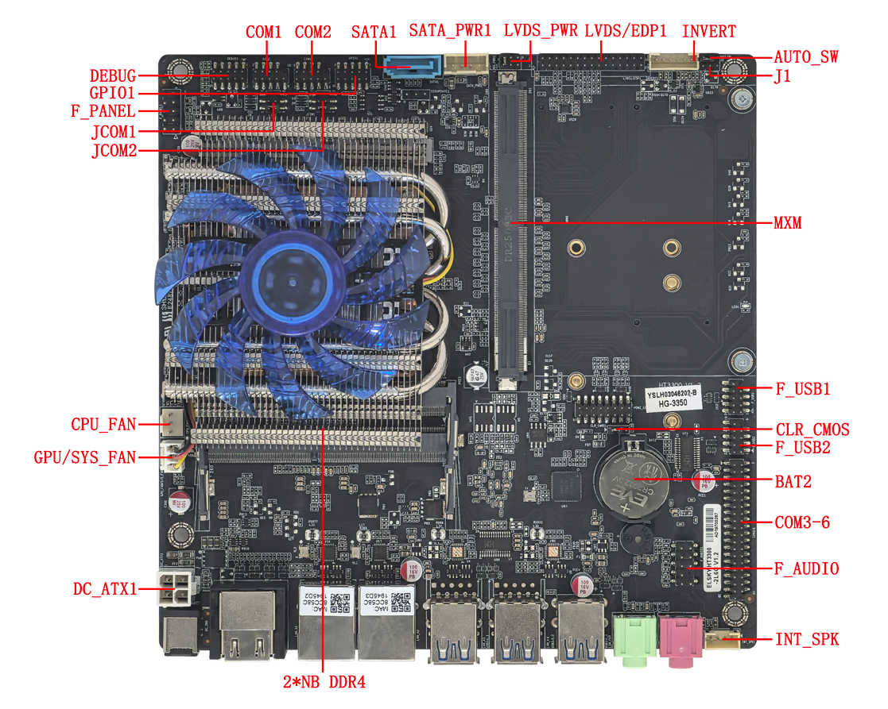
――――――――――――――――――――――――――――――――――――――――――――――――――――――
Image of dual HDMI + 4L interface ↓
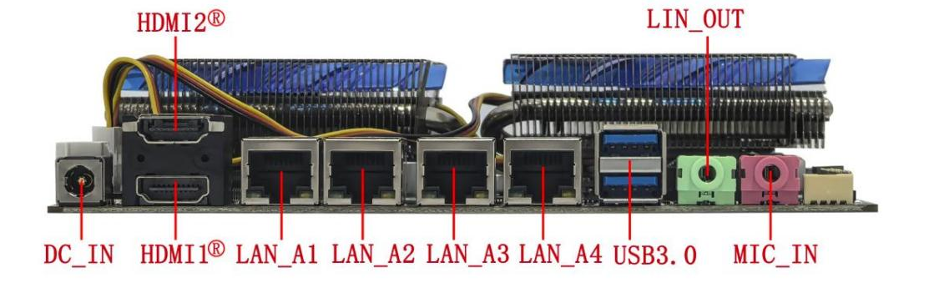
――――――――――――――――――――――――――――――――――――――――――――――――――――――
Dual HDMI + 3L interface images ↓
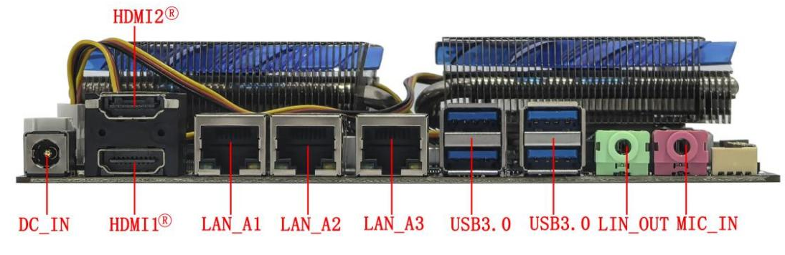
――――――――――――――――――――――――――――――――――――――――――――――――――――――
Dual HDMI + 2L interface images ↓
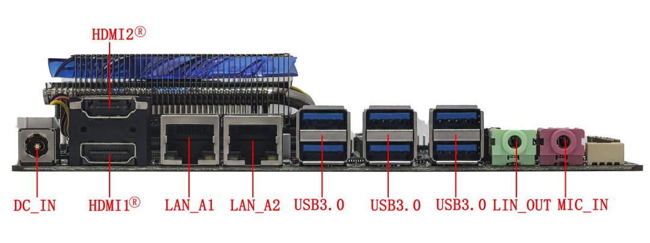
――――――――――――――――――――――――――――――――――――――――――――――――――――――
Image of a single HDMI port with two L ports ↓
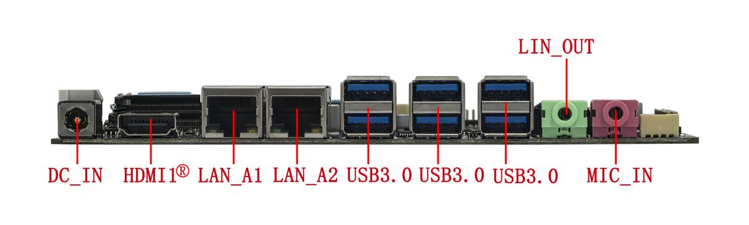
――――――――――――――――――――――――――――――――――――――――――――――――――――――

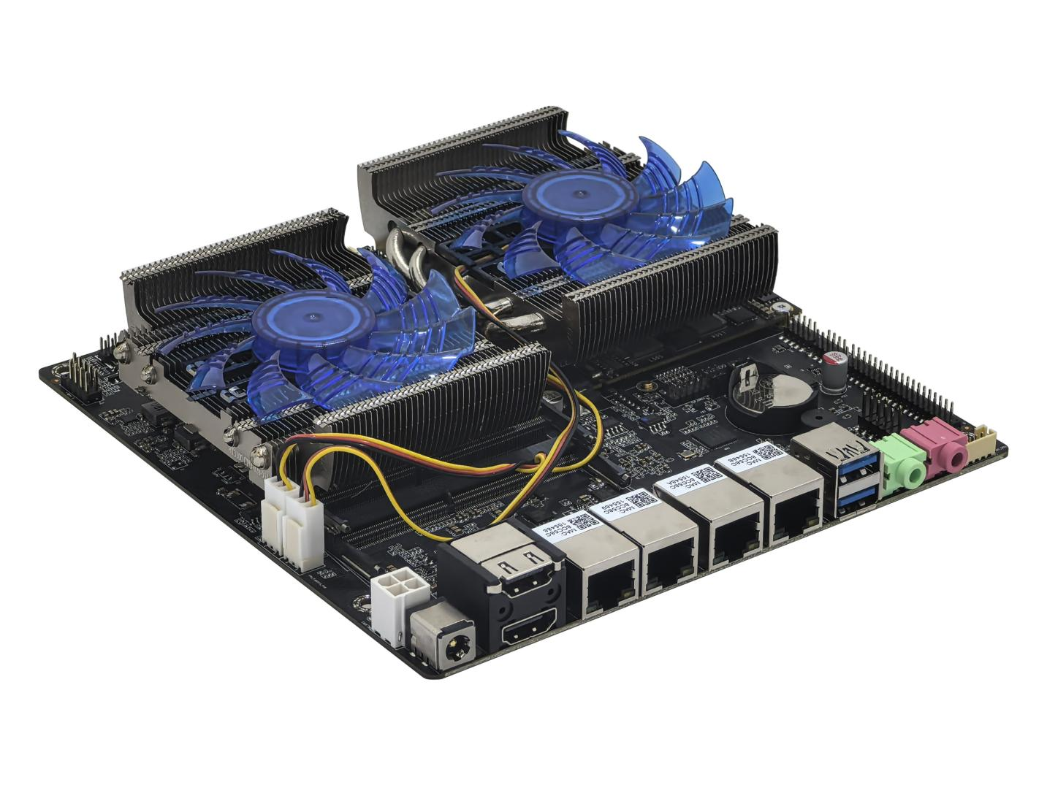
――――――――――――――――――――――――――――――――――――――――――――――――――――――
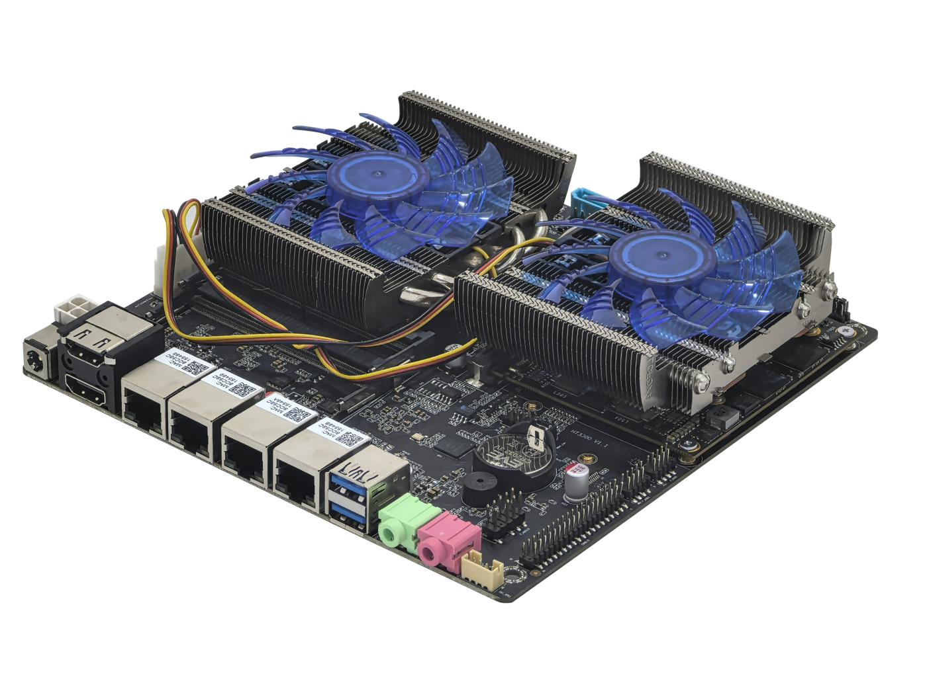
――――――――――――――――――――――――――――――――――――――――――――――――――――――
Image of the back of the motherboard ↓
.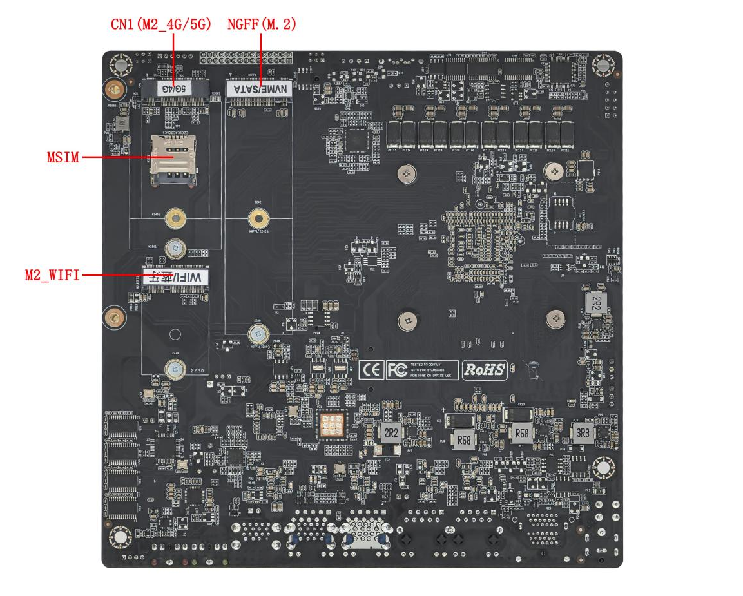
――――――――――――――――――――――――――――――――――――――――――――――――――――――
The images above are for reference only; please refer to the actual product for details.

Product model ordering and configuration options:
Product model | CPU | 4K | LAN | USB 3.0 | USB 2.0 | COM | Memory | SSD | Power
HT3300 | Supports domestic Hygon 3350/3350E/3330/3330E | Determined by MXM graphics card | 2 | 6 | 4 | 2/6 | 2*NB-DDR4  64G (MAX) | 1*M.2  1*SATA | +12V/19V
HT3300 | Supports domestic Hygon 3350/3350E/3330/3330E | Determined by MXM graphics card | 3 | 4
HT3300 | Supports domestic Hygon 3350/3350E/3330/3330E | Determined by MXM graphics card | 4 | 2
Important Note:
Power supply interface:
The motherboard's DC power connector is 5.5*2.5 inches; it supports one 4-pin ATX power connector.
The motherboard power supply supports 12V or 19V; the maximum full load power consumption (motherboard + graphics card + CPU) is about 180W, and it is recommended to use a 12V 15A or 19V 10A or higher power supply .
The motherboard power consumption varies depending on the MXM graphics card model .
CPU:
Supports domestic Hygon 3350 octa-core 3.0GHz processor with turbo boost up to 3.3GHz;
Supports domestic Hygon 3350E eight-core 2.8GHz processor with turbo boost up to 3.0GHz;
Supports domestic Hygon 3330 quad-core 3.0GHz processor with turbo boost up to 3.3GHz;
Supports domestic Hygon 3330E quad-core 2.0GHz processor with turbo boost up to 2.6GHz;
Display Interface: Note: Without an MXM graphics card installed, the motherboard cannot display a dedicated display.
- The displays supported by HDMI1®, HDMI2®, and LVDS/EDP1 on the motherboard are determined by the MXM graphics card ;
- The resolutions supported by the motherboard's HDMI1® and HDMI2® are determined by the MXM graphics card;
- The motherboard LVDS/EDP1 header supports LVDS by default and can be modified to support EDP, sharing the same header; the display of LVDS and EDP1 on the motherboard is determined by the MXM graphics card; the LVDS resolution only supports 1920*1080@60Hz.
- The motherboard EDP1 uses an EDP-B screen cable (20-pin independent screen cable for backlight), and the EDP1 resolution supports 1920*1080@60Hz.
- The motherboard supports MXM graphics cards by default, including Jingjia Micro JM9100/MJ7201/GS7201 and Xindong Fenghua II graphics cards; if using 1030/1650/1050Ti/3050 MXM graphics cards, the motherboard hardware needs to be modified.
- All MXM discrete graphics cards require channel and firmware compatibility to be used. Please refer to the MXM graphics card compatibility table below for details.
- Jingjia Micro JM7201/GS7201/JM9100: Supports Kylin and Tongxin systems, but does not support Windows systems;
1030/1050ti/1650/3050/RX550: Supports Windows 10, Windows 11, Ubuntu, Kylin, UnionTech systems, etc.
ChipPower FengHua II: Supports Windows 10, Windows 11, Kylin, and Tongxin operating systems;
Note: The motherboard does not support HDMI_CON header display.
M.2:
- The motherboard M.2 -WIFI supports Key-E interface M.2 2230 PCIE4.0 x1 & USB, and supports WiFi and Bluetooth modules; the M.2 hard drive cannot be modified .
- The motherboard supports Key-M interface M.2 2280 NVME PCIe 4.0 x4 / SATA dual-protocol adaptive standard SSDs; an optional M.2 2242 hard drive is also available.
- The motherboard 4G/5G-M2 supports Key-B interface M.2 5G (3052/3042) modules or M.2 4G (3042) modules;
USB interface:
- The dual-network motherboard supports 10 USB ports (6 USB 3.0 and 4 USB 2.0).
- The three-network motherboard supports 8 USB ports (4 USB 3.0 and 4 USB 2.0).
- The four-network motherboard supports 6 USB ports (2 USB 3.0, 4 USB 2.0).
- The external USB ports and internal USB headers on the motherboard are powered by S (no power when the computer is off) by default, but can be changed to A (power when the computer is off).
COM port:
- The motherboard supports 2 COM and 6 COM ports optional; it supports RS232 by default, with COM1 optional to support RS232/422/485, and COM2 supporting RS232/RS485; (the motherboard can support 1*RS422 or 2*RS485) .
- COM1/2 can be configured to output 0V/5V/12V on pin 9 via the JCOM1/JCOM2 jumper caps; the default is 0V .
Network card:
Dual-network: Supports 2*Yutaiwei YT6801 Gigabit network cards; can be modified to support 2*Realtek 8111H Gigabit network cards;
Three-network compatibility: Supports 3*Yutai Micro YT6801 gigabit network cards; can be modified to support 3*Realtek 8111H gigabit network cards;
Four-network support: Supports 4*Yutai Micro YT6801 gigabit network cards; can be modified to support 4*Realtek 8111H gigabit network cards;
Wake-on-LAN is supported by default; PoE power supply cannot be modified ; PXE is not supported.
Sound card:
supports the domestic CJC6811A USB sound card chip by default . The USB sound card signal is an independent signal, and the F_AUDIO pin is available .
GPIO:
It supports 8 GPIO signals and can support combinations such as four inputs and four outputs, eight inputs and zero outputs, and zero inputs and eight outputs. It can be further developed and debugged according to requirements.

MXM graphics card compatibility table:
MXM graphics card brand | Graphics card model | CPU model | HDMI1 | HDMI2 | EDP | LVDS | Full board power consumption  (W)
Jingjiawei | GS7201-2G | 3330 | / | 4K 30Hz | / | 1920*1080 | 92W
Jingjiawei | GS7201-2G | 3350 | / | 4K 30Hz | / | 1920*1080 | 125W
Jingjiawei | MJ7201-2G | 3330 | 4K 30Hz | 4K 30Hz | / | 1920*1080 | 92W
Jingjiawei | MJ7201-2G | 3350 | 4K 30Hz | 4K 30Hz | / | 1920*1080 | 125W
Jingjiawei | JM9100-4G | 3330 | 4K 60Hz | 4K 60Hz | 1920*1080 | / | 101W
Jingjiawei | JM9100-4G | 3350 | 4K 60Hz | 4K 60Hz | 1920*1080 | / | 129W
Jingjiawei | JM9100-2G | 3330 | 4K 60Hz | 4K 60Hz | 1920*1080 | / | 82W
Jingjiawei | JM9100-2G | 3350 | 4K 60Hz | 4K 60Hz | 1920*1080 | / | 106W
Innosilicon Technology | Feng Hua No. 2 2G | 3330 | 1920*1080 | 4K 60Hz | / | / | 77W
Innosilicon Technology | Feng Hua No. 2 2G | 3350 | 1920*1080 | 4K 60Hz | / | / | 106W
NVIDIA | GT1030-2G | 3330 | 4K 60Hz | / | / | / | 112W
NVIDIA | GT1030-2G | 3350 | 4K 60Hz | / | / | / | 136W
NVIDIA | GTX1050T-4G | 3330 | 4K 60Hz | 4K 60Hz | / | / | 142W
NVIDIA | GTX1050T-4G | 3350 | 4K 60Hz | 4K 60Hz | / | / | 180W
NVIDIA | RTX3050-6G | 3330 | 4K 60Hz | 4K 60Hz | / | / | 156W
NVIDIA | RTX3050-6G | 3350 | 4K 60Hz | 4K 60Hz | / | / | 188W
NVIDIA | GTX1650-4G | 3330 | 4K 60Hz | 4K 60Hz | / | / | 141W
NVIDIA | GTX1650-4G | 3350 | 4K 60Hz | 4K 60Hz | / | / | 165W
AMD | RX550-4G | 3330 | 4K 60Hz | 4K 60Hz | / | / | 130W
AMD | RX550-4G | 3350 | 4K 60Hz | 4K 60Hz | / | / | 165W
Note:
1. Jingjia Micro MJ7201/GS7201/JM9100: Supports Kylin and Tongxin systems, but does not support Windows systems;
1030/1050ti/1650/3050/RX550: Supports Windows 10, Windows 11, Ubuntu, Kylin, UnionTech systems, etc.
The ChipPower FengHua II supports Windows 10, Windows 11, Kylin, and Tongxin operating systems.
2. Jingjia Micro GS7201/MJ7201/JM9100 supports HDMI display by default. If you need to support LVDS/EDP display, you need to update the VBIOS of the corresponding graphics card.

CPU information
CPU Brand | CPU Specifications | CPU model | clock speed | Turbo Boost | Typical power consumption (W)
Hygon | Haiguang C86 | 3350 | Octa-core 3.0G | 3.3G | 65W
Hygon | Haiguang C86 | 3350E | Octa-core 2.8GHz | 3.0G | 45W
Hygon | Haiguang C86 | 3330 | Quad-core 3.0GHz | 3.3G | 35W
Hygon | Haiguang C86 | 3330E | Quad-core 2.0GHz | 2.6G | 20W

illustrate
Except for the accessories listed that come with the product, the contents of this manual do not represent a commitment by the company, and the company reserves the right to make changes to this manual without prior notice.

We are not responsible for any direct, indirect, intentional or unintentional damage or potential hazards caused by improper installation or use.
Before ordering a product, please consult with the distributor to understand in detail whether the product performance meets your needs.

The contents of this manual are protected by copyright. All rights reserved. No part of this manual may be reproduced in any mechanical, electronic or other manner without permission.
The final interpretation right of this instruction manual belongs to SHENZHEN ELSKY TECHNOLOGY CO.,LTD.

The above ordering information is for reference only. Please contact our sales department for details. Tel: 0755-82260150
Motherboard driver download: https://pan.baidu.com/s/1ie7qi5NutS53ipPecRSYtw
Access password: cbn5

BIOS function keys
BIOS function keys | Function Description
Press Delete when booting up | Enter BIOS function interface
Press F11 when powering on | You can choose to boot from the BIOS or enter the BIOS interface.
← → | Use the left and right arrow keys to select an item.
↑ ↓ | Use the up and down arrows to select items
Enter | Select the item and enter the submenu.
+/- | Change the selection, or add or subtract values.
F1 | Display relevant help content
F9 | Factory reset
F10 | Save changes and exit
Esc | quit

Chapter 1, Product Specifications
Motherboard size | 170mm (L) * 170mm (W) * 24 mm (H) including radiator height: 170mm (L) * 170mm (W) * 38 mm (H)
CPU | Supports domestically produced Hygon 3350, 3350E, 3330, 3330E, etc.
Power supply | 1*DC_ IN | The DC connector has an inner diameter of 2.5mm and supports 12V/19V.  The motherboard consumes approximately 180W under full load ; a 12V 15A or 19V 10A or higher power supply is recommended.
Power supply | 1*ATX (4-pin)
Memory | 2*SO DIMM slots | NB-DDR4 memory, supports 2133/2400/2666/3200 MHz memory, maximum support 64 GB.
Network function | 1/2*LAN interface | Dual-network: Supports 2*Yutaiwei YT6801 Gigabit network cards, can be modified to support 2*Realtek 8111H Gigabit network cards;  Three networks: Supports 3*Yutai Micro YT6801 gigabit network cards, can be modified to support 3*Realtek 8111H gigabit network cards;  Four-network: Supports 4*Yutaiwei YT6801 gigabit network cards, can be modified to support 4*Realtek 8111H gigabit network cards;  Supports Wake-on-LAN ; PoE power supply cannot be modified; PXE is not supported.
Network function | 1*M2_WIFI interface | Supports Key-E interface M.2 2230 PCIe 4.0 x1 & USB, and supports WiFi and Bluetooth modules.
Network function | 1*M2_4G/5G interface | Supports Key-B interface M.2 5G (3052/3042) modules or M.2 4G (3042) modules.
Display function | Dedicated graphics card | 1*MXM slot (If no MXM graphics card is connected, the motherboard will not display anything).
Display function | The display supported by the motherboard is determined by the MXM graphics card.
Display function | 1* HDMI1® port | The motherboard's HDMI1® interface has a resolution determined by the MXM graphics card.
Display function | 1*HDMI2® interface | The motherboard has an HDMI2® port ; the resolution is determined by the MXM graphics card.
Display function | Note: The motherboard does not support HDMI_CON header display.
Display function | 1*LVDS /EDP1 pin | Supports resolution 1920*1080@60Hz ( 30Pin, 2*15Pin, 2.0mm)
Display function | The LVDS/EDP1 header supports LVDS by default and can be modified to support EDP1, sharing the same header; EDP1 uses an EDP-B screen cable (20-pin separate screen cable for backlight) ; the display of LVDS and EDP1 on the motherboard is determined by the MXM graphics card; LVDS resolution only supports 1920x1080@60Hz.
Display function | 1*LVDS_PWR pin | LVDS /EDP1 operating voltage control pin (6-pin, 2*3-pin, 2.0mm)
Display function | 1*INVERT pin | LVDS backlight control pins (6-pin, 1*6-pin, 2.0mm)
Display function | The motherboard supports MXM graphics cards by default, including Jingjia Micro JM9100/MJ7201/GS7201 and Xindong Fenghua II graphics cards; if using MXM graphics cards such as 1030/1650/1050Ti/3050, the motherboard hardware needs to be modified.
USB function | 6 USB 3.0 ports | rear-mounted standard USB 3.0 port with a maximum bandwidth of 5Gbps.
USB function | 1*F_USB 1- pin connector | Front-mounted USB 2.0 header, one set has 2 USB 2.0 ports.  (9-pin, 2*5-pin, 2.0 mm )
USB function | 1*F_USB 2- pin connector | Front-mounted USB 2.0 header, one set has 2 USB 2.0 ports.  (9-pin, 2*5-pin, 2.0 mm )
Sound function | By default, it supports SMIC's domestically produced CJC6811A USB sound card chip.
Sound function | 1*LIN_OUT interface | Supports audio output (green)
Sound function | 1*MIC_IN interface | Microphone input is supported (red).
Sound function | 1* INT_SPK pin | Supports 8 ohms 5 watt speaker output (amplifier)  (4-pin, 1*4-pin, 2.0mm)
Sound function | 1*F_AUDIO pin | Standard audio pins (9-pin, 2*5-pin, 2.54mm)
Hard drive function | 1*NGFF interface | Supports Key-M interface M.2 2280 NVME PCIe 4.0 x4 / SATA adaptive standard SSD;  Optional M.2 2242 hard drive;
Hard drive function | 1*SATA1 interface | Standard SATA hard drive interface, supports SATA 3.0
Hard drive function | 1*SATA_PWR 1- pin connector | The hard drive power supply pins can draw 5V or 12V power.  (4-pin, 1*4-pin, 2.54mm)
On/off function | 1*F_PANEL pin | Switch, power indicator, hard drive indicator, reset pin  (9-pin, 2*5-pin, 2.54mm)
On/off function | 1*AUTO_SW pin | Hardware control power-on pins (3-pin, 1*3-pin, 2.0mm)
Other I/O | 1*COM1 pin | Supports standard RS232 / RS422 / RS485 optional (9Pin, 2*5Pin, 2.0 mm )
Other I/O | 1*COM2 pin | Supports standard RS232 / RS485 (9Pin, 2*5Pin, 2.0 mm ) .
Other I/O | COM3-6 pins | Serial port, supports standard RS232; (39Pin, 2*20Pin, 2.0mm)
Other I/O | 1*CPU_FAN 1 pin​ | CPU fan header , supports temperature control  (3-pin, 1*3-pin, 2.54mm)
Other I/O | 1*GPU_FAN/SYS_FAN pin |  | The system fan header does not support temperature control . (3-pin, 1*3-pin, 2.54mm)
Other I/O | 1*GPIO1 pin | GPIO control pins (10Pin, 2*5Pin, 2.0mm)
Other I/O | 1*CLR_CMOS pin | Motherboard discharge, zeroing pins (3-pin, 1*3-pin, 2.0mm)
Other I/O | 1*SIO-UPDATE pin | SIO's FW update pins (3-pin, 1*3-pin, 2.54mm)
Other I/O | 1*J1 pin | Adjustment pins (3-pin, 1*3-pin, 2.0mm)
Operating environment | Operating temperature: 0℃~ 45 ℃;  Operating humidity: 5%~95% relative humidity, non-condensing.
BIOS | Supports power-on upon startup, scheduled power-on, and intelligent identification of remote power on/off devices.
Operating system | Jingjia Micro JM7201/GS7201/JM9100: Supports Kylin and Tongxin systems, but does not support Windows systems;  1030/1050ti/1650/3050/RX550: Supports Windows 10, Windows 11, Ubuntu, Kylin, UnionTech systems, etc.  ChipPower FengHua II: Supports Windows 10, Windows 11, Kylin, and Tongxin operating systems;

Motherboard dimensions diagram
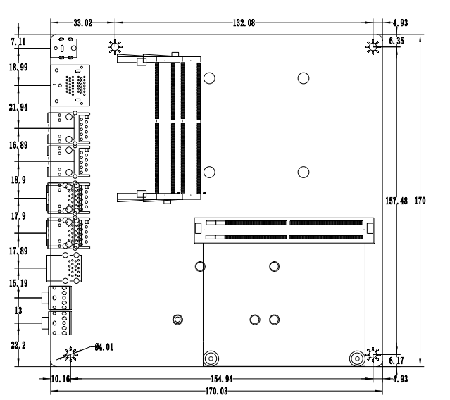
Dual HDMI + 4L interface size
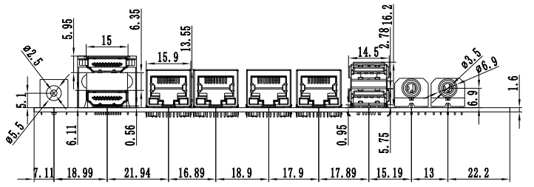
Dual HDMI + 3L Interface Dimension Diagram
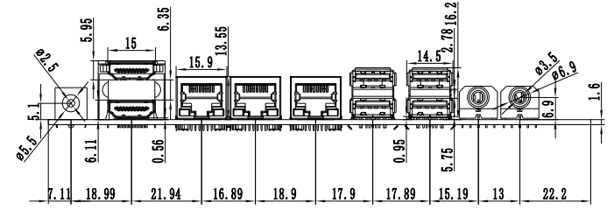

Dual HDMI + 2L Interface Dimension Diagram
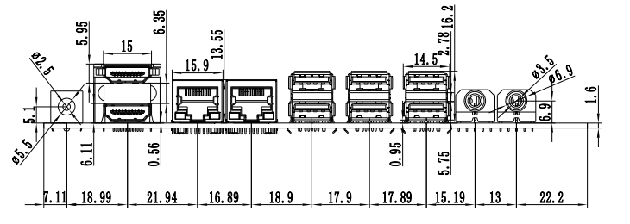
Single HDMI + 2L interface size diagram
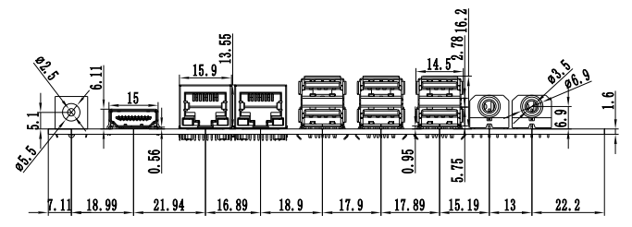
Single HDMI + 3L interface size diagram
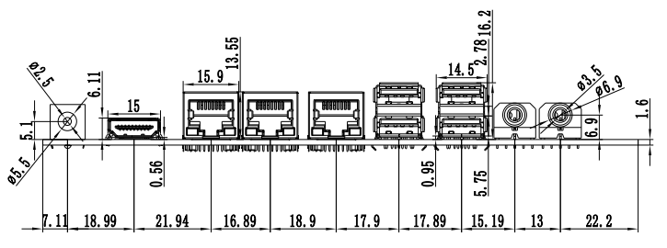
Single HDMI + 4L interface size diagram
