ELSKY IPC6000-6C Mini PC Specification
―――――――――――――――――――――――――――――――――――――――――――――――――――――――
Mini PC size

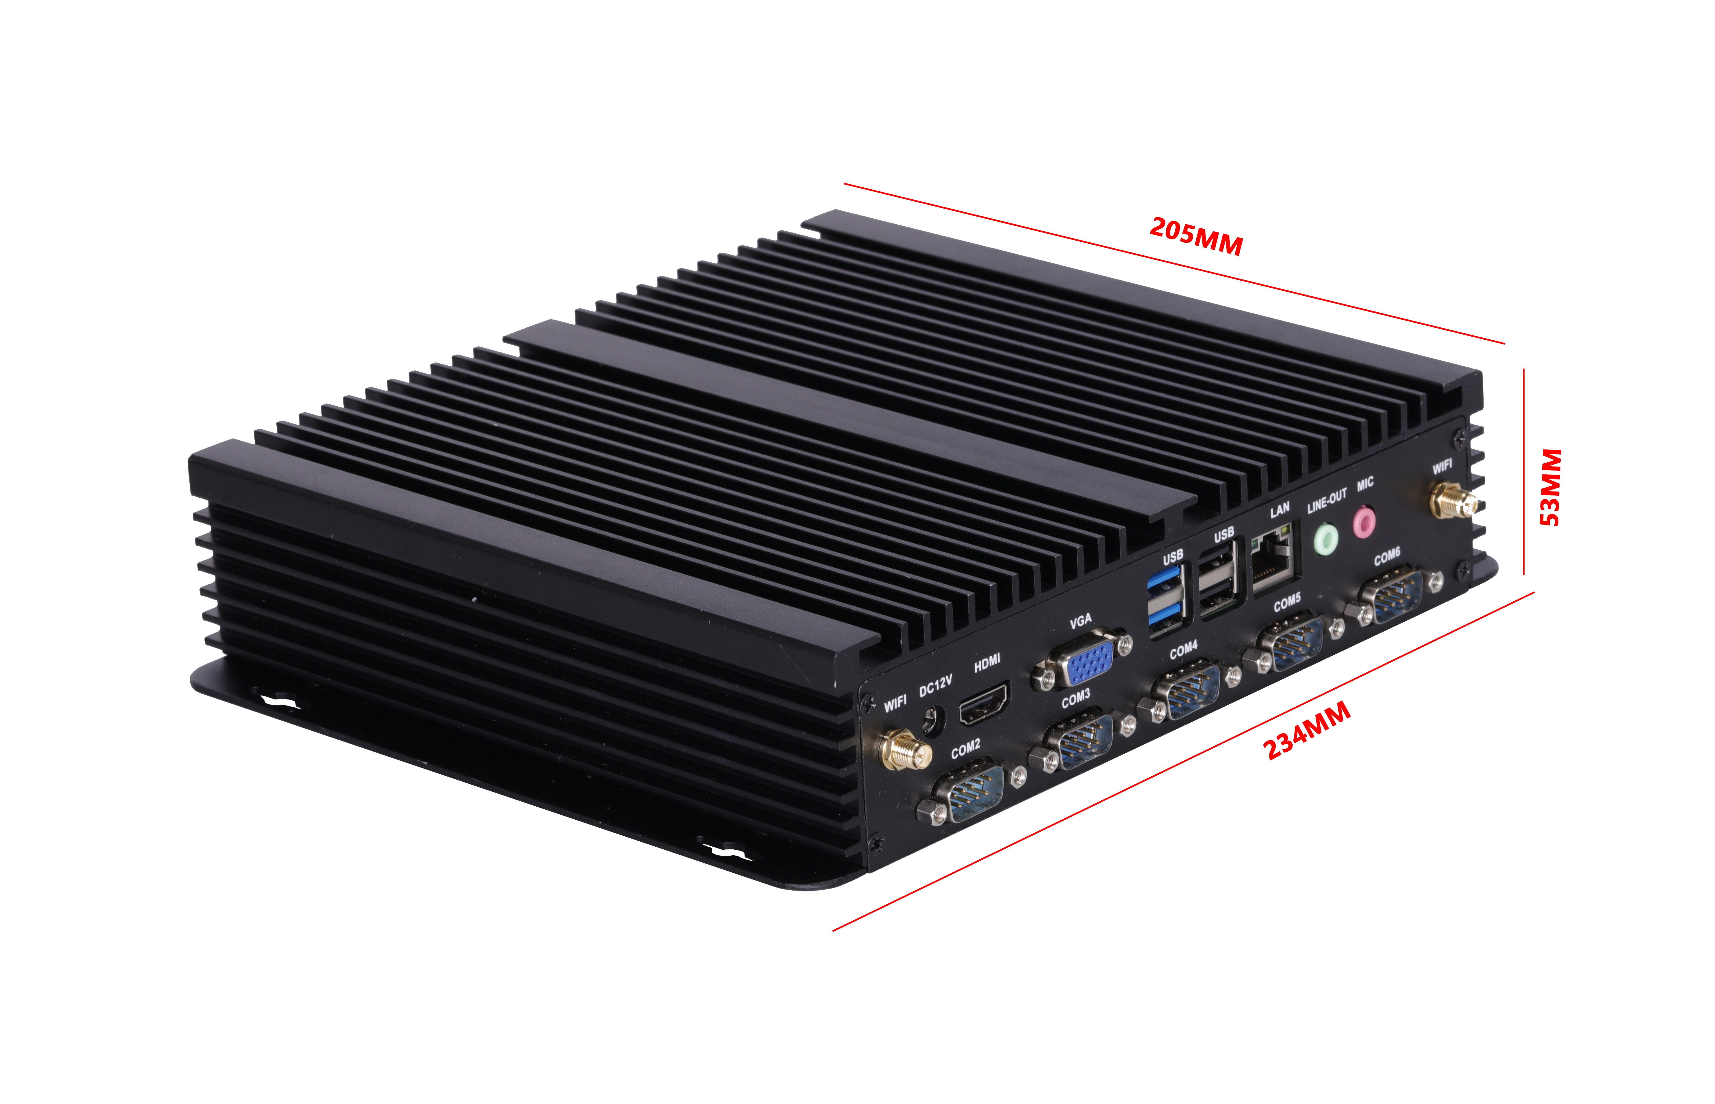
―――――――――――――――――――――――――――――――――――――――――――――――――――――――
Single network interface
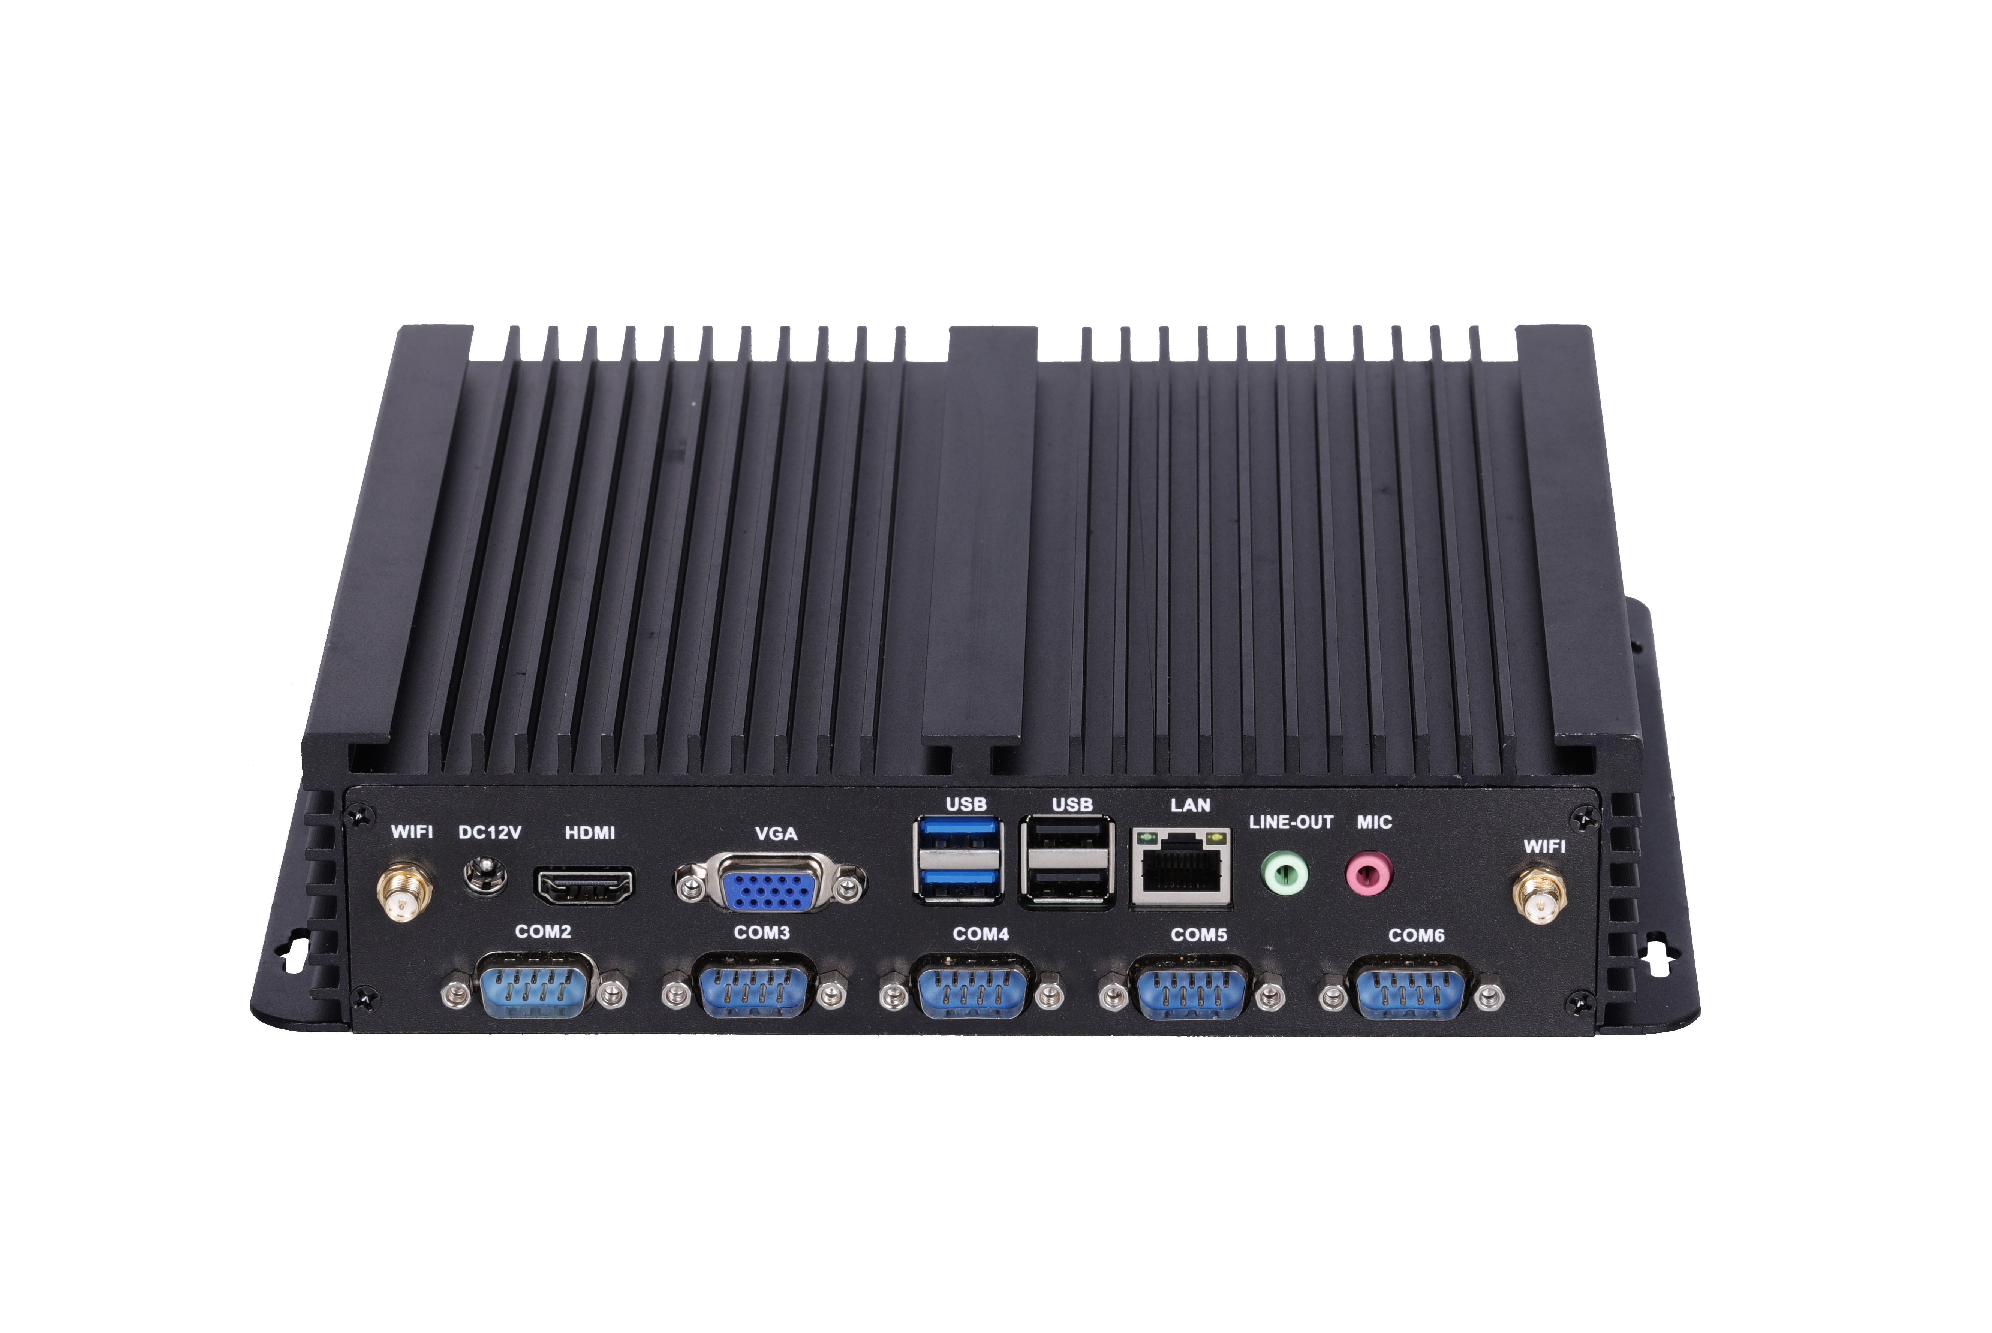
―――――――――――――――――――――――――――――――――――――――――――――――――――――――

―――――――――――――――――――――――――――――――――――――――――――――――――――――――
Dual network interface

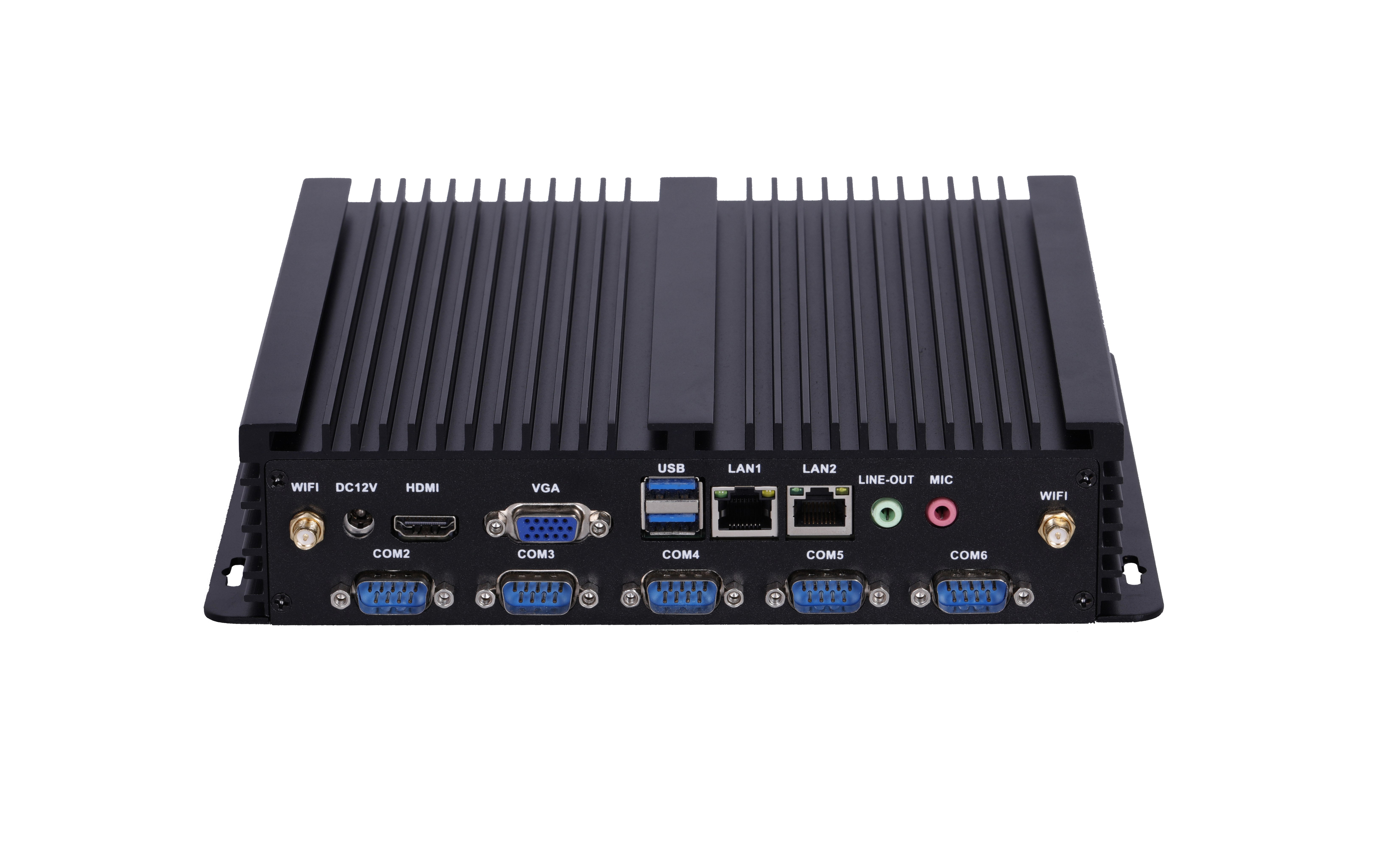

―――――――――――――――――――――――――――――――――――――――――――――――――――――――

DP interface

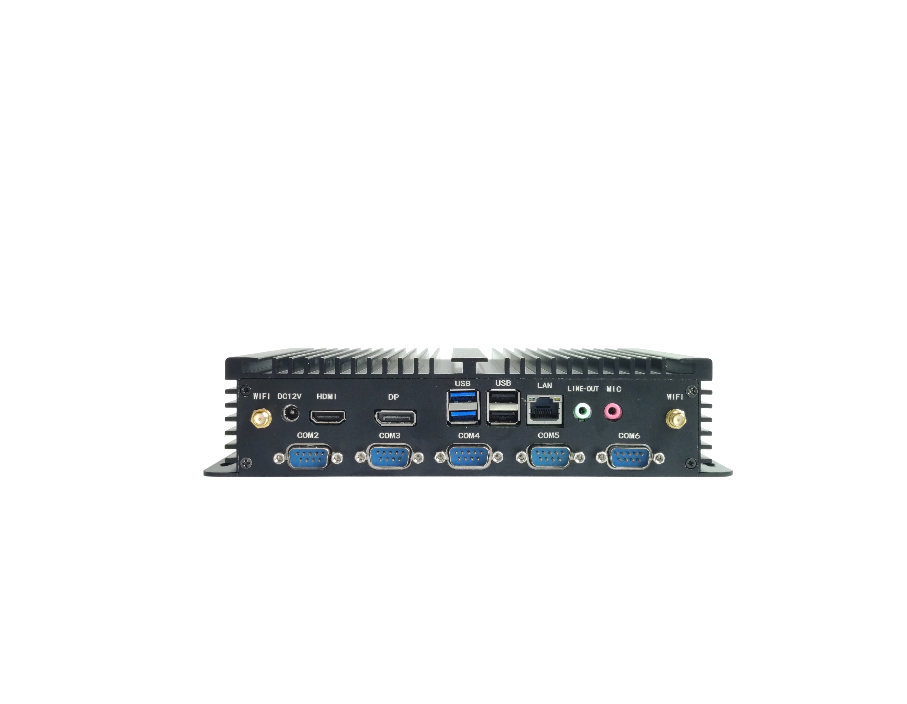

―――――――――――――――――――――――――――――――――――――――――――――――――――――――

―――――――――――――――――――――――――――――――――――――――――――――――――――――――

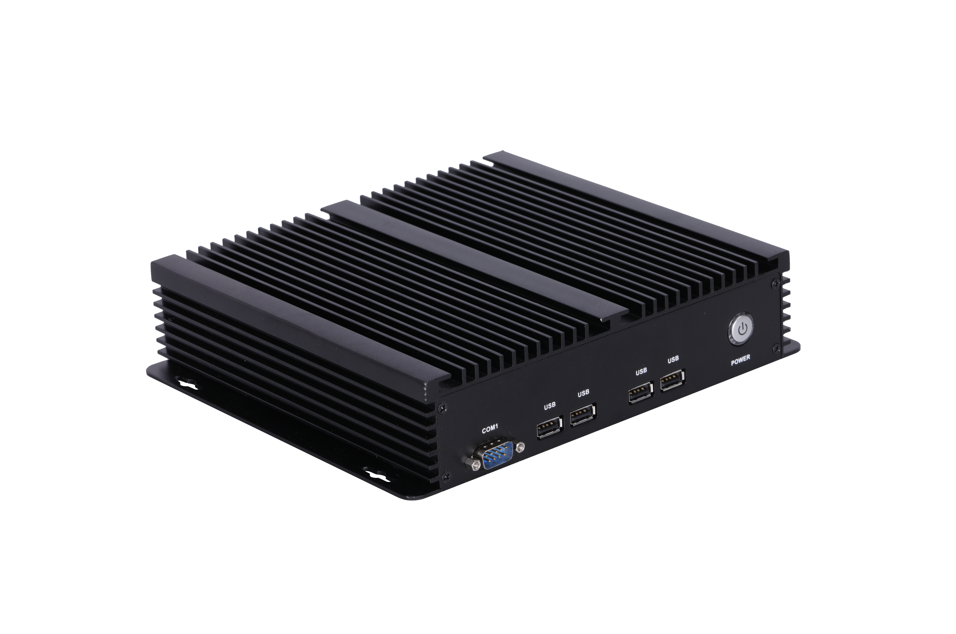

―――――――――――――――――――――――――――――――――――――――――――――――――――――――
LPT interface

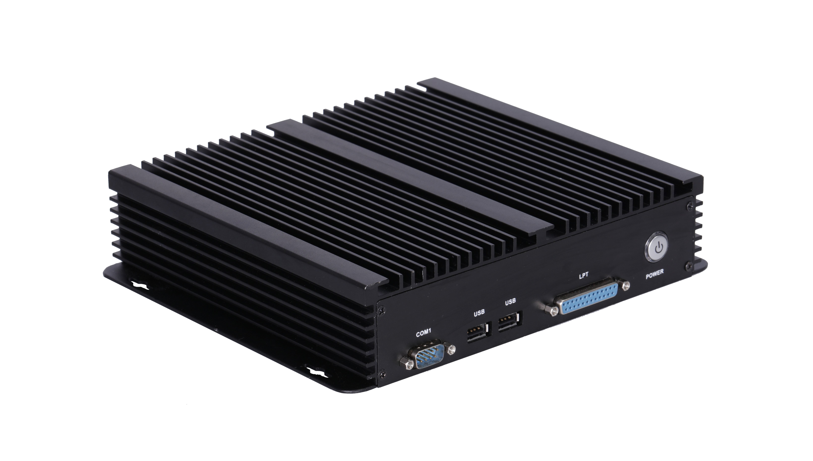

―――――――――――――――――――――――――――――――――――――――――――――――――――――――

―――――――――――――――――――――――――――――――――――――――――――――――――――――――
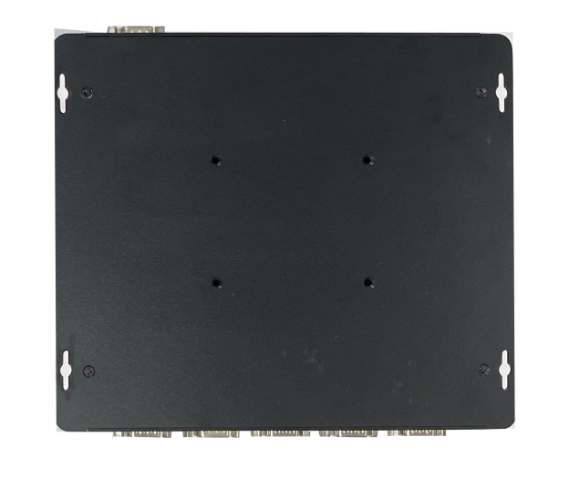
―――――――――――――――――――――――――――――――――――――――――――――――――――――――
The pictures are for reference only, please refer to the actual product!
Product model ordering optional:
PC model | Motherboard | HDMI | LAN | USB2.0 | USB3.0 | COM | SSD | Memory（MAX） | Power
J1900 series | M219F | 2K 60Hz | 1 | 7 | 1 | 6 | 1*MSATA;  1*2.5-inch disk | 1*DDR3;8G | 12V
J1900 series | M219F | 2K 60Hz | 2 | 5 | 1 | 6 | 1*MSATA;  1*2.5-inch disk | 1*DDR3;8G | 12V
J3355 series | M335F | 4K 30Hz | 1 | 5 | 2 | 6 | 1*MSATA;  1*2.5-inch disk | 1*DDR3;8G | 12V
J3355 series | M335F | 4K 30Hz | 2 | 3 | 2 | 6 | 1*MSATA;  1*2.5-inch disk | 1*DDR3;8G | 12V
3rd gen series | HGP series | 2K 60Hz | 1 | 6 | 2 | 6 | 1*MSATA;  1*2.5-inch disk | 1*DDR3;8G | 12V
3rd gen series | HGP series | 2K 60Hz | 2 | 4 | 2 | 6 | 1*MSATA;  1*2.5-inch disk | 1*DDR3;8G | 12V
4th, 5th gen series | QM9400  QM9500 | 4K 30Hz | 1 | 6 | 2 | 6 | 1*MSATA;  1*2.5-inch disk | 1*DDR3;8G | 12V
4th, 5th gen series | QM9400  QM9500 | 4K 30Hz | 2 | 4 | 2 | 6 | 1*MSATA;  1*2.5-inch disk | 1*DDR3;8G | 12V
Domestic Zhaoxin | KC6000 | 4K 30Hz | 1 | 6 | 2 | 6 | 1*MSATA;  1*2.5-inch disk | 2*DDR4;64G | 12V/19V
Domestic Zhaoxin | KC6000 | 4K 30Hz | 2 | 4 | 2 | 6 | 1*MSATA;  1*2.5-inch disk | 2*DDR4;64G | 12V/19V
6th, 7th gen series | QM9600  QM9700 | 4K 30Hz | 1 | 6 | 2 | 6 | 1*MSATA;  1*2.5-inch disk | 2*DDR3;16G | 12V/19V
6th, 7th gen series | QM9600  QM9700 | 4K 30Hz | 2 | 4 | 2 | 6 | 1*MSATA;  1*2.5-inch disk | 2*DDR3;16G | 12V/19V
8th, 10th gen series | QM9850  QM10U | 4K 30Hz | 1 | 6 | 2 | 6 | 1*MSATA;  1*2.5-inch disk;  1*M.2 SSD | 2*DDR4;32G | 12V/19V
8th, 10th gen series | QM9850  QM10U | 4K 30Hz | 2 | 4 | 2 | 6 | 1*MSATA;  1*2.5-inch disk;  1*M.2 SSD | 2*DDR4;32G | 12V/19V

Mini PC Specification:
PC model | IPC6000-J1900 series
Motherboard model | M218F, M219F, M218FC, M219FC, M218H, M219H
PC size | 234mm*205mm*53mm
Power supply | 1*DC_IN | The inner diameter of the DC head is 2.5mm and supports 12V. It is recommended to use a power supply of 12V5A or higher
CPU | Intel Celeron J1800 dual core 2.41GHz, turbo 2.58GHz;  Intel Celeron J1900 quad core 1.99GHz, turbo 2.4GHz;  Intel Pentium J2900 quad core 2.41GHz, turbo 2.66GHz;  Intel Celeron N2840 Dual Core 2.16GHz, turbo 2.58GHz;  Intel Celeron N2930 quad core 1.83GHz, turbo 2.16GHz;  Intel Celeron N2940 quad core 1.83GHz, turbo 2.25GHz;
Chipset | Intel Bay trail SOC chipset
Memory | 1*NB-DDR3 memory, supports 1.35V, 1600MHz memory, maximum support 8GB
Network function | Integrated Realtek 8111E Gigabit Ethernet card or Realtek 8105E 100Mbps Ethernet card optional, supporting Wake on LAN and network PXE function
Network function | Supports WIFI/4G/Bluetooth optional, supports 2 * WIFI antenna pole
Display function | Intel HD Graphics (Sandy Bridge) graphics controller, support single display, dual display replication, and dual display expansion
Display function | 1*VGA DB15 port | Support resolution 1920*1080@60Hz
Display function | 1*HDMI 1.4 port | Support resolution 1920*1080@60Hz
USB function | 1*USB3.0 port | The blue group USB is USB 3.0 speed (blue group, below the chassis direction is USB 3.0)
USB function | 5*USB2.0 port | The black group USB is USB 2.0 speed (the blue group, above the chassis direction is USB 2.0)
Sound function | Integrated Realtek ALC662 HD digital audio decoder, 6-channel high fidelity audio controller  Or integrated Cmedia HS_100B USB audio chip
Sound function | 1*SPK port | Support audio output
Sound function | 1*MIC port | Support microphone input
Sound function | HDMI interface supports HDMI audio output
Hard disk function | 1*MSATA disk;  1*2.5-inch hard drive (SSD or HDD);
Switch function | POWER button | Switch button
Other I/O | 6*COM port | Supports RS232; COM3/4 can optionally support RS232/RS422/RS485;  COM6 can optionally support RS232/RS485;
Other I/O | 1*LPT port | Parallel port, standard printing port
Operating environment | Working temperature: -10 ℃~60 ℃;  Working humidity: 5%~95% relative humidity, no condensation
BIOS | AMI BIOS,support power on, timed power on, and remote power on
Watch Dog | Watchdog programming, supports hardware reset function (256 levels, 0-255 seconds)
Operating system | Windows 10, Windows 8, Windows 7, Linux, etc
Instructions:
☆ Single Gigabit Ethernet port/Dual Gigabit Ethernet port optional for the PC; Dual network ports only affect the number of USB 2.0 ports;
☆ The PC is equipped with wall mounted holes;
Mini PC Specification:
PC model | IPC6000-J3355 series
Motherboard model | M335F
PC size | 234mm*205mm*53mm
Power supply | 1*DC_IN | The inner diameter of the DC head is 2.5mm and supports 12V. It is recommended to use a power supply of 12V5A or higher
CPU | Intel Celeron J3355 dual core 2.0GHz, turbo 2.5GHz;  Intel Celeron J3455 quad core 1.5GHz, turbo 2.3GHz;  Intel Pentium N4200 quad core 1.1GHz, turbo 2.5GHz;
Chipset | Intel Apollo Lake SOC chipset
Memory | 1*NB-DDR3 memory, supports 1.35V, 1600MHz memory, maximum support 8GB
Network function | Integrated Realtek 8111H Gigabit Ethernet card, supporting Wake on LAN and network PXE function
Network function | Supports WIFI/4G/Bluetooth optional, supports 2*WIFI antenna pole
Display function | Intel HD Graphics 500/505 graphics controller, supporting single display, dual display replication, and dual display expansion
Display function | 1*VGA DB15 port | Support resolution 1920*1080@60Hz
Display function | 1*HDMI 1.4 port | Support 4K resolution 4096/3840*2160@30Hz
USB function | 2*USB3.0 port | The blue group USB is USB 3.0 speed
USB function | 5*USB2.0 port | The black group USB is USB 2.0 speed
Sound function | Integrated Realtek ALC662 HD digital audio decoder, 6-channel high fidelity audio controller
Sound function | 1*SPK port | Support audio output
Sound function | 1*MIC port | Support microphone input
Sound function | HDMI interface supports HDMI audio output
Hard disk function | 1*MSATA disk;  1*2.5-inch hard drive (SSD or HDD)
Switch function | POWER button | Switch button
Other I/O | 6*COM port | Supports RS232; COM4/6 can optionally support RS232/RS422/RS485;
Other I/O | 1*LPT port | Parallel port, standard printing port
Operating environment | Working temperature: -10 ℃~60 ℃;  Working humidity: 5%~95% relative humidity, no condensation
BIOS | AMI BIOS， Support power on, timed power on, and remote power on
Watch Dog | Watchdog programming, supports hardware reset function (256 levels, 0-255 seconds)
Operating system | Windows 10 64 bit, Linux, etc
Instructions:
☆ Single Gigabit Ethernet port/Dual Gigabit Ethernet port optional for the PC; Dual network ports only affect the number of USB 2.0 ports;
☆ The PC is equipped with wall mounted holes;

Mini PC Specification:
PC model | IPC6000-3rd gen series
Motherboard model | 1037F, 2117F, i3HGP, i5HGP, i7HGP
PC size | 234mm*205mm*53mm
Power supply | 1*DC_IN | The inner diameter of the DC head is 2.5mm and supports 12V.  It is recommended to use a power supply of 12V5A or higher
3rd gen CPU | Intel Celeron 1037U dual core 1.8GHz;  Intel Pentium 2117U dual core 1.8GHz;  Intel Core i3-3217U dual core 1.8GHz;  Intel Core i3-3227U Dual Core 1.9GHz;  Intel Core i5-3317U dual core 1.7GHz, turbo 2.6GHz;  Intel Core i5-3337U dual core 1.8GHz, turbo 2.7GHz;  Intel Core i5-3427U dual core 1.8GHz, turbo 2.8GHz;  Intel Core i5-3437U dual core 1.9GHz, turbo 2.9GHz;  Intel Core i7-3517U dual core 1.9GHz, turbo 3.0GHz;  Intel Core i7-3537U dual core 2.0GHz, turbo 3.1GHz;  Intel Core i7-3667U dual core 2.0GHz, turbo 3.2GHz;  Intel Core i7-3687U dual core 2.1GHz, turbo 3.3GHz;
Chipset | intel 6 series chipset: HM65, HM67, QM67  intel 7 series chipset: NM70, HM70, HM75, HM76, HM77, QM77
Memory | 1*NB-DDR3 memory, support 1.35V/1.5V,support 1333/1600MHz memory,maximum support 8G
Network function | Integrated Realtek 8111E Gigabit Ethernet card or Realtek 8105E 100Mbps Ethernet card optional, supporting Wake on LAN and network PXE function
Network function | Support WIFI/4G/Bluetooth optional, supports 2*WIFI antenna pole
Display function | Intel HD Graphics 4000 graphics controller, support single display, dual display replication, and dual display expansion
Display function | 1*VGA DB15 port | Support resolution 1920*1080@60Hz
Display function | 1*HDMI 1.4 port | Support resolution 1920*1080@60Hz
USB function | 2*USB3.0 port | The blue group USB is USB3.0 speed  (USB 2.0 speed when using Intel 6 series chipset)
USB function | 4*USB2.0 port | The black group USB is USB2.0 speed
Sound function | Integrated Realtek ALC662 HD digital audio decoder, 6-channel high fidelity audio controller  Or integrated Cmedia HS_100B USB audio chip
Sound function | 1*SPK port | Support audio output
Sound function | 1*MIC port | Support microphone input
Sound function | HDMI interface support HDMI audio output
Hard disk function | 1*MSATA disks;  1*2.5-inch disks (SSD or HDD)
Switch function | POWER button | Switch button
Other I/O | 6*COM port | Support RS232; COM2 optional supports RS422/RS485
Other I/O | 1*LPT port | Parallel port, standard printing port
Operating environment | Working temperature: -10 ℃~60 ℃;  Working humidity: 5%~95% relative humidity, no condensation
BIOS | AMI BIOS,support power on, timed power on, and remote power on
Watch Dog | Watchdog programming, supports hardware reset function (256 levels, 0-255 seconds)
Operating system | Windows 10, Windows 8, Windows 7, Windows XP, Linux, etc
Instructions:
☆ When the main chipset is an Intel 6 series chipset, the blue USB interface is USB 2.0 and there is no USB 3.0;
☆ When the main chipset is Intel 7 series chipset, the blue USB interface is USB 3.0;
☆ Single Gigabit Ethernet port/Dual Gigabit Ethernet port optional for the PC; Dual network ports only affect the number of USB 2.0 ports;
☆ The PC is equipped with wall mounted holes;

Mini PC Specification:
PC model | IPC6000-4th,5th gen series
Motherboard model | QM9400, QM9500 series
PC size | 234mm*205mm*53mm
Power supply | 1*DC_IN | The inner diameter of the DC head is 2.5mm and supports 12V.  It is recommended to use a power supply of 12V5A or higher.
4th gen CPU | Intel Core i3-4005U dual core 1.7GHz; Core i3-4010U dual core 1.7GHz;  Intel Core i3-4025U dual core 1.9GHz; Core i3-4030U dual core 1.9GHz;  Intel Core i3-4100U Dual Core 1.8GHz;  Intel Core i5-4200U dual core 1.6GHz, turbo 2.6GHz; Core i5-4210U dual core 1.7GHz, turbo 2.7GHz;  Intel Core i5-4250U dual core 1.3GHz, turbo 2.6GHz; Core i5-4278U dual core 2.6GHz, turbo 3.1GHz;  Intel Core i5-4300U dual core 1.9GHz, turbo 2.9GHz; Core i5-4308U dual core 2.8GHz, turbo 3.3GHz;  Intel Core i5-4310U dual core 2.0GHz, turbo 3.0GHz; Core i7-4500U dual core 1.8GHz, turbo 3.0GHz;  Intel Core i7-4510U dual core 2.0GHz, turbo 3.1GHz; Core i7-4550U dual core 1.5GHz, turbo 3.0GHz;  Intel Core i7-4558U dual core 2.8GHz, turbo 3.3GHz; Core i7-4578U dual core 3.0GHz, turbo frequency 3.5GHz;  Intel Core i7-4600U dual core 2.1GHz, turbo 3.3GHz; Core i7-4650U dual core 1.7GHz, turbo 3.0GHz;
5th gen CPU | Intel Core i3-5005U Dual Core 2.0GHz; Core i3-5010U dual core 2.1GHz;  Intel Core i3-5015U Dual Core 2.1GHz; Core i3-5020U dual core 2.2GHz;  Intel Core i5-5200U dual core 2.2GHz, turbo 2.7GHz; Core i5-5250U dual core 1.6GHz, turbo 2.7GHz;  Intel Core i5-5257U dual core 2.7GHz, turbo 3.1GHz; Core i5-5287U dual core 2.9GHz, turbo 3.3GHz;  Intel Core i5-5300U dual core 2.3GHz, turbo 2.9GHz; Core i5-5350U dual core 1.8GHz, turbo 2.9GHz;  Intel Core i7-5500U dual core 2.4GHz, turbo 3.0GHz; Core i7-5550U dual core 2.0GHz, turbo 3.0GHz;  Intel Core i7-5557U dual core 3.1GHz, turbo 3.4GHz; Core i7-5600U dual core 2.6GHz, turbo 3.2GHz;  Intel Core i7-5650U dual core 2.2GHz, turbo 3.1GHz;
Chipset | Intel Bay trail SOC chipset
Memory | 1*NB-DDR3 memory, supports 1.35V, 1600MHz memory, maximum support 8GB
Network function | Integrated Realtek 8111E Gigabit Ethernet card or Realtek 8105E 100Mbps Ethernet card optional, supporting Wake on LAN and network PCIe functionality
Network function | Supports WIFI/4G/Bluetooth optional, supports 2*WIFI antenna pole
Display function | Intel HD Graphics (Sandy Bridge) graphics controller, support single display, dual display replication, and dual display expansion
Display function | 1*VGA DB15 port | Support resolution 1920*1080@60Hz
Display function | 1*HDMI 1.4 port | Support 4K resolution 4096/3840*2160@30Hz
USB function | 2*USB3.0 port | The blue group USB is USB 3.0 speed
USB function | 4*USB2.0 port | The black group USB is USB2.0 speed
Sound function | Integrated Realtek ALC662 HD digital audio decoder, 6-channel high fidelity audio controller  Or integrated Cmedia HS_100B USB audio chip
Sound function | 1*SPK port | Support audio output
Sound function | 1*MIC port | Support microphone input
Sound function | HDMI interface supports HDMI audio output
Hard disk function | 1*MSATA disks;  1*2.5-inch disks (SSD or HDD)
Switch function | POWER button | Switch button
Other I/O | 6*COM port | Support RS232; COM2 optional support RS422/RS485
Other I/O | 1*LPT port | Parallel port, standard printing port
Operating environment | Working temperature: -10 ℃~60 ℃;  Working humidity: 5%~95% relative humidity, no condensation
BIOS | AMI BIOS, support power on, timed power on, and remote power on
Watch Dog | Watchdog programming, supports hardware reset function (256 levels, 0-255 seconds)
Operating system | Windows 10, Windows 8, Windows 7, Linux, etc

Mini PC Specification:
PC model | IPC6000-Domestic Zhaoxin Series
Motherboard model | KC6000
PC size | 234mm*205mm*53mm
CPU | Support the full range of domestically produced Zhaoxin KX6000 16NM board mounted CPUs
Memory support | 2*NB-DDR4 memory slot, supports 2133/2400/2666MHZ memory, maximum support 64G
Power supply | 1*DC_IN | The inner diameter of the DC head is 2.5mm, supporting 12V/19V  The U6580 motherboard has a full load power consumption of approximately 90W, and it is recommended to use a power supply of 12V10A or 19V6A or higher
Display function | Integrated ZX C960 DX11 ultra core graphics card, supporting single display, dual display/triple display replication, dual display/triple display expansion
Display function | 1*VGA DB15 port | Support resolution 1920*1080@60HZ
Display function | 1*HDMI 1.4 port | Support 4K resolution 4096/3840*2160@30HZ
Network function | 1*LAN port | Realtek 8111H Gigabit Ethernet card chip, supporting network wake-up and PXE diskless boot function
Network function | Supports WIFI/4G/Bluetooth optional, supports 2*WIFI antenna pole
Hard disk function | 1*MSATA disks;  1*2.5-inch disks (SSD or HDD)
Hard disk function | 1*SATA1 port | Standard SATA 3.0 hard drive interface, maximum transfer speed of 6.0 Gbps
Sound function | Integrated Realtek ALC662 HD digital audio decoder, 6-channel high fidelity audio controller
Sound function | 1*LINE_OUT port | Supports audio output (green)
Sound function | 1*MIC_IN port | Supports microphone input (red)
USB function | 2*USB3.0 port | Rear standard USB 3.0 interface
USB function | 4*USB2.0 port | Rear standard USB 2.0 interface
Switch function | POWER | Switch button
Other I/O | 6*COM port | Supports RS232; COM1 optional supports RS422/RS485
Operating environment | Working temperature: -10 ℃~60 ℃;  Working humidity: 5%~95% relative humidity, no condensation
BIOS | AMI BIOS,support power on, timed power on, and intelligent recognition of remote power on/off devices
Watch Dog | Watchdog programming, supports hardware reset function (256 levels, 0-255 seconds)
Operating system | Support Windows 10 64, Linux,etc
Explanation:
☆ Single Gigabit Ethernet port/Dual Gigabit Ethernet port optional for the PC; Dual network ports only affect the number of USB 2.0 ports;
☆ The PC is equipped with wall mounted holes;

Mini PC Specification:
PC model | IPC6000-6th,7th gen series
Motherboard model | QM9600, QM9700 series;  QM9650,QM9750
PC size | 234mm*205mm*53mm
Power supply | 1*DC_IN | The inner diameter of the DC head is 2.5mm, supporting 12V/19V.  It is recommended to use a power supply of 12V5A or 19V5A or higher
6th gen CPU | Intel Celeron 3855U dual core 1.6GHz;  Intel Celeron 3955U dual core 2.0GHz;  Intel Core i3-6006U dual core 2.0GHz;  Intel Core i3-6100U dual core 2.3GHz;  Intel Core i5-6200U dual core 2.3GHz, turbo 2.8GHz;  Intel Core i5-6300U dual core 2.4GHz, turbo 3.0GHz;  Intel Core i7-6500U dual core 2.5GHz, turbo 3.1GHz;  Intel Core i7-6600U dual core 2.6GHz, turbo 3.4GHz;
7th gen CPU | Intel Celeron 3865U dual core 1.8GHz;  Intel Celeron 3965U dual core 2.2GHz;  Intel Core i3-7020U dual core 2.3GHz;  Intel Core i3-7100U dual core 2.4GHz;  Intel Core i3-7130U dual core 2.7GHz;  Intel Core i5-7200U dual core 2.5GHz, turbo 3.1GHz;  Intel Core i5-7300U dual core 2.6GHz, turbo 3.5GHz;  Intel Core i7-7500U dual core 2.7GHz, turbo 3.5GHz;  Intel Core i7-7600U dual core 2.8GHz, turbo 3.9GHz;
Chipset | Single chip integrated into CPU
Memory | 2*NB-DDR3 memory, supports 1.35V, 1600MHz memory, maximum support 16GB
Network function | Integrated Realtek 8111F Gigabit Ethernet card, supporting Wake on LAN and network PXE function
Network function | Supports WIFI/4G/Bluetooth optional, supports 2*WIFI antenna pole
Display function | 6th generation integrated Intel HD Graphics 510/520 graphics controller, supporting single display, dual display replication, and dual display expansion  7th generation integrated Intel HD Graphics 610/620 graphics controller, supporting single display, dual display replication, and dual display expansion
Display function | 1*VGA DB15 port | Supports resolution 1920*1080@60HZ
Display function | 1*HDMI 1.4 port | Supports 4K resolution 4096/3840*2160@30HZ
USB function | 2*USB3.0 port | The blue group USB is USB 3.0 speed
USB function | 4*USB2.0 port | The black group USB is USB2.0 speed
Sound function | Integrated Realtek ALC662 HD digital audio decoder, 6-channel high fidelity audio controller  Or integrated Cmedia HS_100B USB audio chip
Sound function | 1*SPK port | Support audio output
Sound function | 1*MIC port | Support microphone input
Sound function | HDMI interface supports HDMI audio output
Hard disk function | 1*MSATA disks;  1*2.5-inch disks (SSD or HDD)
Switch function | POWER button | Switch button
Other I/O | 6*COM port | Supports RS232; COM2 optional supports RS422/RS485
Other I/O | 1*LPT port | Parallel port, standard printing port
Operating environment | Working temperature: -10 ℃~60 ℃;  Working humidity: 5%~95% relative humidity, no condensation
BIOS | AMI BIOS,support power on, timed power on, and remote power on
Watch Dog | Watchdog programming, supports hardware reset function (256 levels, 0-255 seconds)
Operating system | Windows 10, Windows 8, Windows 7, Linux, etc
Instructions:
☆ Single Gigabit Ethernet port/Dual Gigabit Ethernet port optional for the PC; Dual network ports only affect the number of USB 2.0 ports;
☆ The PC is equipped with wall mounted holes;

Mini PC Specification:
PC model | IPC6000-8th,10th gen series
Motherboard model | QM9850, QM10U, QM8H, QM9H, QM10H,etc
PC size | 234mm*205mm*53mm
CPU | Supports 8th generation Whiskey Lake CPU: I3-8145U, I5-8265U, I7-8665U, etc
CPU | Supports 10th generation Comet Lake CPU: I3-10110U, I5-10210U, I7-10510U, etc
Memory | 2*NB-DDR4 memory slot, supports 2133/2400/2666MHz memory, maximum support 64GB
Power supply | 1*DC_IN |  | Supports 12V voltage, with a DC head inner diameter of 2.5MM.  The motherboard full load power consumption of approximately 85W.  It is recommended to use a 12V7A or higher power supply
Display function | Integrated Intel UHD Graphics ultra core graphics card, supporting single display, dual/triple display replication, dual/triple display expansion, single display under DOS
Display function | 1*VGA DB15 port |  | Support resolution 1920*1080@60HZ
Display function | 1*HDMI 1.4 port |  | Support 4K resolution 4096/3840*2160@30HZ
Network function | 1*LAN port |  | Realtek 8111H Gigabit network card chip, support network wake-up and PXE diskless boot function
Network function | Support WIFI/4G/Bluetooth optional, supports 2*WIFI antenna pole
Hard disk function | 1*M.2 port | Default support for M.2 2280, optional 2242;  Default NVME (PCIE) protocol, SATA protocol can be changed
Hard disk function | 1*SATA1 port |  | Standard SATA 3.0 hard drive interface, maximum transfer speed of 6.0 Gbps
Hard disk function | Choose between SATA1 signal and MSATA signal, default supports SATA1
Hard disk function | 1*SATA2 port |  | Standard SATA 3.0 hard drive interface, maximum transfer speed of 6.0 Gbps
Sound function | Integrated Realtek ALC662 HD digital audio decoder, 6-channel high fidelity audio controller  Or integrated BBH621 USB audio chip
Sound function | 1*LINE_OUT port |  | Supports audio output (green)
Sound function | 1*MIC_IN port |  | Supports microphone input (red)
USB function | 2*USB3.1 port |  | Rear standard USB 3.1 Gen2 interface, with a maximum transmission bandwidth of 10.0Gbps
USB function | 4*USB2.0 port |  | Rear standard USB 2.0 interface, maximum transmission bandwidth of 480Mbps (60MB/s)
Switch function | POWER |  | Switch button
Other I/O | 6*COM port |  | Supports RS232; COM1 optional supports RS422/RS485
Operating environment | Working temperature: -10 ℃~60 ℃;  Working humidity: 5%~95% relative humidity, no condensation
BIOS | AMI BIOS, support power on, timed power on, and intelligent recognition of remote power on/off devices
Watch Dog | Watchdog programming, supports hardware reset function (256 levels, 0-255 seconds)
Operating system | Supports Windows 10 64, Linux, etc
Instructions:
☆ Single Gigabit Ethernet port/Dual Gigabit Ethernet port optional for the PC; Dual network ports only affect the number of USB 2.0 ports;
☆ The PC is equipped with wall mounted holes;

