ELSKY IPC6900 Mini PC Specification
―――――――――――――――――――――――――――――――――――――――――――――――――――――――
Mini pc size
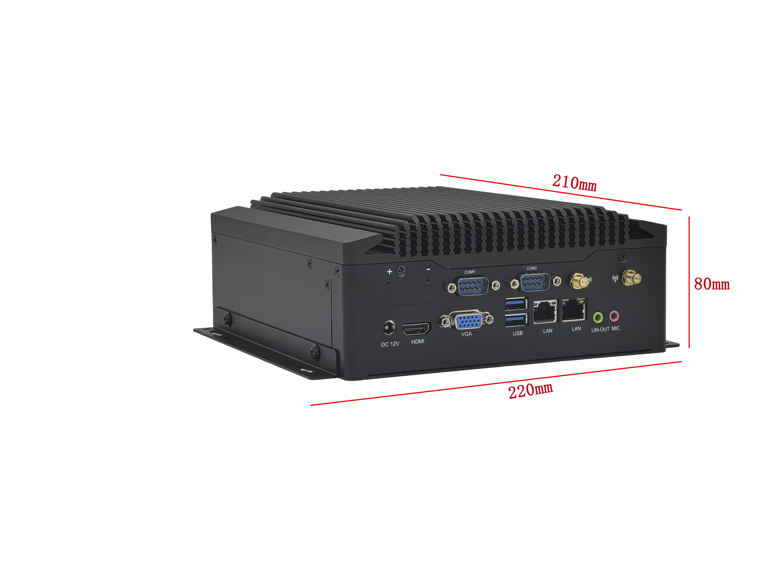
―――――――――――――――――――――――――――――――――――――――――――――――――――――――
Rear interface:VGA+large audio port+single network
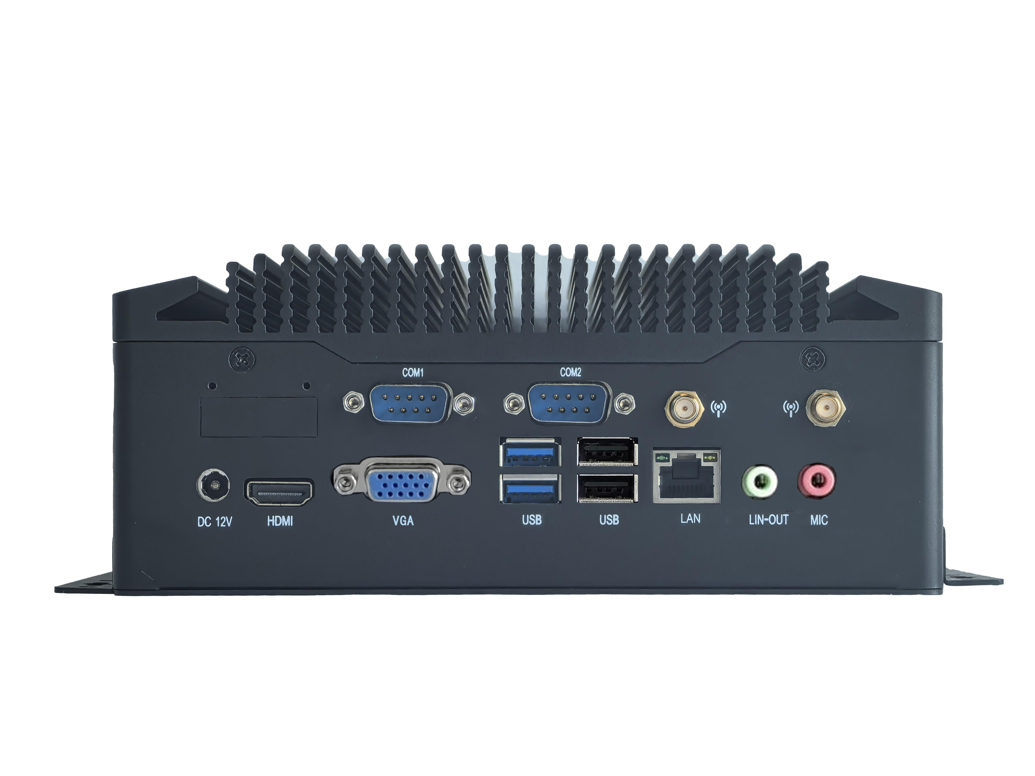
―――――――――――――――――――――――――――――――――――――――――――――――――――――――
Rear interface: VGA+small audio port+single network
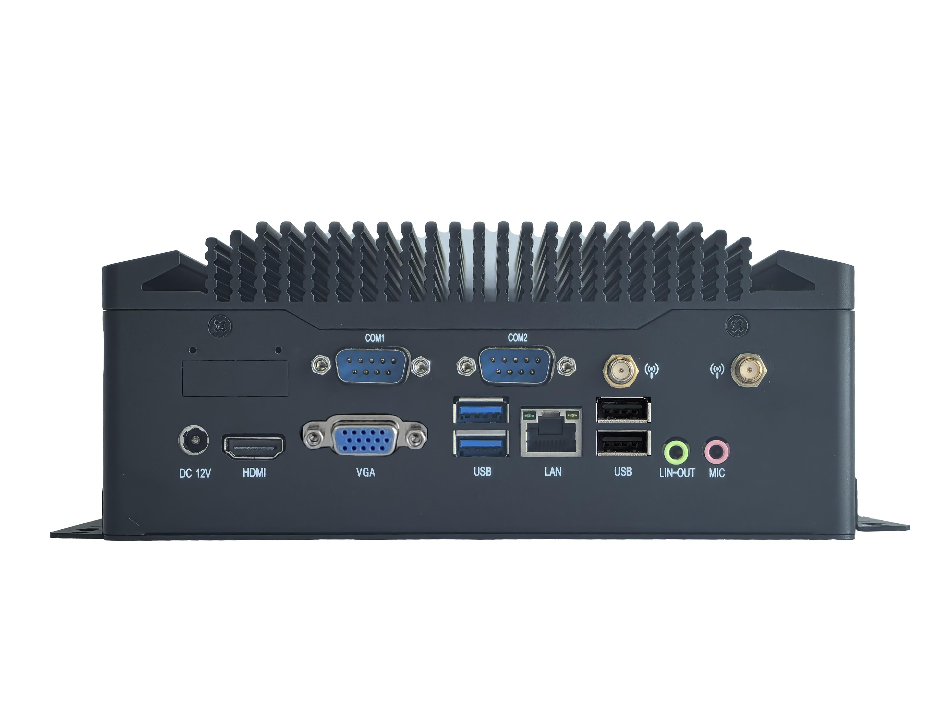
―――――――――――――――――――――――――――――――――――――――――――――――――――――――
Rear interface: VGA+small audio port+dual network
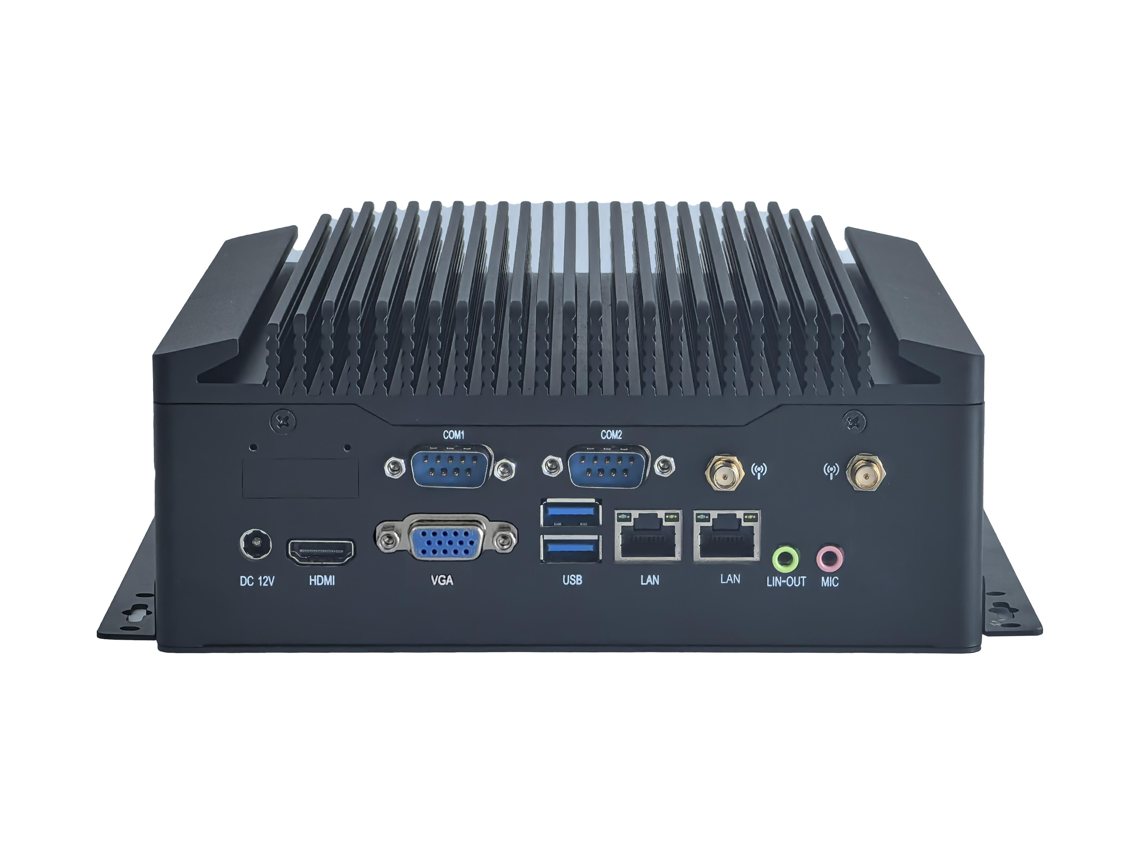
―――――――――――――――――――――――――――――――――――――――――――――――――――――――
Rear interface:DP+large audio port+ single network
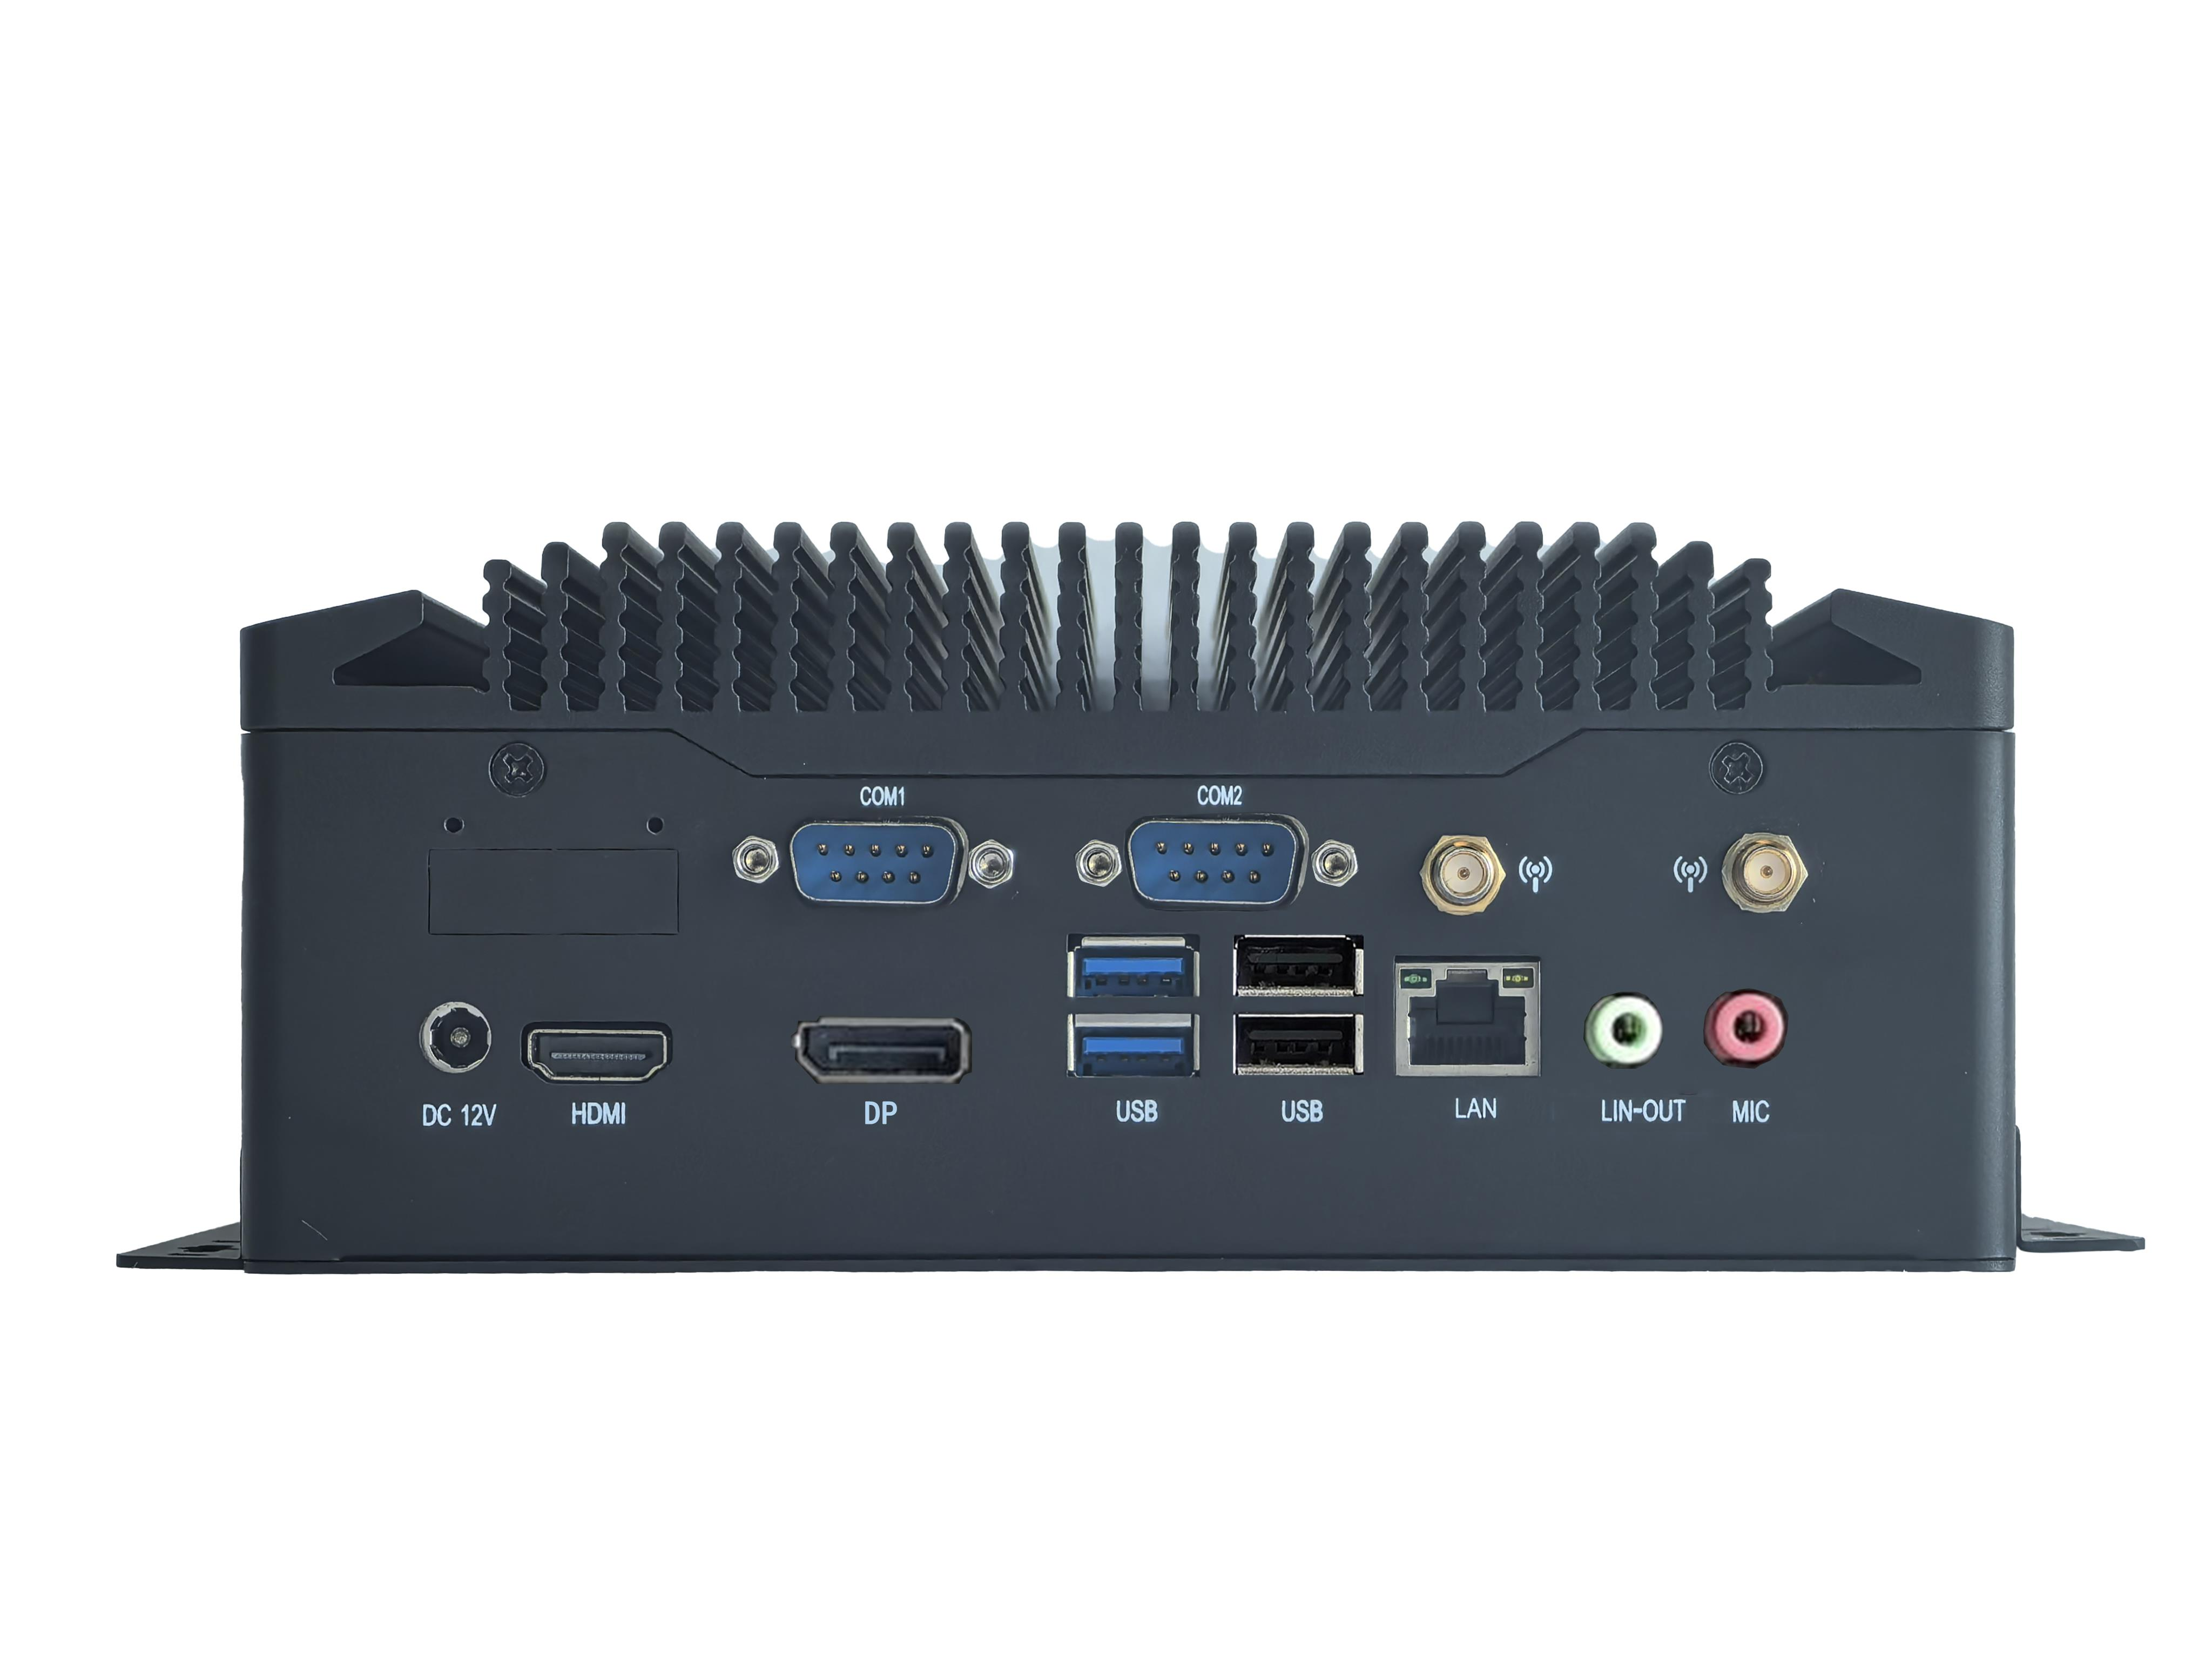
―――――――――――――――――――――――――――――――――――――――――――――――――――――――
Rear interface:Optional Phoenix Terminal
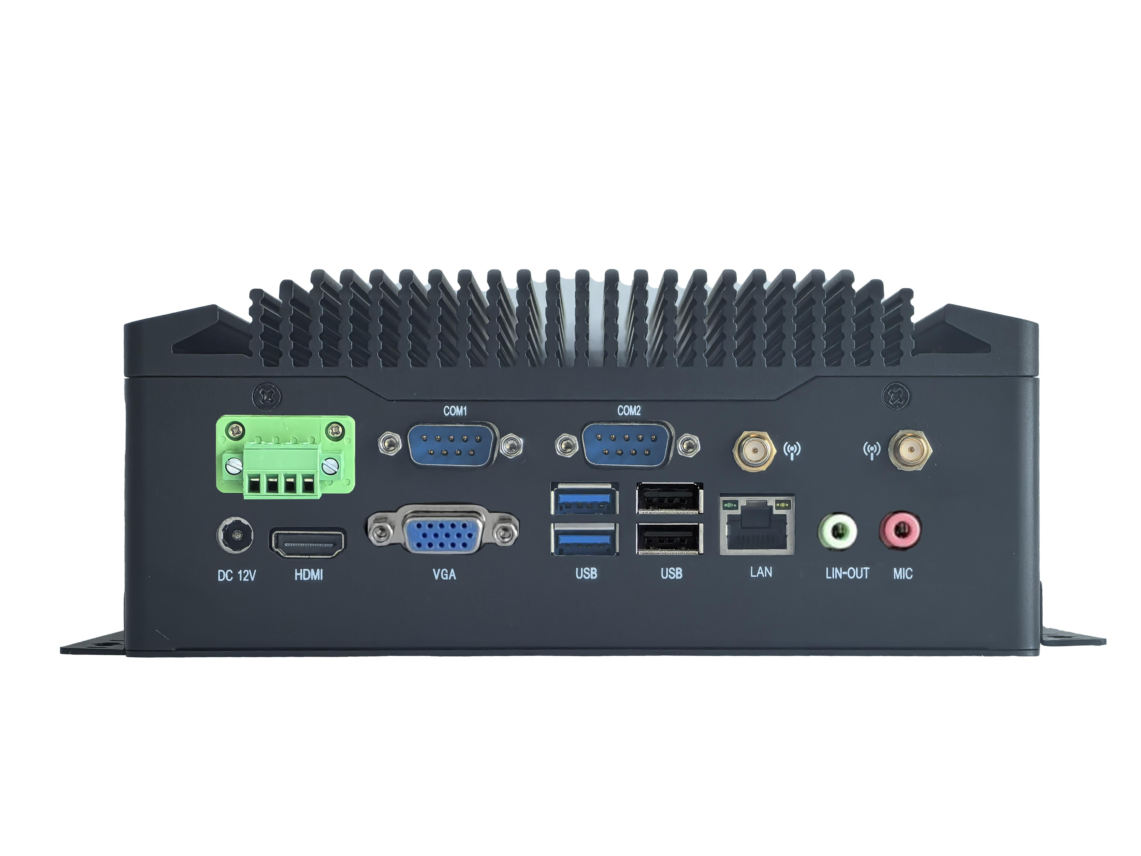
―――――――――――――――――――――――――――――――――――――――――――――――――――――――

10USB front interface
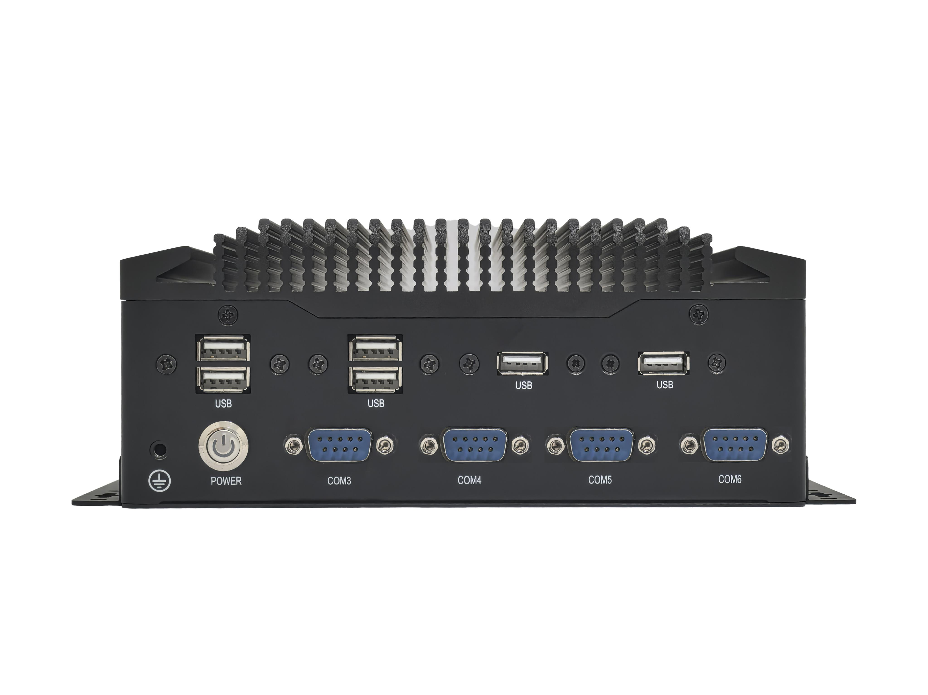
―――――――――――――――――――――――――――――――――――――――――――――――――――――――
8USB front interface
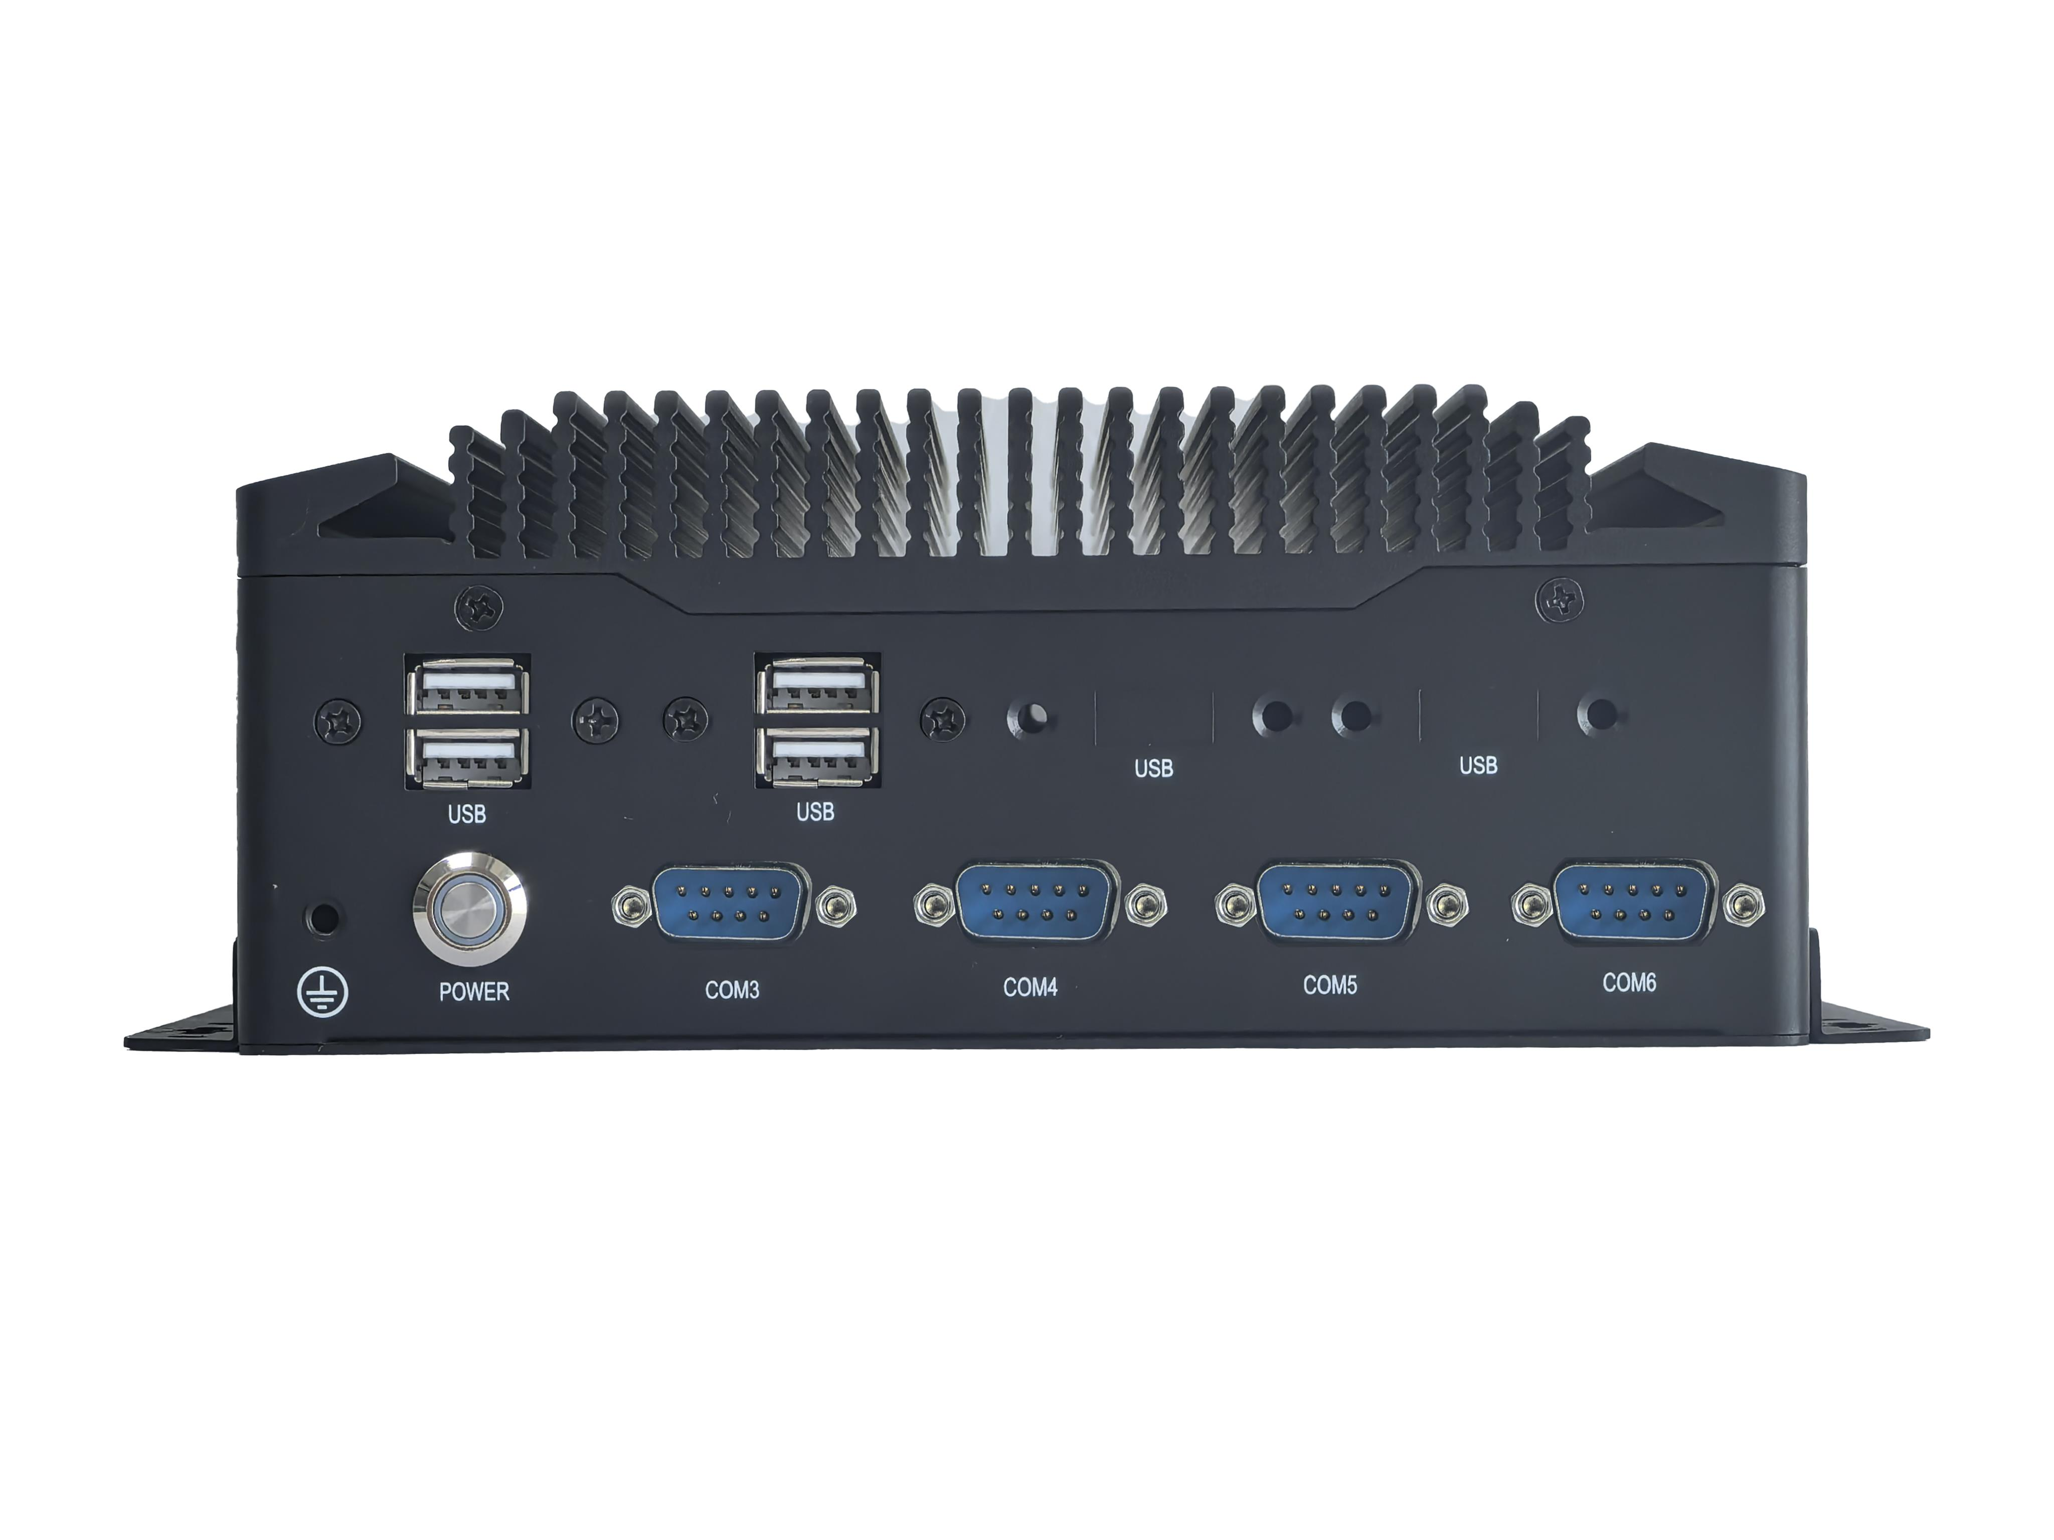
―――――――――――――――――――――――――――――――――――――――――――――――――――――――
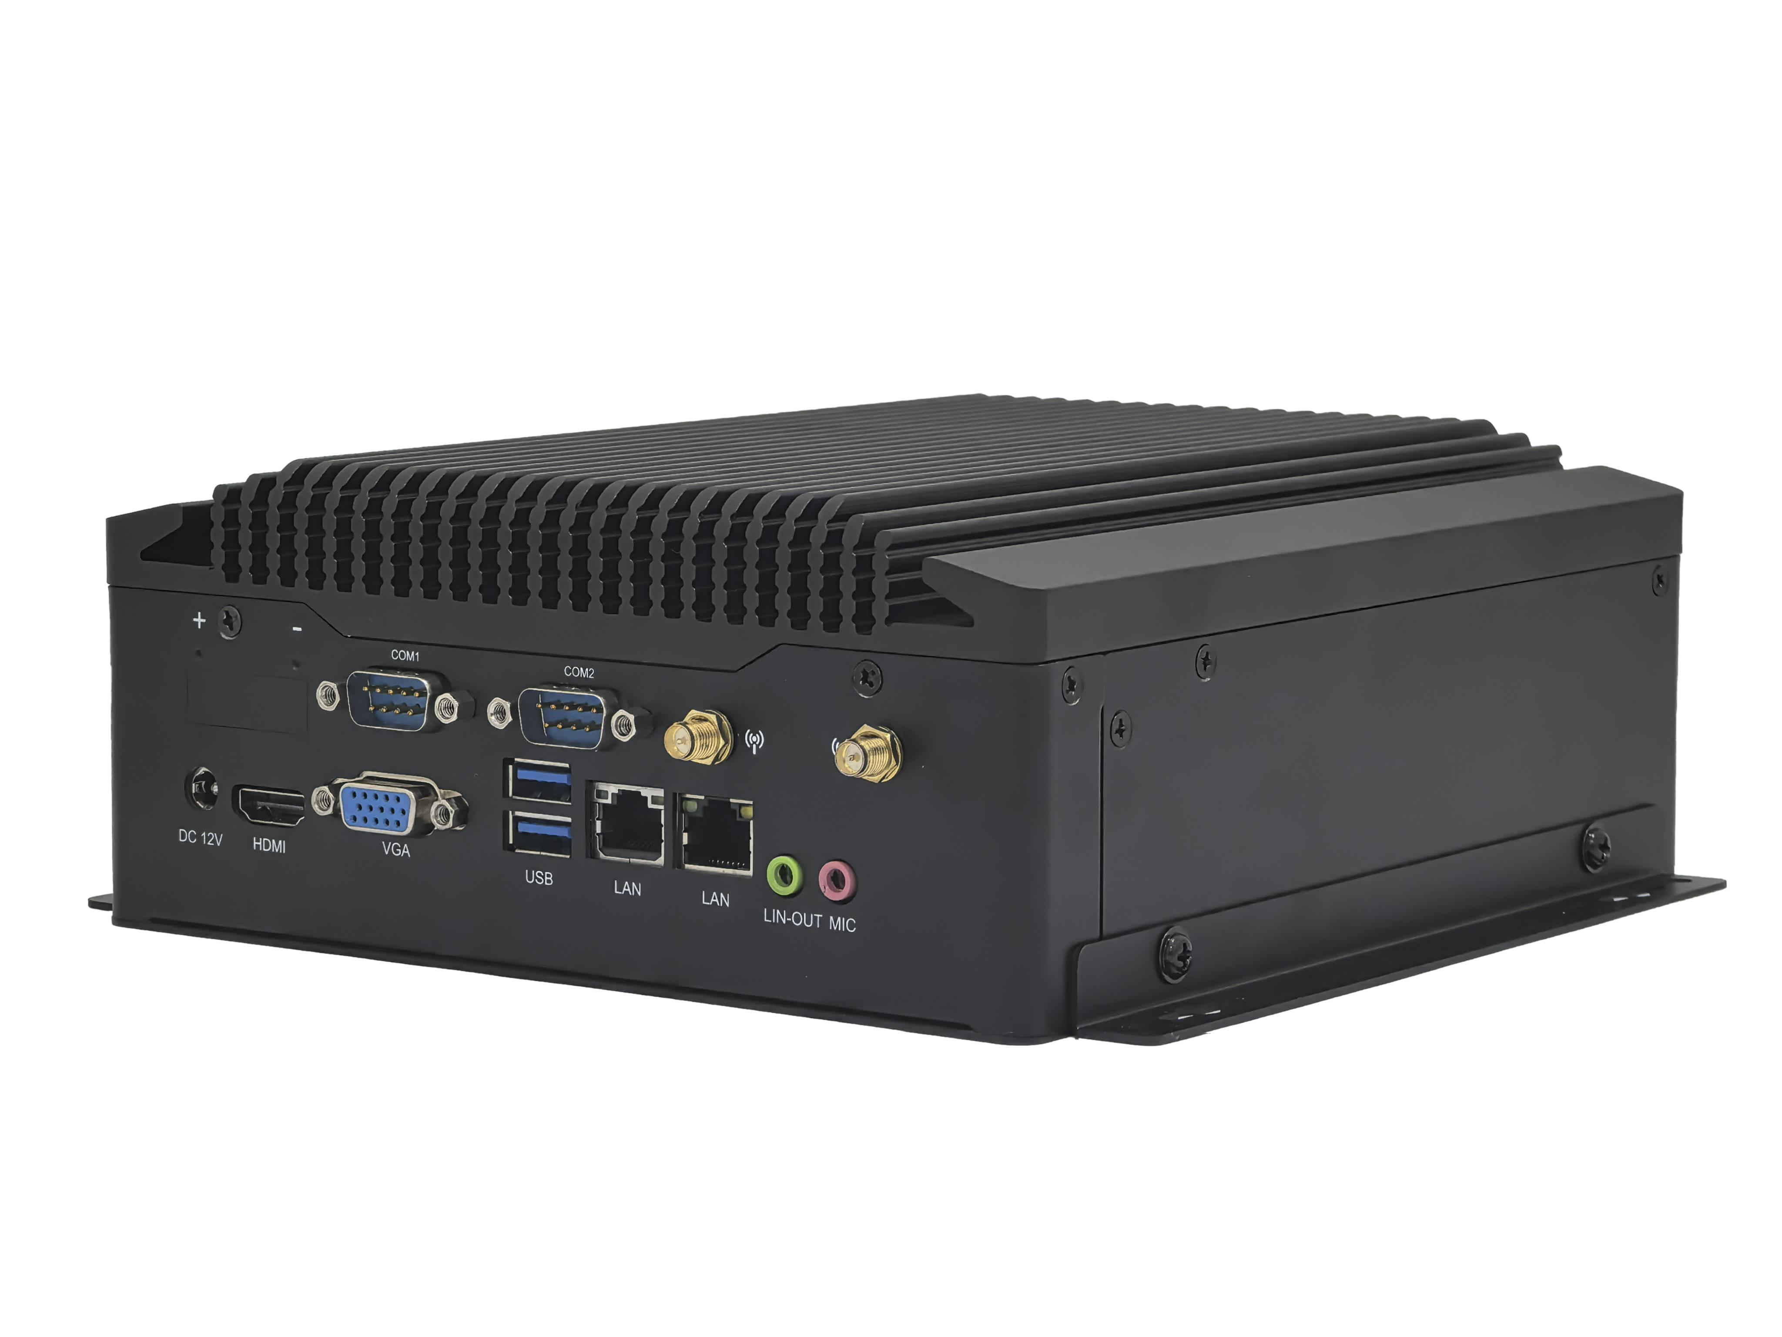
―――――――――――――――――――――――――――――――――――――――――――――――――――――――

Back of mini pc
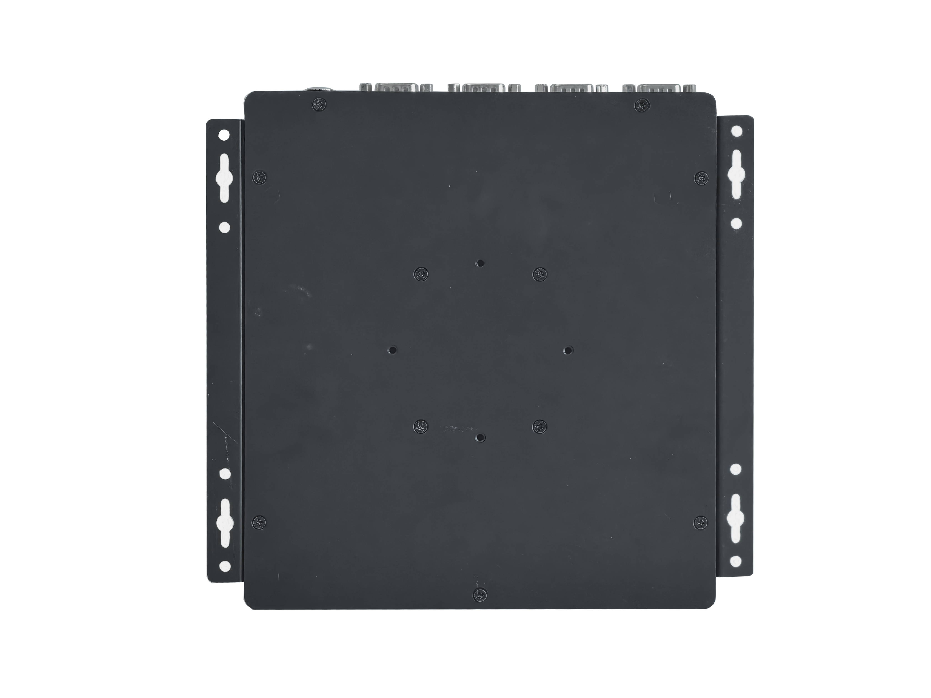
―――――――――――――――――――――――――――――――――――――――――――――――――――――――
Mini pc size
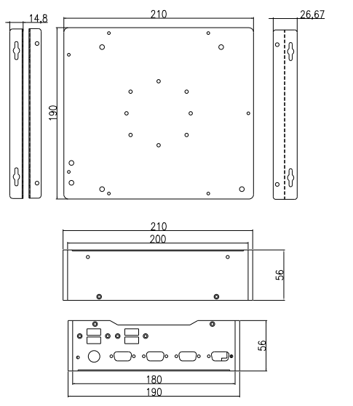
―――――――――――――――――――――――――――――――――――――――――――――――――――――――
The pictures are for reference only, please refer to the actual product!
※※※※※※※※※※※※※※※※※※※※※※※※※※※※※※※※※※※※※※※※※※※※※※※※※
HDMI® | VGA |  | LAN |  | USB2.0 | USB3.0 | COM | SSD | Memory | Power
4K 30Hz | 2K 60Hz |  | 1 |  | 6 | 2 | 2/6 | 1*MSATA  1*SATA | 2*NB-DDR4  MAX 64G | 12V/19V
4K 30Hz |  |  | 2 |  | 4
PC model |  | IPC6900-Zhaoxin KC6000
PC size |  | 220mm(L)*210mm(W)*80mm(H)
Cooling system |  | Fanless+integrated heat dissipation with chassis
Color |  | Black
Adapt to motherboard |  | KC6000
Motherboard |  | CPU |  | Support the full range of domestically produced Zhaoxin KX6000 16NM board mounted CPUs:  KX 6640MA Quad core 2.2G ,turbo frequency 2.6G;  KX 6640A quad core 2.6G; KX U6580 octa core 2.5G;  KX U6780A 8-core 2.7G; KX U6780 8-core 2.7G
 |  | Graphics card |  | Integrated ZX C960 DX11 ultra core graphics card, supporting single display, dual display replication, and dual display expansion
 |  | Memory |  | 2*NB-DDR4,support 2133/2400/2666MHz memory,maximum support 64G
Front panel interface |  | POWER |  | 1*Switch button
 |  | COM |  | 4*COM port,default RS232;
 |  | USB |  | 4*USB2.0 port
Rear panel interface |  | Power port |  | 1*DC power interface (5.5 *2.5mm), recommended 12V10A or 19V5A and above power supply  1*4Pin Phoenix terminal optional, customizable wire sequence
 |  | Display port |  | 1*VGA port (1920*1080@60Hz)  1*HDMI®1.4 port (4096/3840*2160@30Hz)
 |  | LAN |  | Single gigabit network card: Realtek 8111H or Motorcomm YT6801 are optional;  Dual gigabit network card: Realtek 8111H+Realtek 8111H or Motorcomm YT6801+Motorcomm YT6801 optional;  Support network wake-up function and network PXE function;
 |  | USB |  | 2*USB3.0 port  2*USB2.0 port (dual network pc without this interface)
 |  | Audio |  | 1*LINE_OUT port,audio output;  1*MIC_IN port,microphone input;
 |  | WiFi |  | 2*WiFi antenna interface;
 |  | COM |  | 2*COM interface, default RS232; COM1 can choose RS232/RS422/RS485;
Storage |  | MSATA |  | 1*MSATA slot, support MSATA disks
 |  | SATA |  | 1*SATA3.0 hard drive interface, support 2.5-inch SSD/HDD hard drives
Expansion |  | Mini-PCIE |  | 1*Mini-PCIE slot, supports PCIE 3.0 x1 signal, supports WiFi module; Can be modified to support 4G/Bluetooth modules
Operating environment |  | Working temperature |  | -10℃ ~ 60℃
 |  | Storage temperature |  | -20℃ ~ 70℃
 |  | Relative humidity |  | 5%-95% relative humidity,no condensation
 |  | Working vibration |  | 0.5g rms/5-500Hz/random/operating
BIOS |  | Support power on, timed power on, remote power on/off, etc
Watch Dog |  | Watchdog programming, supports hardware reset function (256 levels, 0-255 seconds)
Operating system |  | Windows 10, Windows 7, Linux, etc
※※※※※※※※※※※※※※※※※※※※※※※※※※※※※※※※※※※※※※※※※※※※※※※※※

※※※※※※※※※※※※※※※※※※※※※※※※※※※※※※※※※※※※※※※※※※※※※※※※※
HDMI® | VGA/HDMI2® |  |  | LAN | USB2.0 | USB3.0 | COM | SSD | Memory | Power
4K 30Hz | VGA:2K 60Hz  HDMI2®:4K60Hz |  |  | 1 | 6 | 2 | 2/6 | 1*M.2  1*SATA | 2*NB-DDR4  MAX 64G | 12V/19V
4K 30Hz |  |  |  | 2 | 4
PC model |  | IPC6900-Zhaoxin KC7000
PC size |  | 220mm(L)*210mm(W)*80mm(H)
Cooling system |  | Fanless+integrated heat dissipation with chassis
Color |  | Black
Adapt to motherboard |  | KC7000
Motherboard |  | CPU | Support the full range of domestically produced Zhaoxin KX7000 board mounted CPUs:  Zhaoxin KX 7000 Eight Core 3.5G;
 |  | Graphics card | Integrated ZX C1199 graphics card, support single display, dual display replication, and dual display expansion
 |  | Memory | 2*NB-DDR4 supports 2133/2400/2666MHz memory, maximum support 64GB
Front panel interface |  | POWER | 1*Switch button
 |  | COM | 4*COM port,default RS232;
 |  | USB | 4*USB2.0 port
Rear panel interface |  | Power port | 1*DC power interface (5.5*2.5mm), recommended 12V10A or 19V5A and above power supply  1*4Pin Phoenix terminal optional, customizable wire sequence
 |  | Display port | 1*VGA port (1920*1080@60Hz)  1*HDMI1®2.0 port (4096/3840*2160@60Hz)  Optional 1*HDMI2®2.0 port (4096/3840*2160@60Hz)
 |  | LAN | Single gigabit network card: Motorcomm YT6801 or Realtek 8111H are optional;  Dual gigabit network card: Motorcomm YT6801+Motorcomm YT6801 or Realtek 8111H+Realtek 8111H optional;  Support network wake-up function and network PXE function;
 |  | USB | 2*USB3.0 port  2*USB2.0 port (dual network pc without this interface)
 |  | Audio | 1*LINE_OUT port,audio output;  1*MIC_IN port,microphone input;
 |  | WiFi | 2*WiFi antenna interface;
 |  | COM | 2*COM interface, default RS232; COM1 can choose RS232/RS422/RS485;
Storage |  | M.2_SSD | 1*M.2 Key-M slot, support M.2 2280 NVME PCIE4.0 x2/SATA dual protocol adaptive standard SSD
 |  | SATA | 1*SATA3.0 hard drive interface, support 2.5-inch SSD/HDD hard drives
Expansion |  | M2_WIFI | 1*M2_WIFI interface, supports Key-E interface M.2 2230 PCIE4.0 x1&USB, supports WiFi Bluetooth module
 |  | CN1 | 1*CN1 interface, supports Key-B interface M.2 5G (3052/3042) module, hardware can be modified to support M.2 4G (3042) module
Operating environment |  | Working temperature | -10℃ ~ 60℃
 |  | Storage temperature | -20℃ ~ 70℃
 |  | Relative humidity | 5%-95%=-0.9relative humidity,no condensation
 |  | Working vibration | 0.5g rms/5-500Hz/random/operating
BIOS |  | Support power on, timed power on, remote power on/off, etc
Watch Dog |  | Watchdog programming, supports hardware reset function (256 levels, 0-255 seconds)
Operating system |  | Windows 11, Windows 10, Linux, etc
※※※※※※※※※※※※※※※※※※※※※※※※※※※※※※※※※※※※※※※※※※※※※※※※※

※※※※※※※※※※※※※※※※※※※※※※※※※※※※※※※※※※※※※※※※※※※※※※※※※
HDMI® | VGA |  | LAN |  | USB2.0 | USB3.1 | COM | SSD | Memory | Power
4K 30Hz | 2K 60Hz |  | 1 |  | 6 | 2 | 2/6 | 1*M.2;  1*SATA;  Optional 1*MSATA | 2*NB-DDR4  MAX 64G | 12V/19V
4K 30Hz |  |  | 2 |  | 4
PC model |  | IPC6900-Phytium ET2000
PC size |  | 220mm(L)*210mm(W)*80mm(H)
Cooling system |  | Fanless+integrated heat dissipation with chassis
Color |  | Black
Adapt to motherboard |  | ET2000
Motherboard |  | CPU |  | Domestic Phytium Tengrui D2000 eight core 2.3G;  Domestic Phytium Tengrui FT2000 quad core 2.6G;
 |  | Graphics card |  | Supports X100 bridge with 4G video memory and optional support for X100 bridge with 8G video memory. Supports single display, dual display replication, and dual display expansion
 |  | Memory |  | 2*NB-DDR4, supports 2133/2400/2666MHz memory, maximum support 64GB
Front panel interface |  | POWER |  | 1*Switch button
 |  | COM |  | 4*COM interface, default RS232;
 |  | USB |  | 4*USB 2.0 interface
Rear panel interface |  | Power port |  | 1*DC power interface (5.5*2.5mm), recommended 12V7A or 19V5A and above power supply  1*4Pin Phoenix terminal optional, customizable wire sequence
 |  | Display port |  | 1*VGA port (1920*1080@60Hz)  1*HDMI®1.4 port (4096/3840*2160@30Hz)
 |  | LAN |  | Single gigabit network card: Motorcomm YT6801 or Realtek 8111H are optional;  Dual gigabit network card: Motorcomm YT6801+Motorcomm YT8521SC or Realtek 8111H+Motorcomm YT8521SC optional  Support network wake-up function;
 |  | USB |  | 2*USB3.1 Gen1 port  2*USB2.0 port (dual network pc without this interface)
 |  | Audio |  | 1*LINE_OUT port,audio output;  1*MIC_IN port,microphone input;
 |  | WiFi |  | 2*WiFi antenna interface;
 |  | COM |  | 2*COM interface, default RS232; COM1 can choose RS232/RS422/RS485;
Storage |  | M.2_SSD |  | 1*M.2 Key-M slot, supports M.2 2280 NVME PCIE3.0 x4/SATA dual protocol adaptive standard SSD
 |  | SATA |  | 1*SATA3.0 hard drive interface, support 2.5-inch SSD/HDD hard drives
 |  | MSATA |  | Optional 1*MSATA slot, supports WiFi module by default, can be changed to support MSATA disk
Expansion |  | Mini-PCIE |  | 1*Mini-PCIE slot, supports PCIE 3.0 x1&USB signals, supports WiFi Bluetooth/4G modules; Can be modified to support MSATA disks
Operating environment |  | Working temperature |  | -10℃ ~ 60℃
 |  | Storage temperature |  | -20℃ ~ 70℃
 |  | Relative humidity |  | 5%-95% relative humidity,no condensation
 |  | Working vibration |  | 0.5g rms/5-500Hz/random/operating
BIOS |  | Support power on, timed power on, remote power on/off, etc
Watch Dog |  | Watchdog programming, supports hardware reset function (256 levels, 0-255 seconds)
Operating system |  | Support Galaxy Kirin ( Kylin-Desktop-V10-SP1-Release-2503-ARM64), Linux, etc. Domestic system (supporting X100 version)
※※※※※※※※※※※※※※※※※※※※※※※※※※※※※※※※※※※※※※※※※※※※※※※※※

※※※※※※※※※※※※※※※※※※※※※※※※※※※※※※※※※※※※※※※※※※※※※※※※※
HDMI® | VGA |  | LAN |  | USB2.0 | USB3.0 | COM | SSD | Memory | Power
2K 30Hz | 1024*768@60Hz |  | 1 |  | 6 | 2 | 2/6 | 1*M.2  1*SATA | 1*NB-DDR4  MAX 32G | 12V/19V
2K 30Hz |  |  | 2 |  | 8
PC model |  | IPC6900-Phytium QT2000
PC size |  | 220mm(L)*210mm(W)*80mm(H)
Cooling system |  | Fanless+integrated heat dissipation with chassis
Color |  | Black
Adapt to motherboard |  | QT2000
Motherboard |  | CPU |  | Domestic Phytium Tenglong E2000Q quad core 1.5G;
 |  | Graphics card |  | Support single display, dual display replication, and dual display expansion
 |  | Memory |  | 1*NB-DDR4 supports 2133/2400/2666MHz memory, with a maximum support of 32GB
Front panel interface |  | POWER |  | 1*Switch button
 |  | COM |  | 4*COM interface, default RS232;
 |  | USB |  | 4*USB 2.0 interface
Rear panel interface |  | Power port |  | 1*DC power interface (5.5*2.5mm), recommended 12V4A or 19V3A and above power supply  1*4Pin Phoenix terminal optional, customizable wire sequence
 |  | Display port |  | 1*VGA port (1024*768@60Hz)  1*HDMI®1.4 port (1920*1080@30Hz)
 |  | LAN |  | Single gigabit network card: supports Motorcomm YT8521SC;  Dual gigabit network card: supports Motorcomm YT8521SC+Motorcomm YT8521SC;  Support network wake-up function;
 |  | USB |  | 2*USB3.0 port  2*USB2.0 port (dual network pc without this interface)
 |  | Audio |  | 1*LINE_OUT port,audio output;  1*MIC_IN port,microphone input;
 |  | WiFi |  | 2*WiFi antenna interface;
 |  | COM |  | 2*COM interface, default RS232; COM1 can choose RS232/RS422/RS485;
Storage |  | M.2_SSD |  | 1*M.2 Key-M slot, supports M.2 2280 NVME PCIE3.0 x4/SATA dual protocol adaptive standard SSD
 |  | SATA |  | 1*SATA3.0 hard drive interface, support 2.5-inch SSD/HDD hard drives
Expansion |  | M2_WIFI |  | 1*M2_WIFI interface, supports Key-E interface M.2 2230 PCIE3.0 x1&USB signal, supports WiFi Bluetooth module
Operating environment |  | Working temperature |  | -10℃ ~ 60℃
 |  | Storage temperature |  | -20℃ ~ 70℃
 |  | Relative humidity |  | 5%-95% relative humidity,no condensation
 |  | Working vibration |  | 0.5g rms/5-500Hz/random/operating
BIOS |  | Support power on, timed power on, remote power on/off, etc
Watch Dog |  | Watchdog programming, supports hardware reset function (256 levels, 0-255 seconds)
Operating system |  | Support Galaxy Kylin Embedded System (Kylin-Embedded V10-SP1-General Release Base-2309-ARM64), domestic systems such as Tongxin, etc
※※※※※※※※※※※※※※※※※※※※※※※※※※※※※※※※※※※※※※※※※※※※※※※※※

※※※※※※※※※※※※※※※※※※※※※※※※※※※※※※※※※※※※※※※※※※※※※※※※※
HDMI® | VGA |  | LAN |  | USB2.0 | USB3.1 | COM | SSD | Memory | Power
4K 30Hz | 2K 60Hz |  | 1 |  | 4 | 4 | 2/6 | 1*M.2;  1*SATA;  Optional 1*MSATA | 2*NB-DDR4  MAX 64G | 12V/19V
4K 30Hz |  |  | 2 |  | 4 | 2
PC model |  | IPC6900-Phytium ET3000
PC size |  | 220mm(L)*210mm(W)*80mm(H)
Cooling system |  | Fanless+integrated heat dissipation with chassis
Color |  | Black
Adapt to motherboard |  | ET3000
Motherboard |  | CPU |  | Domestic Phytium Tengrui D3000 8-core 2.5G;
 |  | Graphics card |  | Supports X100 bridge with 4G video memory and optional support for X100 bridge with 8G video memory. Supports single display, dual display replication, and dual display expansion
 |  | Memory |  | 2*NB-DDR4, supports 2133/2400/2666MHz memory, maximum support 64GB
Front panel interface |  | POWER |  | 1*Switch button
 |  | COM |  | 4*COM interface, default RS232;
 |  | USB |  | 4*USB 2.0 interface
Rear panel interface |  | Power port |  | 1*DC power interface (5.5*2.5mm), recommended 12V7A or 19V5A and above power supply
 |  | Display port |  | 1*VGA port (1920*1080@60Hz)  1*HDMI®1.4 port (4096/3840*2160@30Hz)
 |  | LAN |  | Single gigabit network card: Motorcomm YT6801 or Realtek 8111H are optional;  Dual gigabit network card: Motorcomm YT6801+Motorcomm YT8521SC  or Realtek 8111H+MotorcommYT8521SC optional  Support network wake-up function;
 |  | USB |  | Single network host support: 4*USB3.1 Gen1 interface  Dual network host optional support: 2*USB3.1 Gen1 interface
 |  | Audio |  | 1*LINE_OUT port,audio output;  1*MIC_IN port,microphone input;
 |  | WiFi |  | 2*WiFi antenna interface;
 |  | COM |  | 2*COM interface, default RS232; COM1 can choose RS232/RS422/RS485;
Storage |  | M.2_SSD |  | 1*M.2 Key-M slot, support M.2 2280 NVME PCIE4.0 x4/SATA dual protocol adaptive standard SSD; Optional M.2 2242 hard drive;
 |  | SATA |  | 1*SATA3.0 hard drive interface, support 2.5-inch SSD/HDD hard drives
 |  | MSATA |  | Optional 1*MSATA slot, supports WiFi module by default, can be changed to support MSATA disk
Expansion |  | Mini-PCIE |  | 1*Mini-PCIE slot, supports PCIE 3.0 x1&USB signals, supports WIFI Bluetooth/4G modules; Can be modified to support MSATA disks
Operating environment |  | Working temperature |  | -10℃ ~ 60℃
 |  | Storage temperature |  | -20℃ ~ 70℃
 |  | Relative humidity |  | 5%-95% relative humidity,no condensation
 |  | Working vibration |  | 0.5g rms/5-500Hz/random/operating
BIOS |  | Support power on, timed power on, remote power on/off, etc
Watch Dog |  | Watchdog programming, supports hardware reset function (256 levels, 0-255 seconds)
Operating system |  | Support Galaxy Kirin(Kylin-Desktop-V10-SP1-Release-2403-ARM64), Linux, Domestic system (supporting X100 version)
※※※※※※※※※※※※※※※※※※※※※※※※※※※※※※※※※※※※※※※※※※※※※※※※※

※※※※※※※※※※※※※※※※※※※※※※※※※※※※※※※※※※※※※※※※※※※※※※※※※
HDMI® | VGA/DP |  | LAN |  | USB2.0 | USB3.2 | COM | SSD | Memory | Power
4K 30Hz | VGA 2K 60Hz;  Optional DP 4K 60Hz |  | 1 |  | 6 | 2 | 2/6 | 1*M.2;  1*SATA;  Optional 1*MSATA | 2*NB-DDR4  MAX 64G | 12V/19V
4K 30Hz |  |  | 2 |  | 4
PC model |  | IPC6900-8th,10th gen series(QM8H/QM9H/QM10H)
PC size |  | 220mm(L)*210mm(W)*80mm(H)
Cooling system |  | Fanless+integrated heat dissipation with chassis
Color |  | Black
Adapt to motherboard |  | QM8H, QM9H, QM10H
Motherboard |  | CPU |  | QM8H: Intel ® Whiskey Lake 8th generation Core i3-8145U, i5-8265U, i7-8655U, etc;  QM9H: Intel ® Coffee Lake 8th generation Core i3-8109U, i5-8259U, i7-8559U, etc;  QM10H: Intel ® Comet Lake 10th generation Core i3-10110U, i5-10210U, i7-10510U, etc;  (See next page for CPU list details)
 |  | Graphics card |  | Intel UHD Graphics graphics controller, supporting single display, dual display replication, and dual display expansion;
 |  | Memory |  | 2*NB-DDR4 supports 2133/2400/2666MHz memory, with a maximum support of 64GB
Front panel interface |  | POWER |  | 1*Switch button
 |  | COM |  | 4*COM interface, default RS232;
 |  | USB |  | 4*USB 2.0 interface
Rear panel interface |  | Power interface |  | 1*DC power interface (5.5*2.5mm), recommended 12V7A or 19V5A and above power supply;  1*4Pin Phoenix terminal optional, customizable wire sequence;
 |  | Display interface |  | 1*HDMI®1.4 interface (4096/3840*2160@30Hz)  1*VGA interface (1920*1080@60Hz)  Optional 1*DP 1.4 interface (4096/3840*2160@60Hz)
 |  | LAN |  | Single Gigabit Network Card: Realtek 8111H Gigabit Network Card; Optional Motorcomm YT6801 Gigabit Ethernet Card;  Dual Gigabit Network Card: Realtek 8111H+Realtek 8111H Gigabit Network Card; Optional Motorcomm YT6801+Motorcomm YT6801 Gigabit Network Card  Support network wake-up function and network PXE function;
 |  | USB |  | 2*USB3.2 Gen1 interface  2*USB2.0 interface (dual network pc without this interface)
 |  | Audio |  | 1*LINE_OUT interface,audio output;  1*MIC_IN interface,microphone input;
 |  | WiFi |  | 2*WiFi antenna interface
 |  | COM |  | 2*COM port,default RS232; COM1 optional support RS232/RS422/RS485;
Storage |  | M.2_SSD |  | 1*M.2 Key-M slot,support M.2 2280 NVME PCIE3.0 x4 / SATA adaptive standard SSD;  Optional M.2 2242 hard drive
 |  | SATA |  | 1*SATA3.0 hard drive interface,support 2.5 inch SSD/HDD hard drive or 3.5 inch HDD hard drive
 |  | MSATA |  | Optional 1 * MSATA slot, supports WiFi module by default, can be changed to support MSATA disk
Expansion |  | Mini-PCIE |  | 1*Mini-PCIE slot, supports PCIE 3.0 x1 signal, supports WiFi module;  Optional support for WiFi Bluetooth/4G module
 |  | M.2_5G |  | 1*M.2 Key-B slot,support M.2 5G(3052/3042) module
Operating environment |  | Working temperature |  | -10℃ ~ 60℃
 |  | Storage temperature |  | -20℃ ~ 70℃
 |  | Relative humidity |  | 5%-95% relative humidity,no condensation
 |  | Working vibration |  | 0.5g rms/5-500Hz/random/operating
BIOS |  | Support power on, timed power on, remote power on/off, etc
Watch Dog |  | Watchdog programming, supports hardware reset function (256 levels, 0-255 seconds)
Operating system |  | Windows11, Windows 10, Linux,etc
※※※※※※※※※※※※※※※※※※※※※※※※※※※※※※※※※※※※※※※※※※※※※※※※※

The following CPU information is for reference only. Please consult sales for specific requirements!
CPU | CPU brand | CPU model | Main frequency | Turbo | CPU power consumption | Full load power consumption of the entire board
8th gen I3 | Intel Core | 8145U | Dual core 2.1G | 3.9G | 15W | 60W
8th gen I5 | Intel Core | 8365U | Quad core 1.6G | 4.1G | 15W | 60W
8th gen I5 | Intel Core | 8265U | Quad core 1.6G | 3.9G | 15W | 60W
8th gen I7 | Intel Core | 8665U | Quad core 1.9G | 4.8G | 15W | 60W
8th gen I7 | Intel Core | 8565U | Quad core1.8G | 4.6G | 15W | 60W
8th gen I3  (QM9H) | Intel Core | 8109U | Dual core 3.0G | 3.6G | 28W | 70W
8th gen I3  (QM9H) | Intel Core | 8140U | Dual core 2.1G | 3.9G | 15W | 60W
8th gen I5  (QM9H) | Intel Core | 8259U | Quad core 2.3G | 3.8G | 28W | 70W
8th gen I5  (QM9H) | Intel Core | 8269U | Quad core 2.6G | 4.2G | 28W | 70W
8th gen I5  (QM9H) | Intel Core | 8279U | Quad core 2.4G | 4.1G | 28W | 70W
8th gen I5  (QM9H) | Intel Core | 8257U | Quad core 1.4G | 3.9G | 15W | 60W
8th gen I5  (QM9H) | Intel Core | 8260U | Quad core 1.6G | 3.9G | 15W | 60W
8th gen I7  (QM9H) | Intel Core | 8559U | Quad core 2.7G | 4.50 | 28W | 70W
8th gen I7  (QM9H) | Intel Core | 8569U | Quad core 2.8G | 4.7G | 28W | 70W
8th gen I7  (QM9H) | Intel Core | 8557U | Quad core 1.7G | 4.5G | 15W | 60W
10th gen I3 | Intel Core | 10110U | Dual core 2.1G | 4.10G | 15W | 60W
10th gen I5 | Intel Core | 10310U | Quad core 1.7G | 4.40G | 15W | 60W
10th gen I5 | Intel Core | 10210U | Quad core 1.6G | 4.20G | 15W | 60W
10th gen I7 | Intel Core | 10510U | Quad core 1.8G | 4.90G | 15W | 60W
10th gen I7 | Intel Core | 10610U | Quad core 1.8G | 4.90G | 15W | 60W
10th gen I7 | Intel Core | 10810U | Hexa core 1.1G | 4.90G | 15W | 60W
10th gen I7 | Intel Core | 10710U | Hexa core 1.1G | 4.70G | 15W | 60W

※※※※※※※※※※※※※※※※※※※※※※※※※※※※※※※※※※※※※※※※※※※※※※※※※

HDMI® | VGA/DP |  | LAN |  | USB2.0 | USB3.2 | COM | SSD | Memory | Power
4K 30Hz | VGA 2K 60Hz;  Optional  DP 4K 60Hz |  | 1 |  | 6 | 2 | 2/6 | 1*M.2  1*SATA  Optional 1*MSATA | 2*NB-DDR4  MAX 64G | 12V/19V
4K 30Hz |  |  | 2 |  | 4
PC model |  | IPC6900-8th,10th gen series(QM8U/QM10U)
PC size |  | 220mm(L)*210mm(W)*80mm(H)
Cooling system |  | Fanless+integrated heat dissipation with chassis
Color |  | Black
Adapt to motherboard |  | QM8U, QM10U
Motherboard |  | CPU |  | Support Intel® Whiskey Lake 8th generation:  Intel Celeron 4305U dual core 2.2G;  Core i3-8145U dual core 2.1GHz, turbo 3.9GHz;  Intel Core i5-8265U quad core 1.6GHz, turbo 3.9GHz; Core i5-8365U quad core 1.6GHz, turbo 4.1GHz;  Intel Core i7-8655U quad core 1.8GHz, turbo 4.6GHz; Core i7-8665U quad core 1.9GHz, turbo 4.8GHz;  Support Intel ® Comet Lake 10th Generation:  Intel Core i3-10110U dual core 2.1GHz, turbo 4.1GHz;  Intel Core i5-10210U quad core 1.6GHz, turbo 4.2GHz; Core i5-10310U quad core 1.7GHz, turbo 4.4GHz;  Intel Core i7-10510U quad core 1.8GHz, turbo 4.9GHz; Core i7-10610U quad core 1.8GHz, turbo 4.9GHz;  Intel Core i7-10710U six core 1.1GHz, turbo 4.7GHz; Core i7-10810U six core 1.1GHz, turbo 4.9GHz;
 |  | Graphics card |  | Intel® UHD Graphics graphics controller, supporting single display, dual display replication, and dual display expansion;
 |  | Memory |  | 2*NB-DDR4,support 2133/2400/2666MHz memory, maximum support 64GB
Front panel interface |  | POWER |  | 1*Switch button
 |  | COM |  | 4*COM interface ,default RS232;
 |  | USB |  | 4*USB2.0 interface
Rear panel interface |  | Power port |  | 1*DC power interface (5.5*2.5mm), recommended 12V7A or 19V5A and above power supply,  1*4Pin Phoenix terminal optional, customizable wire sequence
 |  | Display port |  | 1*HDMI®1.4 interface (4096/3840*2160@30Hz)  1*VGA interface (1920*1080@60Hz)  Optional 1*DP 1.4 interface (4096/3840*2160@60Hz)
 |  | LAN |  | Single Gigabit Network Card: Realtek 8111H Gigabit Network Card;  Optional Motorcomm YT6801 Gigabit Ethernet Card;  Dual Gigabit Network Card: Realtek 8111H+Realtek 8111H Gigabit Network Card;  Optional Motorcomm YT6801+Motorcomm YT6801 Gigabit Network Card  Support network wake-up function and network PXE function;
 |  | USB |  | 2*USB3.2 Gen1 interface  2*USB2.0 interface (dual network host does not have this interface)
 |  | Audio |  | 1*LINE_OUT interface, audio output  1*MIC_IN interface, microphone input
 |  | WiFi |  | 2*WiFi antenna interface
 |  | COM |  | 2*COM interface, default RS232; COM1 can choose RS232/RS422/RS485;
Storage |  | M.2_SSD |  | 1*M.2 Key-M slot, support M.2 2280 NVME PCIE3.0 x4/SATA adaptive standard SSD; Optional M.2 2242 hard drive
 |  | SATA |  | 2*SATA3.0 hard drive interface, support 2.5-inch SSD/HDD hard drives or 3.5-inch HDD hard drives
 |  | MSATA |  | Optional 1*MSATA slot, supports WiFi module by default,  can be changed to support MSATA disk
Expansion |  | Mini-PCIE |  | 1*Mini-PCIE slot, supports PCIE 3.0 x1 signal, supports WiFi module;  Optional support for WiFi, Bluetooth/4G module
Operating environment |  | Working temperature |  | -10℃ ~ 60℃
 |  | Storage temperature |  | -20℃ ~ 70℃
 |  | Relative humidity |  | 5%-95% relative humidity,no condensation
 |  | Working vibration |  | 0.5g rms/5-500Hz/random/operating
BIOS |  | Support power on, timed power on, remote power on/off, etc
Watch Dog |  | Watchdog programming, supports hardware reset function (256 levels, 0-255 seconds)
Operating system |  | Windows 11, Windows 10, Linux, etc

※※※※※※※※※※※※※※※※※※※※※※※※※※※※※※※※※※※※※※※※※※※※※※※※※
HDMI® | VGA/DP |  | LAN |  | USB2.0 | USB3.2 | COM | SSD | Memory | Power
4K 60Hz | VGA 2K 60Hz;  Optional  DP 4K 60Hz |  | 1 |  | 6 | 2 | 2/6 | 1*M.2;  1*SATA  Optional 1*MSATA | 2*NB-DDR4  MAX 64G | 12V/19V
4K 60Hz |  |  | 2 |  | 4
PC model |  | IPC6900-11th gen series
PC size |  | 220mm(L)*210mm(W)*80mm(H)
Cooling system |  | Fanless+integrated heat dissipation with chassis
Color |  | Black
Adapt to motherboard |  | QM11U
Motherboard |  | CPU |  | Support Intel® Tiger Lake 11th generation:  Intel Core i3-1115G4E dual core 2.2GHz, turbo 3.9GHz; Core i3-1115GRE dual core 2.2GHz, turbo 3.9GHz;  Intel Core i3-1115G4 dual core 3.0GHz, turbo 4.1GHz; Core i3-1125G4 quad core 2.0GHz, turbo 3.7GHz;  Intel Core i5-1145G7E quad core 1.5GHz, turbo 4.1GHz; Core i5-1145GRE quad core 1.5GHz, turbo 4.1GHz;  Intel Core i5-1145G7 quad core 2.6GHz, turbo 4.4GHz; Core i5-1135G7 quad core 2.4GHz, turbo 4.2GHz;  Intel Core i5-1155G7 quad core 2.5GHz, turbo 4.5GHz; Core i7-1185GRE quad core 1.8GHz, turbo 4.4GHz;  Intel Core i7-1185G7E quad core 1.8GHz, turbo 4.4GHz; Core i7-1185G7 quad core 3.0GHz, turbo 4.8GHz;  Intel Core i7-1165G7 quad core 2.8GHz, turbo 4.7GHz; Core i7-1195G7 quad core 2.9GHz, turbo 5.0GHz;
 |  | Graphics card |  | Intel® UHD Graphics / Intel® Iris Xe Graphics graphics controller, support single display, dual display replication, and dual display expansion;
 |  | Memory |  | 2*NB-DDR4,support 2133/2400/2666MHz memory,maximum support 64G
Front panel interface |  | POWER |  | 1*Switch button
 |  | COM |  | 4*COM interface,default RS232;
 |  | USB |  | 4*USB2.0 interface
Rear panel interface |  | Power port |  | 1*DC power interface (5.5*2.5mm), recommended 12V7A or 19V5A and above power supply  1*4Pin Phoenix terminal optional, customizable wire sequence
 |  | Display port |  | 1*HDMI®2.0 interface (4096/3840*2160@60Hz)  1*VGA interface (1920*1080@60Hz)  Optional 1*DP 1.4 interface (4096/3840*2160@60Hz)
 |  | LAN |  | Single Gigabit Network Card: Supports Intel® i219V Gigabit Ethernet card;  Dual Gigabit Network Card: Supports Intel® i219V +Realtek 8111H Gigabit Ethernet card;  Support network wake-up function and network PXE function;
 |  | USB |  | 2*USB3.2 Gen1 interface  2*USB2.0 interface (dual network host does not have this interface)
 |  | Audio |  | 1*LINE_OUT interface ,audio output  1*MIC_IN interface ,microphone input
 |  | WiFi |  | 2*WiFi antenna interface
 |  | COM |  | 2*COM interface,default RS232; optional support 2*RS232/RS422/RS485
Storage |  | M.2_SSD |  | 1*M.2 Key-M slot,support M.2 2280 NVME PCIE3.0 x4 / SATA adaptive standard SSD;  Optional M.2 2242 hard drive
 |  | SATA |  | 1*SATA3.0 hard drive interface, supporting 2.5-inch SSD/HDD hard drives or 3.5-inch HDD hard drives
 |  | MSATA |  | Optional 1*MSATA slot, supports WiFi module by default, can be changed to support MSATA disk
Expansion |  | Mini-PCIE |  | 1*Mini-PCIE slot, supports PCIE 3.0 x1 signal, supports WiFi module;  Optional support for WiFi, Bluetooth/4G module
Operating environment |  | Working temperature |  | -10℃ ~ 60℃
 |  | Storage temperature |  | -20℃ ~ 70℃
 |  | Relative humidity |  | 5%-95% relative humidity,no condensation
 |  | Working vibration |  | 0.5g rms/5-500Hz/random/operating
BIOS |  | Support power on, timed power on, remote power on/off, etc
Watch Dog |  | Watchdog programming, supports hardware reset function (256 levels, 0-255 seconds)
Operating system |  | Windows 11, Windows 10, Linux, etc
※※※※※※※※※※※※※※※※※※※※※※※※※※※※※※※※※※※※※※※※※※※※※※※※※

※※※※※※※※※※※※※※※※※※※※※※※※※※※※※※※※※※※※※※※※※※※※※※※※※
HDMI® | VGA/DP |  | LAN |  | USB2.0 | USB3.2 | COM | SSD | Memory | Power
4K 60Hz | VGA 2K 60Hz;  Optional  DP 4K 60Hz |  | 1 |  | 6 | 2 | 2/6 | 1*M.2  1*SATA | 2*NB-DDR4  MAX 64G | 12V/19V
4K 60Hz |  |  | 2 |  | 4
PC model |  | IPC6900-12th,13th gen series
PC size |  | 220mm(L)*210mm(W)*80mm(H)
Cooling system |  | Fanless+integrated heat dissipation with chassis
Color |  | Black
Adapt to motherboard |  | QM12U, QM13U, QM12P, QM13P, QM12H, QM13H
Motherboard |  | CPU |  | Support Intel ® Alder Lake 12th generation U, P, H series Core i3-1215U, i5-1235U, i7-1260P, i9-12900H, etc  Support Intel ® Raptor Lake 13th generation U, P, H series Core i3-1305U, i5-1334U, i7-1340P, i9-13900H, etc  (See next page for CPU list)
 |  | Graphics card |  | Intel® UHD Graphics / Intel® Iris Xe Graphics graphics controller,support single display,dual display replication,and dual display expansion
 |  | Memory |  | 2*NB-DDR4 supports 2133/2400/2666/2933/320MHz memory, with a maximum support of 64GB
Front panel interface |  | POWER |  | 1*Switch button
 |  | COM |  | 4*COM interface, default RS232;
 |  | USB |  | 4*USB 2.0 interface
Rear panel interface |  | Power port |  | 1*DC power interface (5.5*2.5mm), recommended 12V7A or 19V5A and above power supply  1*4Pin Phoenix terminal optional, customizable wire sequence
 |  | Display port |  | 1*HDMI®2.0 interface (4096/3840*2160@60Hz)  1*VGA interface (1920*1080@60Hz)  Optional 1*DP 1.4 interface (4096/3840*2160@60Hz)
 |  | LAN |  | Single Gigabit Network Card: Intel i219V Gigabit Network Card;  Dual Gigabit Network Card: Intel i219V+Realtek 8111H Gigabit Network Card  Support network wake-up function and network PXE function;
 |  | USB |  | 2*USB3.2 Gen1 interface  2*USB2.0 interface (Dual network host does not have this interface)
 |  | Audio |  | 1*LINE_OUT interface ,audio output;  1*MIC_IN interface,microphone input;
 |  | WiFi |  | 2*WiFi antenna interface
 |  | COM |  | 2*COM interface,default RS232; COM1 optional support RS232/RS422/RS485
Storage |  | M.2_SSD |  | 1*M.2 Key-M slot,support M.2 2280 NVME PCIE4.0 x4 / SATA adaptive standard SSD;  Optional M.2 2242 hard drive;
 |  | SATA |  | 1*SATA3.0 hard drive interface, supporting 2.5-inch SSD/HDD hard drives or 3.5-inch HDD hard drives
Expansion |  | M.2_WiFi |  | 1*M.2 Key-E slot,support M.2 2230 PCIE3.0 x1 & USB,support WiFi Bluetooth module;
 |  | M.2_5G |  | 1*M.2 Key-B slot,support M.2 5G(3052/3042) module or M.2 4G(3042)module;
Operating environment |  | Working temperature |  | -10℃ ~ 60℃
 |  | Storage temperature |  | -20℃ ~ 70℃
 |  | Relative humidity |  | 5%-95% relative humidity,no condensation
 |  | Working vibration |  | 0.5g rms/5-500Hz/random/operating
BIOS |  | Support power on, timed power on, remote power on/off, etc
Watch Dog |  | Watchdog programming, supports hardware reset function (256 levels, 0-255 seconds)
Operating system |  | Windows 11, Windows 10, Linux, etc
※※※※※※※※※※※※※※※※※※※※※※※※※※※※※※※※※※※※※※※※※※※※※※※※※

The following CPU information is for reference only. Please consult sales for specific requirements!
CPU | CPU brand | CPU model | Kernel /thread | Main frequency | Turbo | TDP power consumption(W) | Maximum turbo power consumption of CPU (W)
12th gen I3 | Intel Core | 1215U | 6 cores and 8 threads | 1.2G | 4.4G | 15 | 55
12th gen I5 | Intel Core | 1235U | 10 cores and 12 threads | 1.3G | 4.4G | 15 | 55
12th gen I5 | Intel Core | 1245U | 10 cores and 12 threads | 1.6G | 4.4G | 15 | 55
12th gen I7 | Intel Core | 1265U | 10 cores and 12 threads | 1.8G | 4.8G | 15 | 55
12th gen I7 | Intel Core | 1255U | 10 cores and 12 threads | 1.7G | 4.7G | 15 | 55
13th gen I3 | Intel Core | 1305U | 5 cores and 6 threads | 1.6G | 4.5G | 15 | 55
13th gen I3 | Intel Core | 1315U | 6 cores and 8 threads | 1.2G | 4.5G | 15 | 55
13th gen I5 | Intel Core | 1334U | 10 cores and 12 threads | 1.3G | 4.6G | 15 | 55
13th gen I5 | Intel Core | 1335U | 10 cores and 12 threads | 1.3G | 4.6G | 15 | 55
13th gen I5 | Intel Core | 1345U | 10 cores and 12 threads | 1.6G | 4.7G | 15 | 55
13th gen I7 | Intel Core | 1355U | 10 cores and 12 threads | 1.7G | 5.0G | 15 | 55
13th gen I7 | Intel Core | 1365U | 10 cores and 12 threads | 1.8G | 5.2G | 15 | 55
12th gen I3 | Intel Core | 1220P | 10 cores and 12 threads | 1.5G | 4.4G | 28 | 64
12th gen I5 | Intel Core | 1240P | 12 cores and 16 threads | 1.7G | 4.4G | 28 | 64
12th gen I5 | Intel Core | 1250P | 12 cores and 16 threads | 1.7G | 4.4G | 28 | 64
12th gen I7 | Intel Core | 1280P | 14 cores and 20 threads | 1.8G | 4.8G | 28 | 64
12th gen I7 | Intel Core | 1260P | 12 cores and 16 threads | 2.1G | 4.7G | 28 | 64
12th gen I7 | Intel Core | 1270P | 12 cores and 16 threads | 2.2G | 4.8G | 28 | 64
13th gen I5 | Intel Core | 1340P | 12 cores and 16 threads | 1.8G | 4.6G | 28 | 64
13th gen I5 | Intel Core | 1350P | 12 cores and 16 threads | 1.9G | 4.7G | 28 | 64
13th gen I7 | Intel Core | 1360P | 12 cores and 16 threads | 2.2G | 5.0G | 28 | 64
13th gen I7 | Intel Core | 1370P | 14 cores and 20 threads | 1.9G | 5.2G | 28 | 64
12th gen I5 | Intel Core | 12450H | 8 cores and 12 threads | 2.0G | 4.4G | 45 | 95
12th gen I5 | Intel Core | 12500H | 12 cores and 16 threads | 2.5G | 4.5G | 45 | 95
12th gen I5 | Intel Core | 12600H | 12 cores and 16 threads | 2.7G | 4.5G | 45 | 95
12th gen I7 | Intel Core | 12800H | 14 cores and 20 threads | 2.4G | 4.8G | 45 | 115
12th gen I7 | Intel Core | 12700H | 14 cores and 20 threads | 2.7G | 4.7G | 45 | 115
12th gen I7 | Intel Core | 12650H | 10 cores and 16 threads | 2.3G | 4.7G | 45 | 115
12th gen I9 | Intel Core | 12900H | 14 cores and 20 threads | 2.5G | 5.0G | 45 | 115
13th gen I5 | Intel Core | 13420H | 8 cores and 12 threads | 2.1G | 4.60G | 45 | 95
13th gen I5 | Intel Core | 13500H | 12 cores and 16 threads | 2.6G | 4.70G | 45 | 95
13th gen I5 | Intel Core | 13600H | 12 cores and 16 threads | 2.8G | 4.80G | 45 | 95
13th gen I7 | Intel Core | 13620H | 10 cores and 16 threads | 2.4G | 4.90G | 45 | 115
13th gen I7 | Intel Core | 13700H | 14 cores and 20 threads | 2.4G | 5.00G | 45 | 115
13th gen I7 | Intel Core | 13800H | 14 cores and 20 threads | 2.5G | 5.20G | 45 | 115
13th gen I9 | Intel Core | 13900H | 14 cores and 20 threads | 2.6G | 5.40G | 45 | 115

※※※※※※※※※※※※※※※※※※※※※※※※※※※※※※※※※※※※※※※※※※※※※※※※※
HDMI® | VGA/DP |  | LAN |  | USB2.0 | USB3.1 | COM | SSD | Memory | Power
4K 30Hz | VGA 2K 60Hz;  Optional  DP 4K 60Hz |  | 1 |  | 6 | 2 | 2/6 | 1*MSATA  1*SATA | 2*NB-DDR4  MAX 64G | 12V/19V
4K 30Hz |  |  | 2 |  | 4
PC model |  | IPC6900-H310 series
PC size |  | 220mm(L)*210mm(W)*80mm(H)
Cooling system |  | Fanless+integrated heat dissipation with chassis
Color |  | Black
Adapt to motherboard |  | QM3100, QM3600
Motherboard |  | CPU |  | Support Intel ® Skylate 6th generation LGA1151 Core i3-6100, i5-6400, i7-6700, etc  Support Intel ® Kaby Lake 7th generation LGA1151 Core i3-7100, i5-7400, i7-7700, etc  Support Intel ® Coffee Lake 8th generation LGA1151 Core i3-8100, i5-8400, i7-8700, etc  Support Intel ® Coffee Lake 9th generation LGA1151 Core i3-9100, i5-9400, i7-9700, I9-9900, etc  (See next page for CPU list)
 |  | Graphics card |  | 6th generation: Intel® HD Graphics 530 graphics controller, supporting single display, dual display expansion, and dual display replication  7th generation: Intel® HD Graphics 630 graphics controller, supporting single display, dual display expansion, and dual display replication  8th and 9th generations: Intel® UHD Graphics 630 graphics controller, supporting single display, dual display expansion, and dual display replication
 |  | Memory |  | 2*NB-DDR4,support 2133/2400/2666MHz memory, maximum support 64G
Front panel interface |  | POWER |  | 1*Switch button
 |  | COM |  | 4*COM interface,default RS232;
 |  | USB |  | 4*USB2.0 interface
Rear panel interface |  | Power port |  | 1*DC power interface (5.5*2.5mm), recommended 12V10A or 19V6A and above power supply  1*4Pin Phoenix terminal optional, customizable wire sequence
 |  | Display port |  | 1*HDMI®1.4 interface (4096/3840*2160@30Hz)  1*VGA interface (1920*1080@60Hz)  Optional 1*DP 1.4 interface (4096/3840*2160@60Hz)
 |  | LAN |  | Single Gigabit Network Card: Realtek 8111H Gigabit Network Card;  Dual Gigabit Network Card: Realtek 8111H+Realtek 8111H Gigabit Network Card;  Support network wake-up function and network PXE function;
 |  | USB |  | 2*USB3.1 Gen1 interface  2*USB2.0 interface (Dual network host does not have thid interface)
 |  | Audio |  | 1*LINE_OUT interface,audio output;  1*MIC_IN interface,microphone input;
 |  | WiFi |  | 2*WiFi antenna interface
 |  | COM |  | 2*COM interface, default RS232; COM1 can optionally support RS232/RS422/RS485
Storage |  | MSATA |  | 1*MSATA slot, support MSATA disks
 |  | SATA |  | 1*SATA3.0 hard drive interface, support 2.5-inch SSD/HDD hard drives or 3.5-inch HDD hard drives
Expansion |  | Mini-PCIE |  | 1*Mini-PCIE slot,support PCIE3.0 x1 & USB signal,support WiFi Bluetooth/4G modules
Operating environment |  | Working temperature |  | -10℃ ~ 60℃
 |  | Storage temperature |  | -20℃ ~ 70℃
 |  | Relative humidity |  | 5%-95% relative humidity,no condensation
 |  | Working vibration |  | 0.5g rms/5-500Hz/random/operating
BIOS |  | Support power on, timed power on, remote power on/off, etc
Watch Dog |  | Watchdog programming, supports hardware reset function (256 levels, 0-255 seconds)
Operating system |  | 6th and 7th generation :Supports Windows 11, Windows 10, Windows 8, Windows 7, Linux, etc  8th and 9th generation :Supports Windows 11, Windows 10, Linux, etc
※※※※※※※※※※※※※※※※※※※※※※※※※※※※※※※※※※※※※※※※※※※※※※※※※

The following CPU information is for reference only. Please consult sales for specific requirements!
CPU | CPU brand | CPU model | Main frequency | Turbo | TDP power consumption(W)
6th gen I3 | Intel Core | 6100 | 2 core 3.7G |  | 65
6th gen I3 | Intel Core | 6300 | 2 core 3.8G |  | 65
6th gen I3 | Intel Core | 6320 | 2 core 3.9G |  | 65
6th gen I5 | Intel Core | 6400 | 4 core 2.7G | 3.3G | 65
6th gen I5 | Intel Core | 6500 | 4 core 3.2G | 3.6G | 65
6th gen I5 | Intel Core | 6600 | 4 core 3.3G | 3.9G | 65
6th gen I7 | Intel Core | 6700 | 4 core 3.4G | 4.0G | 65
7th gen I3 | Intel Core | 7100 | 2 core 3.9G |  | 65
7th gen I3 | Intel Core | 7300 | 2 core 4.0G |  | 65
7th gen I3 | Intel Core | 7320 | 2 core 4.1G |  | 65
7th gen I5 | Intel Core | 7400 | 4 core 3.0G | 3.5G | 65
7th gen I5 | Intel Core | 7500 | 4 core 3.4G | 3.8G | 65
7th gen I5 | Intel Core | 7600 | 4 core 3.5G | 4.,1G | 65
7th gen I7 | Intel Core | 7700 | 4 core 3.6G | 4.2G | 65
8th gen I3 | Intel Core | 8100 | 4 core 3.6G |  | 65
8th gen I3 | Intel Core | 8300 | 4 core 3.7G |  | 65
8th gen I5 | Intel Core | 8400 | 6 core 2.8G | 4.0G | 65
8th gen I5 | Intel Core | 8500 | 6 core 3.0G | 4.1G | 65
8th gen I5 | Intel Core | 8600 | 6 core 3.2G | 4.3G | 65
8th gen I7 | Intel Core | 8700 | 6 core 3.2G | 4.6G | 65
9th gen I3 | Intel Core | 9100 | 4 core 3.6G | 4.2G | 65
9th gen I3 | Intel Core | 9300 | 4 core 3.7G | 4.2G | 65
9th gen I5 | Intel Core | 9400 | 6 core 2.9G | 4.1G | 65
9th gen I5 | Intel Core | 9500 | 6 core 3.0G | 4.4G | 65
9th gen I5 | Intel Core | 9600 | 6 core 3.1G | 4.6G | 65
9th gen I7 | Intel Core | 9700 | 8 core 3.0G | 4.7G | 65
9th gen I9 | Intel Core | 9900 | 8 core 3.1G | 5.0G | 65

※※※※※※※※※※※※※※※※※※※※※※※※※※※※※※※※※※※※※※※※※※※※※※※※※

※※※※※※※※※※※※※※※※※※※※※※※※※※※※※※※※※※※※※※※※※※※※※※※※※
HDMI® | VGA/DP |  | LAN |  | USB2.0 | USB3.2 | COM | SSD | Memory | Power
4K 30Hz;  Optional  4K 60Hz | VGA 2K 60Hz;  Optional  DP 4K 60Hz |  | 1 |  | 6 | 2 | 2/6 | 1*MSATA  1*SATA | 2*NB-DDR4  MAX 64G | 12V/19V
4K 30Hz;  Optional  4K 60Hz |  |  | 2 |  | 4
PC model |  | IPC6900-QM5100 series
PC size |  | 220mm(L)*210mm(W)*80mm(H)
Cooling system |  | Fanless+integrated heat dissipation with chassis
Color |  | Black
Adapt to motherboard |  | QM5100
Motherboard |  | CPU |  | Support Intel ® Comet lake 10th generation LGA1200 Core i3-10100, i5-10400, i7-10700, i9-10900, etc  Support Intel ® Rocket Lake 11th generation LGA1200 Core i5-11400, i7-11700, i9-11900, etc  (See next page for CPU list)
 |  | Graphics card |  | 10th generation: Intel ® HD Graphics 630 ultra core graphics card, supporting single display, dual display replication, and dual display expansion;  11th generation: Intel ® HD Graphic 730/750 ultra core graphics card, supporting single display, dual display replication, and dual display expansion;
 |  | Memory |  | 2*NB-DDR4,support 2133/2400/2666/2933MHz memory, maximum support 64G
Front panel interface |  | POWER |  | 1*Switch button
 |  | COM |  | 4*COM interface,default RS232;
 |  | USB |  | 4*USB2.0 interface
Rear panel interface |  | Power port |  | 1*DC power interface (5.5*2.5mm), recommended 12V10A or 19V6A and above power supply;  1*4Pin Phoenix terminal optional, customizable wire sequence
 |  | Display port |  | 1*HDMI ® interface  When the CPU is 11th generation i5/i7/i9, the motherboard HDMI ® Supports 4096/3840*2160@60Hz;  When the CPU is 10th generation i3/i5/i7/i9, the motherboard HDMI ® Supports 4096/3840*2160@30Hz;  1 *VGA interface (1920)*1080@60Hz)  Optional 1*DP 1.4 interface (4096/3840)*2160@60Hz)
 |  | LAN |  | Single Gigabit Network Card: Realtek 8111H Gigabit Network Card, optional support for Motorcomm YT6801 Gigabit Network Card;  Dual Gigabit Network Card: Realtek 8111H+Realtek 8111H Gigabit Network Card, optional support for Motorcomm YT6801+Motorcomm YT6801 Gigabit Network Card;  Support network wake-up function and network PXE function;
 |  | USB |  | 2*USB3.2 Gen1 interface  2*USB2.0 interface (Dual network host does not have this interface)
 |  | Audio |  | 1*LINE_OUT interface,audio output;  1*MIC_IN interface,microphone input;
 |  | WiFi |  | 2*WiFi antenna interface
 |  | COM |  | 2*COM interface, default RS232; Optional support for 2 * RS232/RS422/RS485
Storage |  | MSATA |  | 1*MSATA slot, support MSATA disks
 |  | SATA |  | 1*SATA3.0 hard drive interface, support 2.5-inch SSD/HDD hard drives or 3.5-inch HDD hard drives
Expansion |  | Mini-PCIE |  | 1*Mini-PCIE slot,support PCIE3.0 x1 & USB signals, support WiFi Bluetooth/4G modules
Operating environment |  | Working temperature |  | -10℃ ~ 60℃
 |  | Storage temperature |  | -20℃ ~ 70℃
 |  | Relative humidity |  | 5%-95% relative humidity ,no condensation
 |  | Working vibration |  | 0.5g rms/5-500Hz/random/operating
BIOS |  | Support power on, timed power on, remote power on/off, etc
Watch Dog |  | Watchdog programming, supports hardware reset function (256 levels, 0-255 seconds)
Operating system |  | Supports Windows 11, Windows 10, Linux, etc

※※※※※※※※※※※※※※※※※※※※※※※※※※※※※※※※※※※※※※※※※※※※※※※※※

The following CPU information is for reference only. Please consult sales for specific requirements!

CPU | CPU brand | CPU model | Main frequency | Turbo | TDP power consumption(W)
10th gen I3 | Intel Core | 10100 | 4 core 3.6G | 4.3G | 65
10th gen I3 | Intel Core | 10105 | 4 core 3.7G | 4.4G | 65
10th gen I3 | Intel Core | 10300 | 4 core 3.7G | 4.4G | 65
10th gen I3 | Intel Core | 10305 | 4 core 3.8G | 4.5G | 65
10th gen I3 | Intel Core | 10320 | 4 core 3.8G | 4.6G | 65
10th gen I3 | Intel Core | 10325 | 4 core 3.9G | 4.7G | 65
10th gen I5 | Intel Core | 10400 | 6 core 2.9G | 4.3G | 65
10th gen I5 | Intel Core | 10505 | 6 core 3.2G | 4.6G | 65
10th gen I5 | Intel Core | 10500 | 6 core 3.1G | 4.5G | 65
10th gen I5 | Intel Core | 10600 | 6 core 3.3G | 4.8G | 65
10th gen I7 | Intel Core | 10700 | 8 core 2.9G | 4.8G | 65
10th gen I9 | Intel Core | 10900 | 10 core 2.8G | 5.2G | 65
11th gen I5 | Intel Core | 11400 | 6 core 2.6G | 4.4G | 65
11th gen I5 | Intel Core | 11500 | 6 core 2.7G | 4.6G | 65
11th gen I5 | Intel Core | 11600 | 6 core 2.8G | 4.8G | 65
11th gen I7 | Intel Core | 11700 | 8 core 2.5G | 4.9G | 65
11th gen I9 | Intel Core | 11900 | 8 core 2.5G | 5.2G | 65

※※※※※※※※※※※※※※※※※※※※※※※※※※※※※※※※※※※※※※※※※※※※※※※※※

※※※※※※※※※※※※※※※※※※※※※※※※※※※※※※※※※※※※※※※※※※※※※※※※※
HDMI® | VGA/DP |  | LAN |  | USB2.0 | USB3.2 | COM | SSD | Memory | Power
4K 60Hz | VGA 2K 60Hz;  Optional  DP 4K 60Hz |  | 1 |  | 6 | 2 | 2/6 | 1*M.2  1*SATA | 2*NB-DDR4  MAX 64G | 12V/19V
4K 60Hz |  |  | 2 |  | 4
PC model |  | IPC6900-QM6100 series
PC size |  | 220mm(L)*210mm(W)*80mm(H)
Cooling system |  | Fanless+integrated heat dissipation with chassis
Color |  | Black
Adapt to motherboard |  | QM6100
Motherboard |  | CPU |  | Support Intel ® Alder Lake 12th generation LGA 1700 Core i3-12100, i5-12400, i7-12700, i9-12900, etc  Support Intel ® Raptor Lake 13th generation LGA 1700 Core i3-13100, i5-13400, i7-13400, i9-13900, etc  Support Intel ® Raptor Lake 14th generation LGA 1700 Core i3-14100, i5-14400, i7-14700, i9-14900, etc  (See next page for CPU list)
 |  | Graphics card |  | Intel ® UHD Graphics 730/770 graphics controller, supporting single display, dual display replication, and dual display expansion
 |  | Memory |  | 2*NB-DDR4 supports 2133/2400/2666/2933/320MHz memory, with a maximum support of 64GB
Front panel interface |  | POWER |  | 1*Switch button
 |  | COM |  | 4*COM interface,default RS232;
 |  | USB |  | 4*USB2.0 interface
Rear panel interface |  | Power port |  | 1*DC power interface (5.5*2.5mm), recommended 12V10A or 19V6A and above power supply;  1*4Pin Phoenix terminal optional, customizable wire sequence;
 |  | Display port |  | 1*HDMI®2.0 interface (4096/3840*2160@60Hz)  1*VGA interface (1920*1080@60Hz)  Optional 1*DP 1.4 interface (4096/3840*2160@60Hz)
 |  | LAN |  | Single Gigabit Network Card: Intel ® I219V Gigabit Ethernet card;  Dual Gigabit Network Card: Intel ® I219V+Realtek 8111H Gigabit Ethernet Card;  Support network wake-up function and network PXE function;
 |  | USB |  | 2*USB3.2 Gen1 interface  2*USB2.0 interface (Dual network host does not have this interface)
 |  | Audio |  | 1*LINE_OUT interface,audio output  1*MIC_IN interface,microphone input
 |  | WiFi |  | 2*WiFi antenna interface
 |  | COM |  | 2*COM interface, default RS232; COM1 can optionally support RS232/RS422/RS485
Storage |  | M.2_SSD |  | 1*M.2 Key-M slot, supports M.2 2280 NVME PCIE3.0 x4 protocol, can be changed to support SATA protocol; Optional M.2 2242 hard drive;
 |  | SATA |  | 1*SATA3.0 hard drive interface, support 2.5-inch SSD/HDD hard drives or 3.5-inch HDD hard drives
Expansion |  | Mini-PCIE |  | 1*Mini-PCIE slot, supports PCIE 3.0 x1&USB signals, supports WiFi Bluetooth/4G modules;
Operating environment |  | Working temperature |  | -10℃ ~ 60℃
 |  | Storage temperature |  | -20℃ ~ 70℃
 |  | Relative humidity |  | 5%-95% relative humidity,no condensation
 |  | Working vibration |  | 0.5g rms/5-500Hz/random/operating
BIOS |  | Support power on, timed power on, remote power on/off, etc
Watch Dog |  | Watchdog programming, supports hardware reset function (256 levels, 0-255 seconds)
Operating system |  | Supports Windows 11, Windows 10, Linux, etc
※※※※※※※※※※※※※※※※※※※※※※※※※※※※※※※※※※※※※※※※※※※※※※※※※

※※※※※※※※※※※※※※※※※※※※※※※※※※※※※※※※※※※※※※※※※※※※※※※※※
HDMI® | VGA/DP |  | LAN |  | USB2.0 | USB3.2 | COM | SSD | Memory | Power
4K 60Hz | VGA 2K 60Hz;  Optional  DP 4K 60Hz |  | 1 |  | 6 | 2 | 2/6 | 1*M.2  1*SATA | 2*NB-DDR4  MAX 64G | 12V/19V
PC model |  | IPC6900-QM6300 series
PC size |  | 220mm(L)*210mm(W)*80mm(H)
Cooling system |  | Fanless+integrated heat dissipation with chassis
Color |  | Black
Adapt to motherboard |  | QM6300
Motherboard |  | CPU |  | Support Intel ® Alder Lake 12th generation LGA 1700 Core i3-12100, i5-12400, i7-12700, i9-12900, etc  Support Intel ® Raptor Lake 13th generation LGA 1700 Core i3-13100, i5-13400, i7-13400, i9-13900, etc  Support Intel ® Raptor Lake 14th generation LGA 1700 Core i3-14100, i5-14400, i7-14700, i9-14900, etc  (See next page for CPU list)
 |  | Graphics card |  | Intel ® UHD Graphics 730/770 graphics controller, supporting single display, dual display replication, and dual display expansion
 |  | Memory |  | 2*NB-DDR4 supports 2133/2400/2666/2933/320MHz memory, maximum support of 64GB
Front panel interface |  | POWER |  | 1*Switch button
 |  | COM |  | 4*COM interface, default RS232;
 |  | USB |  | 4*USB 2.0 interface
Rear panel interface |  | Power port |  | 1*DC power interface (5.5*2.5mm), recommended 12V10A or 19V6A and above power supply  1*4Pin Phoenix terminal optional, customizable wire sequence
 |  | Display port |  | 1*HDMI®2.0 interface (4096/3840*2160@60Hz)  1*VGA interface (1920*1080@60Hz)  Optional 1*DP 1.4 interface (4096/3840*2160@60Hz)
 |  | LAN |  | Single Gigabit Network Card: Realtek 8111H Gigabit Network Card;  Support network wake-up function and network PXE function;
 |  | USB |  | 2*USB3.2 Gen1 interface  2*USB2.0 interface (Dual network host does not have this interface)
 |  | Audio |  | 1*LINE-OUT interface: audio output  1*MIC-IN interface: microphone input
 |  | WiFi |  | 2*WiFi antenna interface
 |  | COM |  | 2*COM interface, default RS232; COM1 can optionally support RS232/RS422/RS485
Storage |  | M.2_SSD |  | 1*M.2 Key-M slot, supporting M.2 2280 NVME PCIE3.0 x4/SATA adaptive standard SSD;
 |  | SATA |  | 1*SATA3.0 hard drive interface, support 2.5-inch SSD/HDD hard drives or 3.5-inch HDD hard drives
Expansion |  | M.2_WiFi |  | 1*M.2 Key-E slot, supports M.2 2230 PCIE3.0 x1&USB signal, supports WiFi Bluetooth module;
Operating environment |  | Working temperature |  | -10℃ ~ 60℃
 |  | Storage temperature |  | -20℃ ~ 70℃
 |  | Relative humidity |  | 5%-95% relative humidity,no condensation
 |  | Working vibration |  | 0.5g rms/5-500Hz/random/operating
BIOS |  | Support power on, timed power on, remote power on/off, etc
Watch Dog |  | Watchdog programming, supports hardware reset function (256 levels, 0-255 seconds)
Operating system |  | Supports Windows 11, Windows 10, Linux, etc
※※※※※※※※※※※※※※※※※※※※※※※※※※※※※※※※※※※※※※※※※※※※※※※

The following CPU information is for reference only. Please consult sales for specific requirements!

CPU | CPU brand | CPU model | Main frequency | Turbo | TDP power consumption(W) | Maximum turbo power consumption of CPU (W)
12th gen I3 | Intel Core | 12100 | 4 core 3.3G | 4.3G | 60 | 89
12th gen I3 | Intel Core | 12300 | 4 core 3.5G | 4.4G | 60 | 89
12th gen I5 | Intel Core | 12400 | 6 core 2.5G | 4.4G | 65 | 117
12th gen I5 | Intel Core | 12500 | 6 core 3.0G | 4.6G | 65 | 117
12th gen I5 | Intel Core | 12600 | 6 core 3.3G | 4.8G | 65 | 117
12th gen I7 | Intel Core | 12700 | 12 core 2.1G | 4.9G | 65 | 180
12th gen I9 | Intel Core | 12900 | 16 core 2.4G | 5.1G | 65 | 202
13th gen I3 | Intel Core | 13100 | 4 core 3.4G | 4.5G | 60 | 89
13th gen I5 | Intel Core | 13400 | 10 core2.5G | 4.6G | 65 | 154
13th gen I5 | Intel Core | 13500 | 14 core 2.5G | 4.8G | 65 | 154
13th gen I5 | Intel Core | 13600 | 14 core 2.7G | 5.3G | 65 | 154
13th gen I7 | Intel Core | 13700 | 16 core 2.1G | 5.2G | 65 | 219
13th gen I9 | Intel Core | 13900 | 44 core 2.3G | 5.6G | 65 | 219
14th gen I3 | Intel Core | 14100 | 4 core 3.5GHz | 4.7G | 60 | 154
14th gen I5 | Intel Core | 14400 | 10 core 2.5GHz | 4.7G | 65 | 219
14th gen I5 | Intel Core | 14500 | 14 core 2.6GHz | 5.0G | 65 | 219
14th gen I5 | Intel Core | 14600 | 14 core 2.7GHz | 5.2G | 65 | 219
14th gen I7 | Intel Core | 14700 | 20 core 2.1GHz | 5.4G | 65 | 219
14th gen I9 | Intel Core | 14900 | 24 core 2.0GHz | 5.8G | 65 | 219

※※※※※※※※※※※※※※※※※※※※※※※※※※※※※※※※※※※※※※※※※※※※※※※※※

