ELSKY IPC7000A PC Specification
PC diagram:
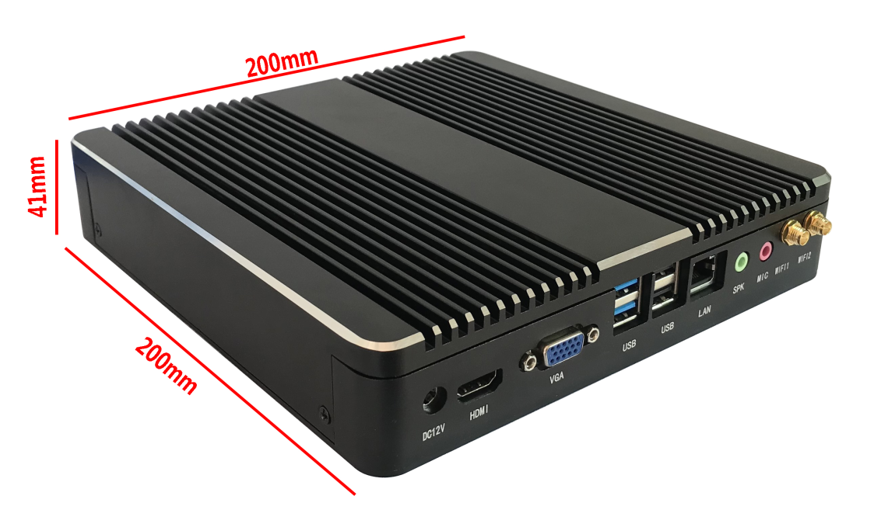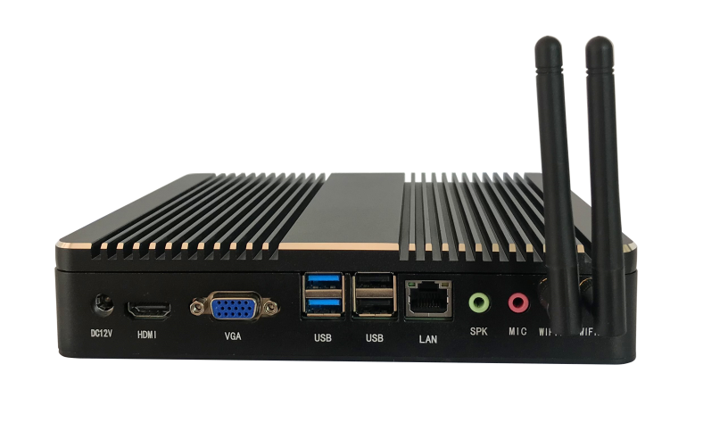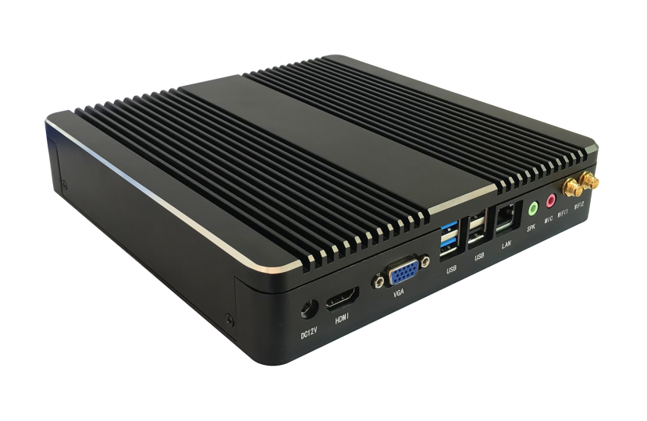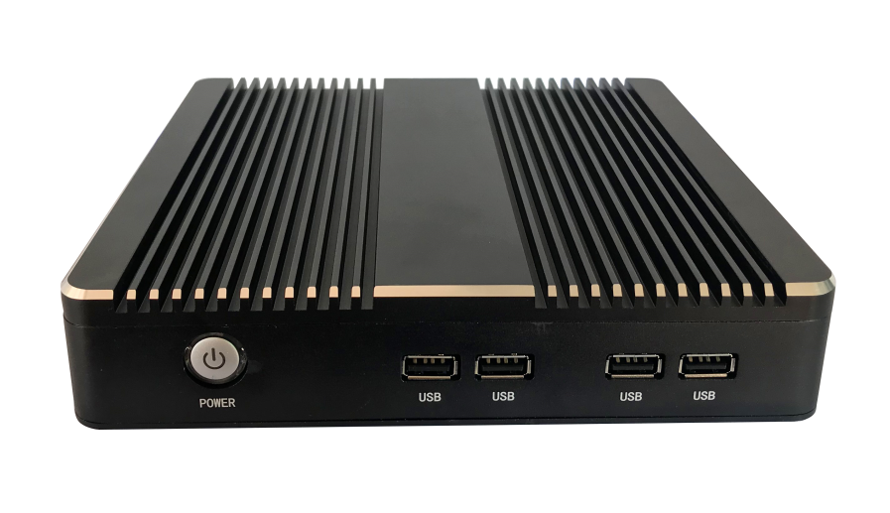

Dual network pc
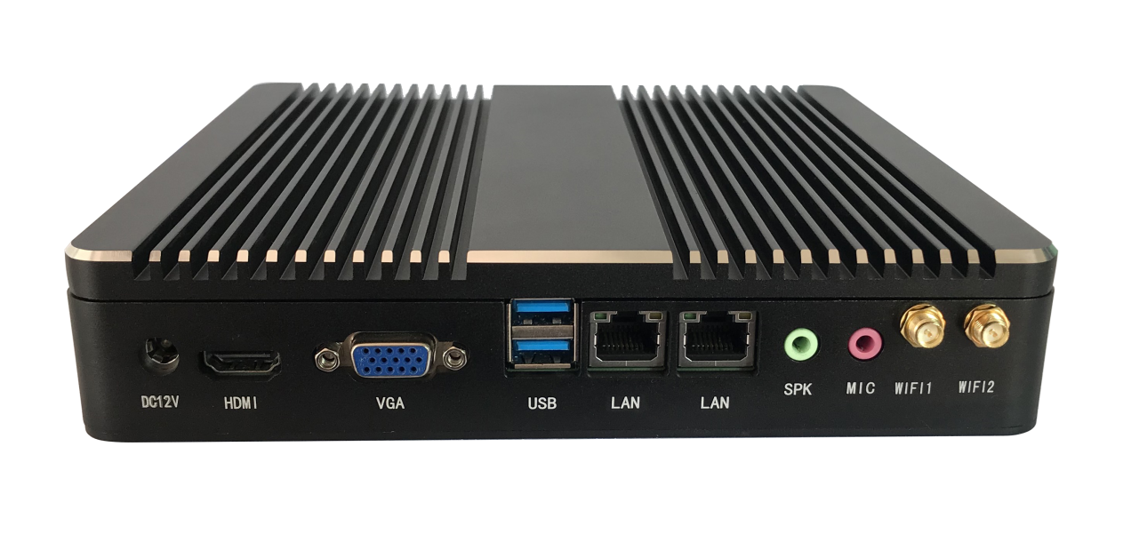

The above pictures are for reference only,please refer to the actual product!
Product model ordering optional:
PC model | LAN | USB2.0 | USB3.0 | SSD | Memory | Power
3th gen series | 1 | 6 | 2 | MSATA | 1*NB-DDR3  8G（MAX） | 12V
3th gen series | 2 | 4 | 2 | MSATA | 1*NB-DDR3  8G（MAX） | 12V
J1900 series | 1 | 7 | 1 | MSATA | 1*NB-DDR3  8G（MAX） | 12V
J1900 series | 2 | 5 | 1 | MSATA | 1*NB-DDR3  8G（MAX） | 12V
6th,7th gen series | 1 | 6 | 2 | MSATA | 2*NB-DDR3  16G（MAX） | 12V/19V
6th,7th gen series | 2 | 4 | 2 | MSATA | 2*NB-DDR3  16G（MAX） | 12V/19V
J3355 series | 1 | 6 | 2 | MSATA/M.2 | 1*NB-DDR3  8G（MAX） | 12V
J3355 series | 2 | 4 | 2 | MSATA/M.2 | 1*NB-DDR3  8G（MAX） | 12V
N3160 series | 1 | 6 | 2 | MSATA | 1*NB-DDR3  8G（MAX） | 12V
N3160 series | 2 | 4 | 2 | MSATA | 1*NB-DDR3  8G（MAX） | 12V
QM9850 | 1 | 6 | 2 | MSATA/M.2 | 2*NB-DDR4  32G（MAX） | 12V/19V
QM9850 | 2 | 4 | 2 | MSATA/M.2 | 2*NB-DDR4  32G（MAX） | 12V/19V

Note: The PC does not support 2.5-inch hard drives. To support it, customization is required!

IPC7000A PC Specification:

PC model | IPC7000A-3th gen series
Motherboard model | 1007F, 1037F, 2117F, i3HGP, i5HGP, i7HGP
PC size | 200mm*200mm*41mm
Power supply | 1*DC_IN | The inner diameter of the DC head is 2.5mm and supports 12V. It is recommended to use a power supply of 12V5A or higher.
3th gen CPU | Intel Celeron 1007U dual core 1.5GHz;  Intel Celeron 1037U dual core 1.8GHz;  Intel Pentium 2117U dual core 1.8GHz;  Intel Core i3-3217U dual core 1.8GHz;  Intel Core i3-3227U Dual Core 1.9GHz;  Intel Core i5-3317U dual core 1.7GHz, turbo 2.6GHz;  Intel Core i5-3337U dual core 1.8GHz, turbo 2.7GHz;  Intel Core i5-3427U dual core 1.8GHz, turbo 2.8GHz;  Intel Core i5-3437U dual core 1.9GHz, turbo 2.9GHz;  Intel Core i7-3517U dual core 1.9GHz, turbo 3.0GHz;  Intel Core i7-3537U dual core 2.0GHz, turbo 3.1GHz;  Intel Core i7-3667U dual core 2.0GHz, turbo 3.2GHz;  Intel Core i7-3687U dual core 2.1GHz, turbo 3.3GHz;
Chipset | Intel 6 series chipset: HM65, HM67, QM67  Intel 7 series chipset: NM70, HM70, HM75, HM76, HM77, QM77
Memory | 1*NB-DDR3 memory ,support 1.35V/1.5V ,support 1333/1600MHz memory ,maximum support 8G
Network function | Integrated Realtek 8111E Gigabit Ethernet card, supporting Wake on LAN and network PXE function
Network function | Supports WIFI/3G/4G and 2*WIFI antenna poles
Display function | Intel HD Graphics 4000 graphics controller, supporting single display, dual display replication, and dual display expansion
Display function | 1*VGA | Supports the highest resolution 1920*1200@60Hz
Display function | 1*HDMI | Supports the highest resolution 1920*1080@60Hz
USB function | 2*USB3.0 | The blue group USB is USB 3.0 speed (USB 2.0 speed when using Intel 6 series chipset)
USB function | 6*USB2.0 | Black group USB with USB 2.0 speed
Sound function | Integrated Realtek ALC662 HD digital audio decoder, 6-channel high fidelity audio controller
Sound function | 1*SPK | Support audio output
Sound function | 1*MIC | Support microphone input
Sound function | HDMI interface supports HDMI audio output
Hard disk function | MSATA disk (8G/16G/32G/64G/120G/128G/240G/256G, etc.)
Switch function | POWER | Switch button
Operating environment | Working temperature: -20 ℃~60 ℃;  Working humidity: 5%~95% relative humidity, no condensation
BIOS | AMI BIOS,support power on, timed power on, and remote power on
Watch Dog | Watchdog programming, supports hardware reset function (256 levels, 0-255 seconds)
Operating system | Windows 10, Windows 8, Windows 7, Windows XP, Linux, etc
Instructions:
☆ When the main chipset is an Intel 6 series chipset, the blue USB interface is USB 2.0 and there is no USB 3.0;
☆ When the main chipset is Intel 7 series chipset, the blue USB interface is USB 3.0;
☆ The PC only supports MSATA disks;
☆ Single Gigabit Ethernet port/Dual Gigabit Ethernet port optional for the PC; Dual network ports only affect the number of USB 2.0 ports;
☆ The PC is equipped with wall mounted holes;

IPC7000A PC Specification:
PC model | IPC7000A-J1900 series
Motherboard model | M218F, M219F, M218FC, M219FC
PC size | 200mm*200mm*41mm
Power supply | 1*DC_IN | The inner diameter of the DC head is 2.5mm and supports 12V. It is recommended to use a power supply of 12V5A or higher
CPU | Intel Celeron J1800 dual core 2.41GHz, turbo 2.58GHz;  Intel Celeron J1900 quad core 1.99GHz, turbo 2.4GHz;  Intel Pentium J2900 quad core 2.41GHz, turbo 2.66GHz;
Chipset | Intel Bay trail SOC chipset
Memory | 1*NB-DDR3 memory,support 1.35V,support 1600MHz memory,maximum support 8G
Network function | Integrated Realtek 8111E Gigabit Ethernet card, supporting Wake on LAN and network PXE function
Network function | Supports WIFI/3G/4G and 2 * WIFI antenna poles
Display function | Intel HD Graphics (Sandy Bridge) graphics controller, supporting single display, dual display replication, and dual display expansion
Display function | 1*VGA | Supports the high resolution 1920*1200@60Hz
Display function | 1*HDMI | Supports the high resolution 1920*1080@60Hz
USB function | 1*USB3.0 | The blue group USB is USB 3.0 speed (blue group, the one above the chassis direction is USB 3.0)
USB function | 7*USB2.0 | The black group USB is USB 2.0 speed (the blue group, below the chassis direction is USB 2.0)
Sound function | Integrated Realtek ALC662 HD digital audio decoder, 6-channel high fidelity audio controller
Sound function | 1*SPK | Support audio output
Sound function | 1*MIC | Support microphone input
Sound function | HDMI interface supports HDMI audio output
Hard disk function | MSATA disk（8G/16G/32G/64G/120G/128G/240G/256G,etc）
Switch function | POWER | Swutch button
Operating environment | Working temperature: -20 ℃~60 ℃;  Working humidity: 5%~95% relative humidity, no condensation
BIOS | AMI BIOS,support power on, timed power on, and remote power on
Watch Dog | Watchdog programming, supports hardware reset function (256 levels, 0-255 seconds)
Operating system | Windows 10, Windows 8, Windows 7, Linux, etc
Instructions:
☆ The blue USB interface of the PC is USB 3.0 on the top of the chassis direction and USB 2.0 on the bottom of the chassis direction;
☆ The PC only supports MSATA disks;
☆ Single Gigabit Ethernet port/Dual Gigabit Ethernet port optional for the PC; Dual network ports only affect the number of USB 2.0 ports;
☆ The PC is equipped with wall mounted holes;

IPC7000A PC Specification:
PC model | IPC7000A-6th,7th gen series
Motherboard model | QM9600, QM9700, QM9600H, QM9700H
PC size | 200mm*200mm*41mm
Power supply | 1*DC_IN | The inner diameter of the DC head is 2.5mm, supporting 12V/19V. It is recommended to use a power supply of 12V5A or 19V5A or higher
6th gen CPU | Intel Celeron 3855U dual core 1.6GHz; Celeron 3955U dual core 2.0GHz;  Intel Core i3-6006U dual core 2.0GHz; Core i3-6100U dual core 2.3GHz;  Intel Core i3-6157U dual core 2.4GHz; Core i3-6167U dual core 2.7GHz;  Intel Core i5-6200U dual core 2.3GHz, turbo 2.8GHz; Core i5-6260U dual core 1.8GHz, turbo 2.9GHz;  Intel Core i5-6267U dual core 2.9GHz, turbo 3.3GHz; Core i5-6287U dual core 3.1GHz, turbo 3.5GHz;  Intel Core i5-6300U dual core 2.4GHz, turbo 3.0GHz; Core i5-6360U dual core 2.0GHz, turbo 3.1GHz;  Intel Core i7-6500U dual core 2.5GHz, turbo 3.1GHz; Core i7-6560U dual core 2.2GHz, turbo 3.2GHz;  Intel Core i7-6567U dual core 3.3GHz, turbo 3.6GHz; Core i7-6600U dual core 2.6GHz, turbo frequency 3.4GHz;  Intel Core i7-6650U dual core 2.2GHz, turbo 3.4GHz; Core i7-6660U dual core 2.4GHz, turbo 3.4GHz;
7th gen CPU | Intel Celeron 3865U dual core 1.8GHz; Celeron 3965U dual core 2.2GHz;  Intel Core i3-7020U dual core 2.3GHz; Core i3-7100U dual core 2.4GHz;  Intel Core i3-7130U dual core 2.7GHz;  Intel Core i5-7200U dual core 2.5GHz, turbo 3.1GHz; Core i5-7260U dual core 2.2GHz, turbo 3.4GHz;  Intel Core i5-7267U dual core 3.1GHz, turbo 3.5GHz; Core i5-7287U dual core 3.3GHz, turbo 3.7GHz;  Intel Core i5-7300U dual core 2.6GHz, turbo 3.5GHz; Core i5-7360U dual core 2.3GHz, turbo 3.6GHz;  Intel Core i7-7500U dual core 2.7GHz, turbo 3.5GHz; Core i7-7560U dual core 2.4GHz, turbo 3.8GHz;  Intel Core i7-7567U dual core 3.5GHz, turbo 4.0GHz; Core i7-7600U dual core 2.8GHz, turbo 3.9GHz;  Intel Core i7-7660U dual core 2.5GHz, turbo 4.0GHz;
Chipset | Single chip integrated into CPU
Memory | 2*NB-DDR3 memory, supports 1.35V, 1600MHz memory, maximum support 16GB
Network function | Integrated Realtek 8111F Gigabit Ethernet card, supporting Wake on LAN and network PXE function
Network function | Supports WIFI/3G/4G and 2*WIFI antenna poles
Display function | 6th generation integrated Intel HD Graphics 510/520 graphics controller, supporting single display, dual display replication, and dual display expansion;  7th generation integrated Intel HD Graphics 610/620 graphics controller, supporting single display, dual display replication, and dual display expansion;
Display function | 1*VGA | Supports the highest resolution 1920*1200@60Hz
Display function | 1*HDMI | Supports 4K resolution 4096/3840*2160@24/30Hz
USB function | 2*USB3.0 | The blue group USB is USB 3.0 speed
USB function | 6*USB2.0 | The black group USB is USB 2.0 speed
Sound function | Integrated Realtek ALC662 HD digital audio decoder, 6-channel high fidelity audio controller
Sound function | 1*SPK | Support audio output
Sound function | 1*MIC | Support microphone input
Sound function | HDMI interface supports HDMI audio output
Hard disk function | MSATA disks（8G/16G/32G/64G/120G/128G/240G/256G,etc）
Switch function | POWER | Switch button
Operating environment | Working temperature: -20 ℃~60 ℃;  Working humidity: 5%~95% relative humidity, no condensation
BIOS | AMI BIOS,support power on, timed power on, and remote power on
Watch Dog | Watchdog programming, supports hardware reset function (256 levels, 0-255 seconds)
Operating system | Windows 10, Windows 8, Windows 7, Linux, etc
Instructions:
☆ The PC only supports MSATA disks;
☆ Single Gigabit Ethernet port/Dual Gigabit Ethernet port optional for the PC; Dual network ports only affect the number of USB 2.0 ports;
☆ HDMI supports 4K output;
☆ The PC is equipped with wall mounted holes;

IPC7000A PC Specification:
PC model | IPC7000A-J3355 series
Motherboard model | M335F
PC size | 200mm*200mm*41mm
Power supply | 1*DC_IN | The inner diameter of the DC head is 2.5mm and supports 12V. It is recommended to use a power supply of 12V5A or higher
CPU | Intel Celeron J3355 dual core 2.0GHz, turbo 2.5GHz;  Intel Celeron J3455 quad core 1.5GHz, Turbo 2.3GHz;  Intel Pentium N4200 quad core 1.1GHz, turbo 2.5GHz;
Chipset | Single chip integrated into CPU
Memory | 1*NB-DDR3 memory, supports 1.35V, 1600MHz memory, maximum support 8GB
Network function | Integrated Realtek 8111E Gigabit Ethernet card, supporting Wake on LAN and network PXE function
Network function | Supports WIFI/3G/4G and 2*WIFI antenna poles
Display function | Intel HD Graphics 500/505 graphics controller, supporti single display, dual display replication, and dual display expansion
Display function | 1*VGA | Supports the highest resolution 1920*1200@60Hz
Display function | 1*HDMI | Supports 4K resolution 4096/3840*2160@24/30Hz
USB function | 2*USB3.0 | The blue group USB is USB 3.0 speed
USB function | 6*USB2.0 | The black group USB is USB 2.0 speed
Sound function | Integrated Realtek ALC662 HD digital audio decoder, 6-channel high fidelity audio controller
Sound function | 1*SPK | Support audio output
Sound function | 1*MIC | Support microphone input
Sound function | HDMI interface supports HDMI audio output
Hard disk function | MSATA disks（8G/16G/32G/64G/120G/128G/240G/256G,etc）
Hard disk function | M.2 2242 hard drives（64G/120G/128G/240G/256G/512G,etc）
Switch function | POWER | Switch button
Operating environment | Working temperature: -20 ℃~60 ℃;  Working humidity: 5%~95% relative humidity, no condensation
BIOS | AMI BIOS， Support power on, timed power on, and remote power on
Watch Dog | Watchdog programming, supports hardware reset function (256 levels, 0-255 seconds)
Operating system | Windows 10 64 bit, Linux ,etc
☆ The PC supports dual hard drives of MSATA and M.2 2242;
☆ Single Gigabit Ethernet port/Dual Gigabit Ethernet port optional for the PC; Dual network ports only affect the number of USB 2.0 ports;
☆ HDMI supports 4K output;
☆ The operating system only supports Windows 10 64 bit systems and Linux series systems;
☆ The PC is equipped with wall mounted holes;

IPC7000A PC Specification
PC model | IPC7000A-N3160 series
Motherboard model | M316F
PC size | 200mm*200mm*41mm
Power supply | 1*DC_IN | The inner diameter of the DC head is 2.5mm and supports 12V. It is recommended to use a power supply of 12V5A or higher
CPU | Intel Celeron N3150 quad core 1.6GHz, Turbo 2.08GHz;  Intel Celeron N3160 quad core 1.6GHz, Turbo 2.24GHz;  Intel Pentium N3700 quad core 1.6GHz, turbo 2.4GHz;
Chipset | Single chip integrated into CPU
Memory | 1*NB-DDR3 memory, supports 1.35V, 1600MHz memory, maximum support 8GB
Network function | Integrated Realtek 8111H Gigabit Ethernet card, support Wake on LAN and network PXE function
Network function | Supports WIFI/3G/4G and 2*WIFI antenna poles
Display function | Intel Celeron processor N3000 series core graphics card, support single display, dual display replication, and dual display expansion
Display function | 1*VGA | Supports the highest resolution 1920*1200@60Hz
Display function | 1*HDMI | Supports 4K resolution 4096/3840*2160@24/30Hz
USB function | 2*USB3.0 | The blue group USB is USB 3.0 speed
USB function | 6*USB2.0 | The black group USB is USB 2.0 speed
Sound function | Integrated Realtek ALC662 HD digital audio decoder, 6-channel high fidelity audio controller
Sound function | 1*SPK | Support audio output
Sound function | 1*MIC | Support microphone input
Sound function | HDMI interface supports HDMI audio output
Hard disk function | MSATA disks（8G/16G/32G/64G/120G/128G/240G/256G,etc）
Switch function | POWER | Switch button
Operating environment | Working temperature: -20 ℃~60 ℃;  Working humidity: 5%~95% relative humidity, no condensation
BIOS | AMI BIOS,support power on, timed power on, and remote power on
Watch Dog | Watchdog programming, supports hardware reset function (256 levels, 0-255 seconds)
Operating system | Windows 10, Windows8.1, Windows7
☆ he PC only supports MSATA disks;
☆ Single Gigabit Ethernet port/Dual Gigabit Ethernet port optional for the PC; Dual network ports only affect the number of USB 2.0 ports;
☆ HDMI supports 4K output;
☆ The operating system does not support Linux system;
☆ The PC is equipped with wall mounted holes;

IPC7000A PC Specification:
PC model | IPC7000A-QM9850
Motherboard model | QM9850
PC size | 200mm*200mm*41mm
Power supply | 1*DC_IN | The inner diameter of the DC head is 2.5mm, supporting 12V/19V. It is recommended to use a power supply of 12V7A or 19V5A or higher
7th gen CPU | Intel Celeron 3865U dual core 1.8GHz; Celeron 3965U dual core 2.2GHz;  Intel Core i3-7020U dual core 2.3GHz; Core i3-7100U dual core 2.4GHz;  Intel Core i3-7130U dual core 2.7GHz;  Intel Core i5-7200U dual core 2.5GHz, turbo 3.1GHz; Core i5-7260U dual core 2.2GHz, turbo 3.4GHz;  Intel Core i5-7267U dual core 3.1GHz, turbo 3.5GHz; Core i5-7287U dual core 3.3GHz, turbo 3.7GHz;  Intel Core i5-7300U dual core 2.6GHz, turbo 3.5GHz; Core i5-7360U dual core 2.3GHz, turbo 3.6GHz;  Intel Core i7-7500U dual core 2.7GHz, turbo 3.5GHz; Core i7-7560U dual core 2.4GHz, turbo 3.8GHz;  Intel Core i7-7567U dual core 3.5GHz, turbo 4.0GHz; Core i7-7600U dual core 2.8GHz, turbo 3.9GHz;  Intel Core i7-7660U dual core 2.5GHz, turbo 4.0GHz;
8th gen CPU | Intel Core i3-8130U dual core 2.2GHz, turbo 3.4GHz;  Intel Core i5-8250U dual core 1.6GHz, turbo 3.4GHz;  Intel Core i5-8350U dual core 1.7GHz, turbo 3.6GHz;  Intel Core i7-8550U dual core 1.8GHz, turbo 4.0GHz;  Intel Core i7-8650U dual core 1.9GHz, turbo 4.2GHz;
Chipset | Single chip integrated into CPU
Memory | 2*NB-DDR4 memory, supports 2133/2400MHz memory, maximum support 32GB
Network function | Integrated Realtek 8111H Gigabit Ethernet card, supporting Wake on LAN and network PXE function
Network function | Supports WIFI/3G/4G and 2*WIFI antenna poles
Display function | Integrated Intel HD Graphics 610/620 graphics controller, support single display, dual display replication, and dual display expansion
Display function | 1*VGA | Supports the highest resolution 1920*1200@60Hz
Display function | 1*HDMI | Supports 4K resolution 4096/3840*2160@24/30Hz
USB function | 2*USB3.0 | The blue group USB is USB 3.0 speed
USB function | 6*USB2.0 | The black group USB is USB 2.0 speed
Sound function | Integrated Realtek ALC662 HD digital audio decoder, 6-channel high fidelity audio controller
Sound function | 1*SPK | Support audio output
Sound function | 1*MIC | Support microphone input
Sound function | HDMI interface supports HDMI audio output
Hard disk function | M.2 2280/2242（64G/128/512G/1TB,etc）  Optional support MSATA disks（8G/16G/32G/64G/120G/128G/240G/256G,etc）
Switch function | POWER | Switch button
Operating environment | Working temperature: -20 ℃~60 ℃;  Working humidity: 5%~95% relative humidity, no condensation
BIOS | AMI BIOS,support power on, timed power on, and remote power on
Watch Dog | Watchdog programming, supports hardware reset function (256 levels, 0-255 seconds)
Operating system | Windows 10, Windows 8, Linux, etc
☆ The PC only supports M.2 disks, optional support for MSATA disks;
☆ Single Gigabit Ethernet port/Dual Gigabit Ethernet port optional for the PC; Dual network ports only affect the number of USB 2.0 ports;
☆ HDMI supports 4K output;
☆ The PC is equipped with wall mounted holes;

