ELSKY KC7000 V1.2 Motherboard Specification
――――――――――――――――――――――――――――――――――――――――――――――――――――――
Motherboard diagram ↓
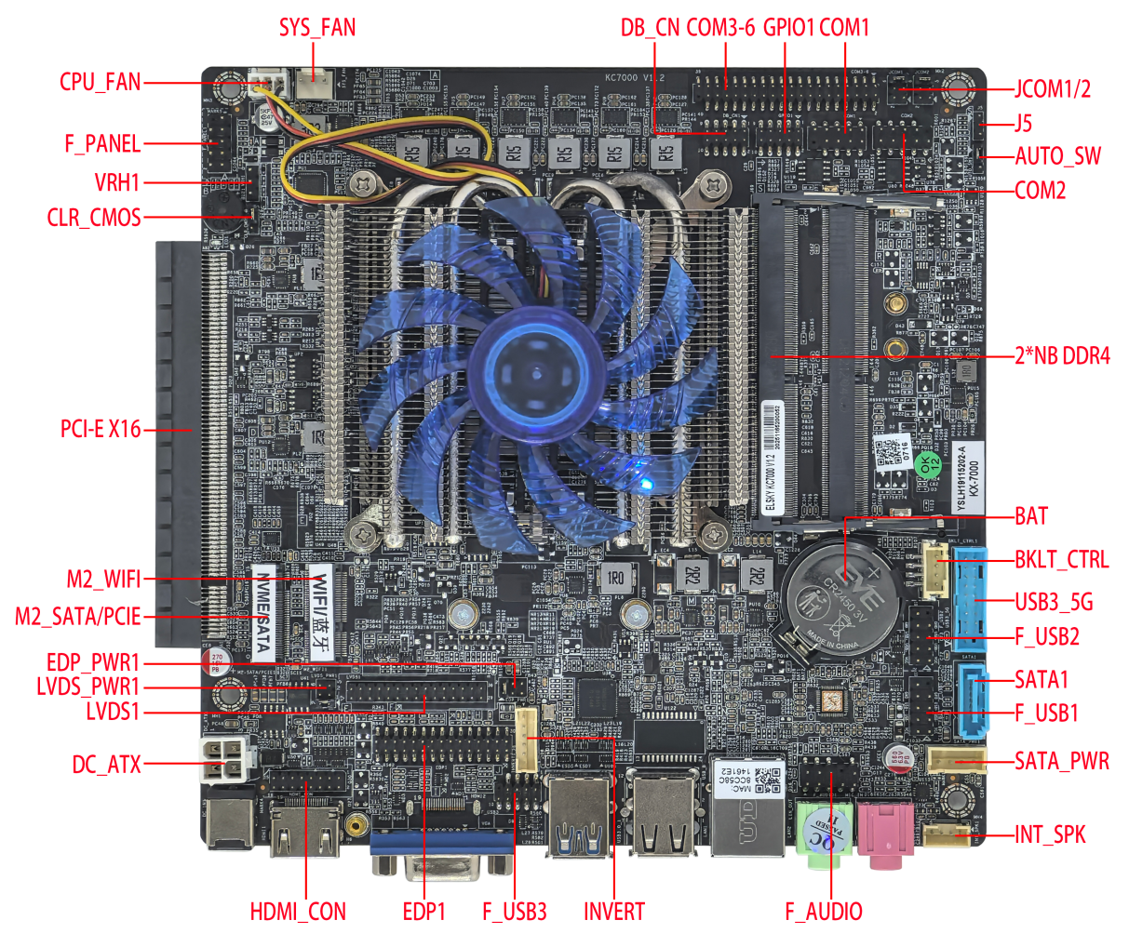

――――――――――――――――――――――――――――――――――――――――――――――――――――――
VGA + HDMI single network interface ↓
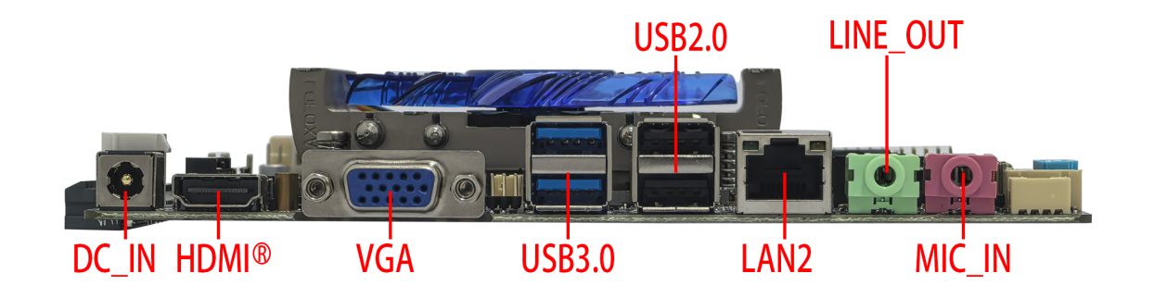
――――――――――――――――――――――――――――――――――――――――――――――――――――――
Image of VGA + HDMI dual network interface ↓
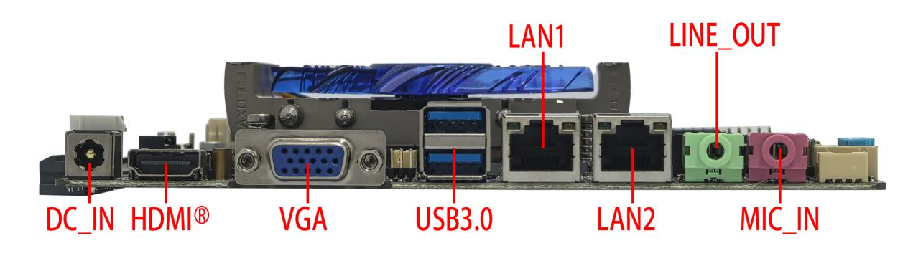
――――――――――――――――――――――――――――――――――――――――――――――――――――――
Dual HDMI single network interface image ↓

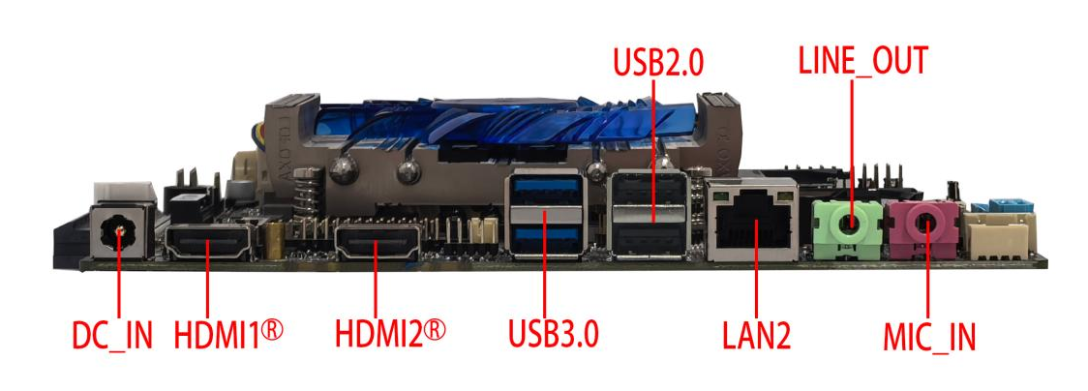
――――――――――――――――――――――――――――――――――――――――――――――――――――――
Dual HDMI and dual network interface images ↓
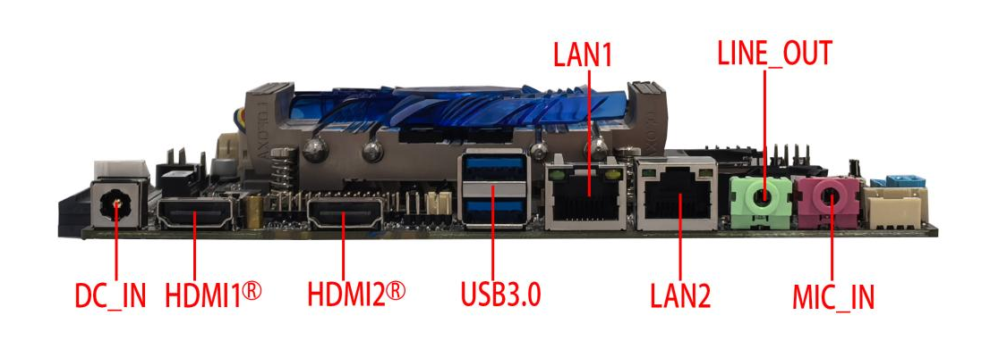
――――――――――――――――――――――――――――――――――――――――――――――――――――――
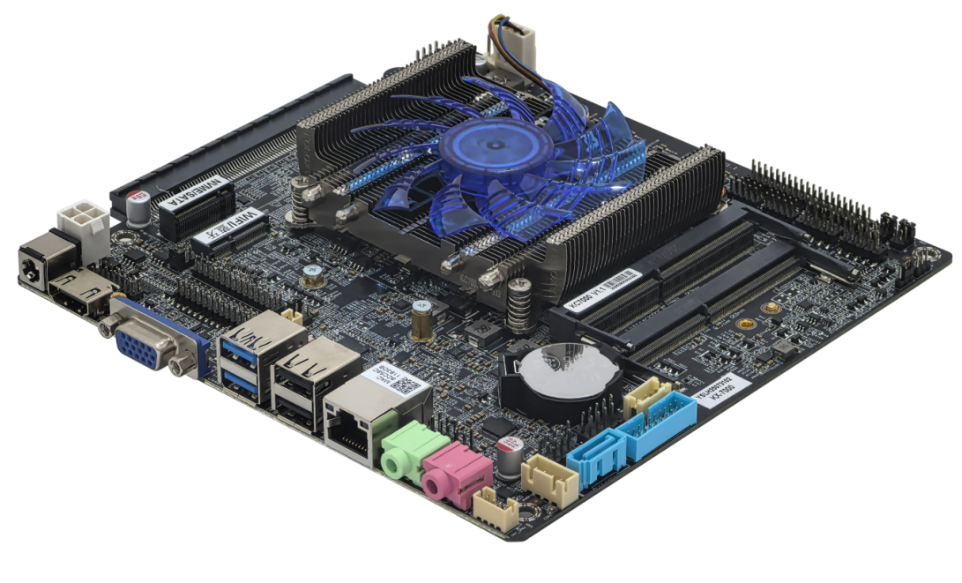
――――――――――――――――――――――――――――――――――――――――――――――――――――――
――――――――――――――――――――――――――――――――――――――――――――――――――――――
Optional no PCIe slot, optional dual HDMI ↓
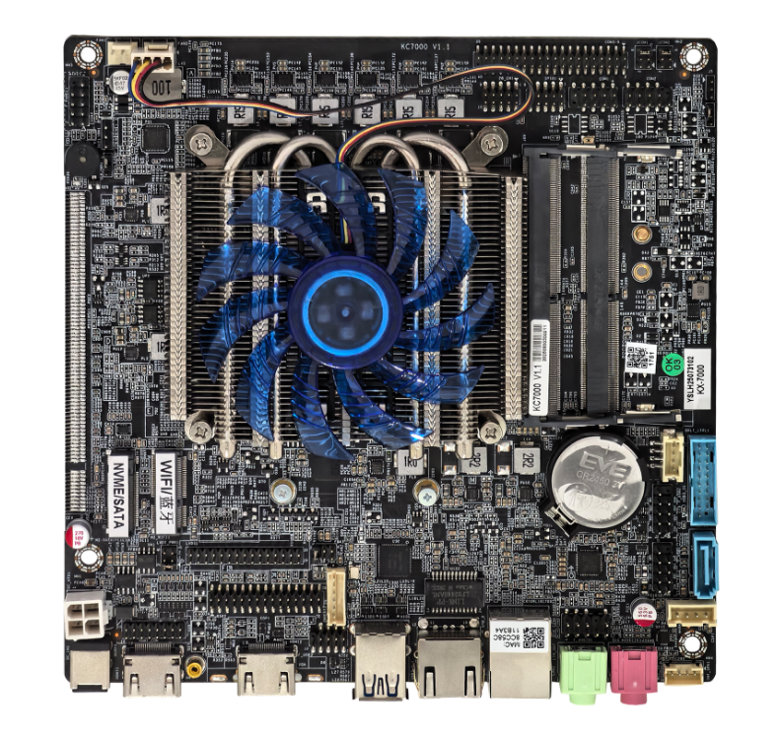
――――――――――――――――――――――――――――――――――――――――――――――――――――――
Motherboard back view ↓
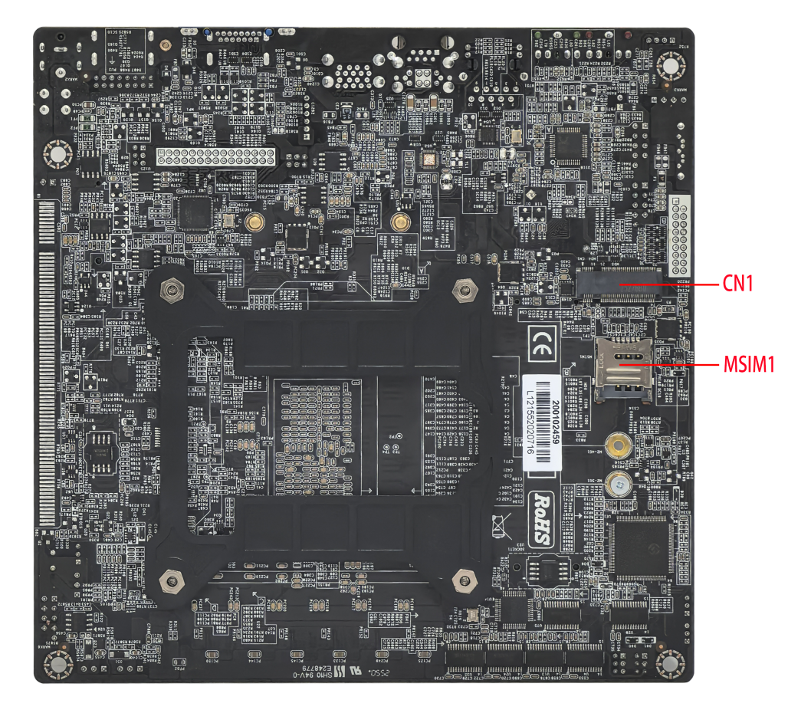
――――――――――――――――――――――――――――――――――――――――――――――――――――――
The images above are for reference only; please refer to the actual product for details.
Product model ordering and configuration options:
Product model | CPU | 4K | COM | LAN | USB 2.0 | USB 3.0 | Memory | SSD | Power
KC7000 | Supports all domestic Zhaoxin KX7000 series surface mount CPUs | 4K 60Hz | 2/6 | 1 | 6 | 4 | 2*NB-DDR4MAX 64G | 1*M.2  1*SATA | +12V/19V
KC7000 |  | 4K 60Hz | 2/6 | 2 | 6 | 4 | 2*NB-DDR4MAX 64G | 1*M.2  1*SATA | +12V/19V
KC7000-2C/6C (without PCIe x16 slot); KC7000-2C/6C-P (with PCIe x16 slot)
Important Note:
Power supply interface:
The motherboard's DC connector is 5.5*2.5 inches; it supports one 4-pin DC-ATX power connector.
The motherboard power supply supports 12V or 19V; the full load power consumption is about 60W, and it is recommended to use a 12V 7A or 19V 5A or higher power supply .
CPU:
The motherboard supports the entire Zhaoxin KX7000 series of surface-mount CPUs;
Display interface:
- The motherboard's HDMI1® 2.0 / HDMI_CON , VGA / HDMI2® 2.0 , and LVDS1 / EDP1 ports support single display, dual/triple display duplication, and dual/triple display expansion; (it can support HDMI1 / HDMI_CON header + VGA + LVDS/EDP triple display; it does not support HDMI1® / HDMI_CON header + HDMI2® + LVDS/EDP triple display, nor does it support HDMI2® + LVDS/EDP dual display; LVDS/EDP/HDMI2® signal selection is required).
- The motherboard's HDMI1® 2.0 and HDMI_CON headers are optional. By default, the HDMI1® 2.0 interface is available, while the HDMI_CON header is unavailable. Supporting the HDMI_CON header requires hardware modification, after which the HDMI1® 2.0 interface will be unavailable . The HDMI1® 2.0 interface supports 4K resolution 4096/3840*2160@60Hz; the HDMI_CON header only supports 2K@60Hz .
- The motherboard 's VGA port can be replaced with an HDMI2® 2.0 port , which supports 4K resolution 4096/3840*2160@60Hz;
- The motherboard can only select one of the three signals: LVDS1, EDP1, and HDMI2® 2.0 . LVDS1 display is supported by default. EDP1 uses an EDP-C screen cable and supports 4K resolution 4096/3840*2160@30Hz. After the motherboard is modified to have dual HDMI® , it can only support two display outputs. After the modification, there will be no signal from LVDS and EDP.
- The motherboard supports one optional PCI-E X16 slot, supports PCIe 4.0 x8 signals, and supports discrete graphics cards and PCIe devices ; after connecting a discrete graphics card, the display interfaces (VGA/HDMI/LVDS1/EDP1) on the motherboard will have no signal output ;

M.2:
- The motherboard supports Key-M interface M.2 2280 NVME PCIe 4.0 x2 / SATA dual-protocol adaptive standard SSDs;
- The motherboard M.2 -WIFI supports Key-E interface M.2 2230 PCIE4.0 x1 & USB, and supports WiFi and Bluetooth modules; the M.2 hard drive cannot be modified .
3. The motherboard CN1 (M.2-4G/5G) supports Key-B interface M.2 5G (3052/3042) modules or M.2 4G (3042) modules; by default, the M.2 4G/5G has no signal and requires hardware modification. After modification, pins 11-19 of the built-in USB3_5G will have no signal, while the built-in USB3_5G will have a full signal by default.
USB interface:
1. The single-network motherboard supports 10 USB ports by default (4 USB 3.0, 6 USB 2.0).
2. The F_USB3 pin has no signal by default and can only be used with an external USB 2.0 interface; after switching to dual network, the F_USB3 pin will have a signal (hardware modification required).
3. The external USB ports and internal USB headers on the motherboard are powered by S power (no power when the computer is off) by default, but can be changed to A power (power when the computer is off).
COM port:
- The motherboard can optionally support 2 or 6 COM ports, and supports RS232 by default; among them, COM1 supports 1 RS232/1 RS422/1 RS485 optional, which can be set through BIOS.
- The motherboard COM1/2 can be configured to output 0V/5V/12V on pin 9 via JCOM1/2/jump caps, with 0V as the default.
Network card:
Single network: Default is domestic Yutaiwei YT6801 gigabit network card; optional Realtek 8111H gigabit network card ;
Dual network: Domestic YT6801 + YT6801 Gigabit Ethernet card or Realtek 8111H + Realtek 8111H Gigabit Ethernet card ;
PoE power supply cannot be modified;
Sound card:
The motherboard supports the Realtek ALC897 sound card by default, but can be modified to support the Senary SN6186 sound card ;

The CPU information below is for reference only. Please consult our sales team for specific requirements!
CPU Brand | CPU Specifications | CPU model | clock speed | Turbo Boost | CPU power consumption (W)
Zhaoxin | KX7000 | KX-7000 | Octa-core 3.5GHz | / | 60

illustrate
Except for the accessories listed that come with the product, the contents of this manual do not represent a commitment by the company, and the company reserves the right to make changes to this manual without prior notice.
We are not responsible for any direct, indirect, intentional or unintentional damage or potential hazards caused by improper installation or use.
Before ordering a product, please consult with the distributor to understand in detail whether the product performance meets your needs.
The contents of this manual are protected by copyright. All rights reserved. No part of this manual may be reproduced in any mechanical, electronic or other manner without permission.
The final interpretation right of this instruction manual belongs to SHENZHEN ELSKY TECHNOLOGY CO.,LTD.

The above ordering information is for reference only. Please contact our sales department for details. Tel: 0755-82260150
Motherboard driver download: https://pan.baidu.com/s/1ie7qi5NutS53ipPecRSYtw
Access password: cbn5

BIOS function keys
BIOS function keys | Function Description
Press Delete when booting up | Enter BIOS function interface
Press F11 when powering on | You can choose to boot from the BIOS or enter the BIOS interface.
← → | Use the left and right arrow keys to select an item.
↑ ↓ | Use the up and down arrows to select items
Enter | Select the item and enter the submenu.
+/- | Change the selection, or add or subtract values.
F9 | Factory reset
F10 | Save changes
Esc | quit

Chapter 1, Product Specifications
Motherboard size | 170mm*170mm * 28mm (thickness with fan)
CPU | Supports domestic Zhaoxin KX-7000 octa-core 3.5GHz processor.
Power supply | 1*DC_ IN |  | The DC connector has an inner diameter of 2.5mm and supports 12V /19V.  The motherboard consumes approximately 60W under full load ; a 12V 7A or 19V 5A or higher power supply is recommended.
Power supply | 1*DC_ATX (4-pin)
Memory | 2*SO DIMM slots |  | NB-DDR4 memory , with a maximum frequency of 3200 MHz and a maximum capacity of 64 GB.
Network function | 1/2*LAN interface |  | Single network: Default support for domestic Yutaiwei YT6801 gigabit network card;  Optional support for Realtek 8111H Gigabit Ethernet adapter;  Dual-network support: Supports domestic YT6801 gigabit network card + YT6801 gigabit network card;  Optional support for Realtek 8111H Gigabit Ethernet adapter + Realtek 8111H Gigabit Ethernet adapter;  Supports Wake-on-LAN and PXE diskless boot functionality.
Network function | 1*CN1 interface |  | Supports Key-B interface M.2 5G (3052/3042) modules or M.2 4G (3042) modules.
Network function | By default, the M.2 4G/5G has no signal and requires hardware modification. After modification, pins 11-19 of the built-in USB3_5G will have no signal, whereas the built-in USB3_5G will have a full signal by default.
Network function | 1*M.2 WiFi interface |  | Supports Key-E interface M.2 2230 PCIe 4.0 x1 & USB, and supports WiFi and Bluetooth modules.
Display function | graphics card | Integrated C-1190 graphics card, supporting single display, dual/triple display duplication, and dual/triple display expansion.  (Supports HDMI1/HDMI_CON header + VGA + LVDS/EDP triple display; does not support HDMI1/HDMI_CON header + HDMI2 + LVDS/EDP triple display, does not support HDMI2 + LVDS/EDP dual display, LVDS/EDP/HDMI2 signal selection is required)
Display function | 1*HDMI1® 2.0 port |  | Supports 4K resolution 4096/3840*2160@60Hz
Display function | 1*HDMI_CON header |  | Supports 2K resolution 1920*1080@60Hz
Display function | 1*VGA DB15 interface |  | Supports resolution 1920*1080@60Hz
Display function | 1*HDMI2® 2.0 port (optional) |  |  |  |  | Supports 4K resolution 4096/3840*2160@60Hz
Display function | Choose between VGA and HDMI2® interfaces .
Display function | 1*LVDS 1 pin |  | Supports resolution 1920*1080@60Hz ( 30Pin, 2*15Pin, 2.0mm)
Display function | 1*EDP1 pin (optional) |  | EDP-C screen cable, supports 4K resolution 4096/3840*2160@30Hz  (30Pin, 2*15Pin, 2.0mm)
Display function | offers a choice between LVDS/EDP/HDMI2® signals , with LVDS headers supported by default.
Display function | 1*EDP_PWR 1 pin |  | EDP working voltage control pin (6-pin, 2*3-pin, 2.0mm)
Display function | 1*LVDS_PWR 1 pin |  | LVDS operating voltage control pin (6-pin, 2*3-pin, 2.0mm)
Display function | 1*BKLT_CTRL pin |  | LVDS brightness adjustment pin (4 Pin, 1* 4 Pin, 2.0mm)
Display function | 1*INVERT pin |  | LVDS backlight control pins (6-pin, 1*6-pin, 2.0mm)
USB function | 2 USB 3.0 ports |  | Rear standard USB 3.0 port
USB function | 2 USB 2.0 ports |  | Rear standard USB 2.0 port (this port is not available on 2*LAN motherboards )
USB function | 1*F_USB 1-pin connector |  | Front-mounted USB 2.0 header, one set has 2 USB 2.0 ports.  (9-pin, 2*5-pin, 2.54mm)
USB function | 1*F_USB2 pin |  | Front-mounted USB 2.0 header, one set has 2 USB 2.0 ports.  (9-pin, 2*5-pin, 2.54mm)
USB function | 1*F_USB 3-pin connector |  | Front-mounted USB 2.0 header, one set has 2 USB 2.0 ports. (9-pin, 2*5-pin, 2.0 mm )
USB function | The F_USB3 pin has no signal by default and can only be used with an external USB 2.0 interface; after switching to dual-network mode, the F_USB3 pin will have a signal (hardware modification required).
USB function | 1*USB 3_5G header |  | Front-mounted USB 3.0 header, one set has 2 USB 3.0 ports ( 19-pin, 2 x 10-pin, 2.0mm).
USB function | The built-in USB 3.5G port has a full signal by default; after switching to support M.2 4G/5G, pins 11-19 of the built-in USB 3.5G port have no signal.
Sound function | The Realtek ALC 897 HD digital audio controller is supported by default ; optional support is available for the integrated Senary SN6186 sound card.
Sound function | 1*LINE_OUT interface |  | Supports audio output (green)
Sound function | 1*MIC_IN interface |  | Microphone input is supported (red).
Sound function | 1* INT_SPK pin |  | Supports 8 ohms 5 watt speaker output (amplifier) (4-pin, 1*4-pin, 2.0mm)
Hard drive function | 1* M.2-SATA/PCIe interface |  |  | Supports Key-M interface M.2 2280 NVME PCIe 4.0 x2 / SATA adaptive standard SSD;
Hard drive function | 1*SATA1 interface |  | Standard SATA hard drive interface, supports SATA 3.0
Hard drive function | 1*SATA_PWR header |  | The hard drive power supply pins can draw 5V or 12V power.  (4-pin, 1*4-pin, 2.54mm)
On/off function | 1*F_PANEL pin |  | Switch, power indicator, hard drive indicator, reset pin (9-pin, 2*5-pin, 2.54mm)
On/off function | 1*AUTO_SW pin |  | Hardware control power-on pins (3-pin, 1*3-pin, 2.0mm)
Other I/O | 1*COM1 pin |  | Supports standard RS232 , with optional support for RS422/RS485  (9-pin, 2*5-pin, 2.54mm).
Other I/O | 1*COM2 pin |  | Supports standard RS232 (9-pin, 2*5-pin, 2.54mm)
Other I/O | 1*COM3~6 pins |  | Supports standard RS232 (39Pin, 2*20Pin, 2.0mm).
Other I/O | 1*JCOM1/2 pins |  | The voltage at pin 9 of COM1/2 is selectable: 0V/5V/12V.  (6-pin, 2*3-pin, 2.0mm)
Other I/O | 1* M SIM card slot |  | Supports SIM cards; a SIM card is required when using 5G /4G.
Other I/O | 1*CLR_CMOS pin |  | Motherboard reset and discharge pins (3-pin, 1*3-pin, 2.0 mm )
Other I/O | 1*CPU_FAN pin |  | CPU fan header , supports temperature control  (3-pin, 1*3-pin, 2.54mm)
Other I/O | 1*SYS_FAN pin |  | SYS fan header , full speed (3-pin, 1*3-pin, 2.54mm)
Other I/O | 1*GPIO 1 pin |  | GPIO control pins (10Pin, 2*5Pin, 2. 0 mm)
Other I/O | 1 PCI-E x16 interface (optional) |  |  |  | Supports PCIe 4.0 x8 signal, and supports discrete graphics cards and PCIe devices.
Other I/O | 1*J5 pin |  | Debugging pins ( 3-pin, 1*3-pin, 2.0 mm )
Other I/O | 1*VRH1 pin |  | Debugging pins ( 3-pin, 1*3-pin, 2.54mm )
Other I/O | 1*DB_CN1 pin |  | Adjustment pins ( 10-pin, 2*5-pin, 2.0 mm )
Operating environment | Operating temperature: 0℃~60℃;  Operating humidity: 5%~95% relative humidity, non-condensing.
BIOS | Supports power-on upon startup, scheduled power-on, and intelligent identification of remote power on/off devices.
Operating system | Supports Windows 1.1, Windows 1.0 , Linux , and domestic operating systems .

1.1 Motherboard Dimensions
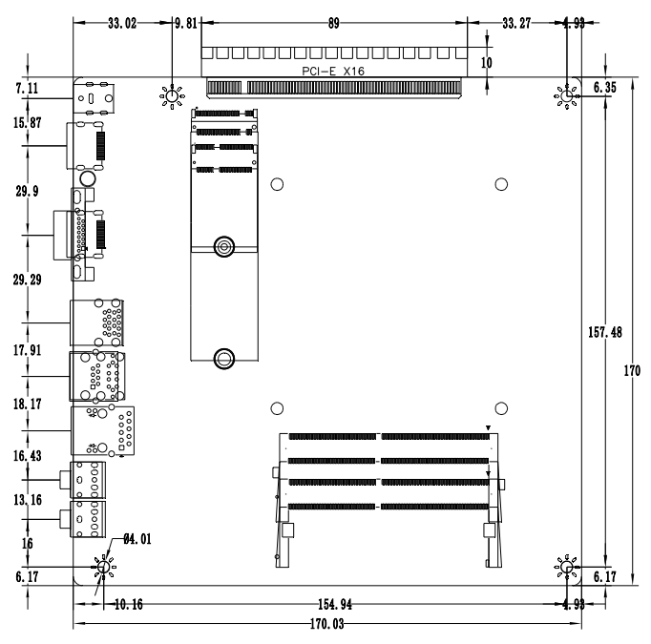
HDMI+VGA+Single Network Size Diagram
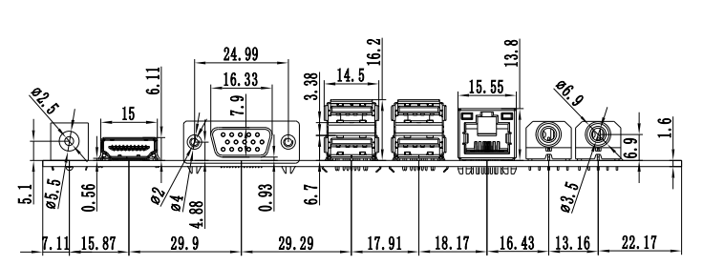
HDMI+VGA+Dual-network size diagram
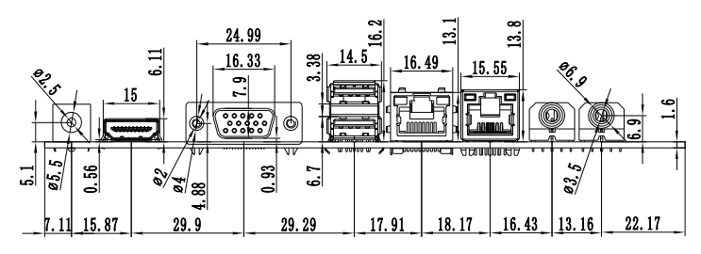
Dual HDMI + Single Network Size Diagram
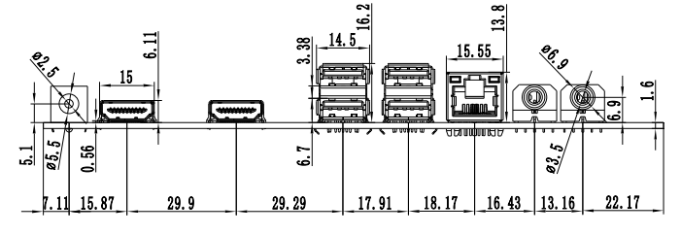
Dual HDMI + Dual Network Size Diagram
