ELSKY LC3500 V1.0A Specification Specification
――――――――――――――――――――――――――――――――――――――――――――――――――――――
Motherboard diagram ↓
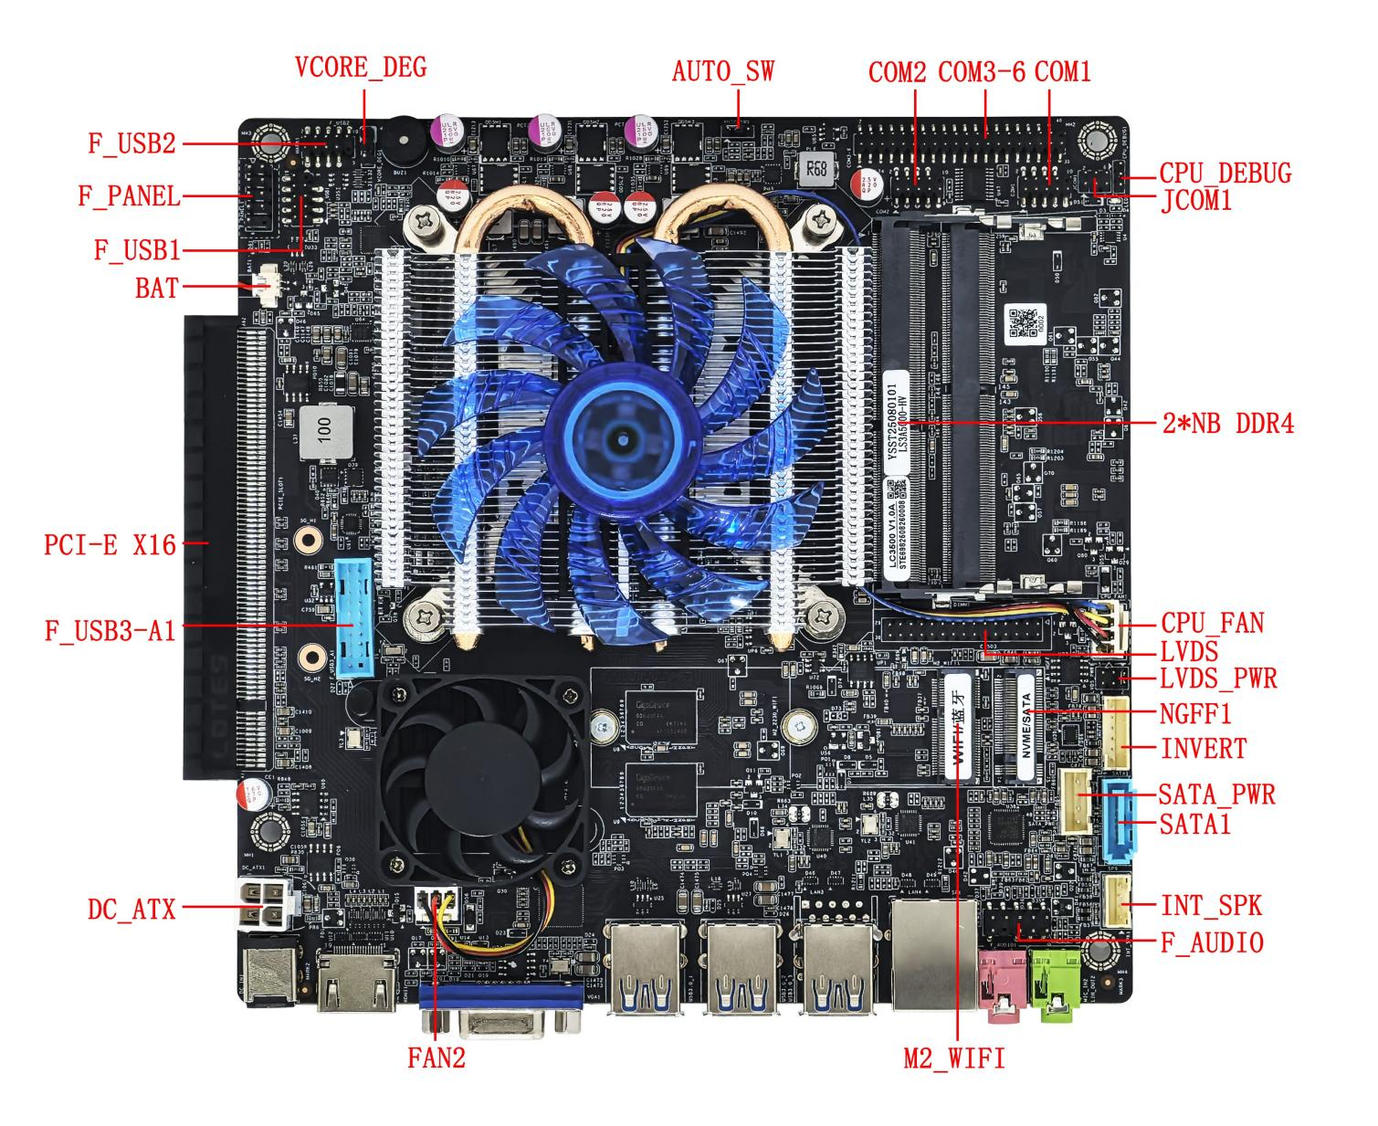
――――――――――――――――――――――――――――――――――――――――――――――――――――――
Single network interface image ↓
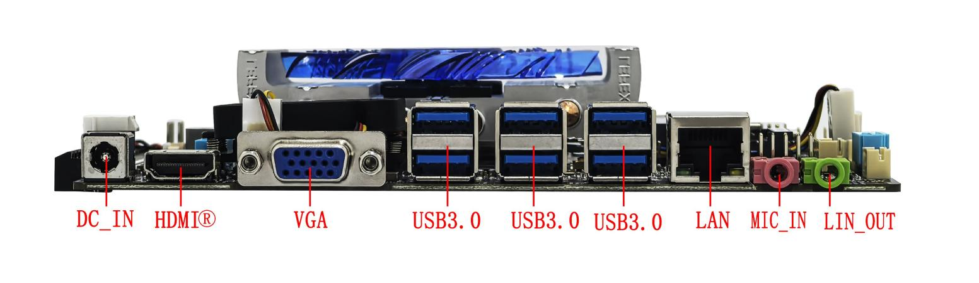
――――――――――――――――――――――――――――――――――――――――――――――――――――――
――――――――――――――――――――――――――――――――――――――――――――――――――――――
Dual network interface image ↓
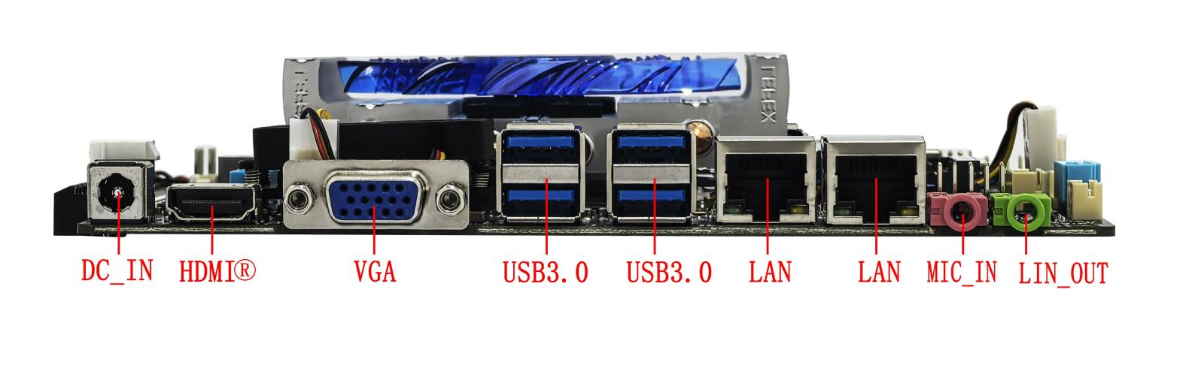
――――――――――――――――――――――――――――――――――――――――――――――――――――――

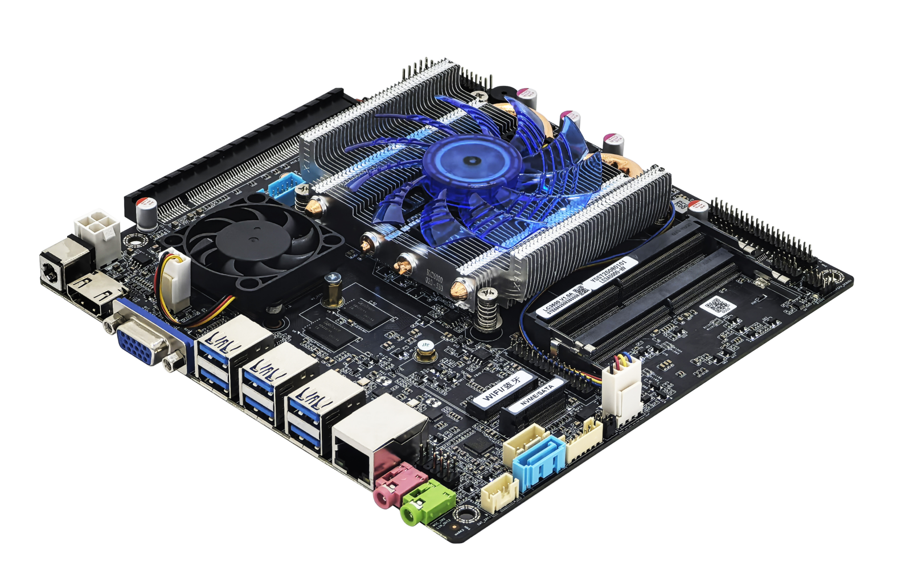

――――――――――――――――――――――――――――――――――――――――――――――――――――――

――――――――――――――――――――――――――――――――――――――――――――――――――――――
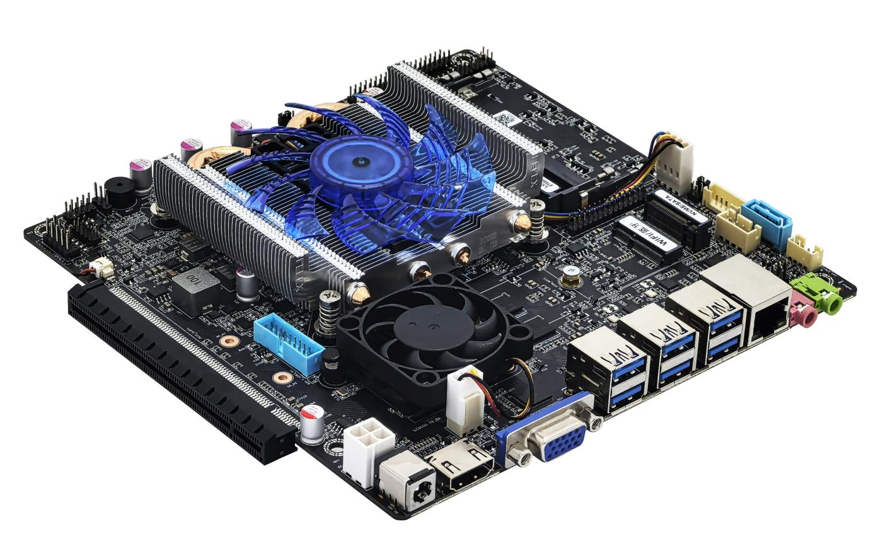
――――――――――――――――――――――――――――――――――――――――――――――――――――――
Motherboard back view ↓
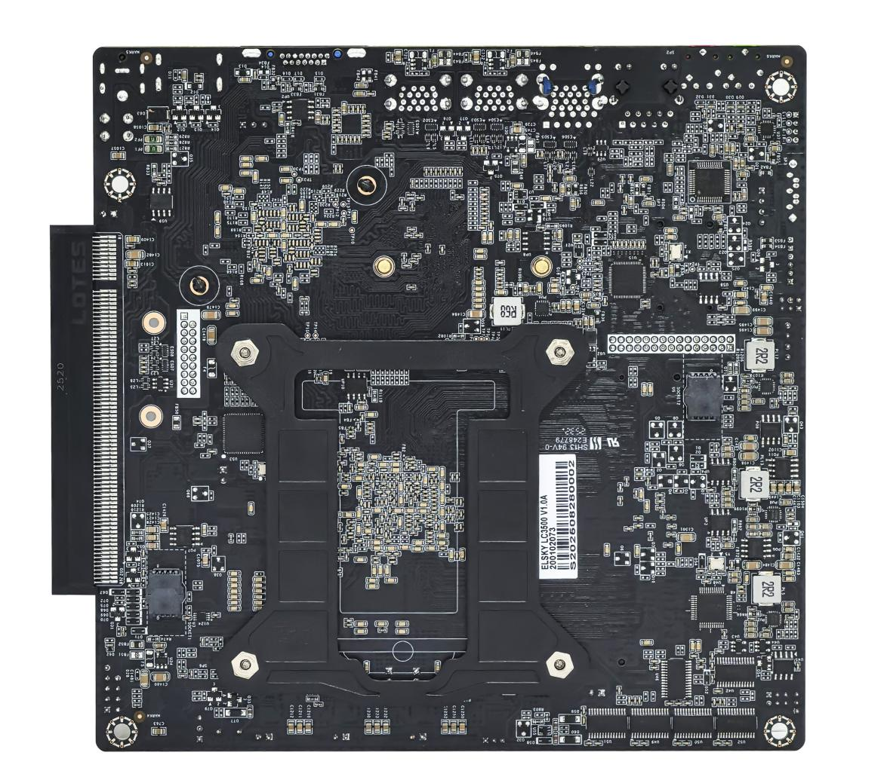
――――――――――――――――――――――――――――――――――――――――――――――――――――――
The images above are for reference only; please refer to the actual product for details.
Product model ordering and configuration options:
Product model | CPU | HDMI®​ | COM | LAN | USB 2.0 | USB 3.0 | Memory | SSD | Power
LC3500 | Supports domestic Loongson LS3A5000-HV/LS3A5000-LL CPUs | 2K 60Hz | 2/6 | 1 | 4 | 8 | 2*NB-DDR4MAX 64G | 1*M.2  1*SATA | +12V/19V
LC3500 | Supports domestic Loongson LS3A5000-HV/LS3A5000-LL CPUs | 2K 60Hz | 2/6 | 2 | 4 | 6 | 2*NB-DDR4MAX 64G | 1*M.2  1*SATA | +12V/19V
Important Note:
Power supply interface:
The motherboard's DC connector is 5.5*2.5 inches; it supports one 4-pin DC-ATX power connector.
The motherboard power supply supports 12V or 19V; the full load power consumption is about 60W (excluding the power consumption of the discrete graphics card), and it is recommended to use a power supply with 12V 7A or 19V 4A or higher .
CPU:
The motherboard supports domestically produced Loongson LS3A5000-HV/LS3A5000-LL CPUs;
Chipset:
The Loongson 7A2000 chipset integrates 1Gb of video memory.
Display interface:
- The motherboard supports HDMI®, VGA, and LVDS for single display, dual/triple display duplication, and dual display expansion .
- The motherboard's HDMI® interface supports 2K resolution 1920*1080@60Hz;
- The motherboard's VGA interface and LVDS header share the same signal, supporting simultaneous display but not separate display. Simultaneous display requires the VGA and LVDS screens to have the same resolution parameters. The LVDS header cannot be modified and supports EDP.
- The motherboard can optionally support 1 PCI-E X16 slot, supports PCIE 3.0 x8 signals, and supports discrete graphics card display ; after connecting a discrete graphics card, the display interfaces (HDMI/VGA/LVDS) on the motherboard will have no signal output ;
M.2:
- The NGFF1 motherboard (M.2-SSD) supports Key-M interface M.2 2280 NVME PCIE3.0 x4 / SATA dual-protocol adaptive standard SSDs;
- The motherboard M.2 -WIFI supports Key-E interface M.2 2230 PCIE3.0 x1 & USB, and supports WiFi and Bluetooth modules; the M.2 hard drive cannot be modified .
USB interface:
- The single-network motherboard supports 12 USB ports by default (8 USB 3.0 and 4 USB 2.0).
- The external USB ports and internal USB headers on the motherboard are powered by S (no power when the computer is off) by default. The internal USB headers cannot be changed to A (power when the computer is off). The external USB ports can be changed to A.
COM port:
The motherboard supports 6 COM and 2 COM options; it supports RS232 by default; COM1 can be selected to support RS232/485, or 1*RS485 .
Pin 9 of COM1 can be set to 0V/5V/12V via JCOM1;
Network card:
Single network: Default support for domestic YT6801 gigabit network card; optional support for Realtek 8111H gigabit network card ;
Dual network: Supports domestic YT6801 + YT6801 gigabit network card or optional Realtek 8111H + Realtek 8111H gigabit network card ; PoE power supply cannot be modified.
Sound card:
The motherboard supports the Senary SN6186 sound card by default, but can be modified to support the Realtek ALC897 sound card ;

Product Specifications
Motherboard size | 170mm*170mm*33mm
CPU | Supports domestically produced Loongson LS3A5000-HV and LS3A5000-LL processors.
Chipset | Loongson 7A2000
Power supply | 1*DC_ IN | The DC connector has an inner diameter of 2.5mm and supports 12V /19V.  The motherboard consumes approximately 60W under full load; a 12V 7A or 19V 4A or higher power supply is recommended.
Power supply | 1*DC_ATX (4-pin)
Memory | 2*SO DIMM slots | NB-DDR4 memory , maximum frequency supported 3200MHz , maximum capacity supported 64GB
Network function | 1/2*LAN interface | Single network: Default support for domestic Yutaiwei YT6801 gigabit network card;  Optional support for Realtek 8111H Gigabit Ethernet adapter;  Dual-network support: Supports domestic YT6801 gigabit network card + YT6801 gigabit network card;  Optional support for Realtek 8111H Gigabit Ethernet adapter + Realtek 8111H Gigabit Ethernet adapter;  Supports Wake-on-LAN and PXE diskless boot functionality.
Network function | 1*M.2_WiFi interface | Supports Key-E interface M.2 2230 PCIe 3.0 x1 & USB, and supports WiFi and Bluetooth modules.
Display function | graphics card | Integrated Loongson core graphics card with 1Gb video memory, supporting single display, dual/triple display duplication, and dual display expansion.
Display function | 1*HDMI® 1.4 port | Supports 2K resolution 1920*1080@60Hz
Display function | 1*VGA DB15 interface | Supports resolution 1920*1080@60Hz
Display function | 1*LVDS 1 pin | Supports resolution 1920*1080@60Hz ( 30Pin, 2*15Pin, 2.0mm)
Display function | 1*LVDS_PWR 1 pin | LVDS operating voltage control pin (6-pin, 2*3-pin, 2.0mm)
Display function | 1*INVERT pin | LVDS backlight control pins (6-pin, 1*6-pin, 2.0mm)
Display function | The motherboard uses the same VGA/LVDS signal, supports simultaneous display, but does not support different displays. Simultaneous display requires the VGA and LVDS screens to have the same resolution parameters; the LVDS pins cannot be modified and support EDP.
Display function | 1 PCI-E X16 slot | Supports PCIe 3.0 x8 signal , can connect to discrete graphics cards and PCI-E devices.
USB function | 6 USB 3.0 ports | Rear standard USB 3.0 port
USB function | 1*F_USB 1-pin connector | Front-mounted USB 2.0 header, one set has 2 USB 2.0 ports.  (9-pin, 2*5-pin, 2.0 mm )
USB function | 1*F_USB2 pin | Front-mounted USB 2.0 header, one set has 2 USB 2.0 ports.  (9-pin, 2*5-pin, 2.0 mm )
USB function | 1*F_USB3_A connector | Front-mounted USB 3.0 header, one set has 2 USB 3.0 ports  (19-pin, 2 x 10-pin, 2.0mm ) .
Sound function | The Senary SN6186 integrated sound card is supported by default ; optional support is available for the Realtek ALC 897 HD digital audio controller.
Sound function | 1*LINE_OUT interface | Supports audio output (green)
Sound function | 1*MIC_IN interface | Microphone input is supported (red).
Sound function | 1*INT_SPK pin | Supports 8 ohms 5 watt speaker output (amplifier)  (4-pin, 1*4-pin, 2.0mm)
Sound function | 1*F_AUDIO pin | Standard audio pins (9-pin, 2*5-pin, 2.54mm)
Hard drive function | 1*NGFF interface | Supports Key-M interface M.2 2280 NVMe PCIe 3.0 x4 / SATA dual-protocol adaptive standard SSD
Hard drive function | 1*SATA1 interface | Standard SATA hard drive interface, supports SATA 3.0
Hard drive function | 1*SATA_PWR header | The hard drive power supply pins can draw 5V or 12V power.  (4-pin, 1*4-pin, 2.54mm)
On/off function | 1*F_PANEL pin | Switch, power indicator, hard drive indicator, reset pin  (9-pin, 2*5-pin, 2.54mm)
On/off function | 1*AUTO_SW pin | Hardware control power-on pins (3-pin, 1*3-pin, 2.0mm)
Other I/O | 1*COM1 pin | Supports standard RS232 /RS485 optional (9-pin, 2*5-pin, 2.0 mm )
Other I/O | 1*COM2 pin | Supports standard RS232 (9-pin, 2*5-pin, 2.0 mm )
Other I/O | 1*COM3~6 pins | Supports standard RS232 (39Pin, 2*20Pin, 2.0mm).
Other I/O | 1*JCOM1 pin | COM1 pin 9 is set to 0V/5V/12V (6-pin, 2*3-pin, 2.0mm)
Other I/O | 1 * CPU_FAN 1 pin​ | CPU fan header , supports temperature control (4 Pin, 1* 4 Pin, 2.54mm)
Other I/O | 1 *FAN 2 pins | Chipset fan header , full speed (3-pin, 1*3-pin, 2.54mm)
Other I/O | 1*VCORE_DEG1 pin | Nuclear power chip debugging or firmware burning (3Pin, 1*3Pin, 2.54mm)
Other I/O | 1*CPU_DEBUG pin | Debugging pins ( 3-pin, 1*3-pin, 2.0 mm )
Operating environment | Operating temperature: 0℃~60℃;  Operating humidity: 5%~95% relative humidity, non-condensing.
BIOS | Supports power-on upon startup, scheduled power-on, and intelligent identification of remote power on/off devices.
Operating system | Supports Loongson processors . Domestic operating systems such as Kylin and UOS

The CPU information below is for reference only. Please consult our sales team for specific requirements!
CPU Brand | CPU Specifications | CPU model | clock speed | Turbo Boost | CPU power consumption (W)
Loongson | Loongson 3A500 | LS3A5000-HV | Quad-core 2.5GHz | / | 35
Loongson | Loongson 3A500 | LS3A5000-LL | Quad-core 2.3GHz | / | 30

illustrate
Except for the accessories listed that come with the product, the contents of this manual do not represent a commitment by the company, and the company reserves the right to make changes to this manual without prior notice.
We are not responsible for any direct, indirect, intentional or unintentional damage or potential hazards caused by improper installation or use.
Before ordering a product, please consult with the distributor to understand in detail whether the product performance meets your needs.
The contents of this manual are protected by copyright. All rights reserved. No part of this manual may be reproduced in any mechanical, electronic or other manner without permission.
The final interpretation right of this instruction manual belongs to SHENZHEN ELSKY TECHNOLOGY CO.,LTD.

The above ordering information is for reference only. Please contact our sales department for details. Tel: 0755-82260150
Motherboard driver download: https://pan.baidu.com/s/1ie7qi5NutS53ipPecRSYtw
Access password: cbn5

