ELSKY M100F M150F V1.2B Motherboard Specification
――――――――――――――――――――――――――――――――――――――――――――――――――――――
6C motherboard↓(default)
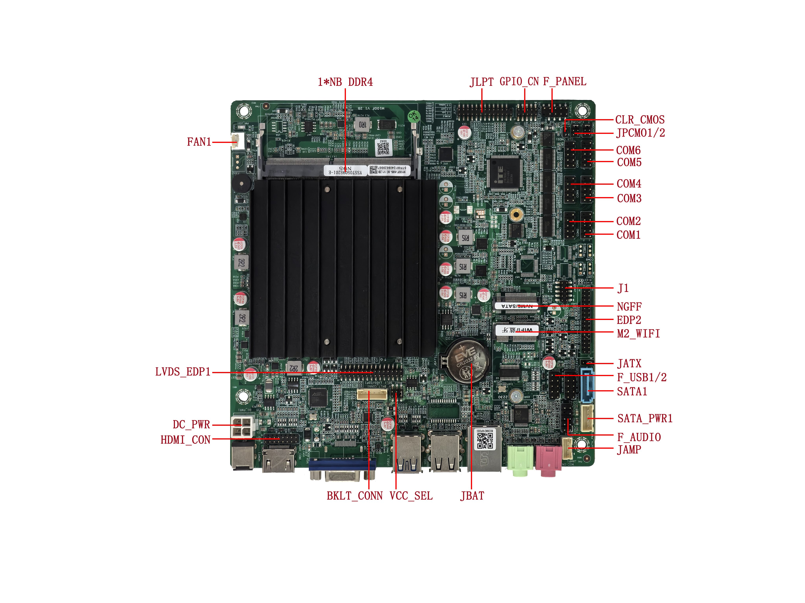
――――――――――――――――――――――――――――――――――――――――――――――――――――――
VGA+single network interface(default)↓
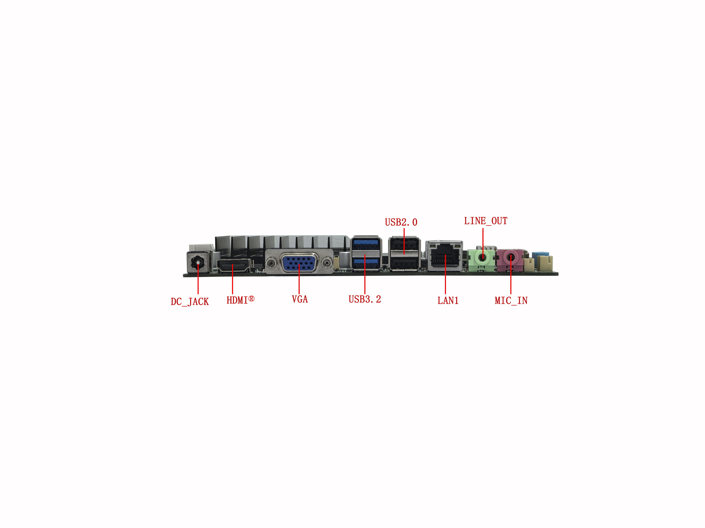
――――――――――――――――――――――――――――――――――――――――――――――――――――――
VGA+dual network interface↓
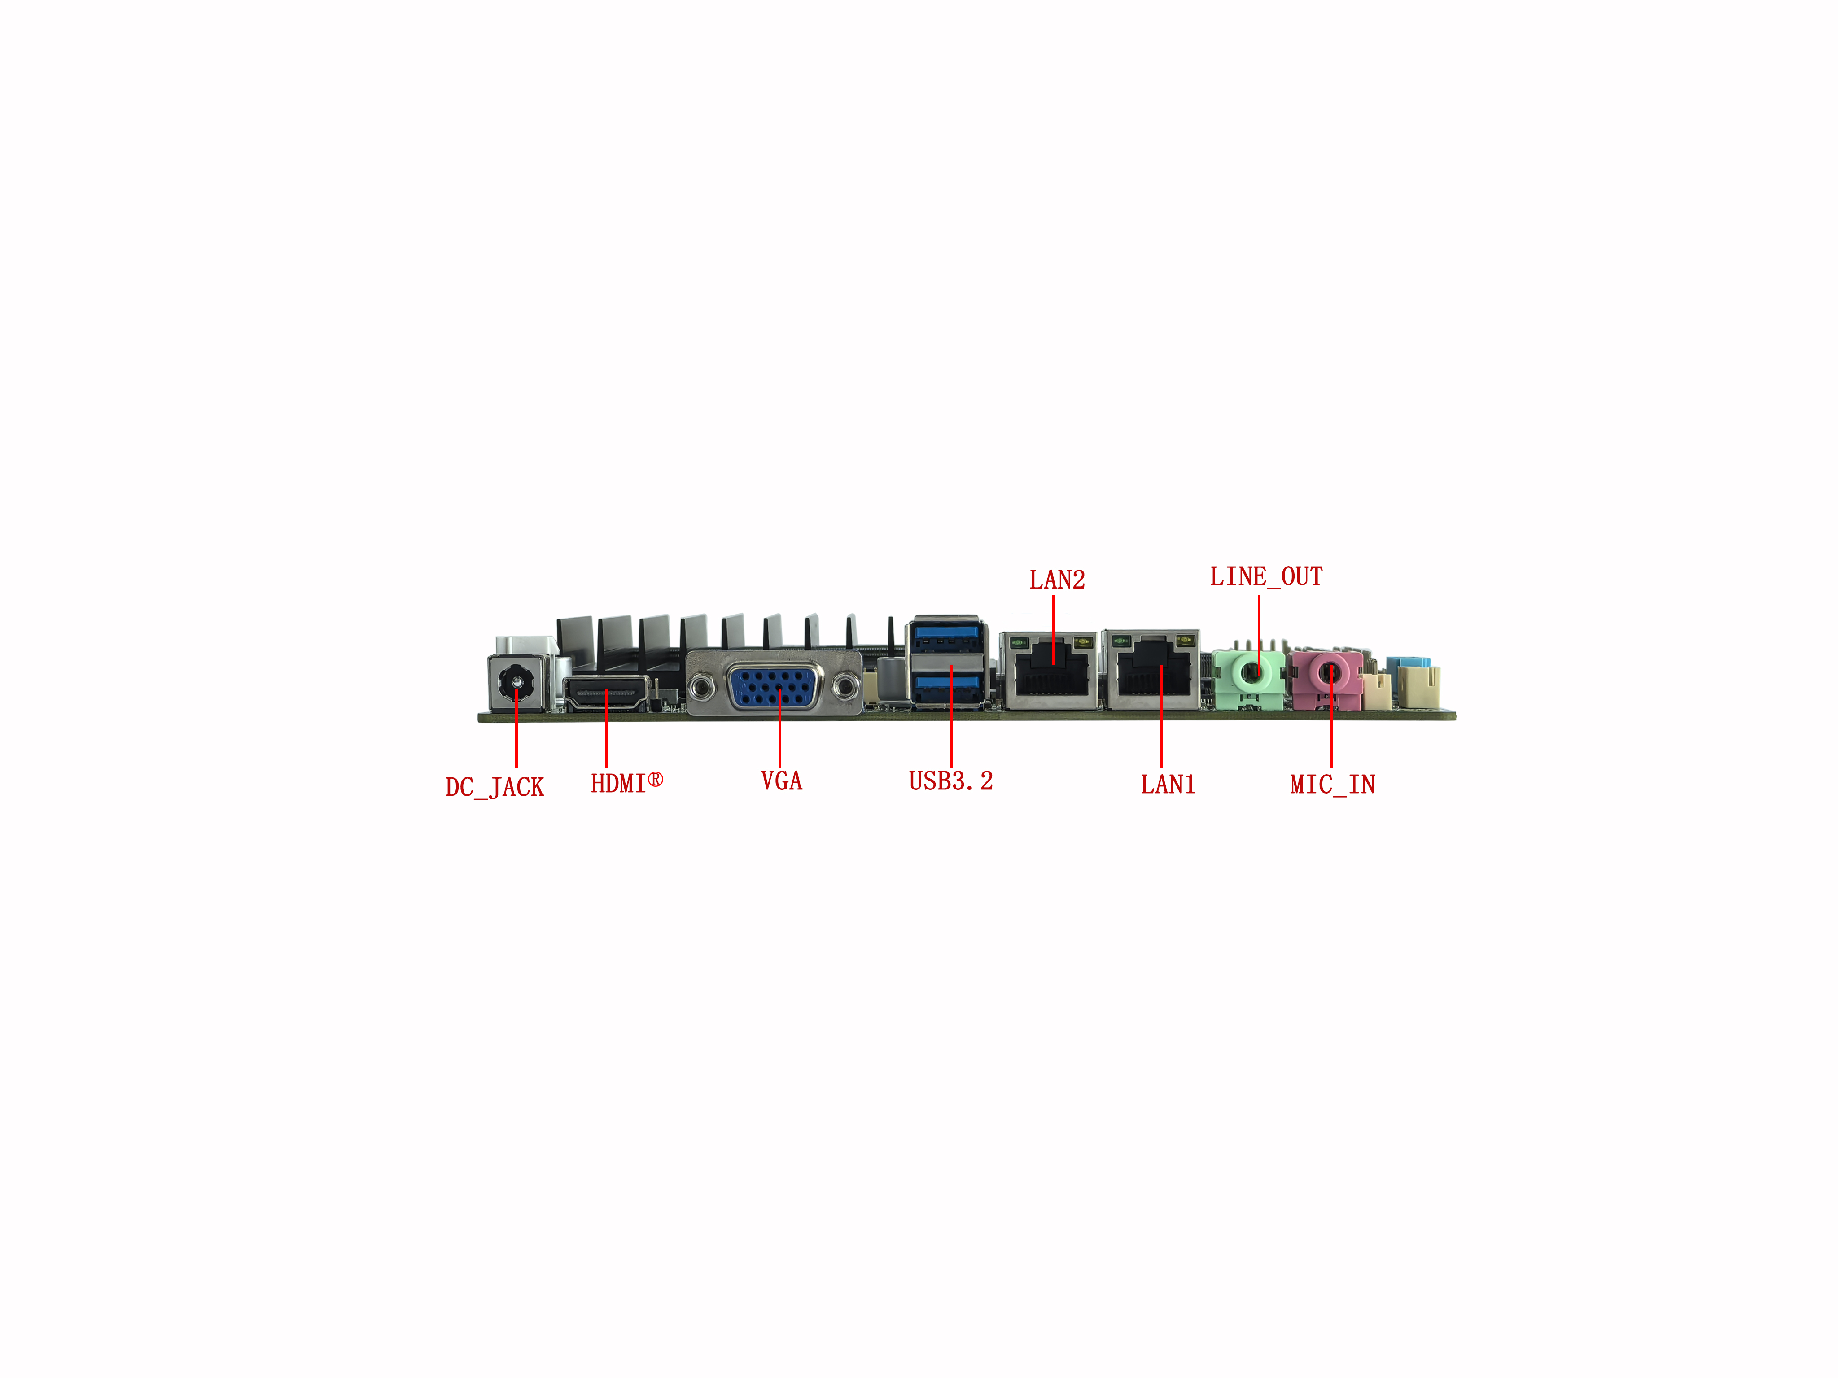
――――――――――――――――――――――――――――――――――――――――――――――――――――――
DP+single network interface↓
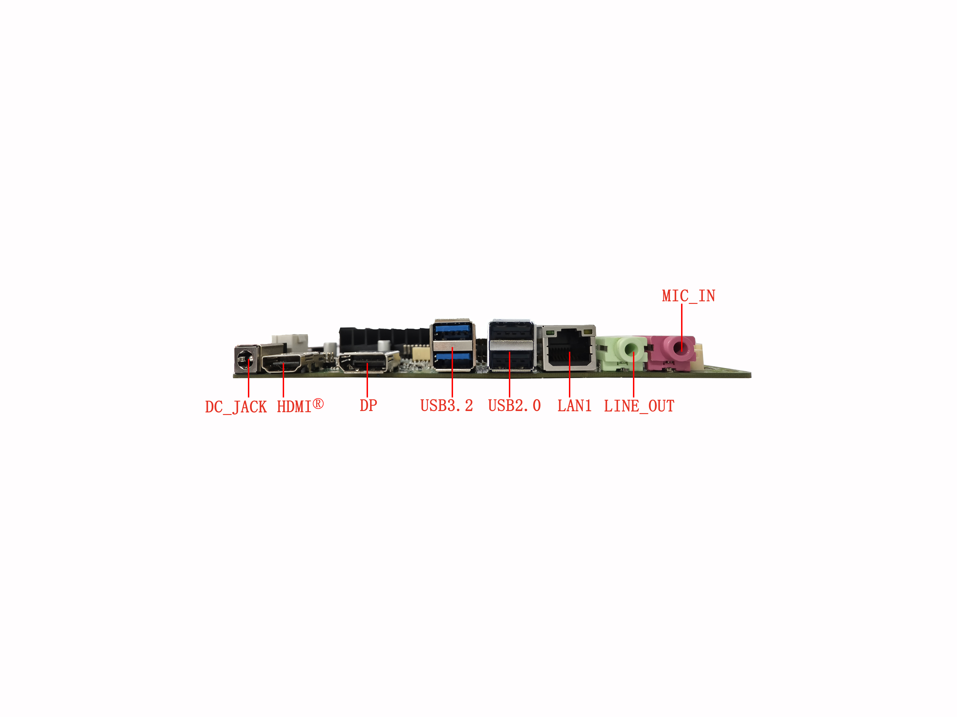
――――――――――――――――――――――――――――――――――――――――――――――――――――――
DP+dual network interface↓
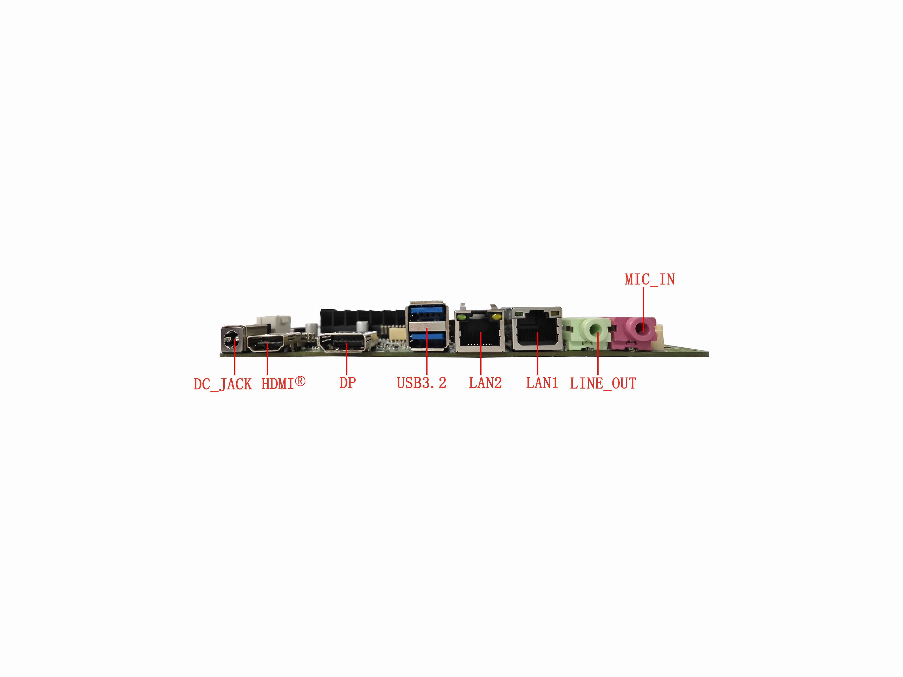
――――――――――――――――――――――――――――――――――――――――――――――――――――――
10C motherboard↓
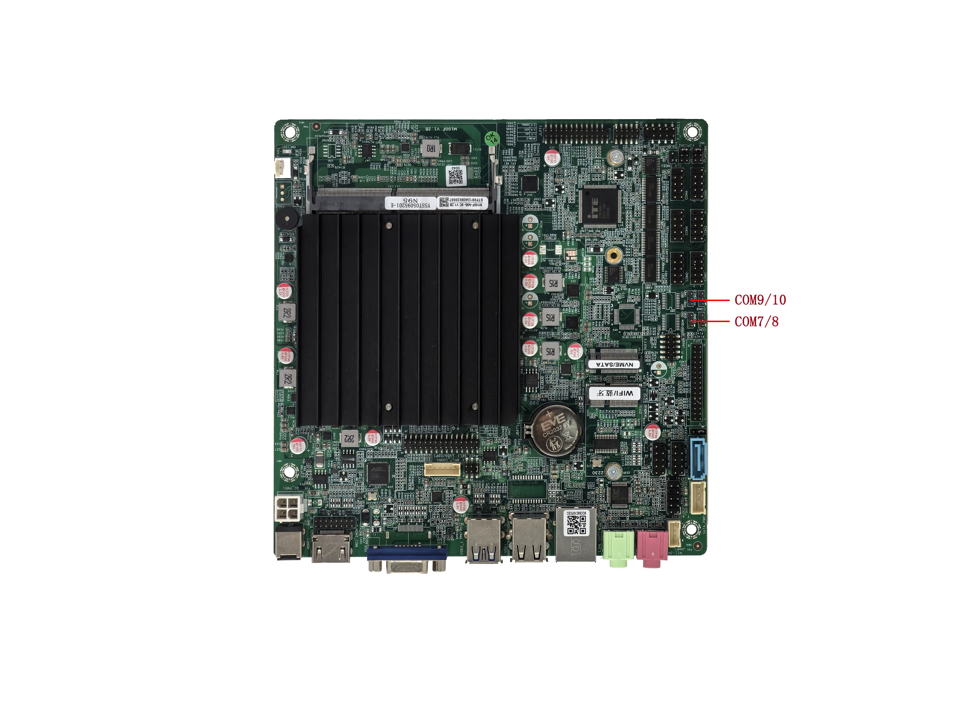
――――――――――――――――――――――――――――――――――――――――――――――――――――――
2C motherboard↓
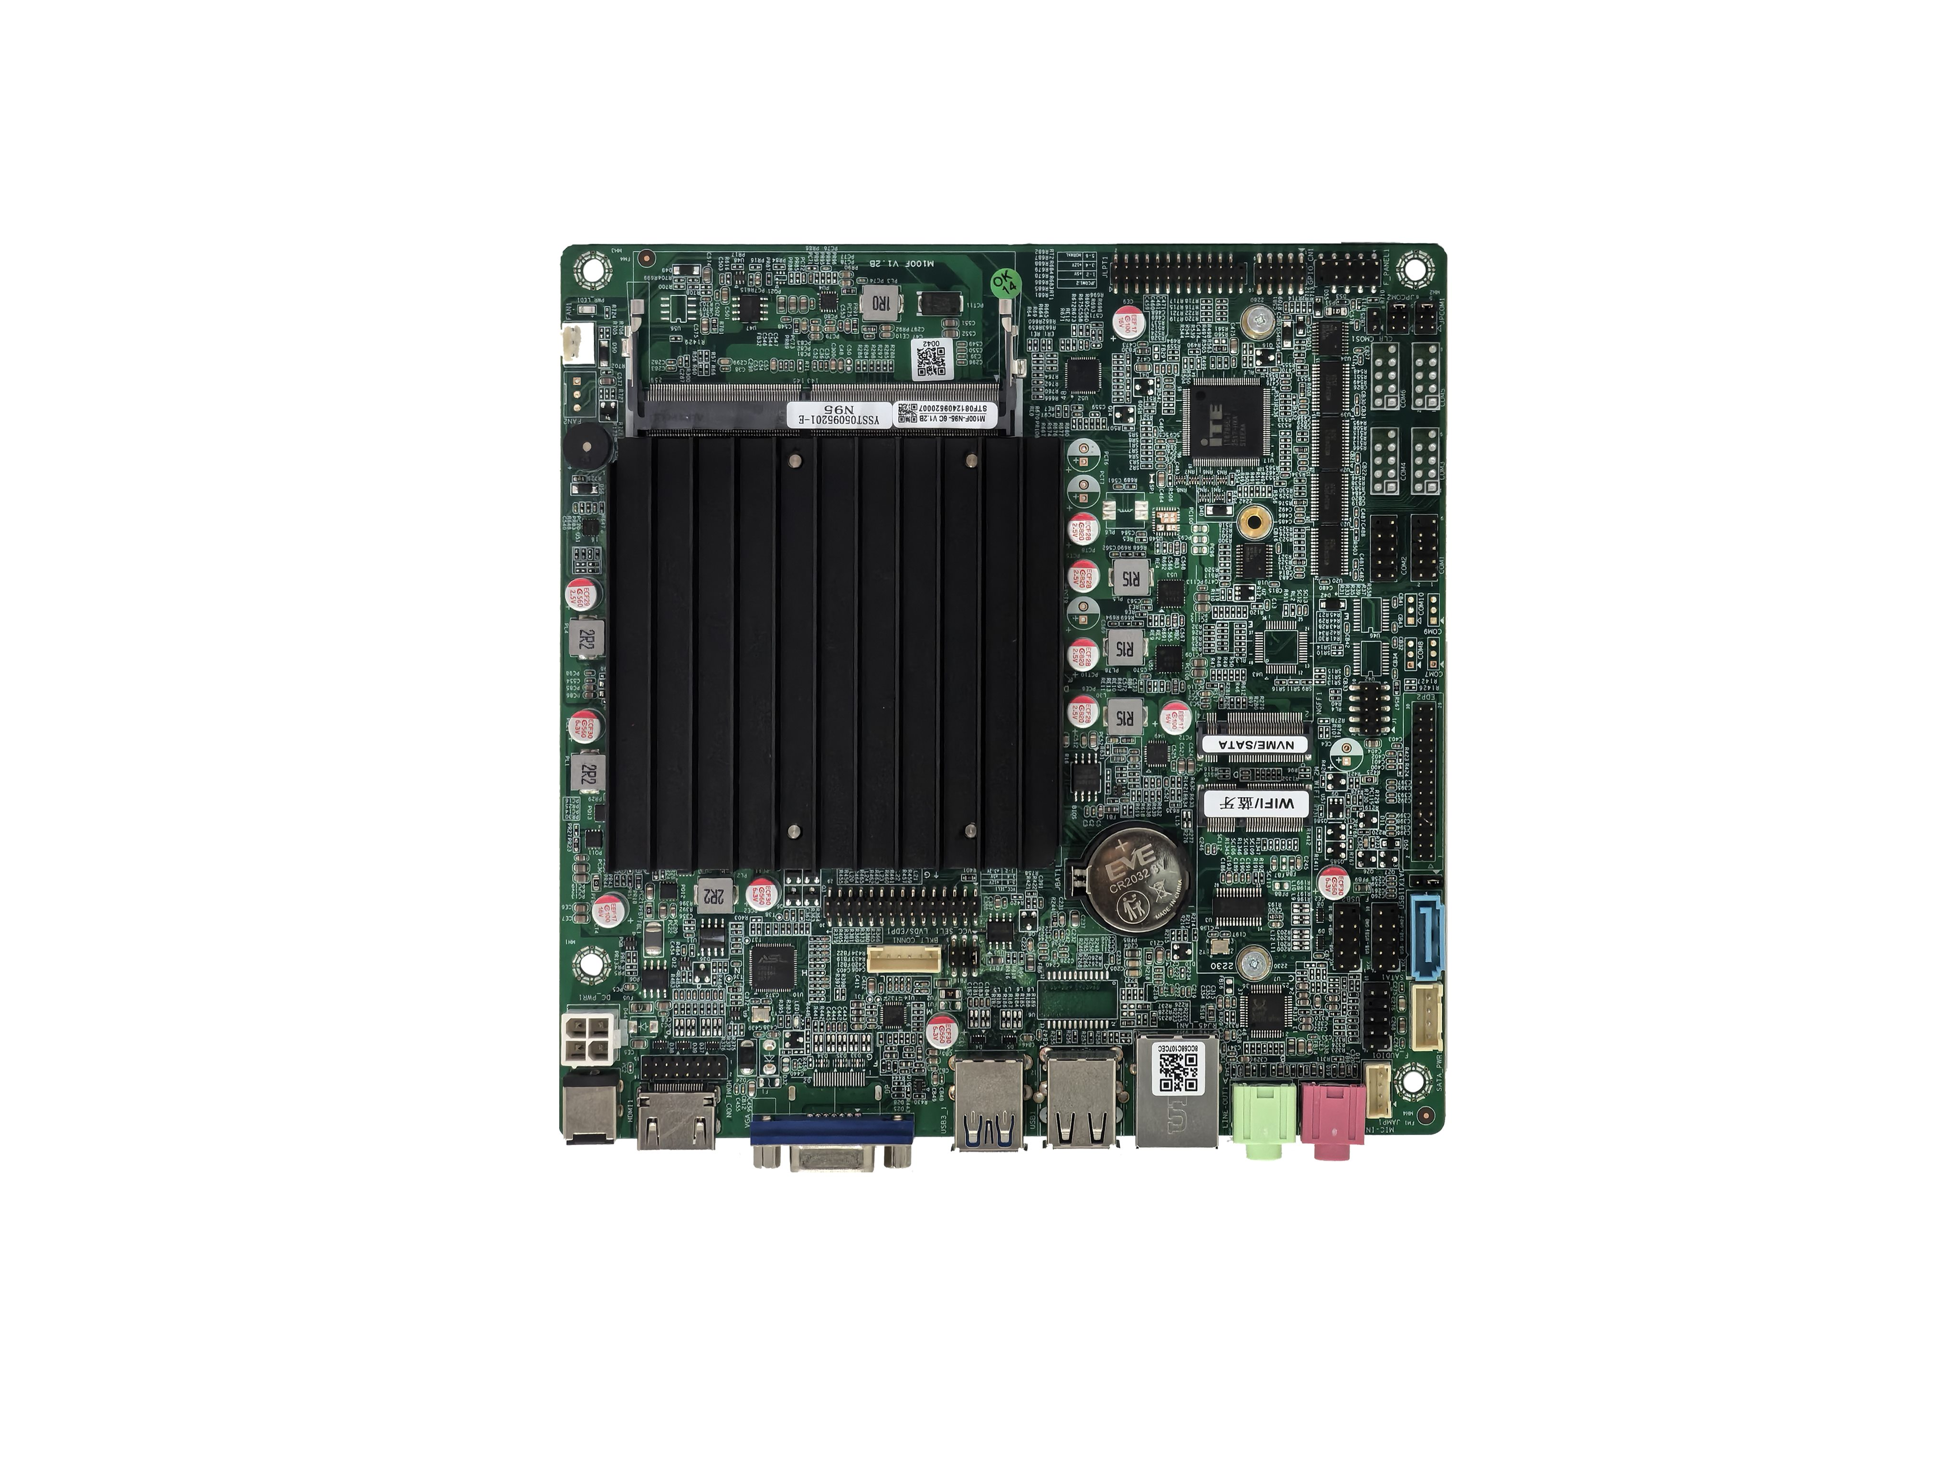
――――――――――――――――――――――――――――――――――――――――――――――――――――――
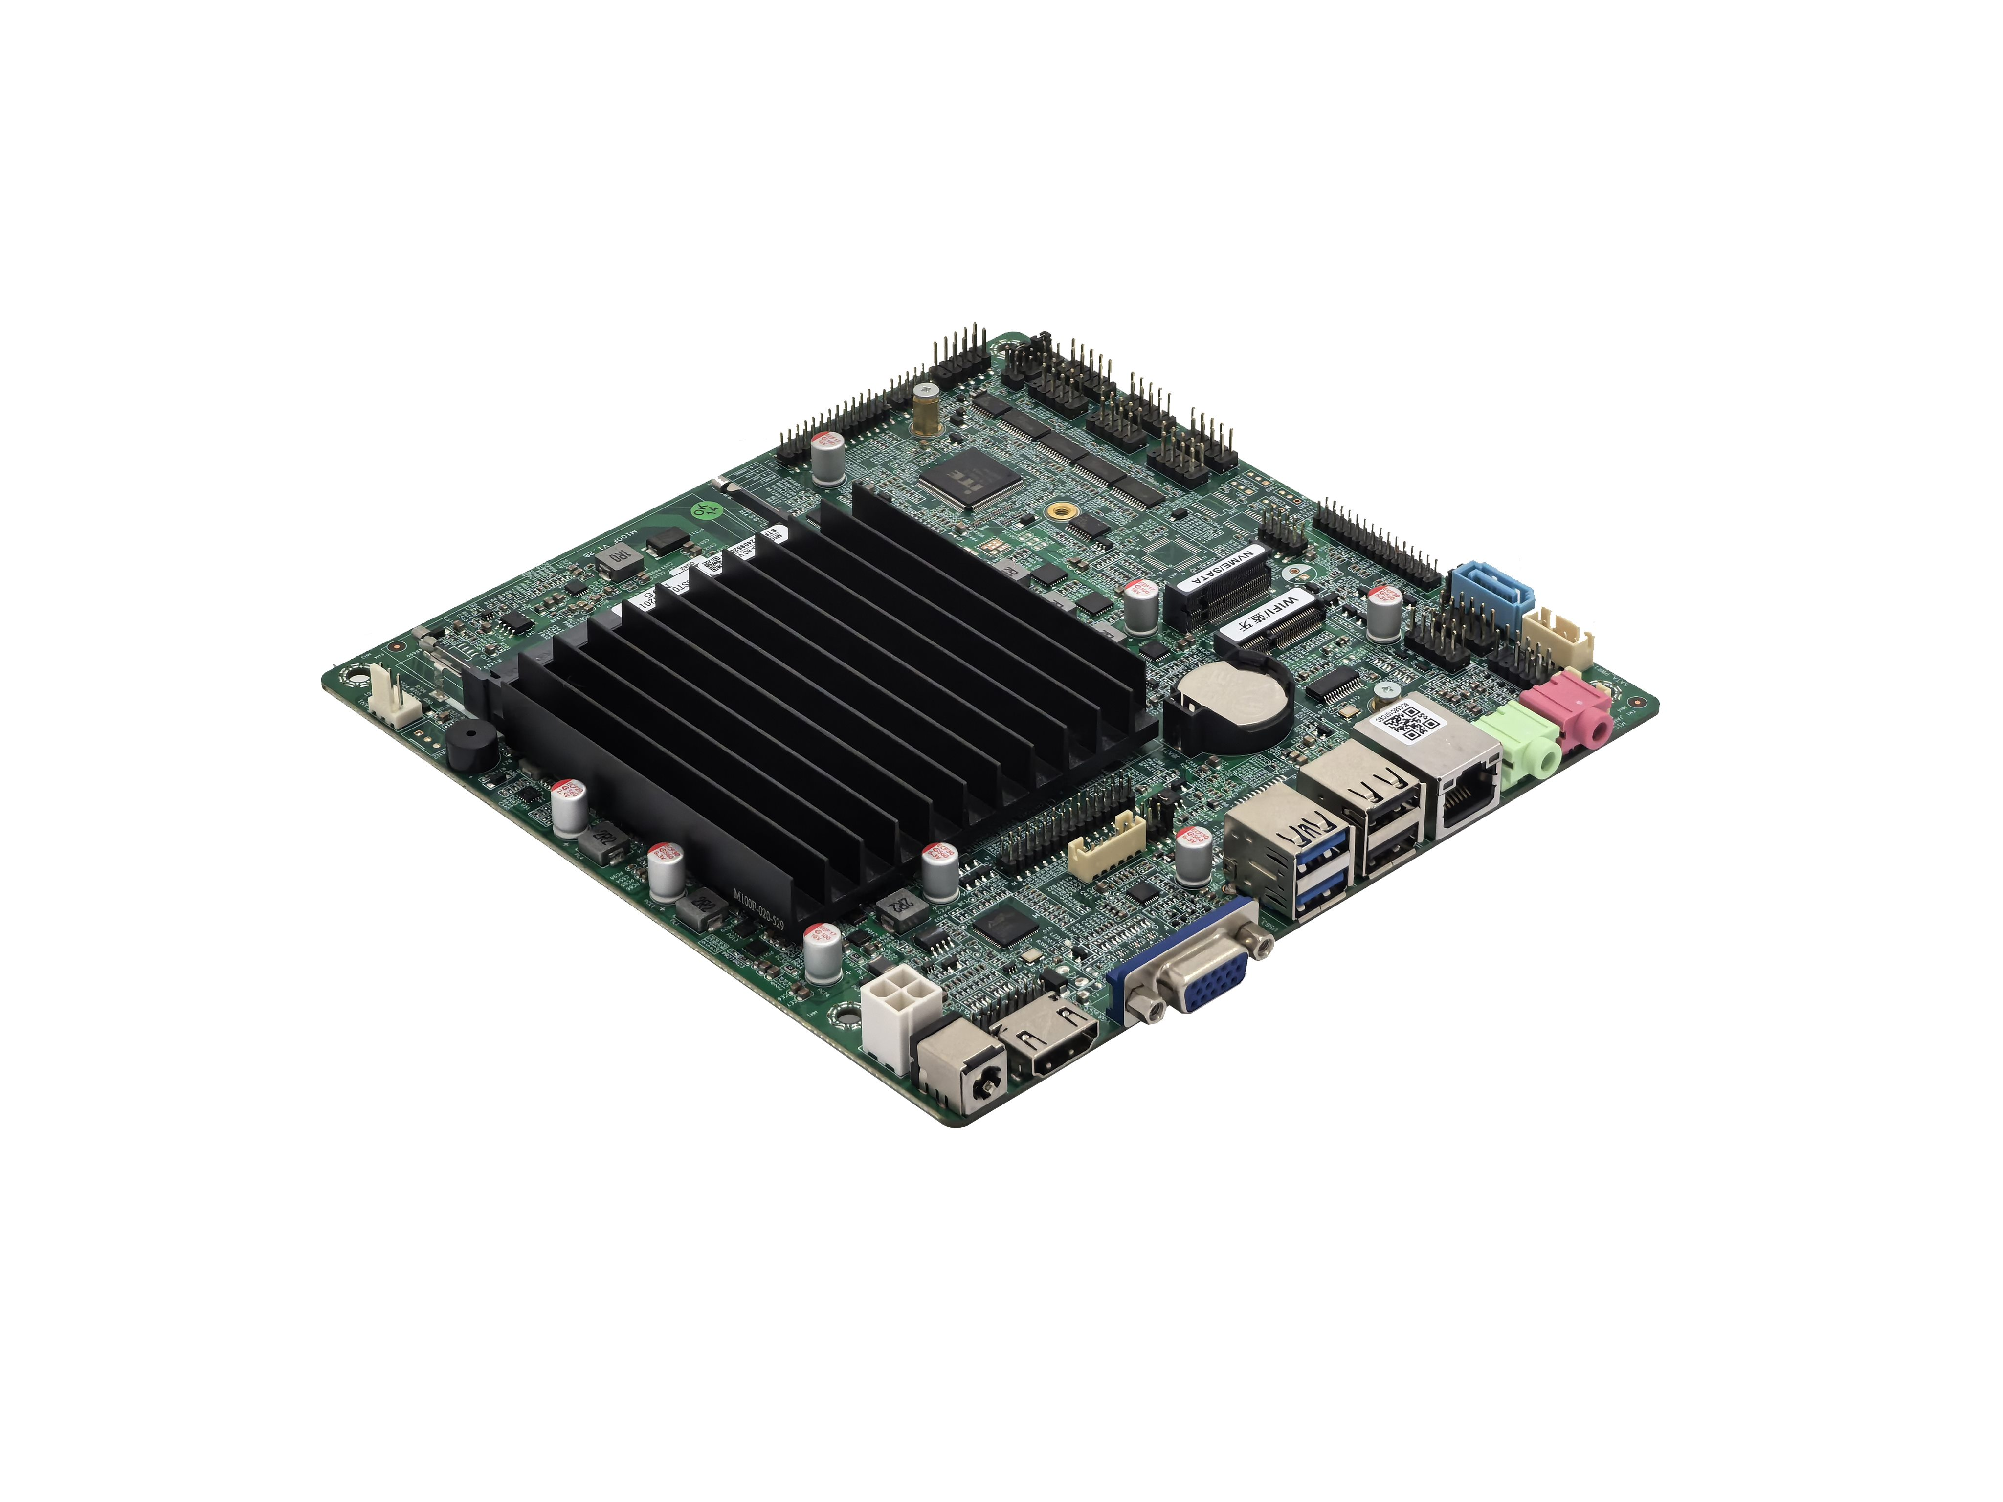
――――――――――――――――――――――――――――――――――――――――――――――――――――――
Back of motherboard↓
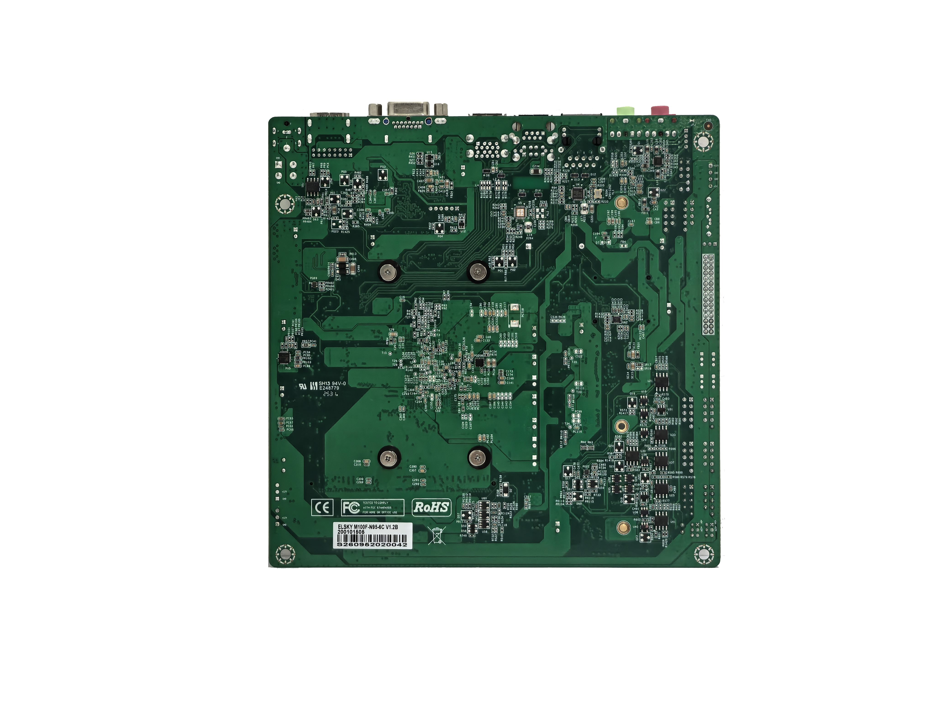
――――――――――――――――――――――――――――――――――――――――――――――――――――――
The above pictures are for reference only.
Please refer to the actual product for details!

Model | CPU | COM | 4K | LAN | USB2.0 | USB3.2 | SSD | Memory | Power
M100F | Support Intel® Alder Lake-N series N200, N100,N97,N95, i3-N305, etc | 6C/2C/10C  optional | √ | 1 | 6 | 2 | 1*M.2  1*SATA | 1*NB-DDR4  MAX 16G | +12V
M150F | Support Intel ® Twin Lake series N150, N250, i3-N350, i3-N335, etc | 6C/2C/10C  optional | √ | 2 | 4 | 2 | 1*M.2  1*SATA | 1*NB-DDR4  MAX 16G | +12V
Important notice:
Power supply interface:
Mainboard DC interface specification 5.5 * 2.5, supports 1 4pin ATX power interface;
The motherboard only supports 12V power supply, with a full load of about 30W.
It is recommended to use a 12V4A or higher power supply;
Display interface:
1.VGA/DP 1.4, HDMI®2.0/HDMI_CON pin, LVDS/EDP1, EDP2 support single display, dual display/triple display replication, dual display/triple display expansion;
2.The motherboard VGA and DP 1.4 are optional interfaces, with VGA interface supported by default; Can be modified to support DP 1.4 interface, DP interface does not support DP++;
3. The motherboard supports LVDS by default, but can be changed to support EDP1 with shared pins. After the change, it supports dual EDP;
4. The motherboard EDP2 cannot be displayed independently and needs to be used in conjunction with EDP1 or LVDS;
5.EDP1 uses EDP-B screen cable (20 pin backlight separated screen cable),EDP2 uses EDP-A screen cable (30 pin backlight integrated screen cable); EDP1/EDP2 does not support 4K resolution;
6.The motherboard DP 1.4 port and HDMI®2.0 port/HDMI_CON pin support 4K resolution 4096/3840*2160@60Hz;
M.2:
The motherboard NGFF supports Key-M interface M.2 2280 NVME PCIE3.0 x2 / SATA dual protocol adaptive standard SSD; Optional M.2 2242 hard drive;
The motherboard M.2-WIFI support Key-E interface M.2 2230 PCIE3.0 x1 & USB,supports WiFi Bluetooth module; M.2 hard drive cannot be modified;
USB interface:
1. The motherboard supports 8*USB by default (2*USB3.2 Gen1, 6*USB2.0);
2. The USB interface and pins on the motherboard default to S power (not charged after shutdown), and can be changed to A power (charged after shutdown);
COM interface:
1. The motherboard supports optional 2COM/6COM/10COM versions; COM3/4 supports RS232/RS422/RS485;
COM2/COM6 optional support RS232/RS485, set through BIOS; 10COM motherboard COM7/8/9/10 supports only RS232 with a 3Pin pin configuration;
2. The JPCOM1/2 pins on the motherboard control the voltage of pin 9 of COM1/2 to 0V/5V/12V, with a default of 0V;
3. All serial ports on the motherboard can be modified to hardware and support TTL;
Network card:
Single network: default Realtek 8111H Gigabit Ethernet card, optional Motorcomm YT6801 Gigabit Ethernet card;
Dual network: Realtek 8111H+Realtek 8111H Gigabit Ethernet card, optional Motorcomm YT6801+Motorcomm YT6801 Gigabit Ethernet card;
POE power supply cannot be changed;
Sound card:
The motherboard supports Realtek ALC897 sound card by default and cannot be changed to USB sound card;
System:
The main frequency of N100 and i3-N300 is 0.8G,does not support Windows 11 21H2 version, but support Windows 11 22H2 and above versions,
Supports Windows 10;

The following CPU information is for reference only. Please consult sales for specific requirements!
CPU brand | CPU model | Dominant frequency | Maximum turbo frequency | CPU power consumption
Intel Core | i3-N300 | 8-core 0.8G | 3.80G | 7W
Intel Core | i3-N305 | 8-core 1.8G | 3.80G | 15W
Intel Core | i3-N350 | 8-core 1.6G | 3.9G | 7W
Intel Core | i3-N355 | 8-core 1.6G | 3.9G | 15W
Intel | N50 |  | 3.40G | 6W
Intel | N95 | 4-core 1.7G | 3.40G | 15W
Intel | N97 | 4-core 2.0G | 3.60G | 12W
Intel | N100 | 4-core 0.8G | 3.40G | 6W
Intel | N200 | 4-core 1.0G | 3.70G | 6W
Intel | N150 | 4-core 1.0G | 3.6G | 6W
Intel | N250 | 4-core 1.2G | 3.8G | 6W

Explanation

Except for the accessories listed with the product configuration, the content contained in this manual does not represent our company's commitment. Our company reserves the right to make changes to this manual without further notice.
We are not responsible for any direct, indirect, intentional or unintentional damage or hidden dangers caused by improper installation or use.
Before ordering the product, please inquire with the distributor in detail about whether the product performance meets your needs.
The content of this manual is protected by copyright, and all rights reserved. Without permission, it may not be copied in any mechanical, electronic, or other way.The final interpretation right of this manual belongs to SHENZHEN ELSKY TECHNOLOGY CO.,LTD.
The above ordering information is for reference only. For specific inquiries, please consult our business and phone number is :0755-82260150
The motherboard driver download: https://pan.baidu.com/s/1ie7qi5NutS53ipPecRSYtw
Access password: cbn5

Chapter 1: Product Specifications
Size | 170mm(L)*170mm(W)*22mm(H)
CPU | M100F supports Intel ® Alder Lake-N series N200, N100, N97, N95, i3-N305, etc  M150F supports Intel ® Twin Lake series N150, N250, i3-N350, i3-N335, etc
Memory | 1*NB-DDR4 SODIMM memory slot, supports single channel 3200MHz memory, low voltage 1.2V, maximum support 16GB
Power supply | 1*DC_JACK | Supports 12V voltage, with a DC head inner diameter of 2.5mm  The motherboard has a full load power consumption of approximately 30W. It is recommended to use a 12V/4A or higher power supply
Power supply | 1*DC_PWR（4Pin）
Display function | Intel® UHD Graphics,support single display, dual display/triple display replication, dual display/triple display expansion
Display function | 1*VGA DB15 port | Support resolution 1920*1080@60Hz
Display function | 1*DP 1.4 port (optional) | DP does not support DP++,support 4K resolution 4096/3840*2160@60Hz
Display function | VGA interface can be modified to support DP 1.4 interface
Display function | 1*HDMI® 2.0 port | 4K resolution 4096/3840*2160@60Hz
Display function | 1*HDMI_CON pin | 4K resolution 4096/3840*2160@60Hz （16Pin，2*8Pin，2.0mm）
Display function | 1*LVDS/EDP1 pin | Support resolution 1920*1080@60Hz （30Pin，2*15Pin，2.0mm）
Display function | LVDS and EDP1 are optional and share pins. EDP1 does not support 4K resolution and uses EDP-B screen cable
Display function | 1*VCC_SEL pin | LVDS/EDP1 voltage control pin （6Pin，2*3Pin，2.0mm）
Display function | 1*BKLT_CONN pin | LVDS/EDP1 backlight switch control pin （6Pin，1*6Pin，2.0mm）
Display function | 1*EDP2 pin | Use EDP-A screen cable,support resolution1920*1080@60Hz  （30Pin，2*15Pin，2.0mm）
Network function | 1/2*RJ45 LAN port | Single network: default Realtek 8111H Gigabit Ethernet card;  Optional Motorcomm YT6801 Gigabit Ethernet Card;  Dual network: supports Realtek 8111H+Realtek 8111H Gigabit Ethernet cards;  Optional Motorcomm YT6801+Motorcomm YT6801 Gigabit Network Card;  Support network wake-up and PXE diskless boot function
Network function | 1*M2_WIFI port | Support Key-E interface M.2 2230 PCIE3.0 x1 & USB,support WiFi Bluetooth module;
Hard disk function | 1*SATA port | Standard SATA 3.0 hard drive interface
Hard disk function | 1*NGFF(M.2) port | Support Key-M interface M.2 2280 NVME PCIE3.0 x2 / SATA dual protocol adaptive standard SSD; Optional M.2 2242 hard drive;
Hard disk function | 1*SATA_PWR pin | Hard drive power supply pin, capable of supplying 5V and 12V power （4Pin，1*4Pin，2.54mm）
Sound function | Default support for Realtek ALC897 HD digital audio decoder and 6-channel high fidelity audio controller
Sound function | 1*LINE_OUT port | Supports audio output (green)
Sound function | 1*MIC_IN port | Supports microphone input (red)
Sound function | 1*JAMP pin | The amplifier supports dual channel output with 8 ohms and 5 watts speakers （4Pin，1*4Pin，2.0mm）
Sound function | 1*F_AUDIO pin | Standard audio pin （9Pin，2*5Pin，2.54mm）
USB function | 2*USB3.2 port | Rear standard USB 3.2 Gen1 interface, with a maximum transmission bandwidth of 5Gbps
USB function | 2*USB2.0 port | Rear standard USB 2.0 interface, with a maximum transmission bandwidth of 480Mbps
USB function | 1*F_USB1 pin | Front USB 2.0 pins, one set with 2*USB 2.0 （9Pin，2*5Pin，2.54mm）
USB function | 1*F_USB2 pin | Front USB 2.0 pins, one set with 2*USB 2.0 （9Pin，2*5Pin，2.54mm）
Switch function | 1*F_PANEL pin | Switch, power light, hard disk light, restart pin （9Pin，2*5Pin，2.54mm）
Switch function | 1*JATX pin | Support hardware control for power on and startup（3Pin，1*3Pin，2.0mm）
Other I/O | COM1～6 pin | Serial port, supports RS232 by default （9Pin，2*5Pin，2.54mm）
Other I/O | COM7~10 pin (optional) | Serial port, supports RS232 by default （3Pin，1*3Pin，2.0mm）
Other I/O | COM3/4 pin | Serial port, optional support RS232/422/485 （9Pin，2*5Pin，2.54mm）
Other I/O | COM2/6 pin | Serial port, optional support RS232/485 （9Pin，2*5Pin，2.54mm）
Other I/O | 1*JPCOM1/2 pin | Can control the ninth pin voltage of COM1/2 to 0V/5V/12V  （6Pin，2*3Pin，2.0mm）
Other I/O | All serial ports can be hardware modified and support TTL
Other I/O | 1*JLPT pin | Parallel port, standard printing interface pins （25Pin，2*13Pin，2.0mm）
Other I/O | 1*CLR_CMOS pin | Motherboard reset and discharge pins （2Pin，1*2Pin，2.54mm）
Other I/O | 1*FAN1 pin | CPU fan pin, default does not support temperature control; Adjustable hardware supports temperature control （3Pin，1*3Pin，2.54mm）
Other I/O | 1*FAN2 pin | Default no pins; System fan pin, does not support temperature control （3Pin，1*3Pin，2.54mm）
Other I/O | 1*GPIO_CN pin | GPIO control pin （10Pin，2*5Pin，2.0mm）
Other I/O | 1*J1 pin | Debugging pins （10Pin，2*5Pin，2.0mm）
Operating environment | Working temperature: -10 ℃~60 ℃;  Working humidity: 5%~95% relative humidity, no condensation
BIOS | AMI BIOS,support timed startup and intelligent recognition of remote power on/off devices
Watch Dog | Watchdog programming, supports hardware reset function (256 levels, 0-255 seconds)
Operating system | Windows 11, Windows 10, Linux,etc  (N100 and i3-N300 support Windows 10, Windows 11 22H2 and above versions)

Motherboard Size
――――――――――――――――――――――――――――――――――――――――――――――――――――――
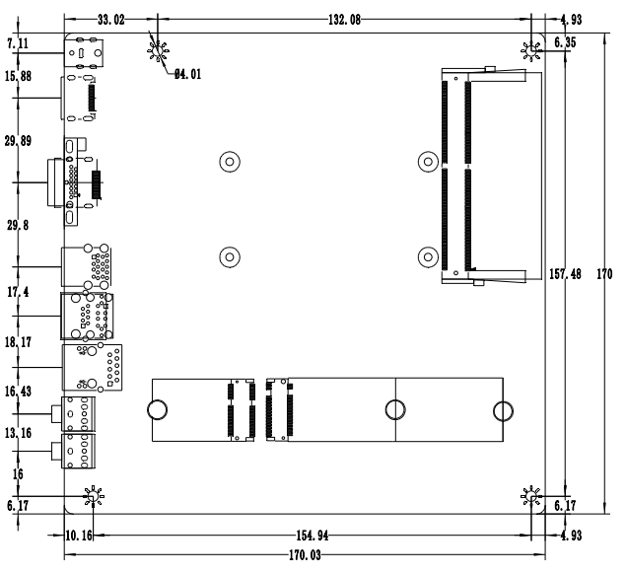
――――――――――――――――――――――――――――――――――――――――――――――――――――――

――――――――――――――――――――――――――――――――――――――――――――――――――――――
HDMI®+VGA+single network↓(default)
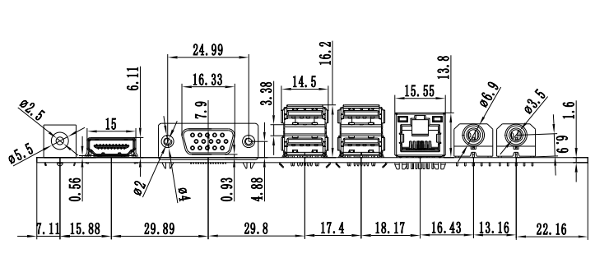
――――――――――――――――――――――――――――――――――――――――――――――――――――――
HDMI®+VGA+dual network↓
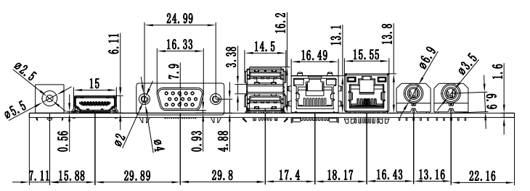
――――――――――――――――――――――――――――――――――――――――――――――――――――――
HDMI®+DP+single network↓
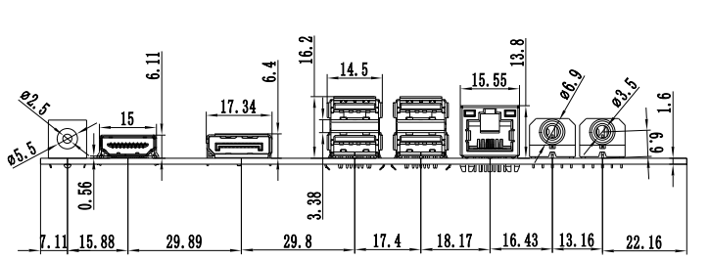
――――――――――――――――――――――――――――――――――――――――――――――――――――――
HDMI®+DP+dual network↓
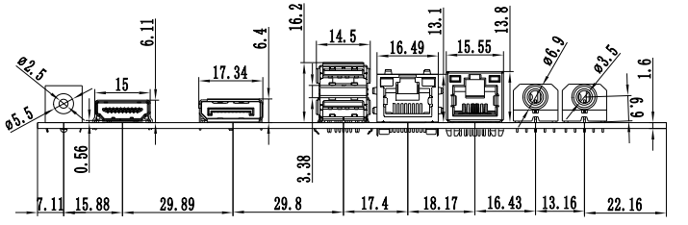
――――――――――――――――――――――――――――――――――――――――――――――――――――――

Chapter 2: Definition and Explanation of Motherboard Pin

2.0 Pin 1 identification method
Method 1: Look at the silk screen markings next to the pins on the front of the motherboard, which will be represented by triangle symbols or bold lines or 1 ;
Method 2: Look at the solder pads on the back of the motherboard, the square solder pad is the first pin;
Pay attention to distinguishing the first pin when inserting devices and connecting cables, otherwise it may damage the motherboard and devices.

2.1 HDMI Pin Definition
Tag number: HDMI_CON （2*8Pin，2.0mm） |  |  |  | Pin number diagram
Pin | Definition | Pin | Definition | 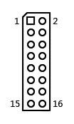
1 | HDMI_TXD2P+ | 2 | HDMI_TXD1P
3 | HDMI_TXD2N- | 4 | HDMI_TXD1N-
5 | GND | 6 | GND
7 | HDMI_TXD0P+ | 8 | HDMI_TXC0P+
9 | HDMI_TXD0N- | 10 | HDMI_TXC0N-
11 | GND | 12 | HDMI_5V
13 | HDMI_CLK | 14 | HDMI_5V
15 | HDMI_DATA | 16 | HDMI_HPD
Attention: When inserting the HDMI cable, the first pin of the cable must correspond to the first pin of the motherboard pin. Incorrect or misplaced insertion may result in no display.

2.2 LVDS Pin Definition
Tag number: LVDS/EDP1 （2*15Pin，2.0mm） |  |  |  | Pin number diagram
Pin | Definition | Pin | Definition | 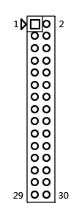
1 | VCC | 2 | VCC
3 | VCC | 4 | GND
5 | GND | 6 | GND
7 | ADO0- | 8 | ADO0+
9 | ADO1- | 10 | ADO1+
11 | ADO2- | 12 | ADO2+
13 | GND | 14 | GND
15 | ACLK- | 16 | ACLK+
17 | ADO3- | 18 | ADO3+
19 | BDO0- | 20 | BDO0+
21 | BDO1- | 22 | BDO1+
23 | BDO2- | 24 | BDO2+
25 | GND | 26 | GND
27 | BCLK- | 28 | BCLK+
29 | BDO3- | 30 | BDO3+
Attention: When inserting the screen cable, the first pin of the screen cable must correspond to the first pin of the motherboard pin. There is a risk of burning the screen and motherboard if it is inserted incorrectly or misplaced!

2.2.1 Definition of backlight power supply
Note: LVDS and EDP1 share pins
Tag number: BKLT_CONN （1*6Pin，2.0mm） |  | Pin number diagram
Pin | Definition | 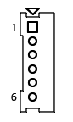
1 | +12V
2 | +12V
3 | ON/OFF(Backlight switch)
4 | ADJ  (Backlight brightness adjustment)
5 | GND
6 | GND

2.2.2 Screen working voltage
Note: LVDS and EDP1 share pins
Tag number: VCC_SEL （2*3Pin，2.0mm） |  | Pin number diagram
Pin | Definition | 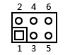
1-2 short circuit | +3.3V
3-4 short circuit | +5V
5-6 short circuit | +12V
Attention: Different sizes of screens require different working voltages. The motherboard provides three types of screen working voltages: 3.3V, 5V, and 12V. Please set the corresponding value of LVDS_PWR according to the required working voltage of the screen, otherwise there is a risk of screen burning and motherboard burning!

2.3 EDP1 Pin Definition
Note: LVDS and EDP1 share pins
Tag number: LVDS/EDP1 （2*15Pin，2.0mm） |  |  |  | Pin number diagram
Pin | Definition | Pin | Definition | 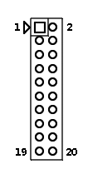
1 | VCC | 2 | VCC
3 | VCC | 4 | HPD
5 | GND | 6 | GND
7 | TX0N- | 8 | TX0P+
9 | TX1N- | 10 | TX1P+
11 | TX2N- | 12 | TX2P+
13 | GND | 14 | GND
15 | AUX- | 16 | AUX+
17 | TX3N- | 18 | TX3P+
19 | NC | 20 | NC
21pin-30pin is empty
Attention: When inserting the screen cable, the first pin of the screen cable must correspond to the first pin of the motherboard pin. There is a risk of burning the screen and motherboard if inserted incorrectly or incorrectly!

2.4 EDP2 Pin Definition
Tag number: EDP2 （2*15Pin，2.0mm） |  |  |  |  | Pin number diagram
Pin | Definition |  | Pin | Definition
1 | VCC |  | 2 | VCC
3 | GND |  | 4 | GND
5 | TX0P+ |  | 6 | TX2P+
7 | TX0N- |  | 8 | TX2N-
9 | GND |  | 10 | GND
11 | TX1P+ |  | 12 | TX3P+
13 | TX1N- |  | 14 | TX3N-
15 | GND |  | 16 | GND
17 | AUXP+ |  | 18 | HPD
19 | AUXN- |  | 20 | NC
21 | GND | 22 |  | GND
23 | GND | 24 |  | GND
25 | BKLT_EN | 26 |  | BKCTRL
27 | VCC | 28 |  | VCC
29 | VCC | 30 |  | NC
Attention: When inserting the screen cable, the first pin of the screen cable must correspond to the first pin of the motherboard pin. There is a risk of burning the screen and motherboard if inserted incorrectly or incorrectly!

2.5 Serial port (COM) function and pin definition
The motherboard supports standard RS232 2*COM, 6*COM, and 10*COM options;
COM3/4 support RS232/RS422/RS485；COM2/COM6 optionally support RS232/RS485, through BIOS settings；The 10COM motherboard’s COM7/8/9/10 is 3Pin pin,only support RS232;
The 9th pin of COM1/2/3 can be used to change the jumper settings through JPCOM1/JPCOM2/JPCOM3, selecting the 9th pin to output+5V or+12V voltage
Tag number: JPCOM1/2（2*3Pin，2.0mm） |  | Pin number diagram
Pin | COM1/2/3 pin 9 is charged | 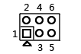
1-2 short circuit | +5V
3-4 short circuit | +12V
5-6 short circuit | Uncharged(default)

2.5.1 COM1~6 Pin Definition
Tag number: COM1~6 （2*5Pin，2.54mm） |  |  |  | Pin number diagram
Pin | Definition | Pin | Definition | 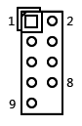
1 | DCD | 2 | RXD
3 | TXD | 4 | DTR
5 | GND | 6 | DSR
7 | RTS | 8 | CTS
9 | RI | 10 | NC

2.5.2 Definition of RS422/RS485 for COM2/COM3/COM4/COM6
Tag number: COM2/3/4/6（2*5Pin，2.54mm）
Signal | Pin Definition
RS485 | 1（S485-) | 2（S485+）
RS422 | 1（TXD-） | 2（TXD+)
RS422 | 3（RXD+） | 4（RXD-）

2.5.3 COM7/8/9/10 Pin Definition
Tag number:COM7/8/9/10（1*3Pin，2.0mm） |  | Pin number diagram
Pin | Pin Definition | 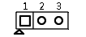
1 | GND
2 | RXD
3 | TXD

2.6 USB Pin Definition
Tag number: F_USB1/2 （2*5Pin，2.54mm） |  |  |  | Pin number diagram
Pin | Definition | Pin | Definition | 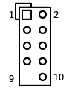
1 | VCC+5V | 2 | VCC+5V
3 | DATA0- | 4 | DATA1-
5 | DATA0+ | 6 | DATA1+
7 | GND | 8 | GND
9 | NC | 10 | GND

2.7 Definition of Speaker (Amplifier) Pin
Tag number: JAMP （1*4Pin，2.0mm） |  | Pin number diagram
Pin | Definition | 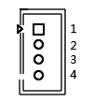
1 | L+
2 | L-
3 | R-
4 | R+

2.8 Definition of Audio Interface and Pin
Tag number: F_AUDIO （2*5Pin，2.54mm） |  |  |  | Pin number diagram
Pin | Definition | Pin | Definition | 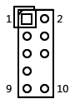
1 | MIC-L | 2 | GND
3 | MIC-R | 4 | NC
5 | LINE OUT-R | 6 | MIC_JD
7 | FAUDIO_JD | 8 | NC
9 | LINE OUT-L | 10 | LINE_JD

2.9 GPIO_CN Pin Definition
Tag number: GPIO_CN （2*5Pin，2.0mm） |  |  |  | Pin number diagram
Pin | Definition | Pin | Definition | 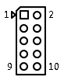
1 | GND | 2 | +5V
3 | GPIO_IN0 | 4 | GPIO_OUT0
5 | GPIO_IN1 | 6 | GPIO_OUT1
7 | GPIO_IN2 | 8 | GPIO_OUT2
9 | GPIO_IN3 | 10 | GPIO_OUT3
GPIO_IN and OUT can be adjusted according to demand

2.10 LPT Pin Definition
Tag number: JLPT （2*13Pin，2.0mm） |  |  |  | Pin number diagram
Pin | Definition | Pin | Definition | 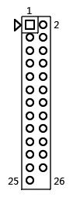
1 | STB | 2 | AFD
3 | PD0 | 4 | ERR
5 | PD1 | 6 | INIT
7 | PD2 | 8 | SLIN
9 | PD3 | 10 | GND
11 | PD4 | 12 | GND
13 | PD5 | 14 | GND
15 | PD6 | 16 | GND
17 | PD7 | 18 | GND
19 | ACK | 20 | GND
21 | BUSY | 22 | GND
23 | PE | 24 | GND
25 | SLCT | 26 | NC

2.11 Definition of power supply and switch pins
The motherboard provides a 2.5 standard DC header (DC_JACK); A 4pin ATX power interface, defined as:
Tag number: DC_PWR（2*2Pin，4.2mm） |  | Pin number diagram
Pin | Definition | 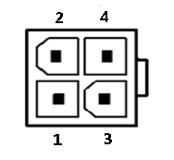
1 | GND
2 | GND
3 | +12V
4 | +12V
Definition of switch pin:
Tag number: F_PANEL （2*5Pin，2.54mm） |  |  |  |  |  | Pin number diagram
Pin | Definition |  | Pin | Definition
1 | HDLED+ | Hard disk light | 2 | PWRLED+ | Hard disk light
3 | HDLED- | Hard disk light | 4 | GND | Hard disk light
5 | RST | Restart | 6 | P_SW IN | Switch
7 | GND | Restart | 8 | GND | Switch
9 | NC |  | 10
(1) The hard drive indicator light (HDDLED on pins 1 and 3, with pin 1 being the positive pole of the LED) will flash when the hard drive is performing read and write operations, indicating that the hard drive is running;
(2) The power indicator light (2nd and 4th pins Power LED, with the 2nd pin being the positive pole of the LED) lights up when the motherboard is powered on; When the motherboard is powered off, the power indicator light goes out;
(3) When the reset button (5th and 7th pins Reset Button) system fails and cannot continue to work, resetting can restart the system;
(4) The power switch control (6th and 8th pins Power Button) is connected to the bounce switch on the front panel of the chassis and can be used to turn on or off the computer.

2.12 Power on and start up - hardware control
Tag number: JATX （1*3Pin，2.0mm） |  | Pin number diagram
Setting | Function
1-2 short circuit | Turn off the power on function
2-3 short circuit | Turn on the power on function
Attention: Hardware control and software control (BIOS settings) cannot be set simultaneously during power on and startup, as simultaneous settings may conflict.

2.13 Fan interface definition
Tag number: FAN1/FAN2 （1*3Pin，2.54mm） |  | Pin number diagram
Pin | Definition | 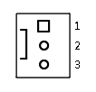
1 | GND
2 | +12V
3 | TAC(Fan speed detection)

2.14 Hard disk interface and definition
1 SATA 3.0 hard drive interface, 1 4pin hard drive power supply voltage interface; 1 MSATA interface; The transmission speed can reach 6Gbps.
SATA1 Definition: SATA_PWR1 Definition:
Tag number: SATA1 |  |  | Tag number: SATA_PWR1 （1*4Pin，2.54mm） |  | Pin number diagram
Pin | Definition |  | Pin | Definition | 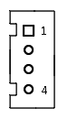
1 | GND |  | 1 | 12V
2 | SATA_TXP |  | 2 | GND
3 | SATA_TXN |  | 3 | GND
4 | GND |  | 4 | 5V
5 | SATA_RXN
6 | SATA_RXP
7 | GND
Attention: The first pin of the SATA_PWR hard drive power supply interface has a 12V output and the fourth pin has a 5V output. When using it, please use the power cord provided by our company to avoid burning out the hard drive.

2.15 Motherboard discharge reset and battery
CMOS is powered by button batteries on the motherboard, clearing CMOS will result in clearing previous BIOS settings and setting them to their original factory settings
Steps: (1) Turn off the computer and disconnect the power supply;
(2) Short circuit pins 1 and 2 of "CLR_CMOS" using a jumper cap for 5-6 seconds, and then restore to remove the jumper cap;
(3) Press the "Delete" key on the keyboard to enter the BIOS interface during startup;
(4) Enter the BIOS interface and press the "F9" key ->"Enter" to reload the optimal default value;
(5) Press F10 to save and exit the settings.

Definition of CMOS pins:
Tag number: CLR_CMOS （1*2Pin，2.54mm）
Pin | Function
1-2 short circuit | Clear CMOS content and restore BIOS to factory settings

Attention: Please do not clear the CMOS when the computer is powered on to avoid damaging the motherboard.
After power failure, re plugging and unplugging the button battery can also achieve the motherboard reset function.

Attention: Please ensure that the positive pole of the battery is facing upwards; Please ensure that the battery voltage is sufficient between 2.8V and 3.3V; Please make sure to use the same model or type of battery recommended by the manufacturer when replacing the battery. If the battery is not properly replaced, there is a risk of explosion!

BIOS function buttons
BIOS Function Key | Functional Description
Press Delete when starting up | Enter the BIOS function interface
Press F11 to power on | Select the startup option, or choose to enter the BIOS function interface
← → | Move the left and right arrows to select an item
↑ ↓ | Move the up and down arrows to select an item
Enter | Select the project and enter the submenu
+/- | Change the selection or add or subtract numerical values
F1 | Display relevant help content
F9 | Restore factory settings
F10 | Save changes and exit
Esc | Exit

