
ELSKY M219SE V1.3 Manual
――――――――――――――――――――――――――――――――――――――――――――――――――――――
Fanless motherboard diagram ↓
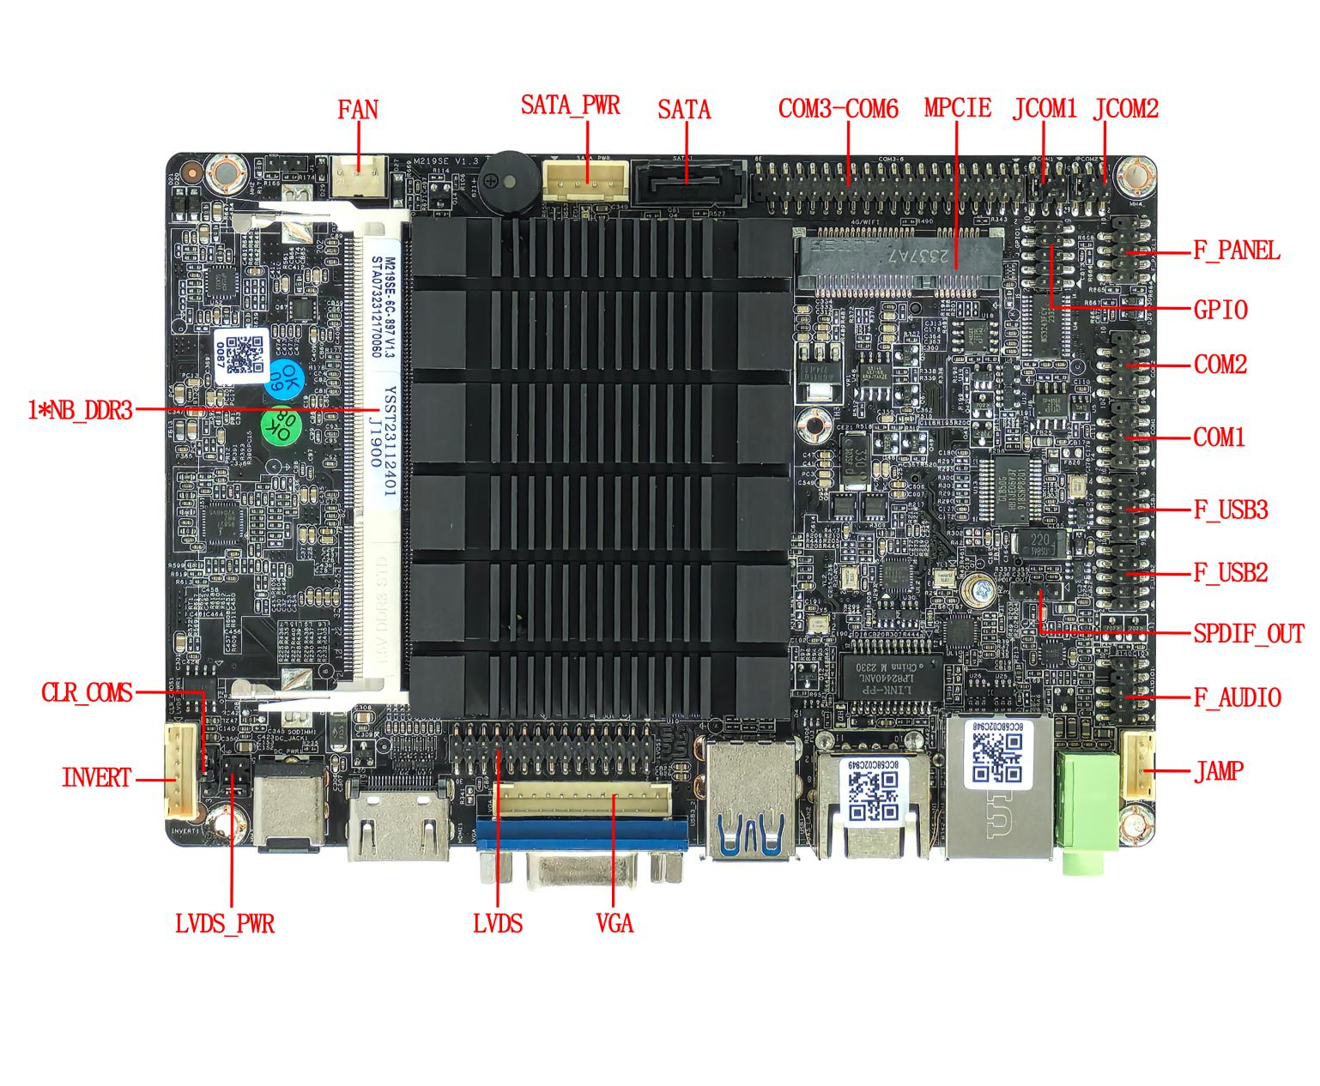

――――――――――――――――――――――――――――――――――――――――――――――――――――――

――――――――――――――――――――――――――――――――――――――――――――――――――――――
Schematic diagram of motherboard with fan ↓
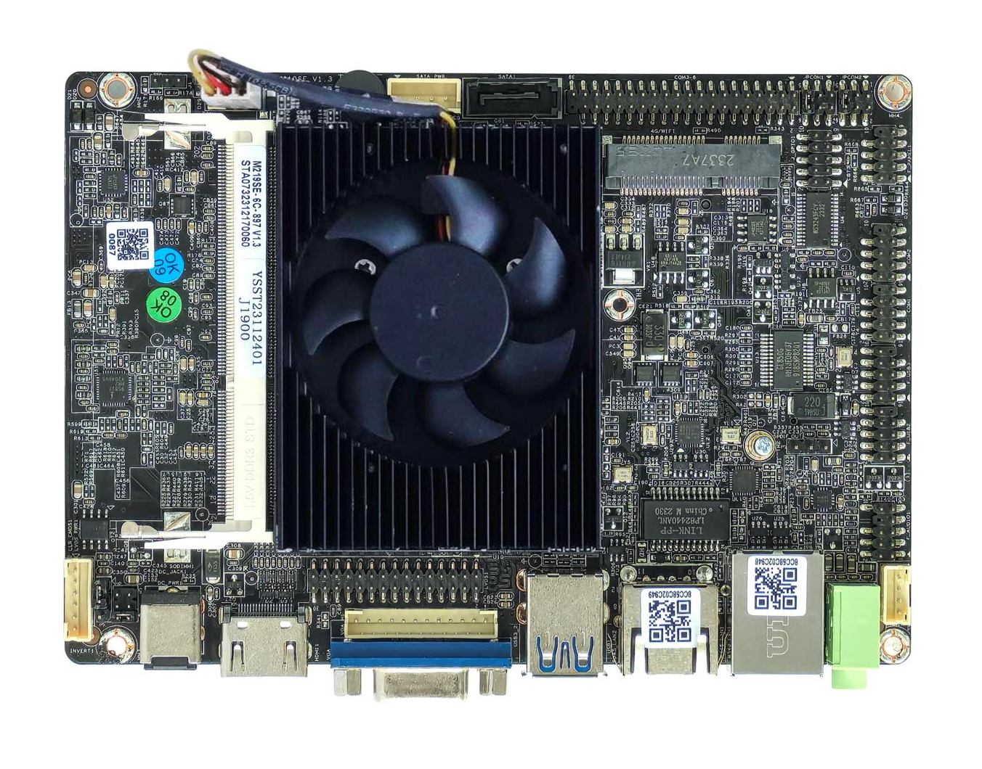
――――――――――――――――――――――――――――――――――――――――――――――――――――――
Single network interface picture↓ ( default )
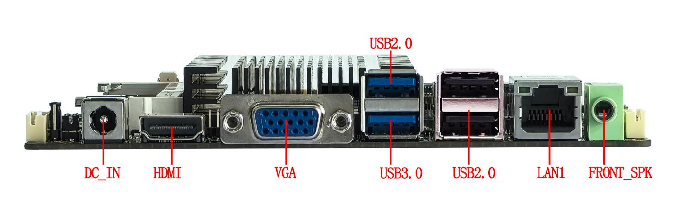
――――――――――――――――――――――――――――――――――――――――――――――――――――――
Dual network interface picture↓
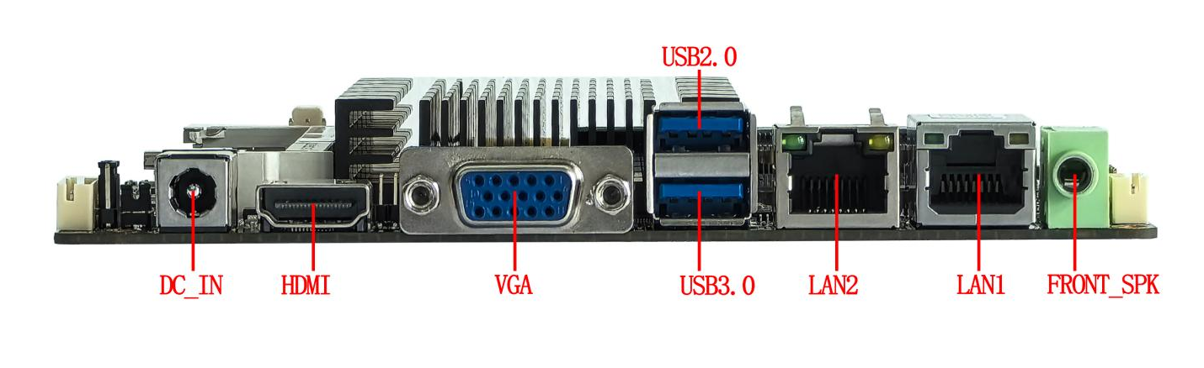
――――――――――――――――――――――――――――――――――――――――――――――――――――――
back of the motherboard ↓
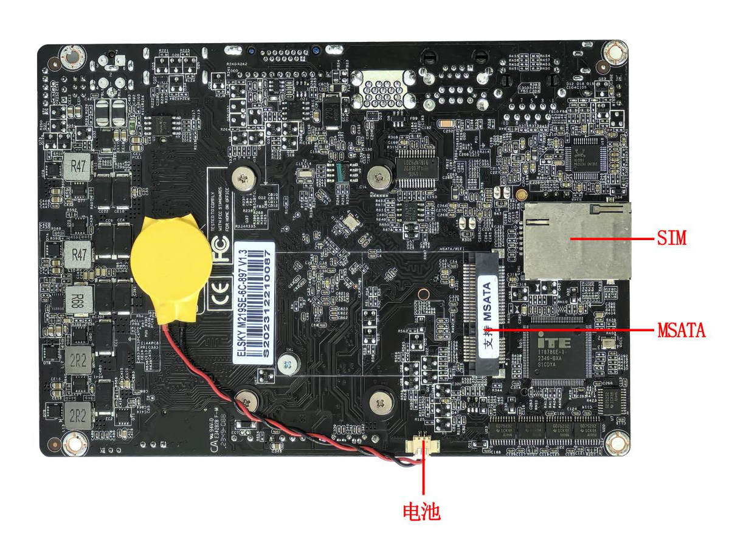
――――――――――――――――――――――――――――――――――――――――――――――――――――――
Modified ATX socket picture↓
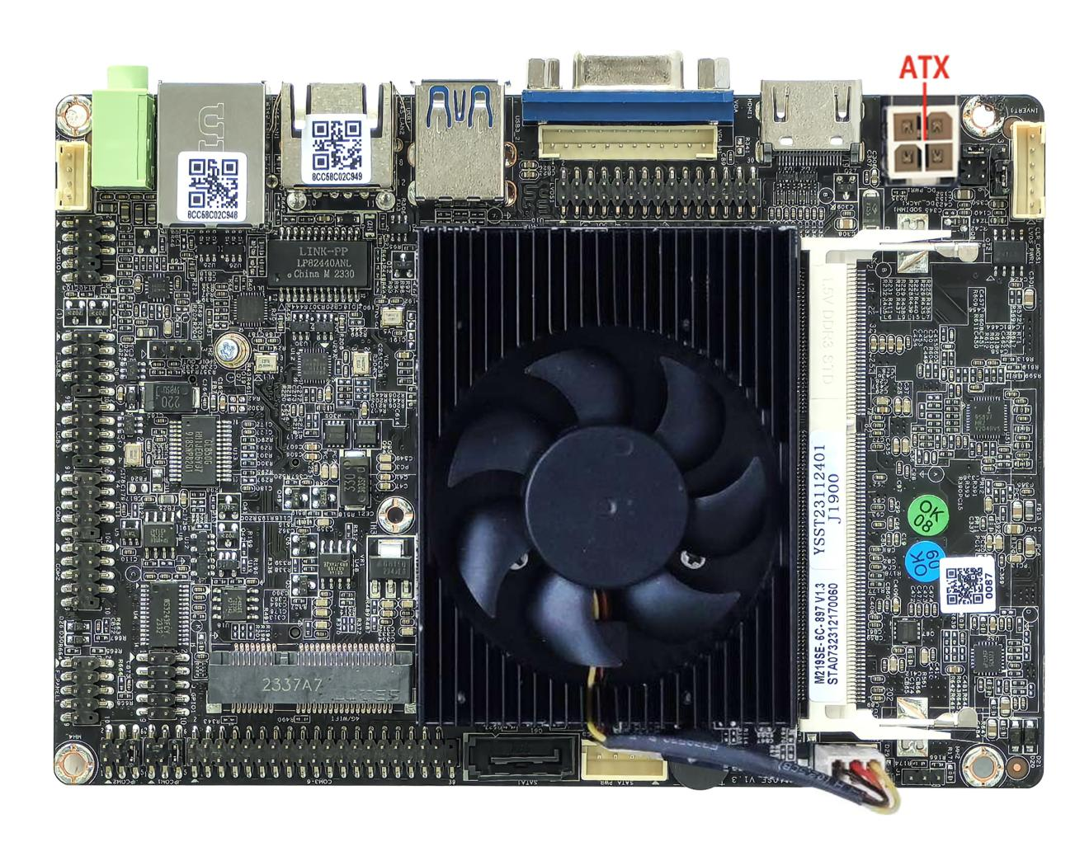
――――――――――――――――――――――――――――――――――――――――――――――――――――――
The above pictures are for reference only, please refer to the actual product for details!
Product model ordering options:
Motherboard model | CPU | SSD | COM | LAN | USB2.0 | USB3.0 | Memory | Power
M218SE | Celeron J1800  Celeron J1900  Pentium J2900  Optional | 1*MSATA/  1*SATA | 6 | 1 | 7 | 1 | 1*NB DDR3  MAX 8GB | +12V
M219SE | Celeron J1800  Celeron J1900  Pentium J2900  Optional | 1*MSATA/  1*SATA | 6 | 2 | 5 | 1 | 1*NB DDR3  MAX 8GB | +12V
Important Tips :
Power supply interface:
The motherboard DC interface specification is 5.5*2.5, and can be changed to 4Pin ATX interface power supply;
The motherboard consumes about 30W of power when fully loaded. It is recommended to use a 12V 4A or higher power supply .
Display interface:
- The motherboard VGA/VGA_OUT, HDMI, LVDS/EDP support single display, dual display copy, dual display expansion, and single display under DOS;
- The motherboard supports LVDS and EDP, and supports LVDS by default. If you want to use EDP, you need to change the board and share the pins.
- The motherboard EDP does not support 4K resolution, use EDP-B (20Pin independent backlight) screen cable;
MATA :
The MSATA interface on the motherboard defaults to coexisting SATA signals and USB signals, supporting MSATA hard drives; the SATA signal can be changed to PCIE signal; after the change, it can support WiFi modules;
Mini_PCIE
The Mini-PCIE motherboard supports the coexistence of PCIE signals and USB signals by default (supports WiFi/4G/Bluetooth modules by default);
USB interface
- The main dual-network motherboard defaults to 6*USB (1*USB3.0, 5USB2.0), and the single-network motherboard defaults to 8*USB (1*USB3.0, 7USB2.0)
- There are 1 external USB3.0 interface (USB3_2 lower interface is 3.0), 3 USB2.0 interfaces (USB3_2 upper interface is 2.0), and built-in F_USB2/F_USB3 are full signal available;
COM port
- The motherboard supports 6*COM, RS232 is supported by default; COM1 supports RS232/422/485 optional, through BIOS settings;
- The 9th pin of COM1/2 on the motherboard can be set to carry 5V/12V via JCOM1/JCOM2 respectively;
Network Card:
The motherboard has dual Gigabit Ethernet ports by default, which can be changed to a single Gigabit Ethernet port, but the POE power supply cannot be changed;
Single network: Realtek 8111H Gigabit network card or Yutaiwei YT6801 Gigabit network card optional;
Dual network: Realtek8111H+Realtek8111H Gigabit network card or Yutaiwei YT6801+Yutaiwei YT6801 Gigabit network card optional;
Sound Card:
The motherboard supports Realtek ALC 897 sound card by default. The green audio interface only supports audio output (FRONT_SPK) and does not support MIC_IN. The built-in F_AUDIO pin supports FRONT_SPK and MIC_IN. The amplifier is available, but the USB sound card is not supported.

Illustrate

Except for the accessories listed with the product, the contents of this manual do not represent the company's commitment. The company reserves the right to change this manual without further notice.
We are not responsible for any direct, indirect, intentional or unintentional damages and hidden dangers caused by improper installation or use.
Before ordering a product, please consult your dealer to learn in detail whether the product performance meets your needs.
The contents of this manual are protected by copyright. All rights reserved. No reproduction in mechanical, electronic or other ways is allowed without permission.
The final right of interpretation of this manual belongs to SHENZHEN ELSKY TECHNOLOGY CO.,LTD.

The above ordering information is for reference only. For details, please consult the sales department at 0755-82260150
Motherboard driver download https://pan.baidu.com/s/1ie7qi5NutS53ipPecRSYtw
Access password cbn5

The following CPU information is for reference only. Please consult sales for specific needs!

CPU Brand | CPU Model | Frequency | Turbo | CPU power consumption (W) | Full load power consumption ( W )
Intel Celeron | J1800 | Dual core 2.41G | 2.58G | 10 | 30
Intel Celeron | J1900 | Quad-core 1.99G | 2.41G | 10 | 30
Intel Pentium | J2900 | Quad-core 2.41G | 2.66G | 10 | 30

BIOS function keys
BIOS function keys | Functional Description
Press Delete on boot | Enter the BIOS function interface
Press F11 to start the computer | Select the startup item, or choose to enter the BIOS function interface
← → | Move the left and right arrows to select an item
↑ ↓ | Move up and down arrows to select items
Enter | Select the item and enter the submenu
+/- | Change selections, or add or subtract values
F1 | Display related help content
F9 | Restore factory settings
F10 | Save changes and exit
Esc | quit

Chapter 1. Product Specifications

Motherboard size | 145mm*100mm*18mm
CPU Processor | Intel® Processor Celeron J1900 , Celeron J1800, Pentium J2900
Chipset | Intel Bay trail SOC chipset
Power supply | 1* DC_IN | The inner diameter of the DC head is 2.5MM and supports 12V  The full load power consumption of the motherboard is about 30W. It is recommended to use a 12V 4 A or higher power supply.
Power supply | 1*ATX (4Pin) optional
Memory | 1*NB-DDR3L memory, low voltage 1.35V memory, support 1333/1600MHz memory, maximum support 8G
Display functions | Intel(R) HD Graphics graphics controller , supports single display, dual display copy, dual display expansion, single display under DOS
Display functions | 1*VGA_OUT pin | Support resolution 1920*1080@60HZ (12Pin, 1*12Pin, 2.0mm)
Display functions | 1*VGA DB15 interface | Support resolution 1920*1080@60HZ
Display functions | 1*HDMI 1.4 interface | Support resolution 1920*1080@60HZ
Display functions | 1*LVDS pin | Support resolution 1920*1080@60HZ (30 Pin, 2*15Pin, 2.0mm)
Display functions | 1*EDP pin (optional) | Support resolution 1920*1080@60HZ (30 Pin, 2*15Pin, 2.0mm)
Display functions | LVDS and EDP are selected, LVDS is the default, and the pins are shared. EDP uses EDP-B screen cable
Display functions | 1*INVERT1 pin | LVDS backlight switch control pin (6Pin, 1*6Pin, 2.0mm)
Display functions | 1*LVDS_PWR pin | LVDS working voltage control pin (6 Pin, 2*3Pin, 2.0mm)
Network Features | 1/2*RJ45 LAN | Dual network and single network optional, support network wake-up and PXE diskless boot function  Single network Realtek 8111H; optional Yutaiwei YT6801;  Default dual network: Realtek 8111H+Realtek 8111H or Yutaiwei YT6801+Yutaiwei YT6801;
Network Features | 1*Mini-PCIE interface | PCIE2.0 signal, support WIFI/4G/Bluetooth, etc.
Hard disk function | 1*SATA1 interface | Standard SATA2.0 hard disk interface, maximum transmission speed 3.0 Gbps
Hard disk function | 1*SATA_PWR pin | Hard disk power supply pin, can take power 5V, 12V (4Pin, 1*4Pin, 2.54mm)
Hard disk function | 1*MSATA interface | Support standard MSATA 2.0
Sound Features | Integrated Realtek ALC 897 HD digital audio decoder , 6-channel high-fidelity audio controller
Sound Features | 1*FRONT_OUT interface | Support audio output
Sound Features | 1*F_AUDIO pin | Standard audio pin (9 Pin, 2*5Pin, 2.0mm)
Sound Features | 1*JAMP pin | The amplifier supports 8 ohm 5 watt speaker dual channel output  (4 Pin, 1*4Pin, 2.0mm)
Sound Features | 1*SPDIF pin | Digital audio pin (3Pin , 1*3Pin, 2.54mm)
USB Function | 1*USB3.0 interface | Rear standard USB3.0 interface
USB Function | 3*USB2.0 interface | Rear standard USB2.0 interface
USB Function | 1*F_USB2 pin | Front USB2.0 pin, one set has 2*USB2.0 (9Pin, 2*5Pin, 2.0mm)
USB Function | 1*F_USB3 pin | Front USB2.0 pin, one set has 2*USB2.0 (9Pin, 2*5Pin, 2.0mm)
Switch function | 1*F_PANEL pin | Switch, power light, hard disk light, restart pin (9Pin, 2*5Pin, 2.0mm)
Other I/O | COM1 pin | Serial port, support RS232/RS422/RS485 optional ( 9Pin, 2*5Pin, 2.0mm)
Other I/O | COM2 pin | Serial port, support standard RS232 ( 9Pin, 2*5Pin, 2.0mm)
Other I/O | COM3~6 pins | Serial port, support standard RS232 (3 9Pin, 2*20Pin, 2.0mm)
Other I/O | 1*JPCOM1 pin | Control the voltage of COM1 pin 9: 0V/5V/12V optional  (6Pin, 2*3Pin, 2.0mm)
Other I/O | 1*JPCOM2 pin | Control COM2 pin 9 voltage 0V/5V/12V optional ( 6Pin, 2*3Pin, 2.0mm)
Other I/O | 1*SIM card slot | Support SIM card, SIM card is required when using 4G
Other I/O | 1*CLR_CMOS pin | CLR_CMOS motherboard clear and discharge pin (3Pin, 1*3Pin, 2.54mm)
Other I/O | 1*FAN1 pin | CPU fan pin, does not support temperature control (3Pin, 1*3Pin, 2.54mm)
Other I/O | 1*J_GPIO pin | GPIO control pin ( 10Pin, 2*5Pin, 2.0mm)
Operating Environment | Working temperature: -10℃~60℃;  Working humidity: 5%~95% relative humidity, no condensation
BIOS | AMI BIOS, supports power-on, scheduled power-on, remote power on and off, and intelligent device identification
Operating system | Supports Windows 10, Windows 8, Windows 7, Linux, etc.

1.1 motherboard Dimensions
――――――――――――――――――――――――――――――――――――――――――――――――――――――
Front size
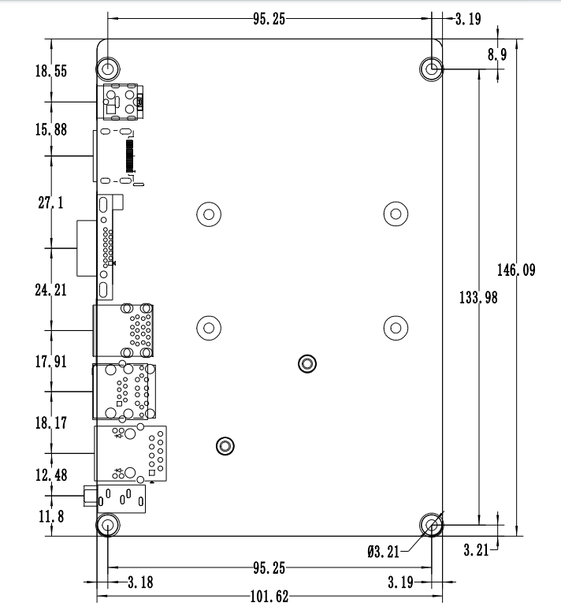
――――――――――――――――――――――――――――――――――――――――――――――――――――――
Single network interface size↓



