ELSKY M612F V1.3 Specification
――――――――――――――――――――――――――――――――――――――――――――――――――――――
6C motherboard↓
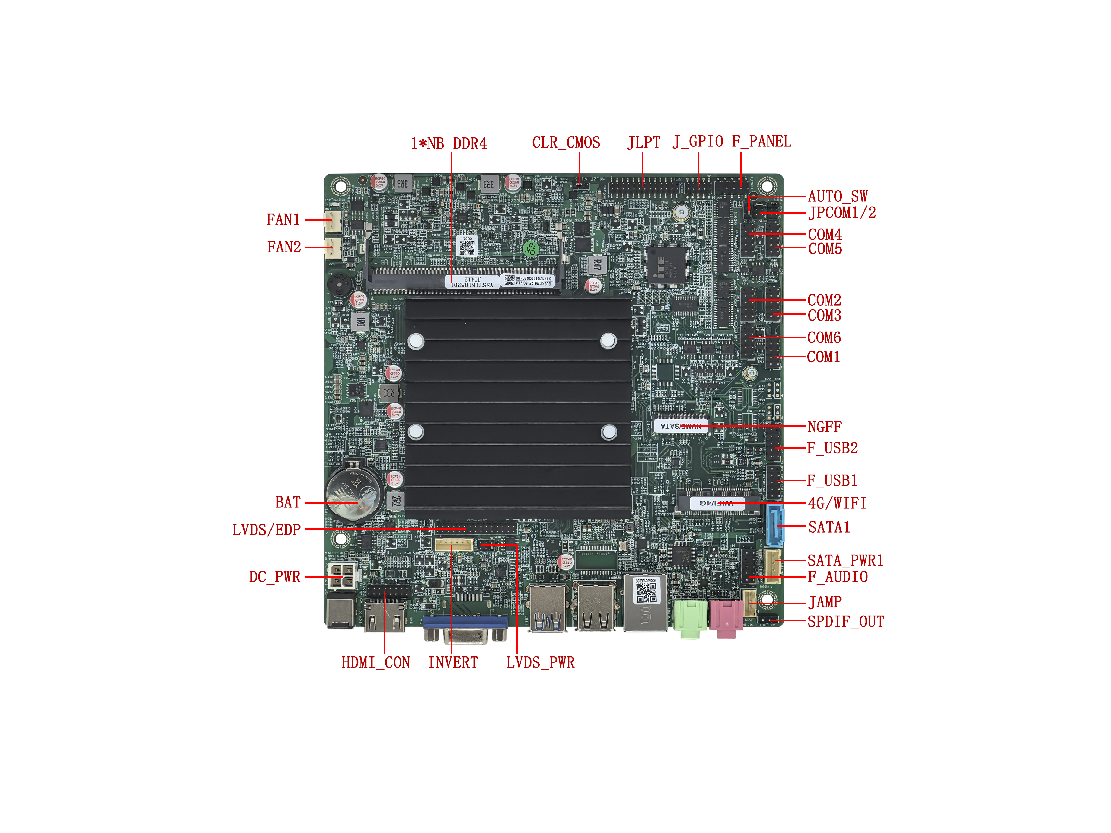
――――――――――――――――――――――――――――――――――――――――――――――――――――――
VGA+single network interface(default)↓
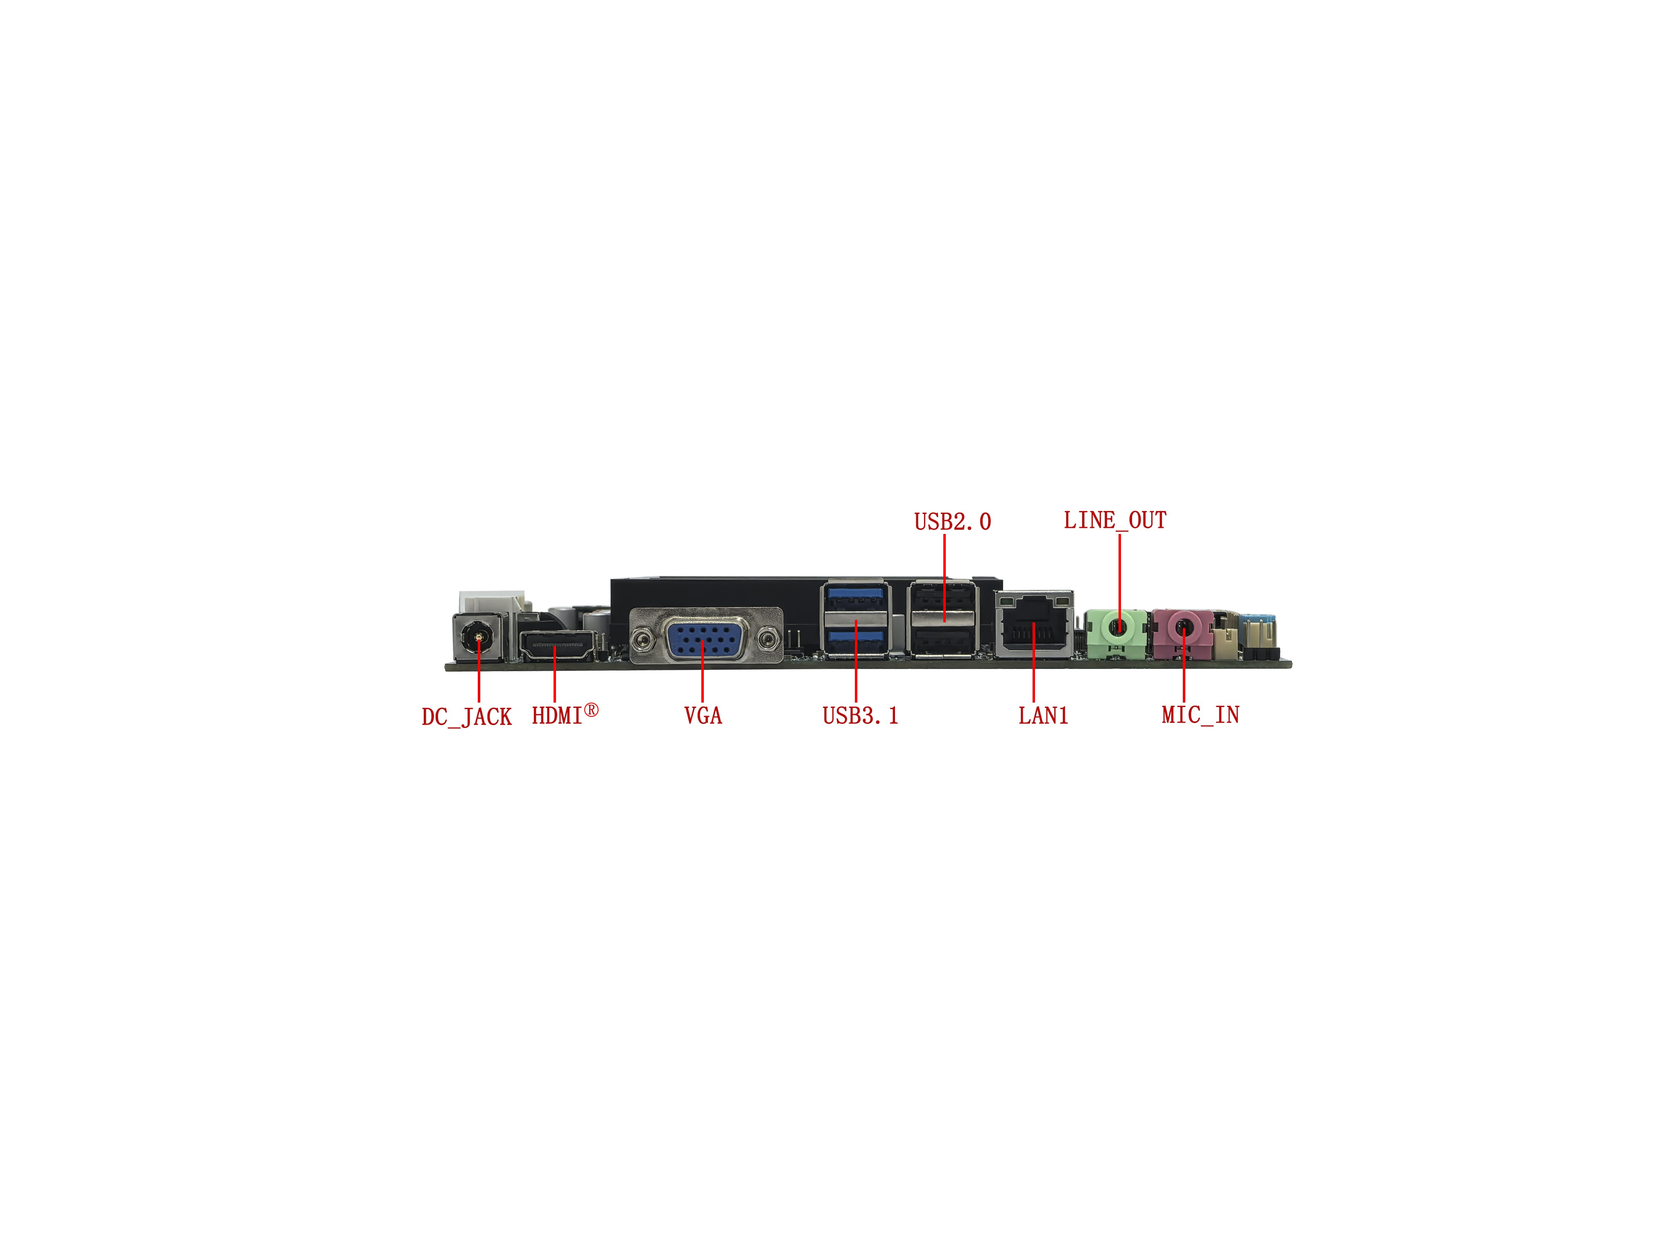
――――――――――――――――――――――――――――――――――――――――――――――――――――――
VGA+dual network interface↓
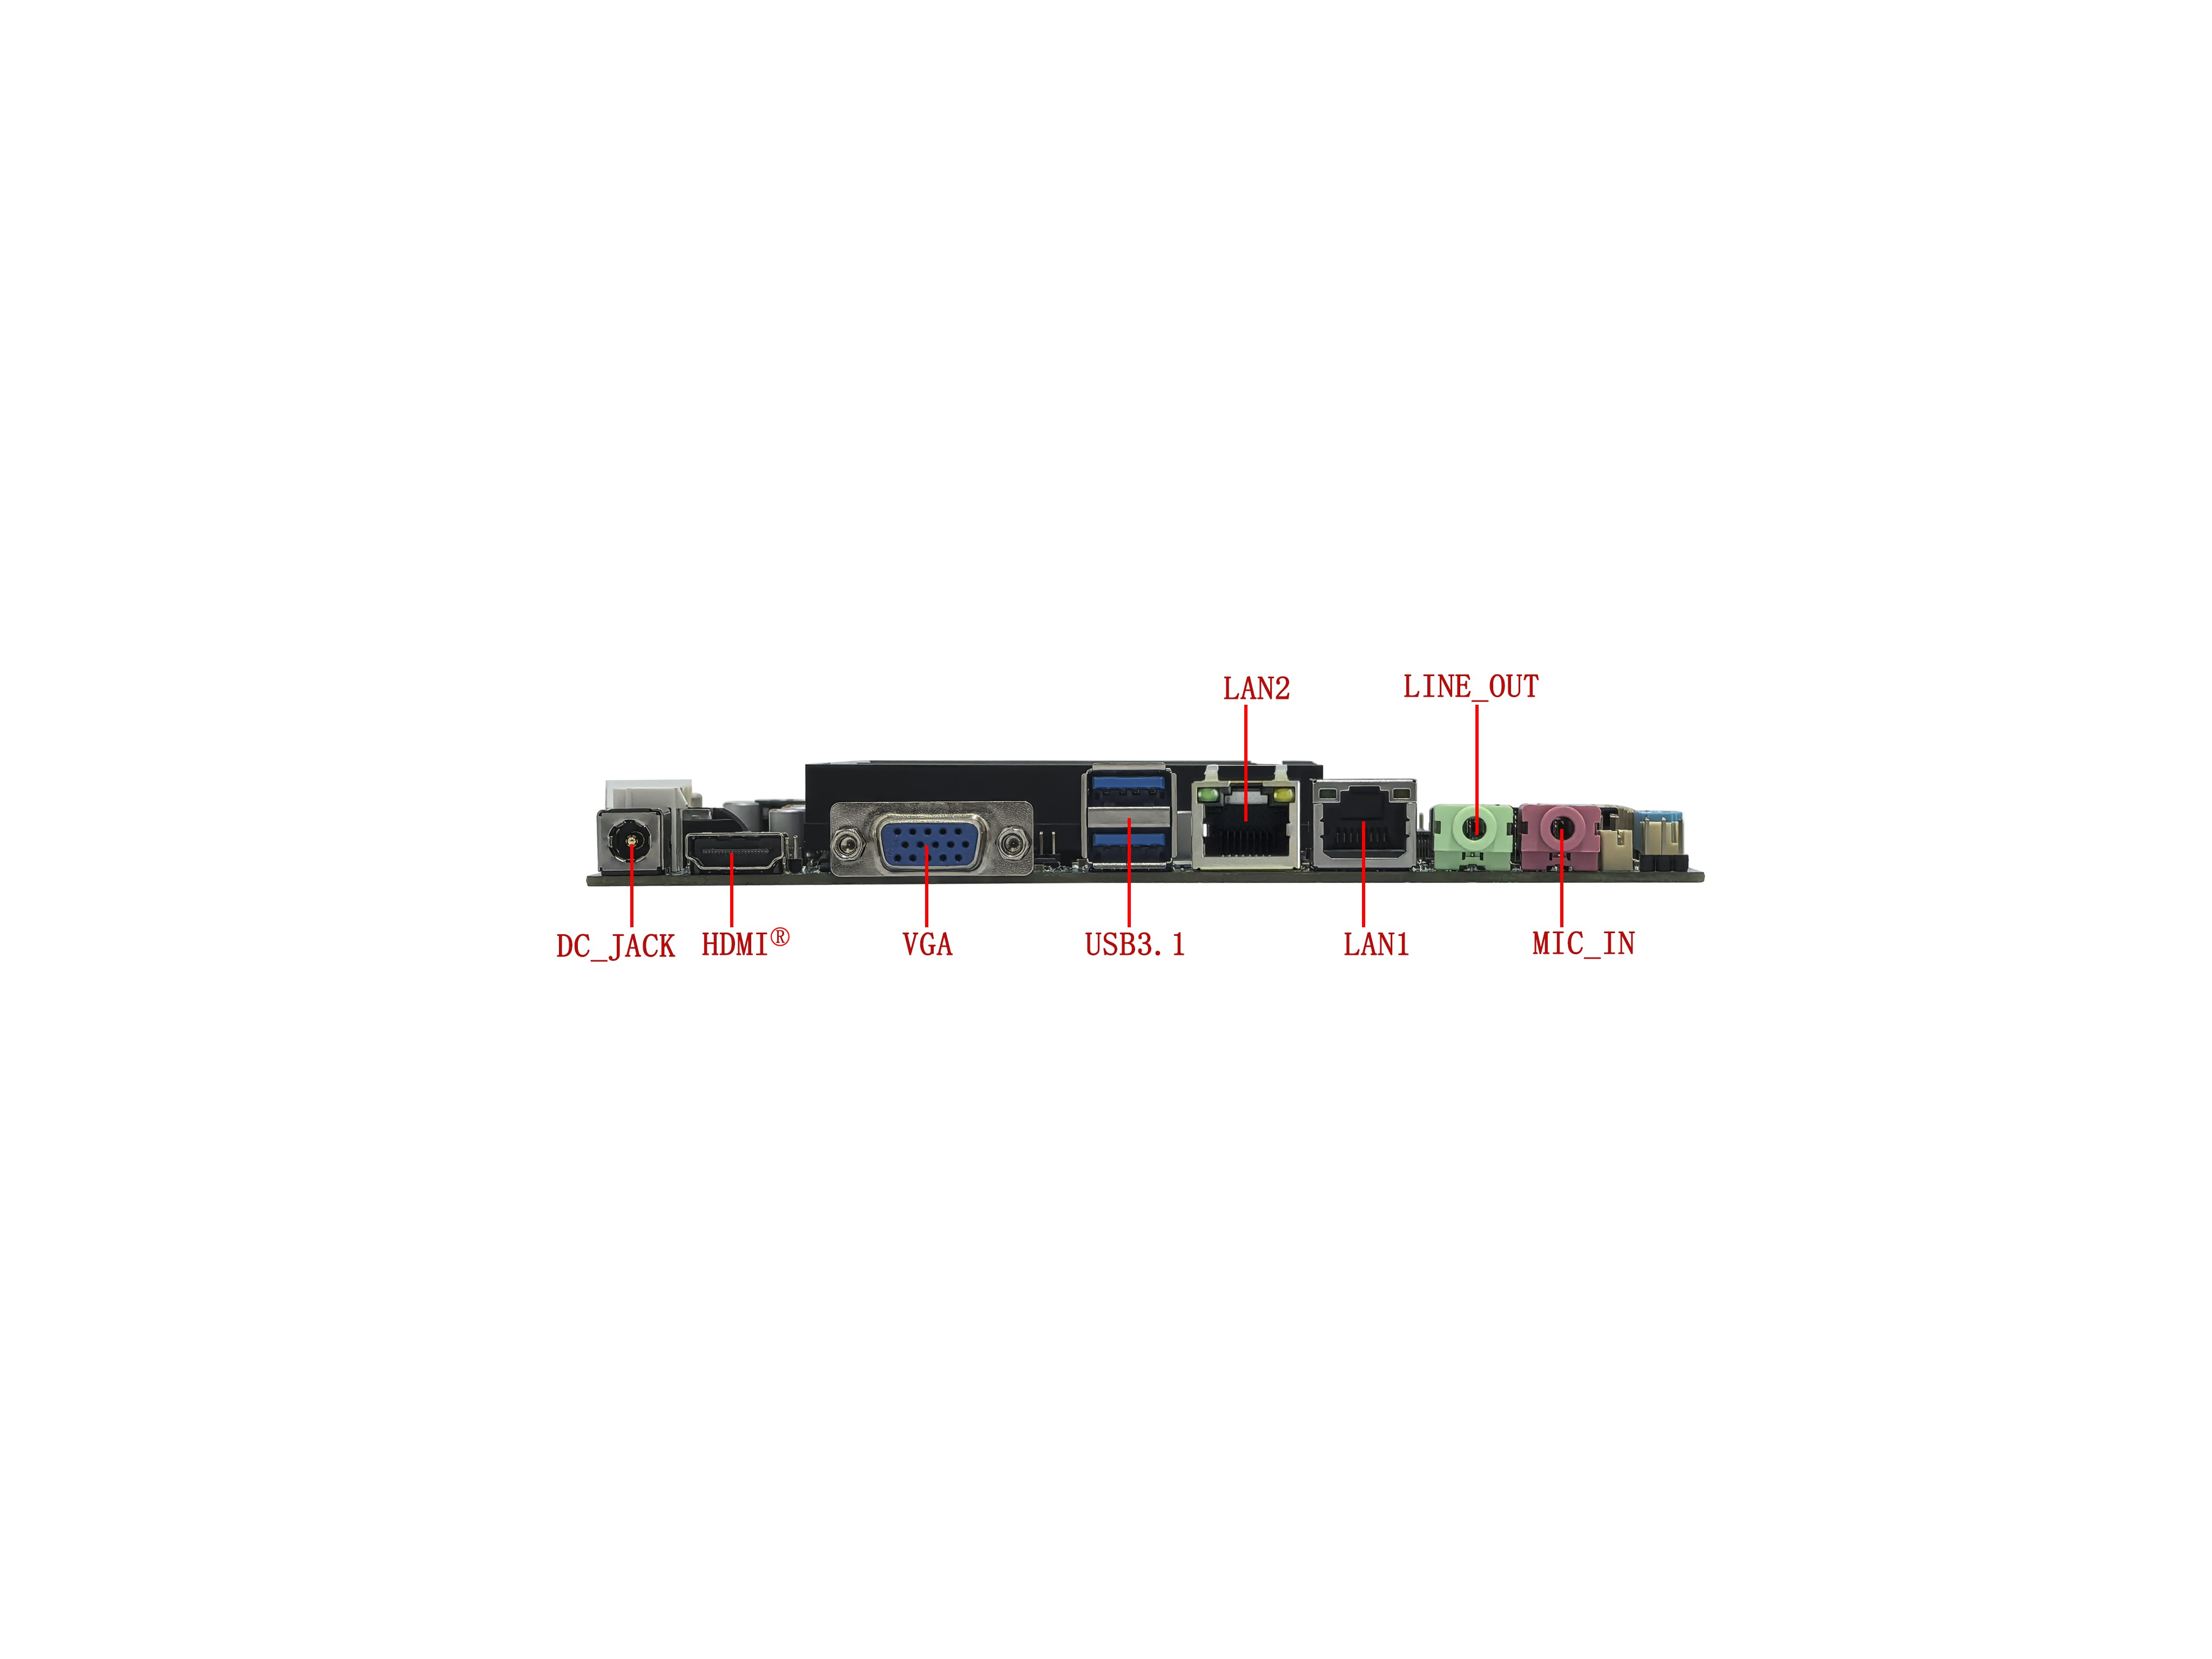
――――――――――――――――――――――――――――――――――――――――――――――――――――――
DP+single network interface↓
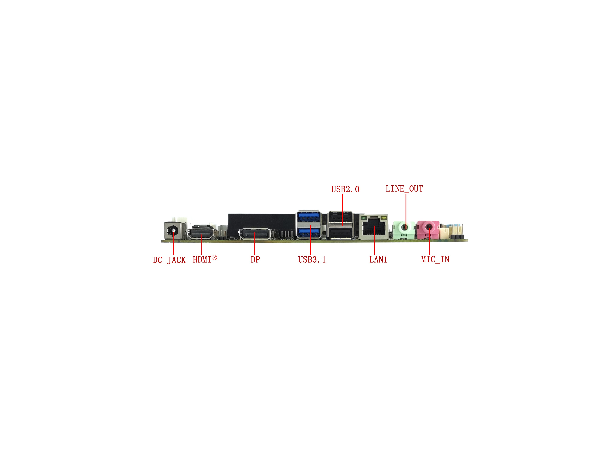
――――――――――――――――――――――――――――――――――――――――――――――――――――――
DP+dual network interface↓
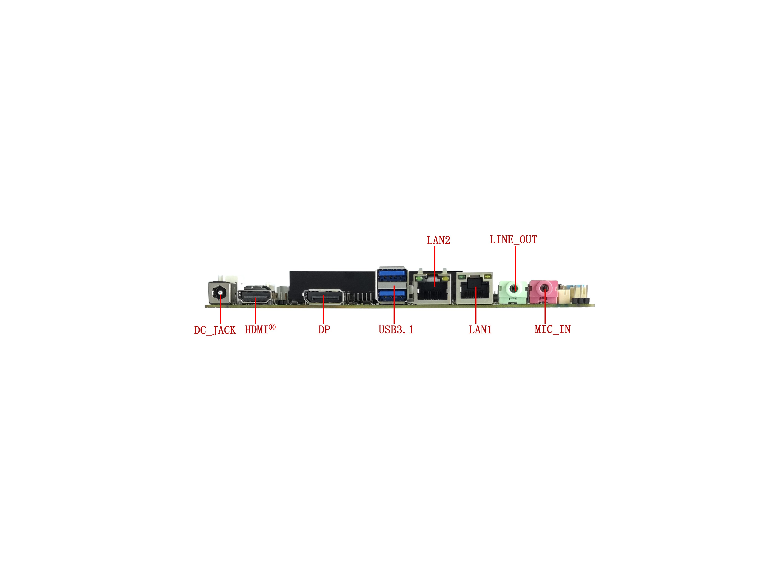
――――――――――――――――――――――――――――――――――――――――――――――――――――――
10C motherboard↓
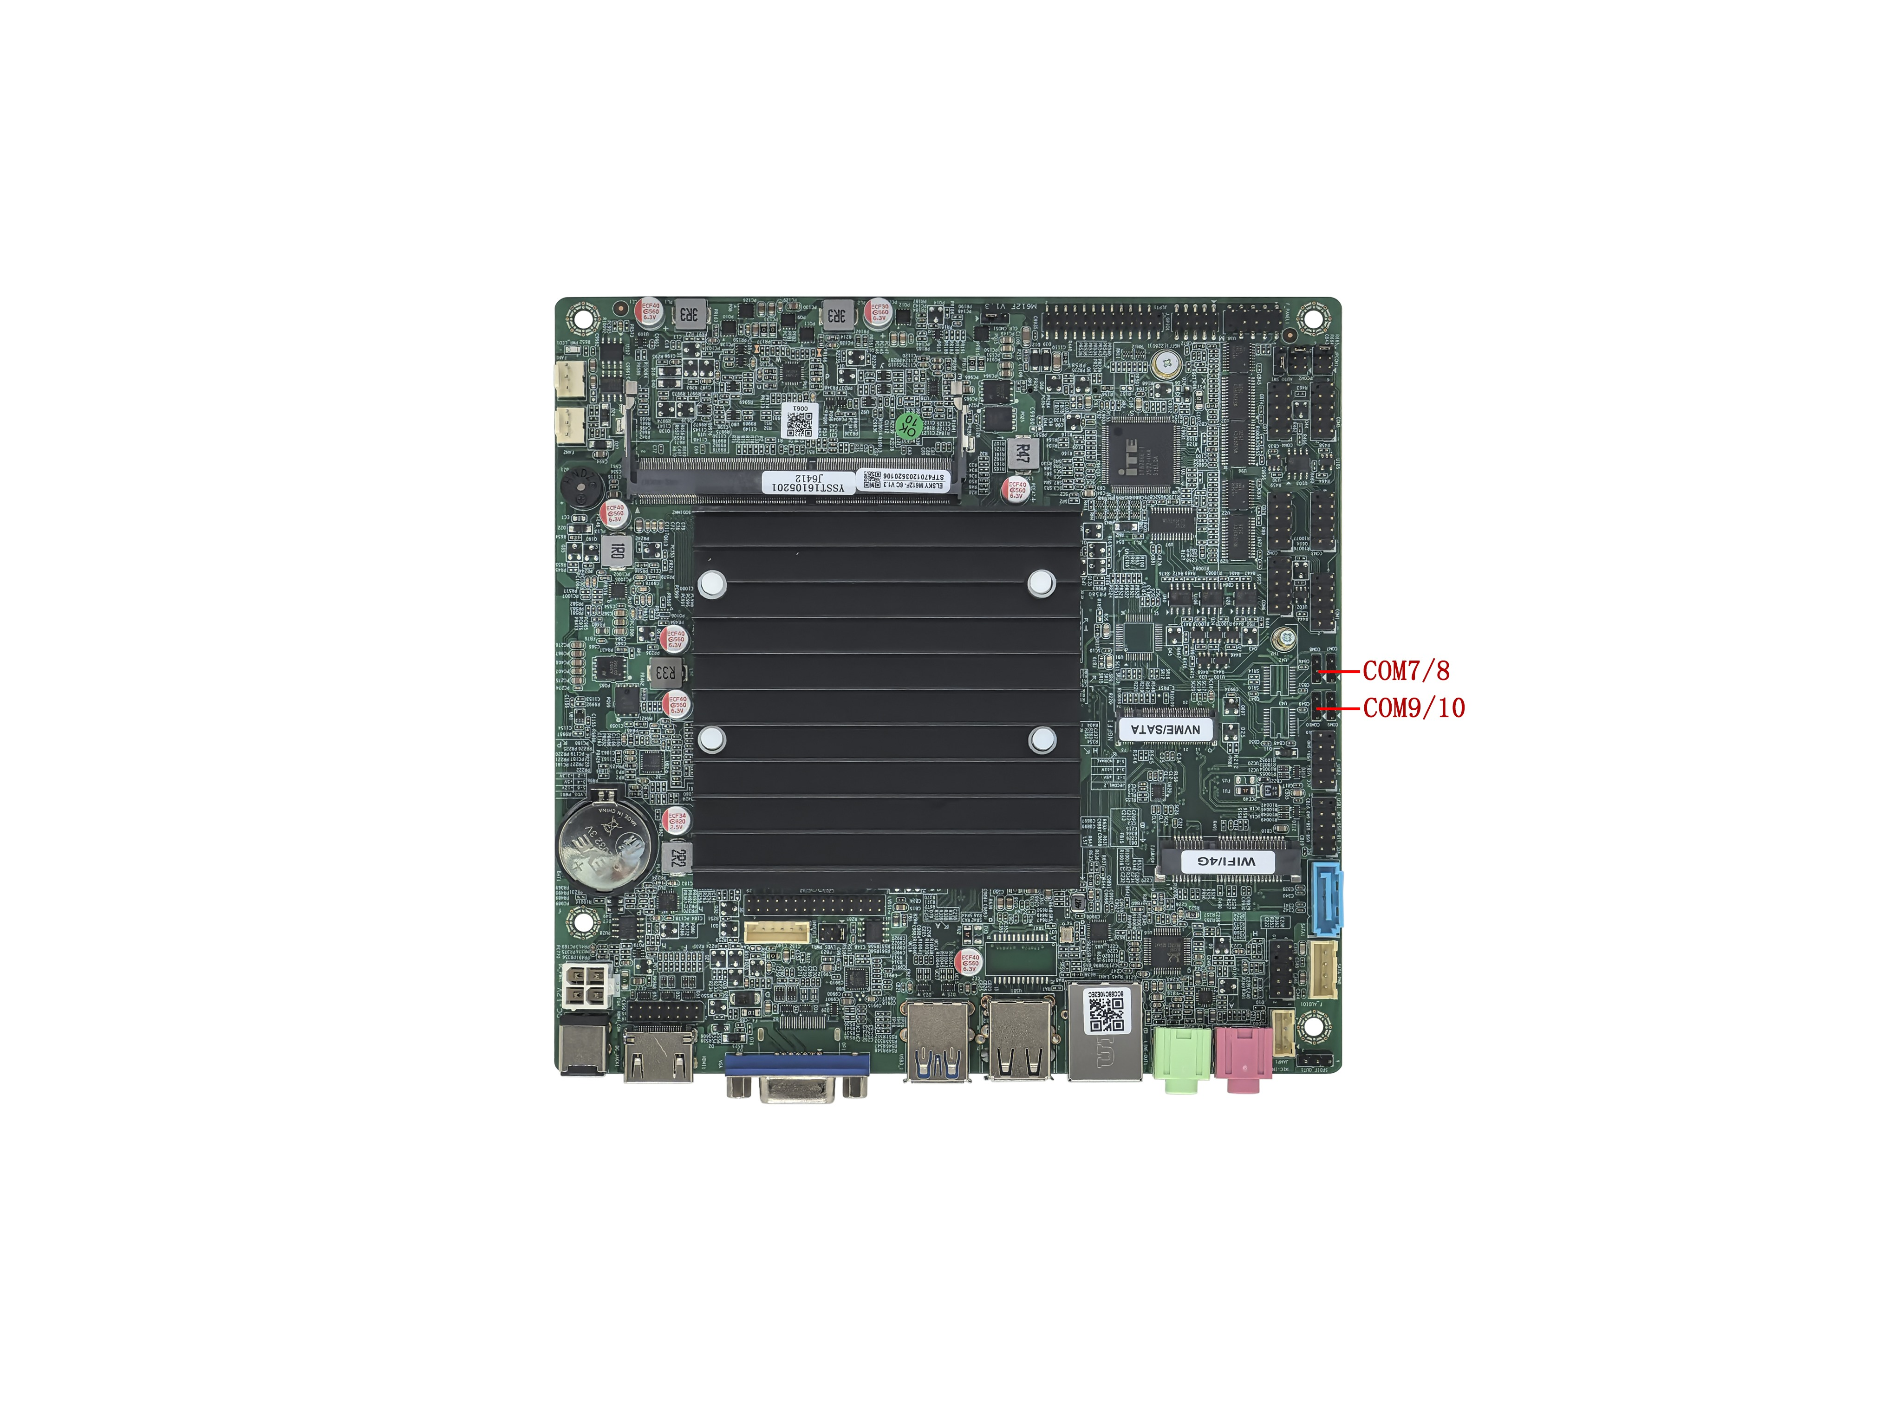

――――――――――――――――――――――――――――――――――――――――――――――――――――――
2C+DP motherboard↓
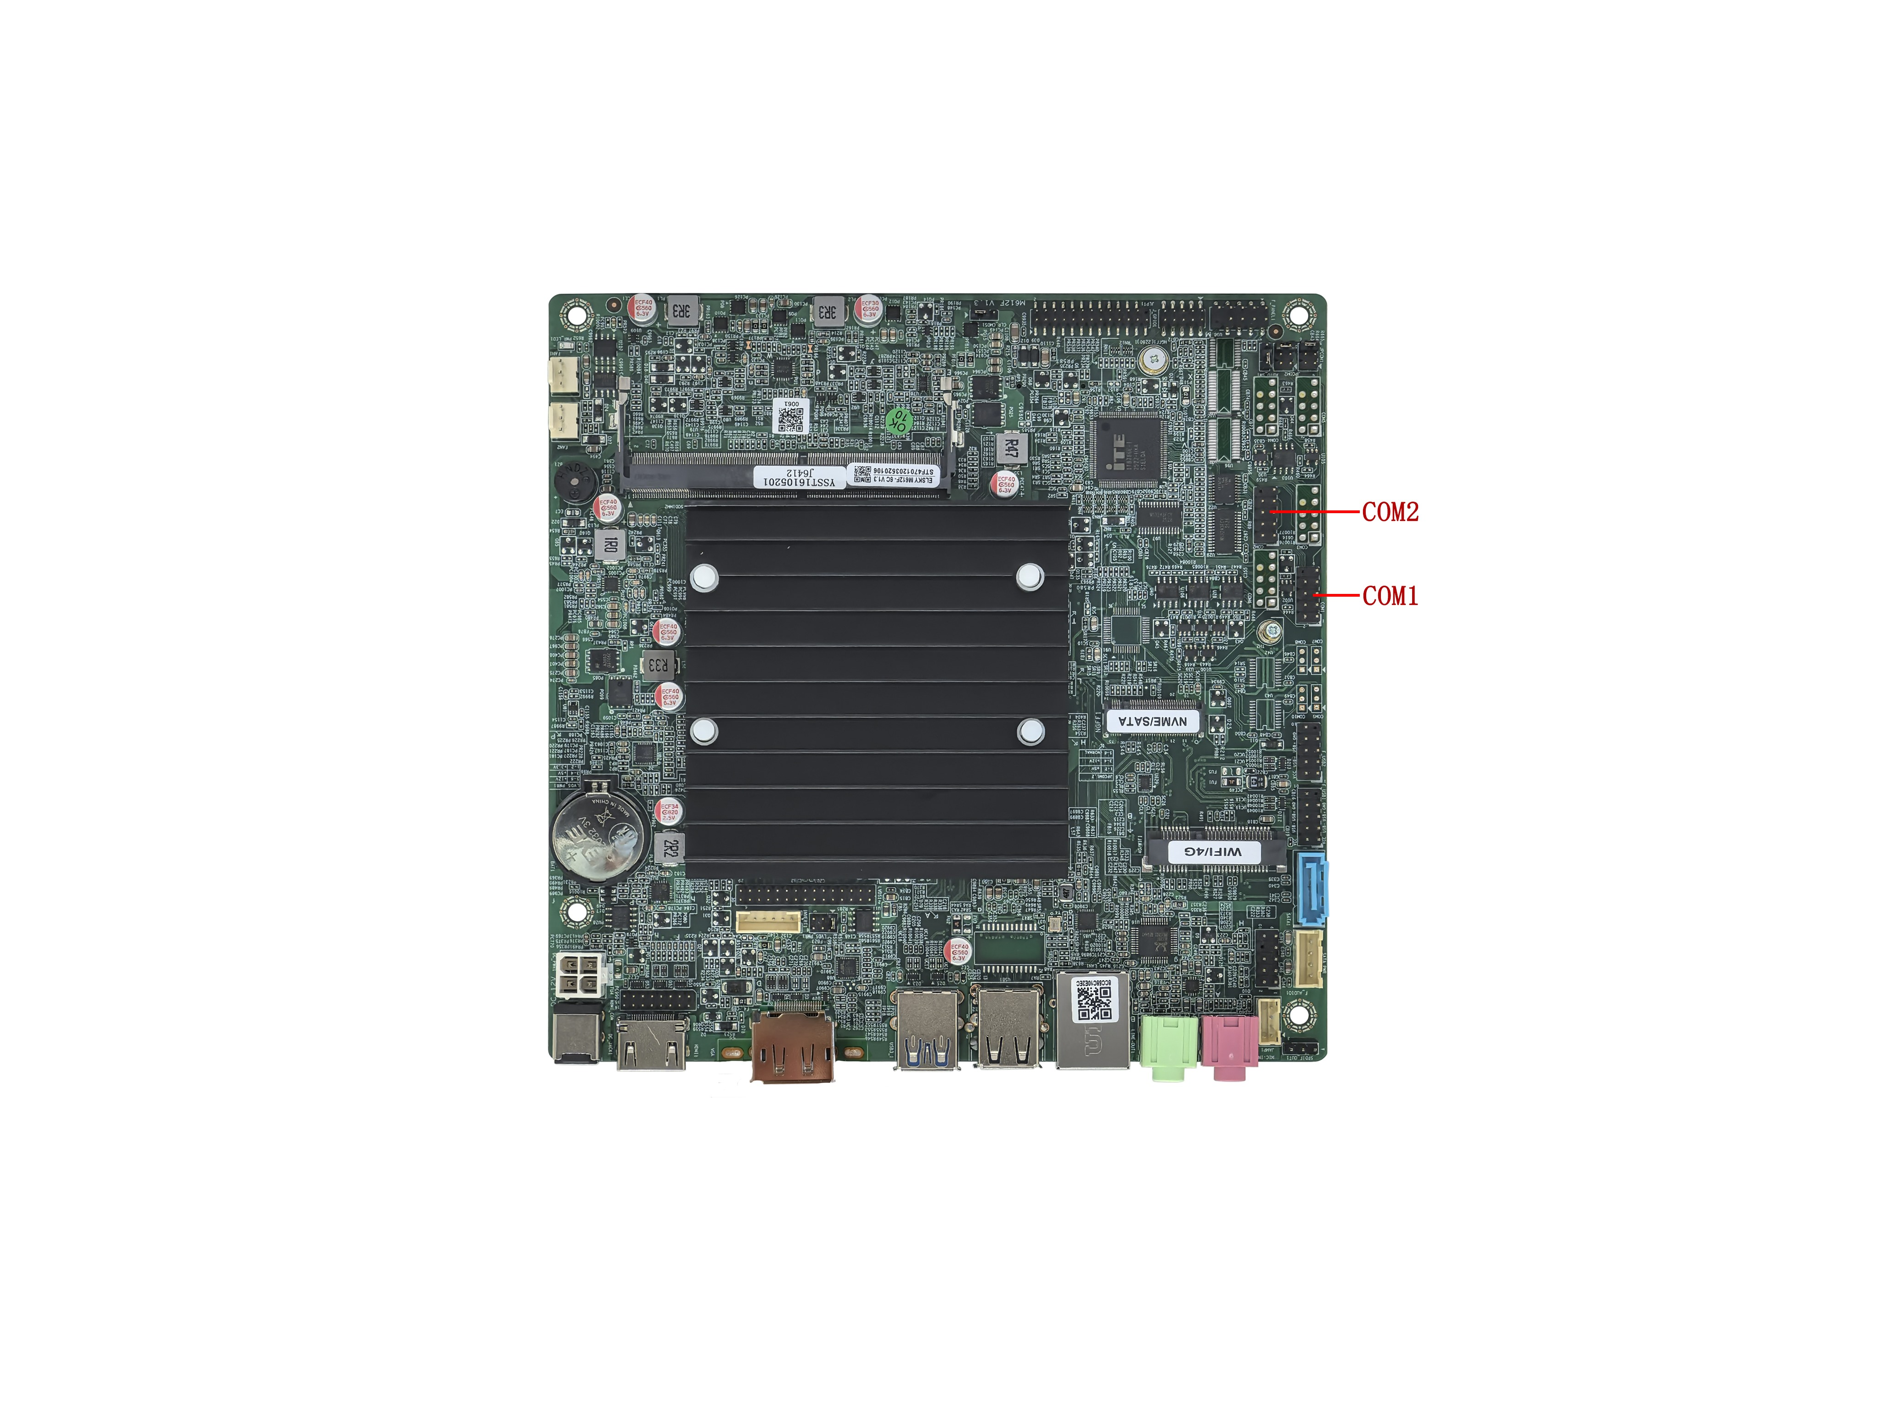
―――――――――――――――――――――――――――――――――――――――――――――――――――――
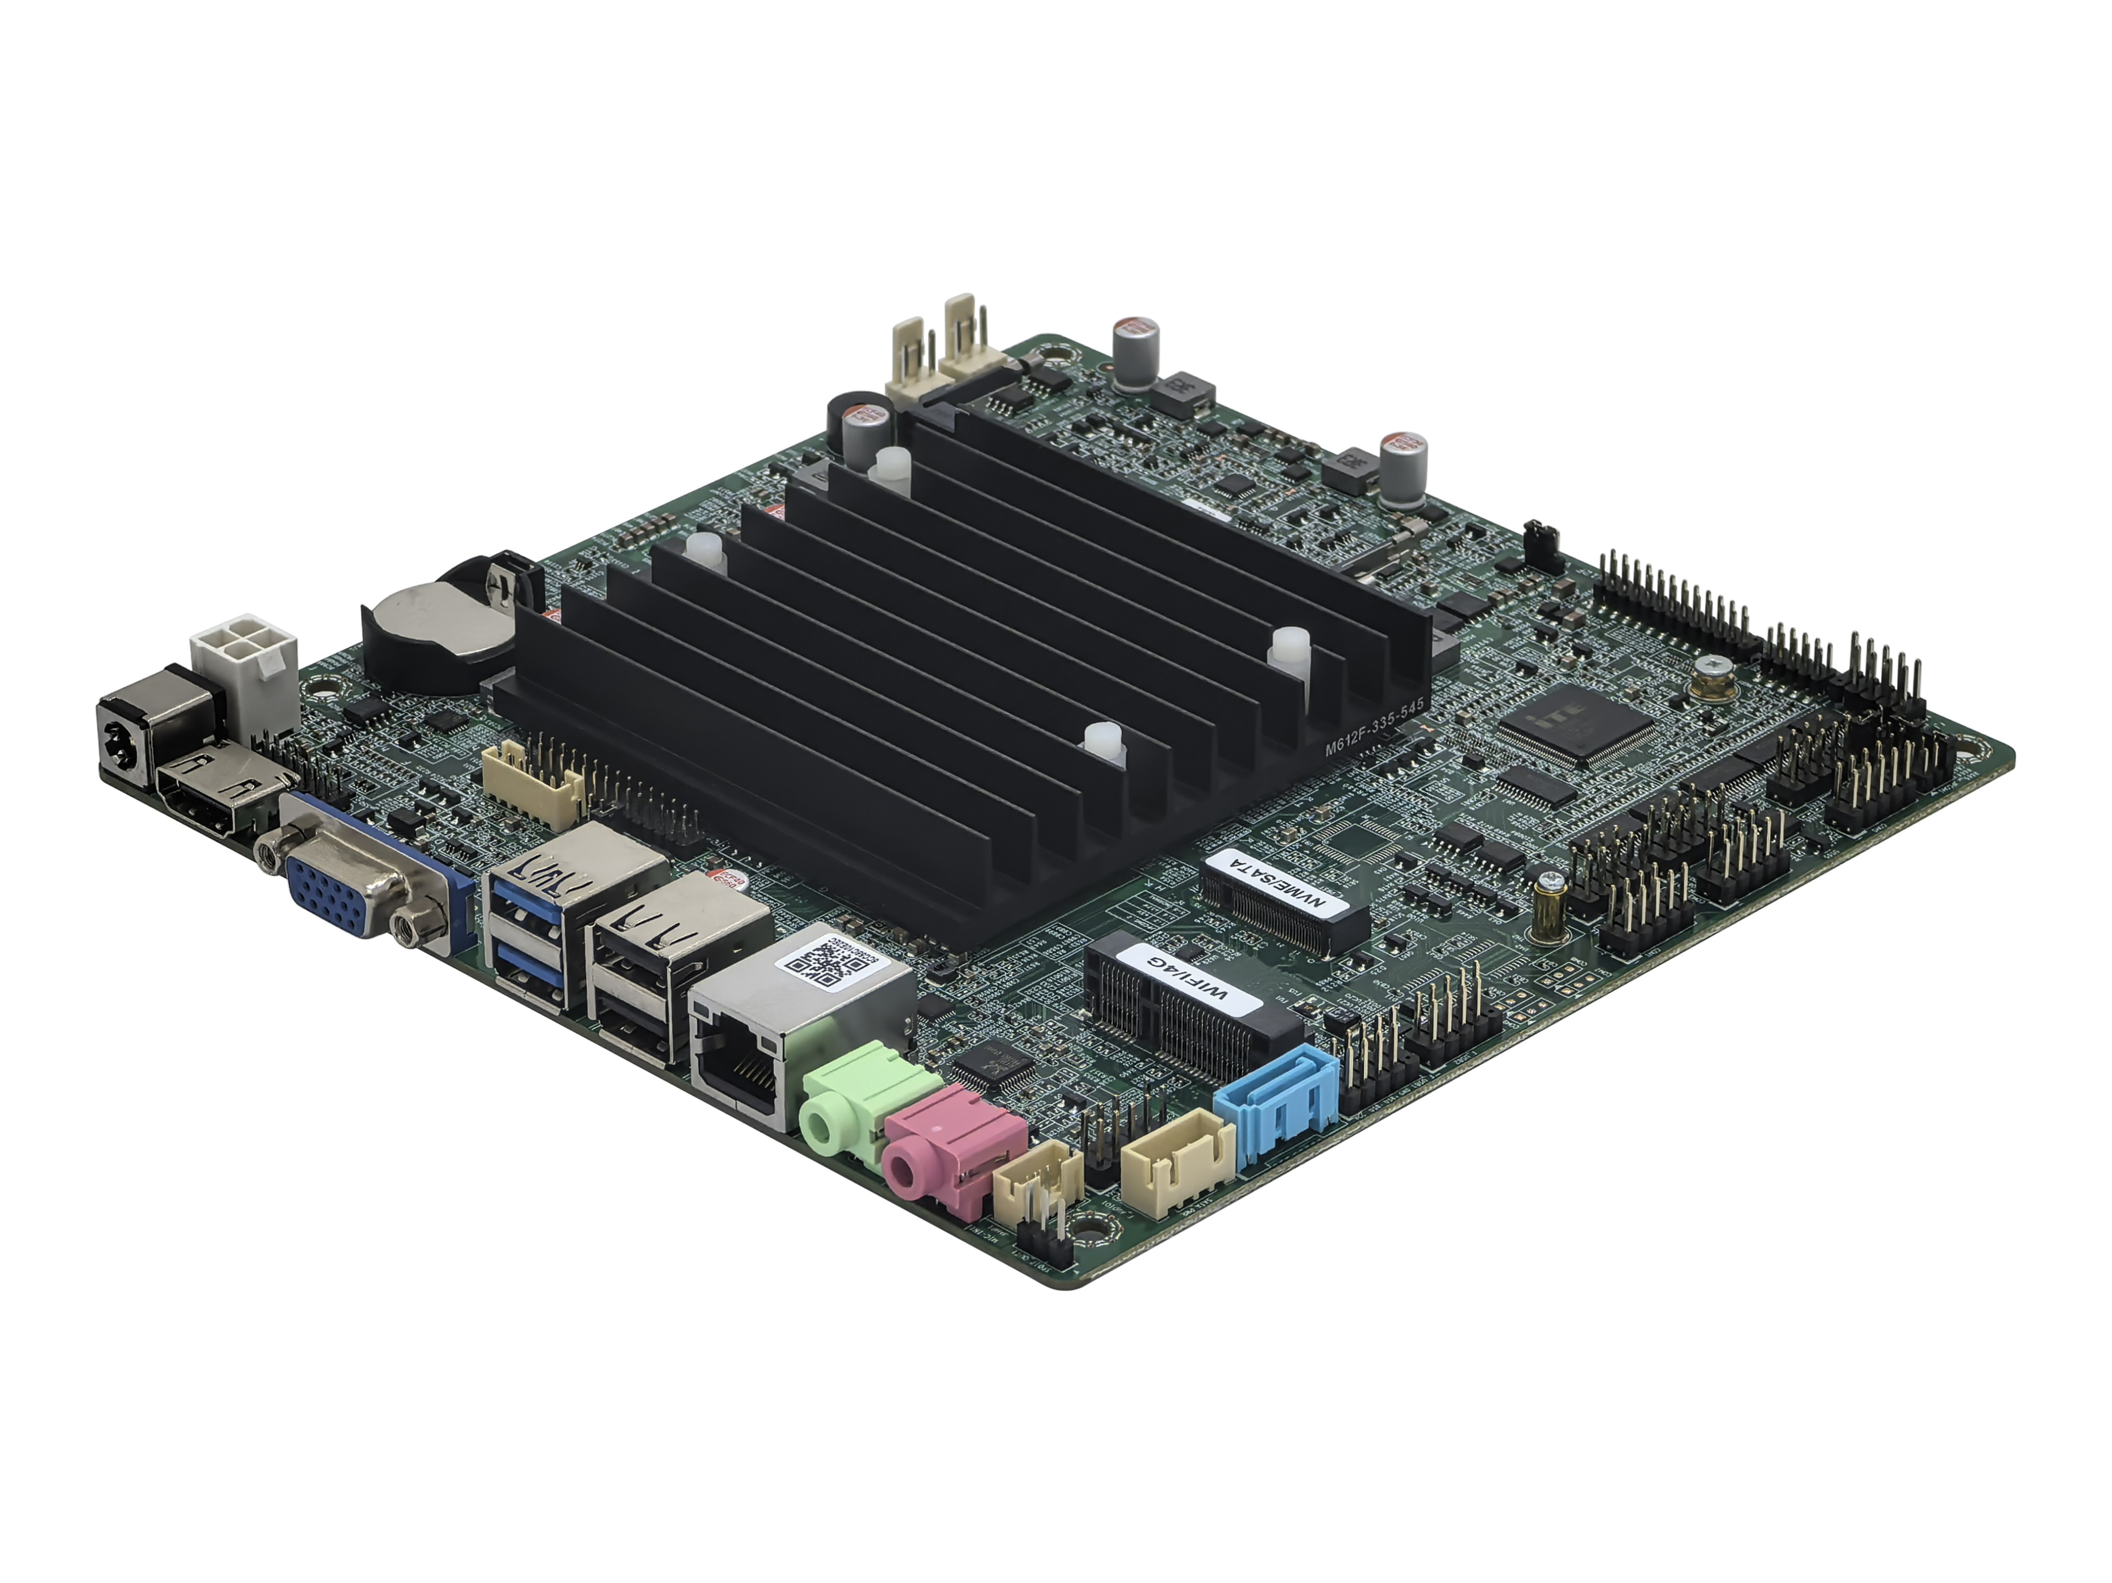
―――――――――――――――――――――――――――――――――――――――――――――――――――――
Back of motherboard↓
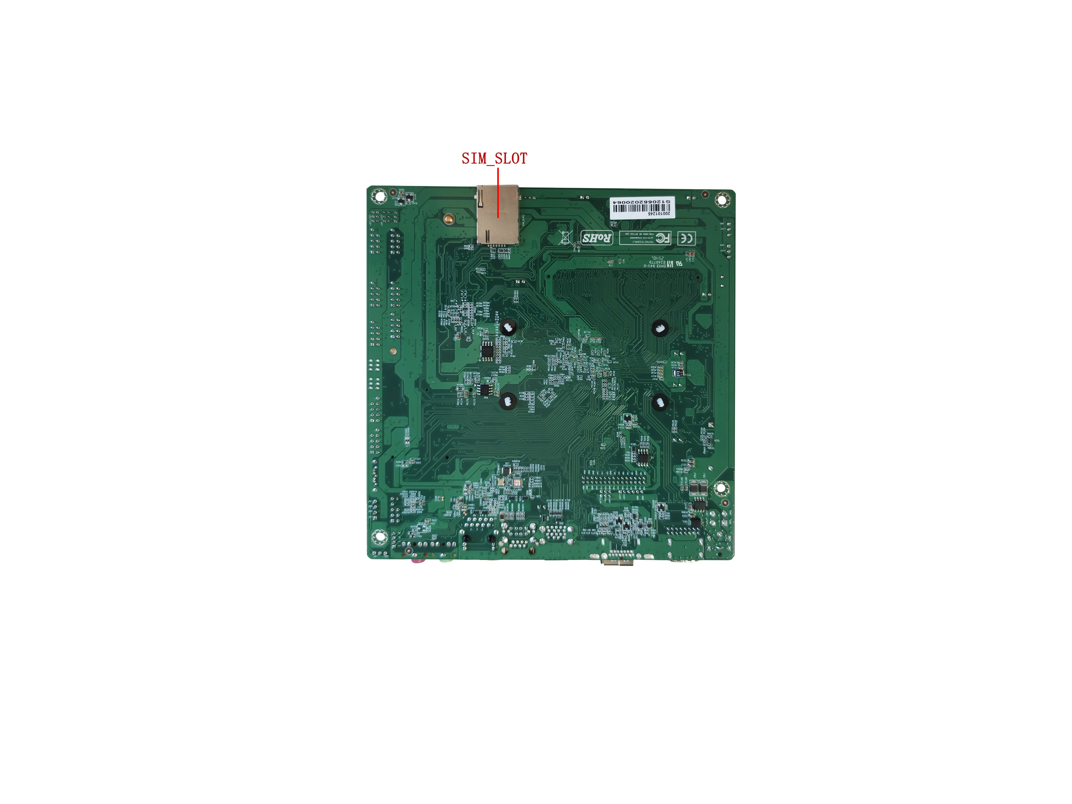
――――――――――――――――――――――――――――――――――――――――――――――――――――――
The above pictures are for reference only.
Please refer to the actual product for details!

Product model ordering optional:
Model | CPU | COM | 4K | LAN | USB2.0 | USB3.1 | SSD | Memory | Power
M612F | Support Intel® Elkhart LakeK  J and N series CPU(e.g.:J6412) | 10C/6C/2C | √ | 1 | 6 | 2 | 1*M.2  1*SATA 3.0 | 1*NB-DDR4  16G（MAX） | +12V
 |  |  |  | 2 | 4 | 2 | 1*M.2  1*SATA 3.0 | 1*NB-DDR4  16G（MAX） | +12V
Single network motherboard defaults to 8USB,dual network motherboard defaults to 6USB;
Important notice:
Power supply interface:
The motherboard DC interface specification 5.5*2.5, supports a 4Pin ATX (DC_PWR) power interface;
The motherboard only supports 12V power supply, with a full load of about 30W. It is recommended to use a 12V4A or higher power supply;
Display interface:
1.VGA/DP, HDMI®/HDMI_CON1 pin, LVDS/EDP support single display, dual display/triple display replication, dual display/triple display expansion, and dual display under SHELL;
2.VGA interface and DP interface are optional interfaces, with VGA interface supported by default and DP interface supported by modification;
3. The motherboard DP supports DP++(supports DP cable and DP to HDMI ordinary cable/active adapter cable) and supports 4K resolution 4096/3840*2160@60Hz；
4. The motherboard's LVDS pins support LVDS by default, but can be changed to support EDP. Shared pins are used, and EDP uses EDP-B screen cables (20 pin backlight separate independent screen cables); EDP supports 2K resolution 1920X1080@60Hz;
5.The motherboard external HDMI® interface supports HDMI 2.0 and 4K resolution 4096/3840*2160@60Hz; Built in HDMI_CON1 pin supports 4K resolution 4096/3840*2160@30Hz; To use the built-in HDMI pin for a 4K screen, the external HDMI® interface needs to be removed, otherwise some screens may be affected by interference;
Mini-PCIE:
The motherboard's 4G/WIFI (Mini-PCIE ) interface supports PCIE3.0 x1 & USB signals, with USB being an independent signal; Default support for WiFi Bluetooth/4G module;
M.2:
The motherboard supports Key-M interface M.2 2280 NVME PCIE3.0 x2/SATA dual protocol adaptive standard SSD;
USB interface:
1. The motherboard supports 8*USB by default (2*USB3.1 Gen1, 6*USB2.0);
2. The USB interface and pins on the motherboard default to S power (not charged after shutdown), and can be changed to A power (charged after shutdown);
COM interface:
1. The motherboard supports optional 2COM/6COM/10COM versions; The 2COM version motherboard COM1 supports RS232/RS485; The COM1/3/4/6 of the 6COM/10COM version motherboard can optionally support RS232/RS485, which can be set through BIOS; The 10COM motherboard COM7/8/9/10 supports only RS232 with a 3pin pin configuration;
2. The JPCOM1/2 pins on the motherboard control the voltage of pin 9 of COM1/2 to 0V/5V/12V, with a default of 0V;
Network card:
Single network: default Realtek 8111H Gigabit Ethernet card, optional support Motorcomm YT6801 Gigabit Ethernet card;
Optional support Realtek 8106E 100Mbps network card;
Dual network: supports Realtek 8111H+Realtek 8111H Gigabit Ethernet cards; Optional support Motorcomm YT6801+Motorcomm YT6801 Gigabit Ethernet card;
Optional support for Realtek 8106E+Realtek 8106E 100Mbps network card;
POE power supply cannot be changed;
Sound card:
The motherboard supports Realtek ALC897 sound card by default and cannot be changed to USB sound card;

The following CPU information is for reference only. Please consult sales for specific requirements!
CPU brand | CPU model | Main frequency | Turbo | CPU power consumption | Full load power consumption
Intel Celeron | J6412 | Quad core 2.00G | 2.60G | 10W | 30W
Intel Celeron | J6413 | Quad core 1.80G | 3.00G | 10W | 30W
Intel Celeron | N6210 | Dual core 1.20G | 2.60G | 6.5W | 30W
Intel Celeron | N6211 | Dual core 1.20G | 3.00G | 6.5W | 30W
Intel Pentium | J6426 | Quad core 2.00G | 3.00G | 10W | 30W
Intel Pentium | N6415 | Quad core 1.20G | 3.00G | 6.5W | 30W

Instructions
Except for the accessories configured with the product, the content contained in this manual does not represent the company's commitment, and the Company reserves the right to change this manual without prior notice.
It is not responsible for any direct, indirect, intentional or unintentional damage and hidden dangers caused by improper installation or use.
Before ordering the product, please ask the distributor for details about whether the product performance meets your needs.
The contents of this manual are protected by copyright, all rights reserved, and may not be reproduced mechanically, electronically or in any other way without permission.
The final interpretation of this manual belongs to SHENZHEN ELSKY TECHNOLOGY CO.,LTD.

The above ordering information is for reference, please consult us for details.
Tel:0755-82260150
Motherboard driver download: https://pan.baidu.com/s/1ie7qi5NutS53ipPecRSYtw
Access password: cbn5

Chapter 1: Product Specifications
Size | 170mm(L)*170mm(W)*22mm(H)
CPU | Intel ® Processor: Celeron J6412/J6413/N6210/N6211, Pentium J6426/N6415
Memory support | 1*NB-DDR4 SODIMM memory slot, supports single channel 3200MHz memory, low voltage 1.2V, maximum support 16GB
Power supply | 1*DC_JACK | Supports 12V voltage, with a DC head inner diameter of 2.5mm  The motherboard has a full load power consumption of approximately 30W.  It is recommended to use a 12V/4A or higher power supply
Power supply | 1*DC_PWR（4Pin）
Display function | Intel® UHD Graphics,supports single display, dual display/triple display replication, dual display/triple display expansion, and dual display under SHELL
Display function | 1*VGA DB15 port | Support resolution 1920*1080@60Hz
Display function | 1*DP port(optional) | Support DP++ and 4K resolution 4096/3840*2160@60Hz
Display function | VGA interface can be changed to support DP interface
Display function | 1*HDMI® 2.0 port | 4K resolution 4096/3840*2160@60Hz
Display function | 1*HDMI_CON pin | 4K resolution 4096/3840*2160@30Hz （16Pin，2*8Pin，2.0mm）
Display function | 1*LVDS/EDP pin | Support resolution 1920*1080@60Hz （30Pin，2*15Pin，2.0mm）
Display function | 1*LVDS_PWR pin | LVDS voltage control pin （6Pin，2*3Pin，2.0mm）
Display function | 1*INVERT pin | LVDS backlight switch control pin （6Pin，1*6Pin，2.0mm）
Display function | LVDS and EDP are two options, using a total of one set of pins
Network function | 1/2*RJ45 LAN port | Gigabit network card or 100Mbps network card optional, support network wake-up and PXE diskless boot function;  Gigabit: default single network Realtek 8111H, optional support for Motorcomm YT6801 Gigabit network card;  Dual network: Realtek 8111H+Realtek 8111H; Optional support for Motorcomm YT6801+Motorcomm YT6801 Gigabit Ethernet card;  100Mbps: Single network Realtek 8106E, dual network Realtek 8106E+Realtek 8106E
Network function | 1*4G/WIFI(Mini_PCIE) port |  | Supports PCIE3.0 x1&USB signals, WiFi Bluetooth/4G modules
Hard disk function | 1*SATA1 port | Standard SATA 3.0 hard drive interface
Hard disk function | 1*NGFF(M.2) port | Support Key-M interface M.2 2280 NVME PCIE3.0 x2 / SATA adaptive standard SSD;
Hard disk function | 1*SATA_PWR1 pin | Hard drive power supply pin, capable of supplying 5V and 12V power （4Pin，1*4Pin，2.54mm）
Sound function | Default support for Realtek ALC897 HD digital audio decoder and 6-channel high fidelity audio controller
Sound function | 1*LINE_OUT port | Supports audio output (green)
Sound function | 1*MIC_IN port | Supports microphone input (red)
Sound function | 1*JAMP pin | The amplifier supports dual channel output with 8 ohms and 5 watts speakers （4Pin，1*4Pin，2.0mm）
Sound function | 1*F_AUDIO pin | Standard audio pin （9Pin，2*5Pin，2.54mm）
Sound function | 1*SPDIF_OUT pin | Digital audio pin （3Pin，1*3Pin，2.54mm）
USB function | 2*USB3.1 port | Rear standard USB 3.1 Gen1 interface, with a maximum transmission bandwidth of 5Gbps
USB function | 2*USB2.0 port | Rear standard USB 2.0 interface, with a maximum transmission bandwidth of 480Mbps
USB function | 1*F_USB1 pin | Front USB 2.0 pins, one set with 2*USB 2.0 （9Pin，2*5Pin，2.54mm）
USB function | 1*F_USB2 pin | Front USB 2.0 pins, one set with 2*USB 2.0 （9Pin，2*5Pin，2.54mm）
Switch function | 1*F_PANEL pin | Switch, power light, hard disk light, restart pin （9Pin，2*5Pin，2.54mm）
Switch function | 1*AUTO-SW pin | Support hardware control for power on and startup （3Pin，1*3Pin，2.0mm）
Other I/O | COM1～6 pin | Serial port, supports RS232 by default （9Pin，2*5Pin，2.54mm）
Other I/O | COM7~10 pin | Serial port, supports RS232 by default （3Pin，1*3Pin，2.0mm）
Other I/O | COM1/3/4/6 pin | Serial port, optional support for RS232/485 （9Pin，2*5Pin，2.54mm）
Other I/O | 1*JPCOM1/2 pin | Can control the 9th pin voltage of COM1/2 to 0V/5V/12V（6Pin，2*3Pin，2.0mm）
Other I/O | 1*JLPT pin | Parallel port, standard printing interface pins （25Pin，2*13Pin，2.0mm）
Other I/O | 1*SIM_SLOT slot | Supports SIM card, SIM card is required when using 4G
Other I/O | 1*CLR_CMOS pin | Motherboard reset and discharge pins （3Pin，1*3Pin，2.0mm）
Other I/O | 1*FAN1 pin | CPU fan pin, supports temperature control （3Pin，1*3Pin，2.54mm）
Other I/O | 1*FAN2 pin | System fan pin, does not support temperature control（3Pin，1*3Pin，2.54mm）
Other I/O | 1*J_GPIO pin | GPIO control pin （10Pin，2*5Pin，2.0mm）
Operating environment | Working temperature: -10 ℃~60 ℃;  Working humidity: 5%~95% relative humidity, no condensation
BIOS | AMI BIOS,support timed startup and intelligent recognition of remote power on/off devices
Watch Dog | Watchdog programming, supports hardware reset function (256 levels, 0-255 seconds)
Operating system | Windows 11, Windows 10, Linux,etc
――――――――――――――――――――――――――――――――――――――――――――――――――――――

1.1 Motherboard size
――――――――――――――――――――――――――――――――――――――――――――――――――――――
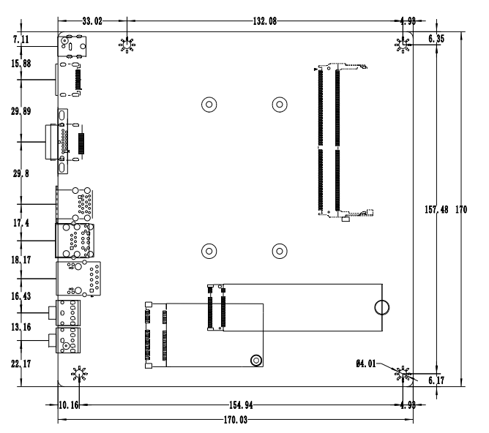
――――――――――――――――――――――――――――――――――――――――――――――――――――――
VGA+single network
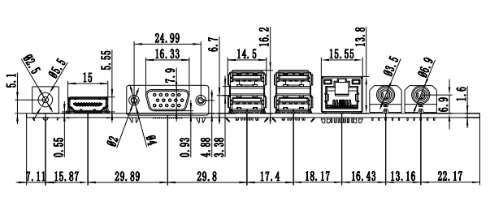
――――――――――――――――――――――――――――――――――――――――――――――――――――――
VGA+dual network
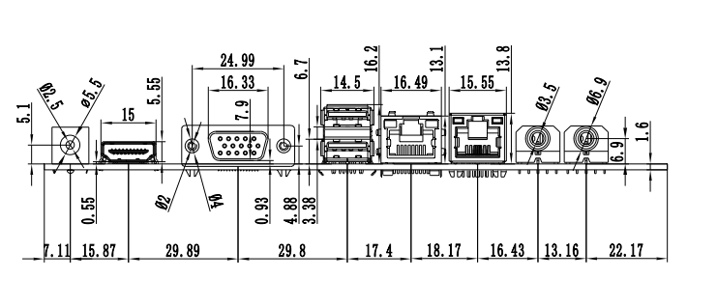
――――――――――――――――――――――――――――――――――――――――――――――――――――――
DP+single network
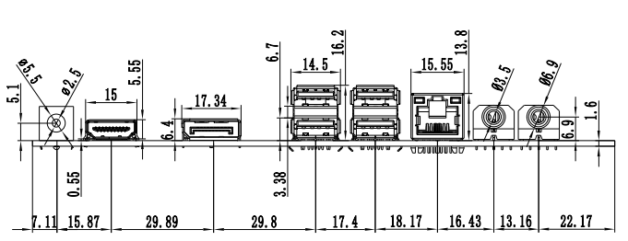
――――――――――――――――――――――――――――――――――――――――――――――――――――――
DP+dual network



