ELSKY NANO12U NANO13U V1.2 Motherboard Specification
――――――――――――――――――――――――――――――――――――――――――――――――――――――
Motherboard diagram↓
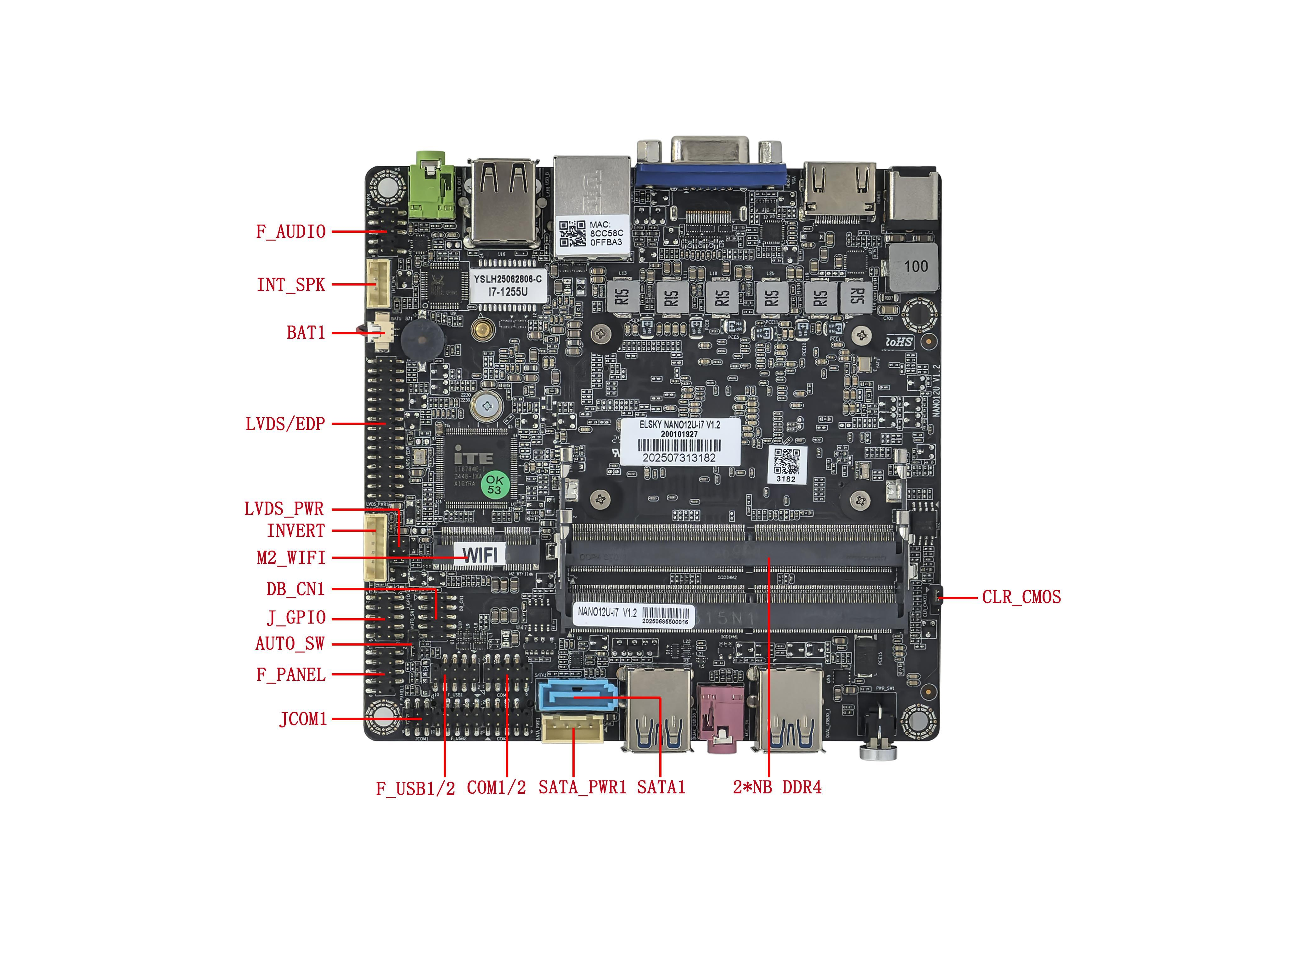
――――――――――――――――――――――――――――――――――――――――――――――――――――――
VGA+ single network interface↓
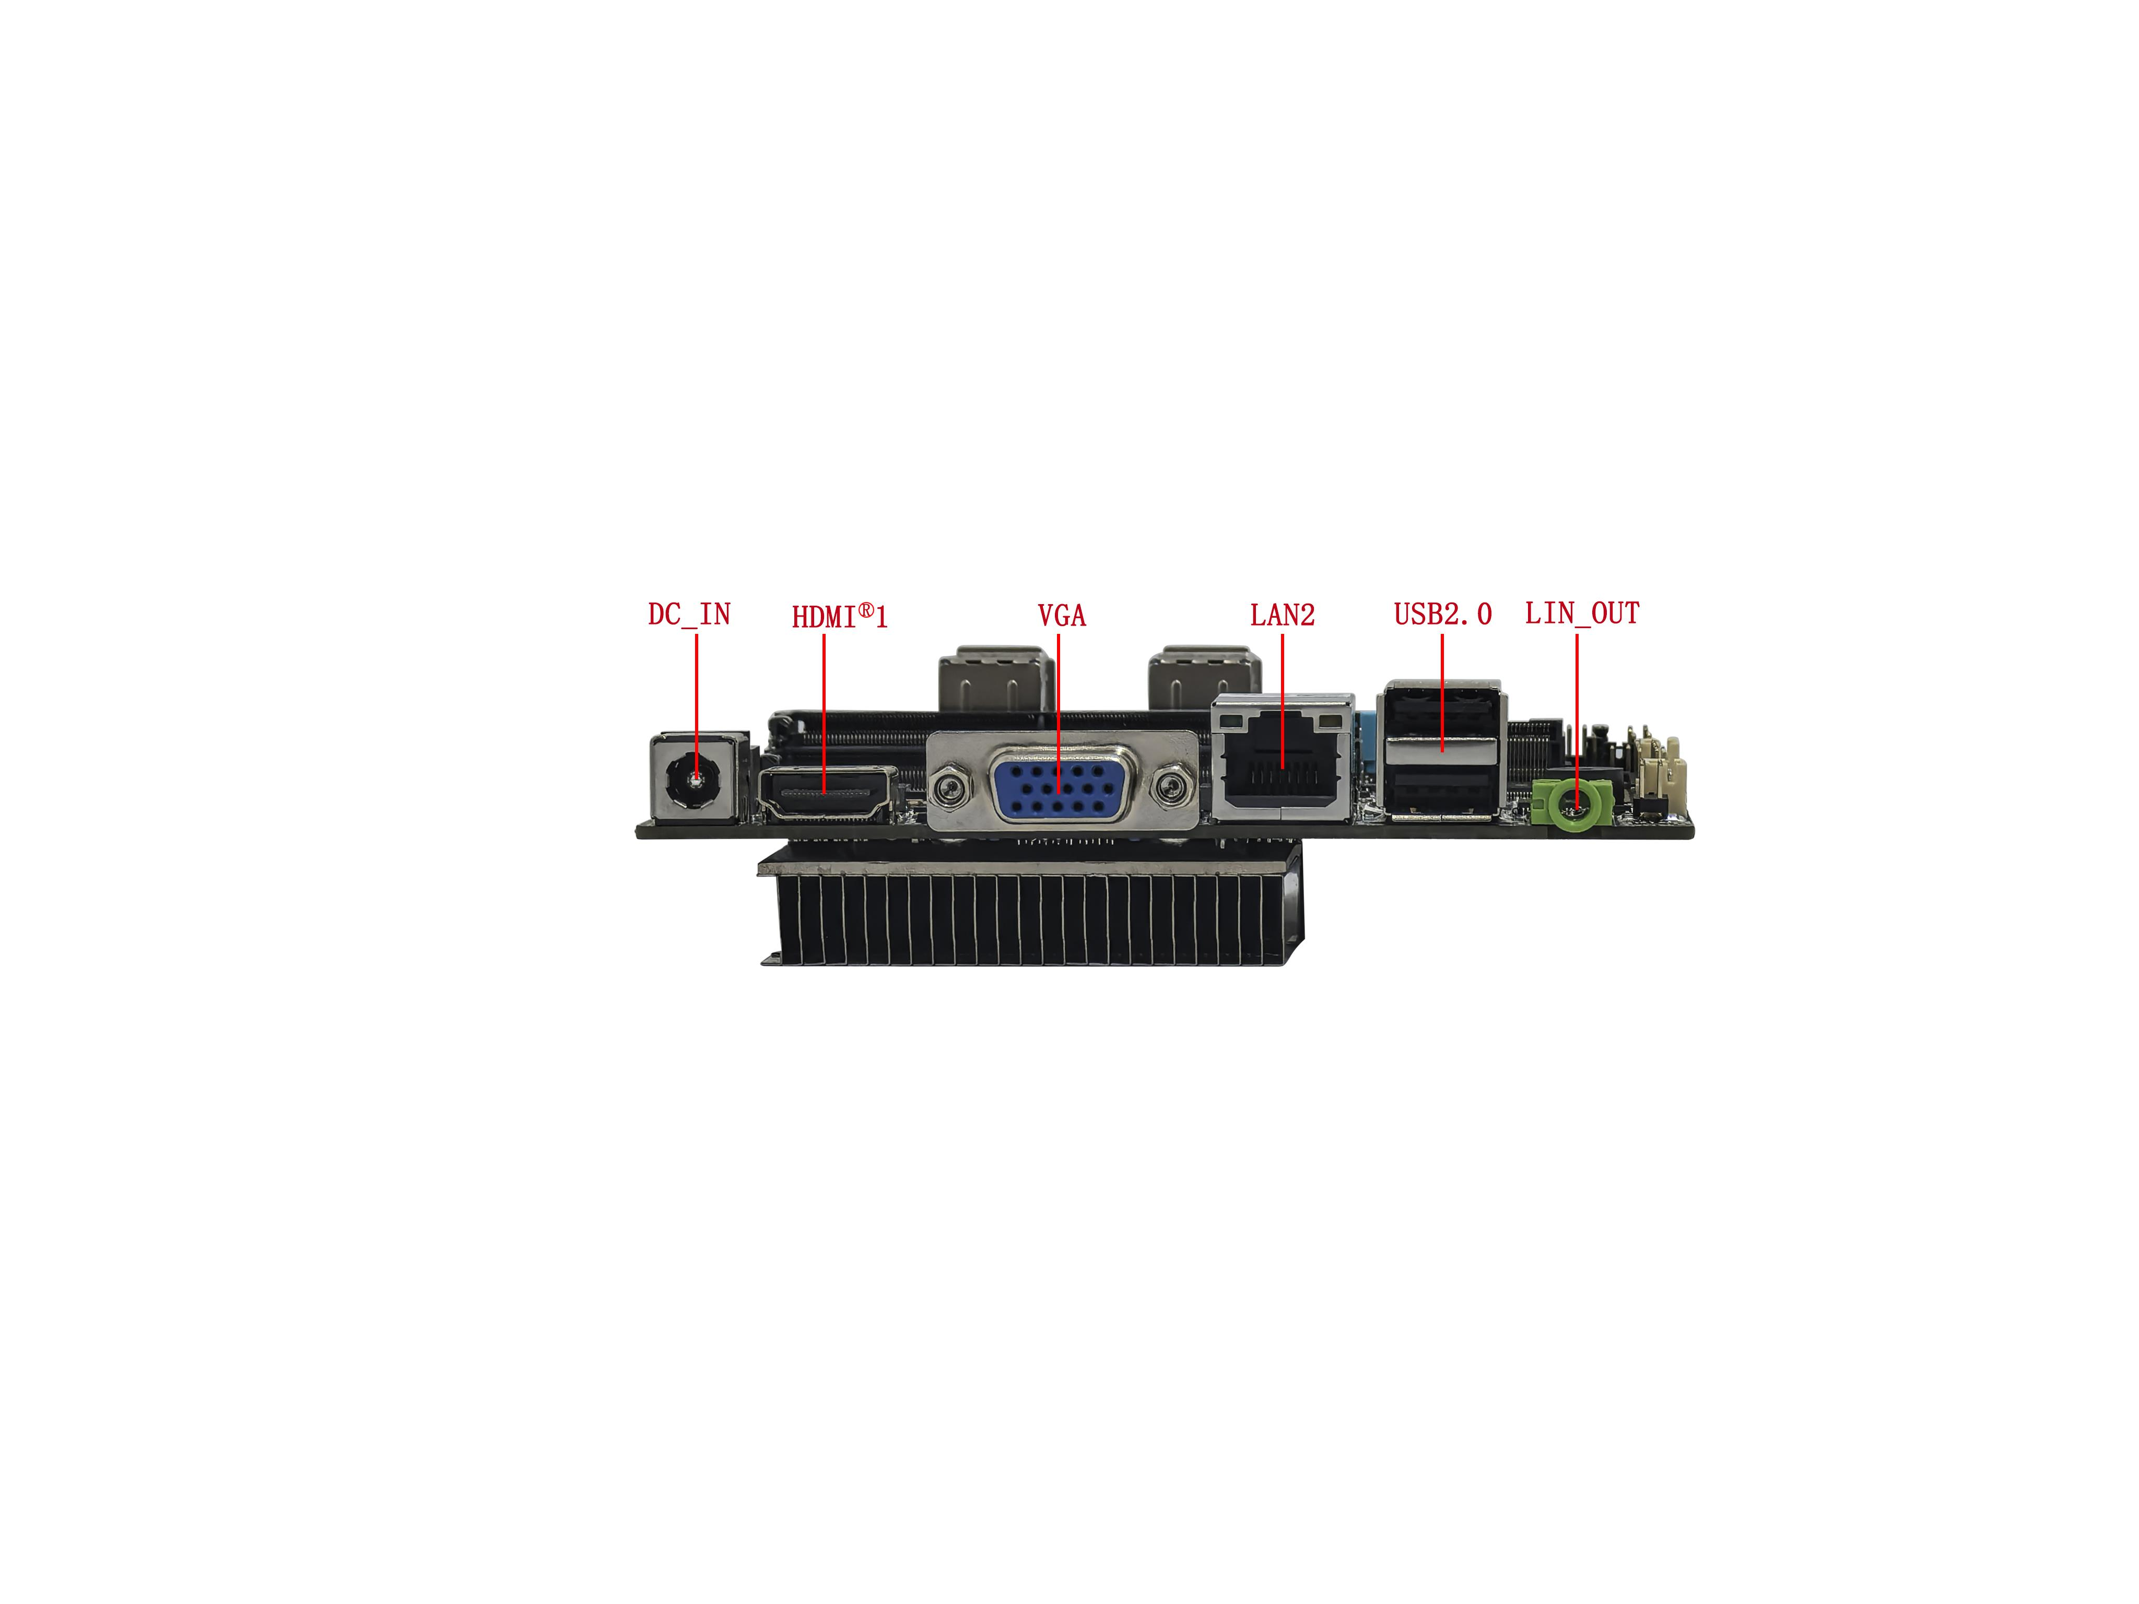
――――――――――――――――――――――――――――――――――――――――――――――――――――――
VGA+ dual network interface↓
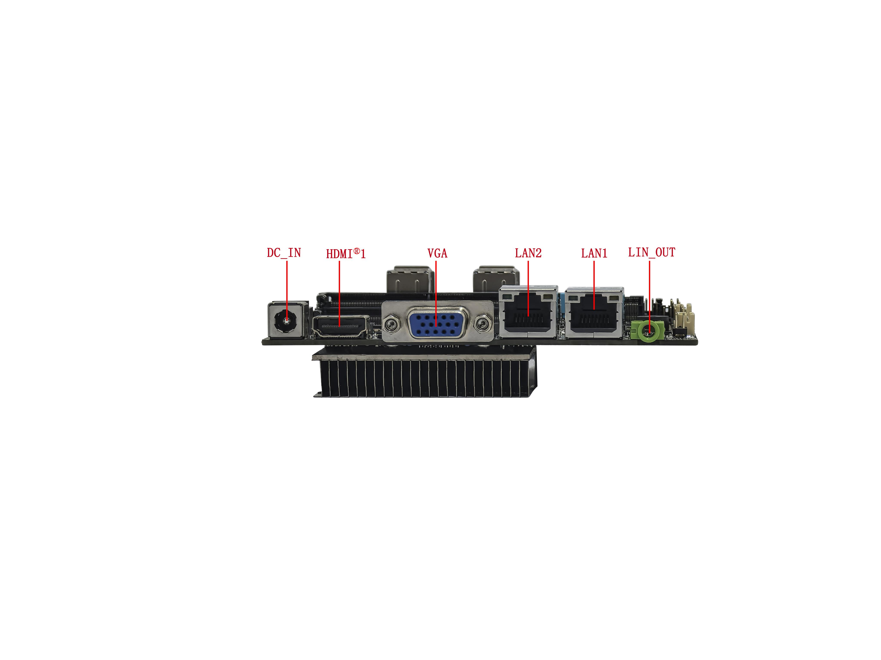
――――――――――――――――――――――――――――――――――――――――――――――――――――――
Dual HMDI+ single network interface↓
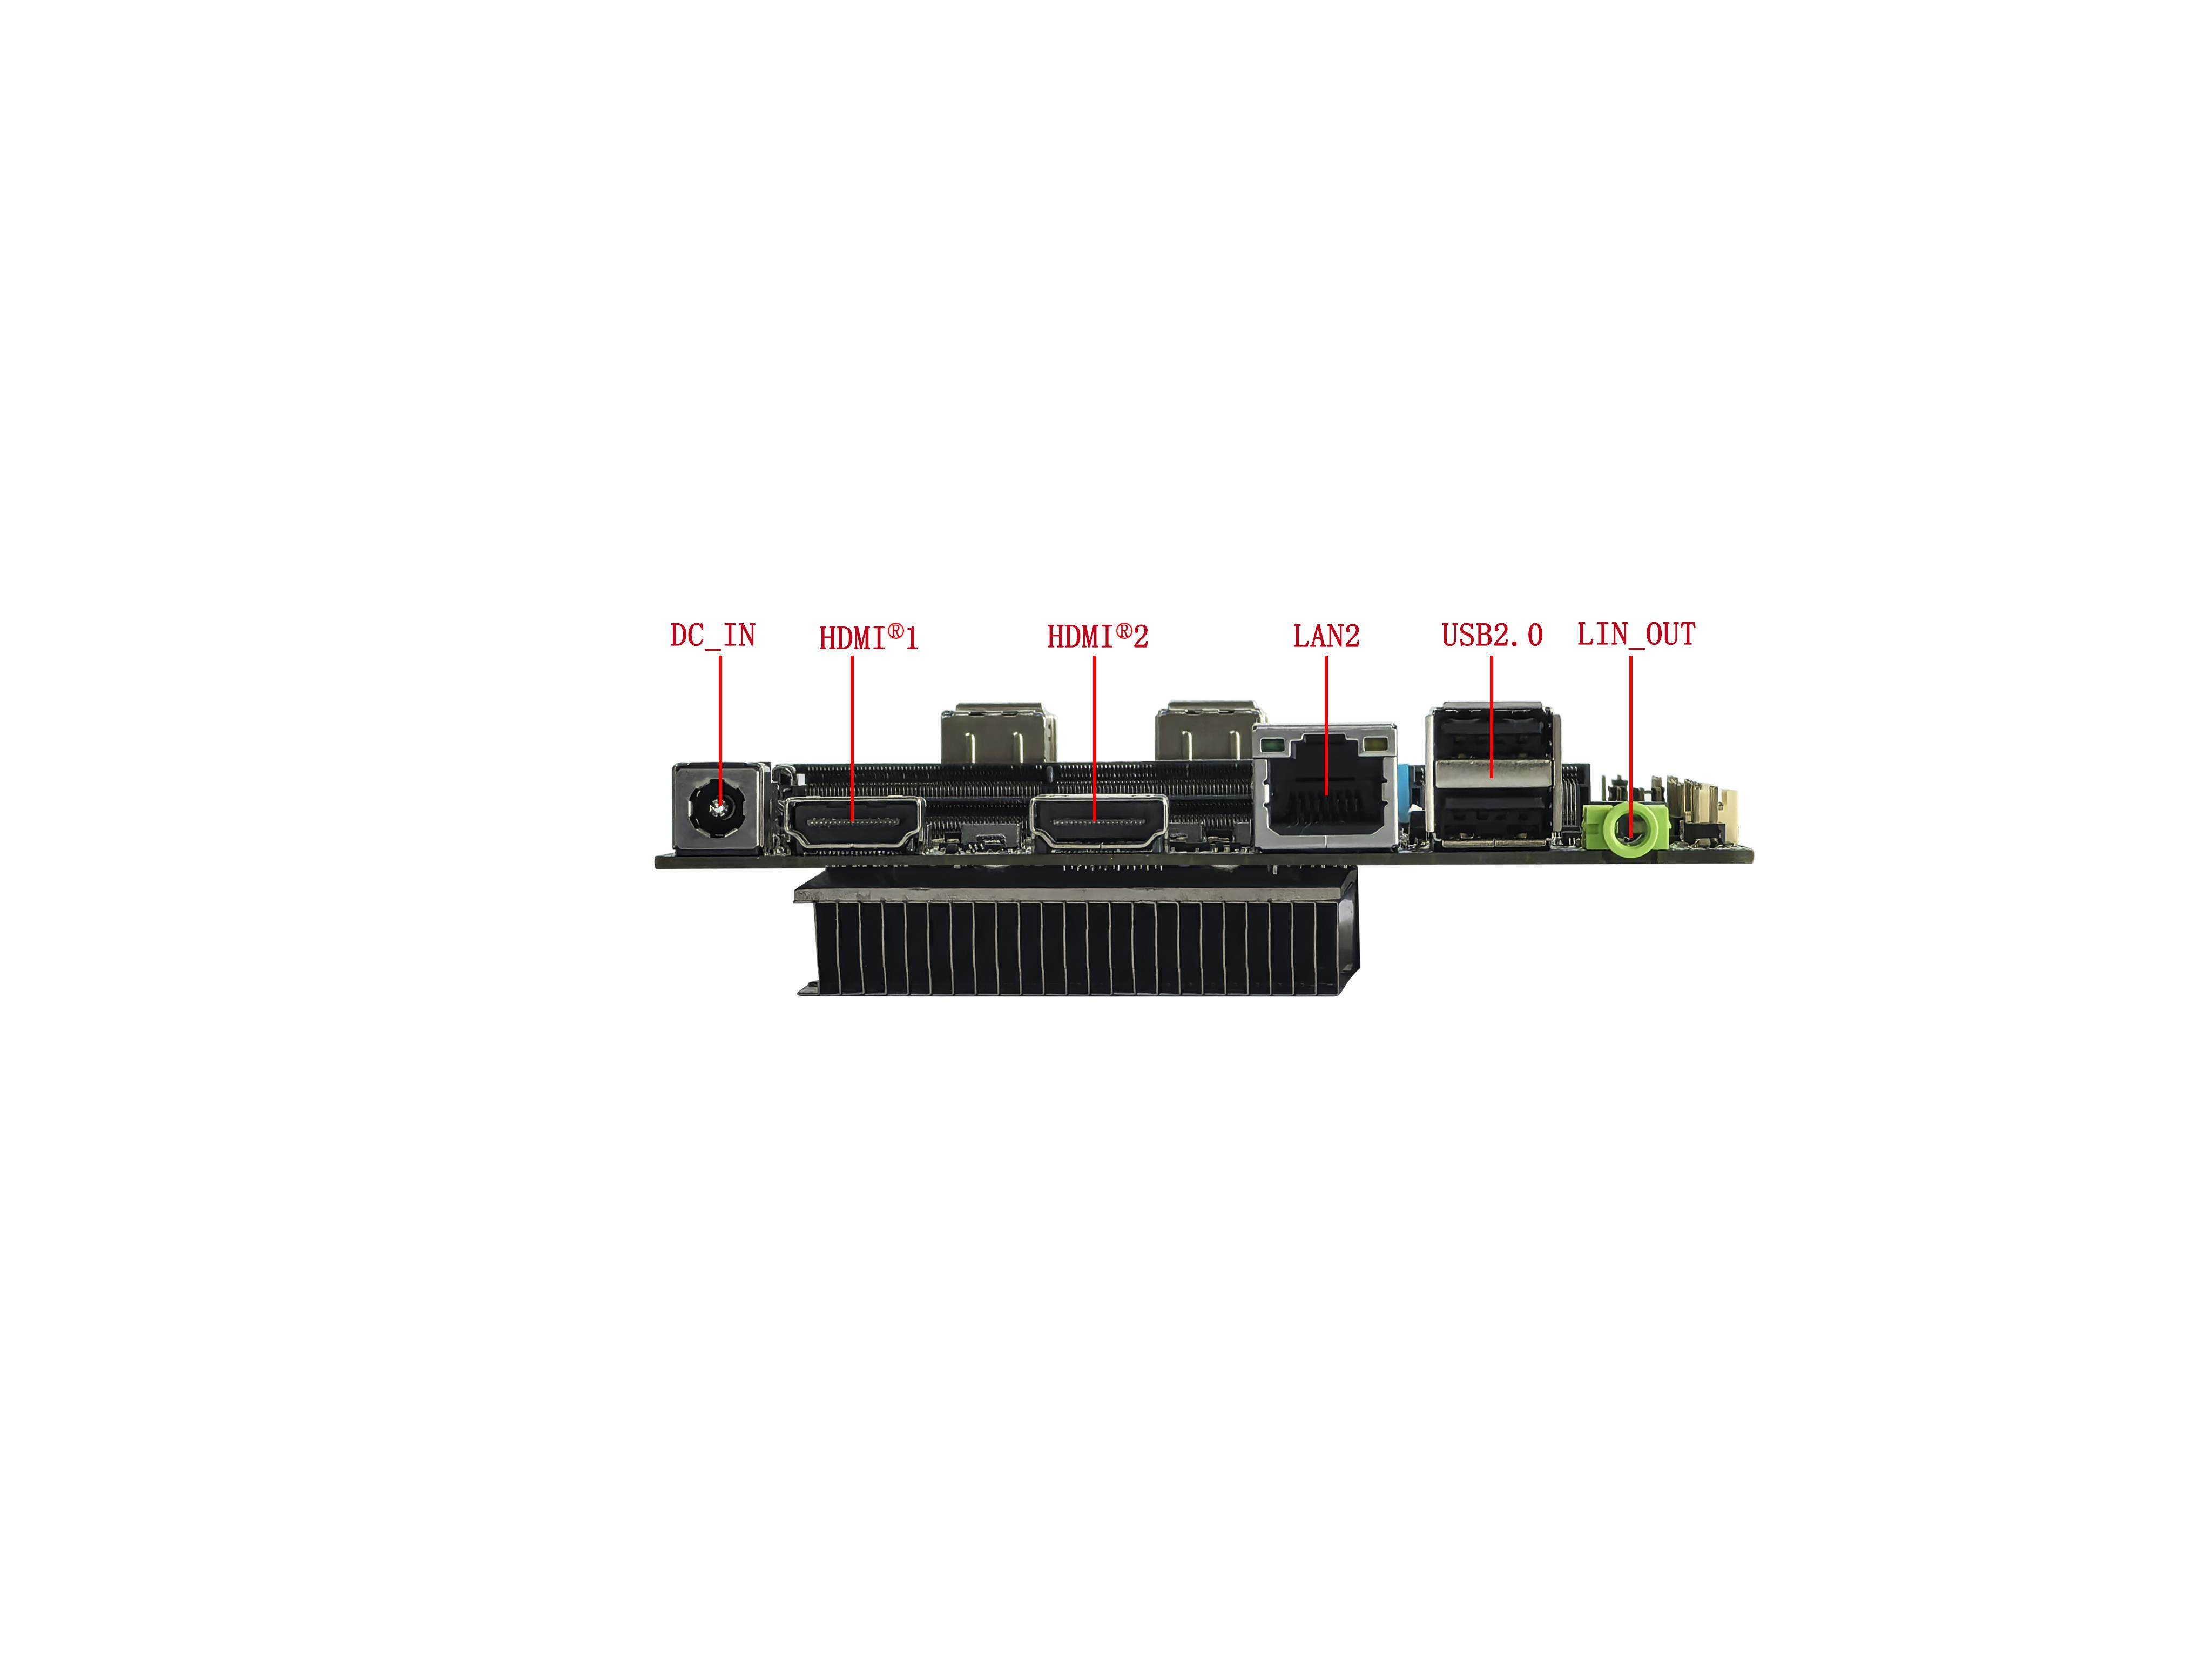
――――――――――――――――――――――――――――――――――――――――――――――――――――――
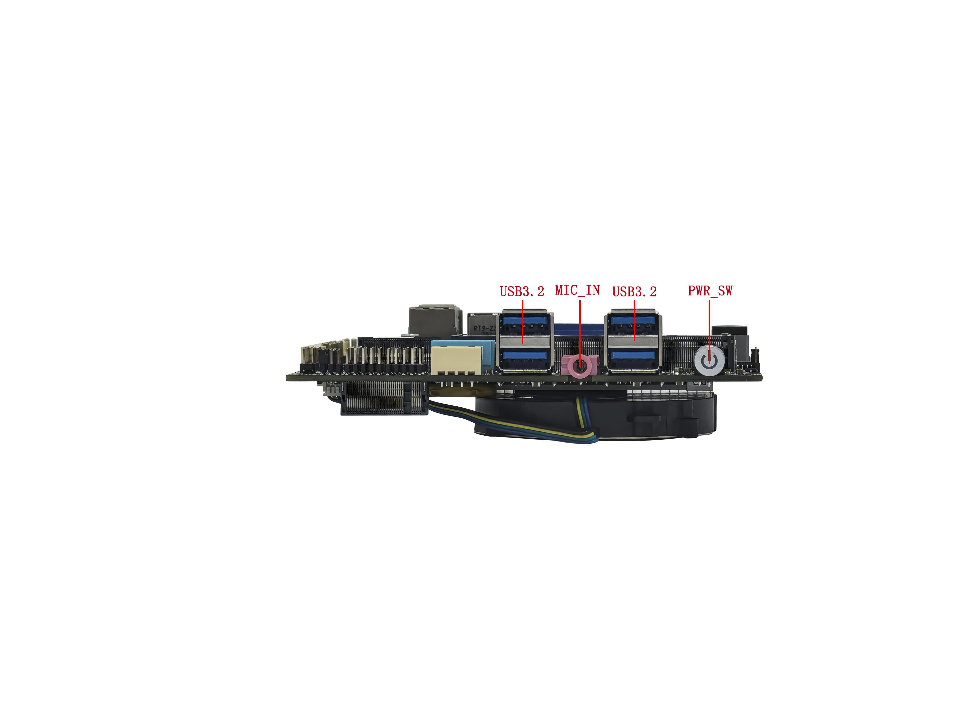
――――――――――――――――――――――――――――――――――――――――――――――――――――――
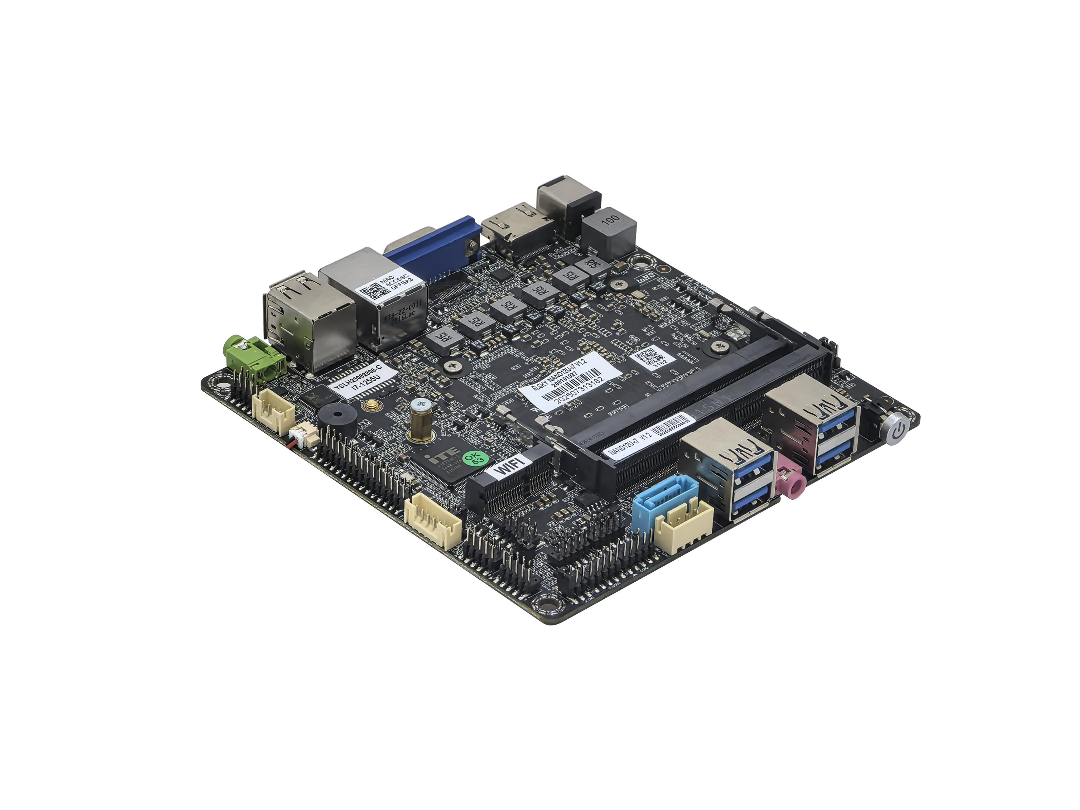
――――――――――――――――――――――――――――――――――――――――――――――――――――――
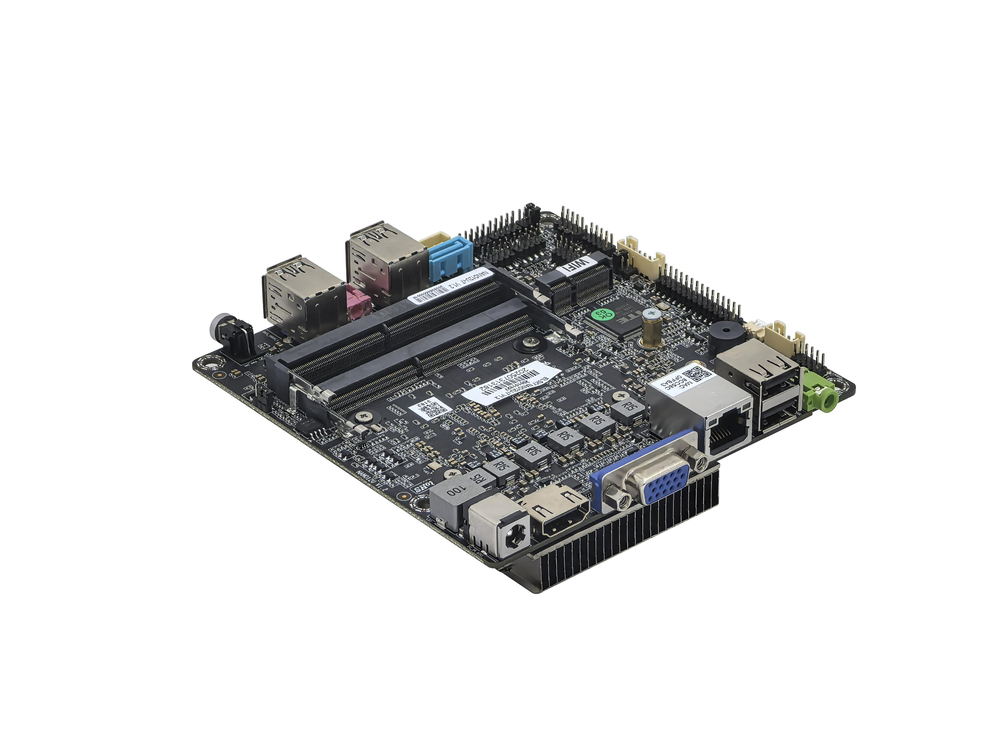
――――――――――――――――――――――――――――――――――――――――――――――――――――――
Back of motherboard↓
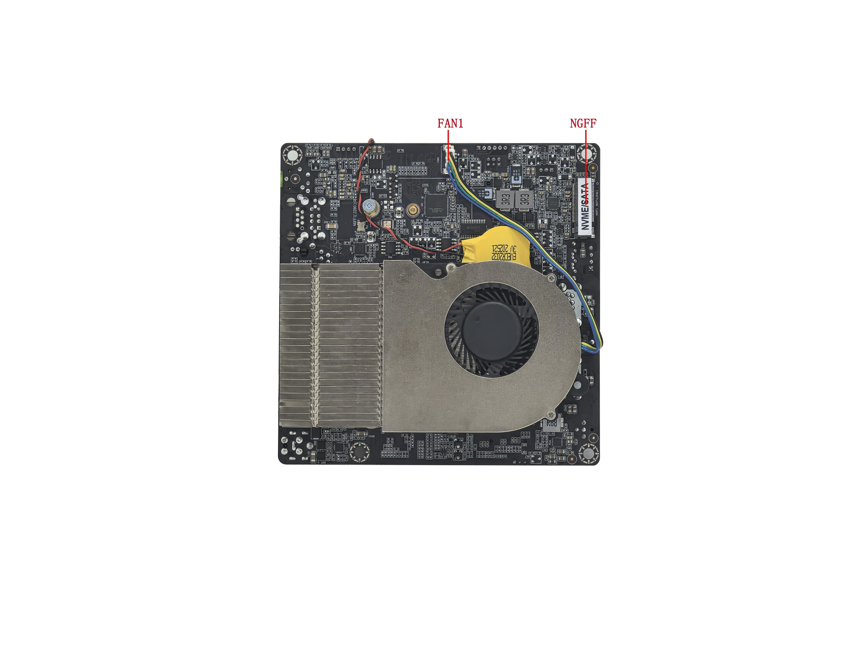
――――――――――――――――――――――――――――――――――――――――――――――――――――――
The above pictures are for reference only, please refer to the actual product for details!
Product model ordering optional:
Model | CPU | 4K | COM | LAN | USB2.0 | USB3.2 | SSD | Memory | Power
NANO12U | Support Intel® Alder Lake 12th gen U/P/H series i3,i5,i7,i9 | Support | 2 | 1 | 6 | 4 | 1*M.2  1*SATA | 2*NB-DDR4  Max 64G | 12V~24Vwide voltage
NANO12U | Support Intel® Alder Lake 12th gen U/P/H series i3,i5,i7,i9 | Support | 2 | 2 | 4 | 4 | 1*M.2  1*SATA | 2*NB-DDR4  Max 64G | 12V~24Vwide voltage
NANO13U | Support Intel® Raptor Lake 13th gen U/P/H series i3,i5,i7,i9 | Support | 2 | 1 | 6 | 4 | 1*M.2  1*SATA | 2*NB-DDR4  Max 64G | 12V~24Vwide voltage
NANO13U | Support Intel® Raptor Lake 13th gen U/P/H series i3,i5,i7,i9 | Support | 2 | 2 | 4 | 4 | 1*M.2  1*SATA | 2*NB-DDR4  Max 64G | 12V~24Vwide voltage

Important notice:
Power supply interface:
The motherboard supports 12V~24V wide voltage power supply; The DC interface specification of the motherboard is 5.5 * 2.5, which can be modified to support a 4pin ATX1 power socket;
The maximum turbo power consumption of the U series CPU is 55W, and it is recommended to use a 12V 7A or higher power supply;
The maximum turbo power consumption of the P series CPU is 64W, and it is recommended to use a 12V 7A or higher power supply;
The maximum turbo power consumption of the H series CPU is 115W, and it is recommended to use a 12V 10A or higher power supply;
Display interface:
1. Motherboard VGA/HDMI®2, HDMI®1, LVDS/EDP support single display, dual display/triple display replication, dual display/triple display expansion, and dual display under SHELL;
2. Motherboard VGA interface and HDMI®2 interfaces are optional, default supports VGA interface, can be changed to support HDMI®2 interfaces;
3 HDMI®1, HDMI®2 supports 4K resolution 4096/3840*2160@60Hz;
4.The motherboard's LVDS/EDP pins support LVDS by default, but can be changed to support EDP and share pins;
5.EDP uses EDP-B screen cable (20pin backlight separated independent screen cable), EDP supports 4K resolution 4096/3840*2160@60Hz;
M.2:
1. The motherboard M2_WIFI supports Key-E interface M.2 2230 PCIE3.0 x1 WiFi module, but does not support Bluetooth by default. It can be changed to support Bluetooth, but after the change, there is no signal at pins 2/4/6/8/10 of the built-in F_USB2;
2. The motherboard NGFF supports Key-M interface M.2 2280 NVME PCIE4.0 x4/SATA dual protocol adaptive standard SSD;
USB interface:
1.The motherboard supports 10*USB by default (4*USB3.2 Gen1,6*USB2.0);
2. All USB interfaces and pins on the motherboard default to S power (not charged after shutdown), and can be changed to A power (charged after shutdown);
COM interface:
1. The motherboard supports 2*COM; The COM1 port can optionally support RS232/RS422/RS485, which can be set through BIOS;
2. The motherboard COM1 can be set to output 0V/5V/12V through JCOM1 jump cap on the 9th pin, with a default of 0V;
Network card:
Single network: default support for Realtek 8111H Gigabit Ethernet card; Optional support for Motorcomm YT6801 Gigabit Ethernet card;
Dual network: supports Realtek 8111H and Realtek 8111H dual gigabit network cards; Optional support for Motorcomm YT6801+Motorcomm YT6801 dual gigabit network cards;
POE power supply cannot be changed;
Sound card:
The motherboard supports Realtek ALC897 sound card by default and cannot be changed to USB sound card;

The following CPU information is for reference only. Please consult sales for specific requirements!
CPU | CPU brand | CPU model | Kernel/Thread | Main frequency | Turbo | CPU basic power consumption (W) | Maximum turbo power consumption (W)
12th gen I3 | Core | 1215U | 6 cores and 8 threads | 1.2G | 4.4G | 15 | 55
12th gen I5 | Core | 1235U | 10 cores and 12 threads | 1.3G | 4.4G | 15 | 55
12th gen I5 | Core | 1245U | 10 cores and 12 threads | 1.6G | 4.4G | 15 | 55
12th gen I7 | Core | 1265U | 10 cores and 12 threads | 1.8G | 4.8G | 15 | 55
12th gen I7 | Core | 1255U | 10 cores and 12 threads | 1.7G | 4.7G | 15 | 55
13th gen I3 | Core | 1305U | 5 cores and 6 threads | 1.6G | 4.5G | 15 | 55
13th gen I3 | Core | 1315U | 6 cores and 8 threads | 1.2G | 4.5G | 15 | 55
13th gen I5 | Core | 1334U | 10 cores and 12 threads | 1.3G | 4.6G | 15 | 55
13th gen I5 | Core | 1335U | 10 cores and 12 threads | 1.3G | 4.6G | 15 | 55
13th gen I5 | Core | 1345U | 10 cores and 12 threads | 1.6G | 4.7G | 15 | 55
13th gen I7 | Core | 1355U | 10 cores and 12 threads | 1.7G | 5.0G | 15 | 55
13th gen I7 | Core | 1365U | 10 cores and 12 threads | 1.8G | 5.2G | 15 | 55
12th gen I3 | Core | 1220P | 10 cores and 12 threads | 1.5G | 4.4G | 28 | 64
12th gen I5 | Core | 1240P | 12 cores and 16 threads | 1.7G | 4.4G | 28 | 64
12th gen I5 | Core | 1250P | 12 cores and 16 threads | 1.7G | 4.4G | 28 | 64
12th gen I7 | Core | 1280P | 14 cores and 20 threads | 1.8G | 4.8G | 28 | 64
12th gen I7 | Core | 1260P | 12 cores and 16 threads | 2.1G | 4.7G | 28 | 64
12th gen I7 | Core | 1270P | 12 cores and 16 threads | 2.2G | 4.8G | 28 | 64
13th gen I5 | Core | 1340P | 12 cores and 16 threads | 1.8G | 4.6G | 28 | 64
13th gen I5 | Core | 1350P | 12 cores and 16 threads | 1.9G | 4.7G | 28 | 64
13th gen I7 | Core | 1360P | 12 cores and 16 threads | 2.2G | 5.0G | 28 | 64
13th gen I7 | Core | 1370P | 14 cores and 20 threads | 1.9G | 5.2G | 28 | 64
12th gen I5 | Core | 12450H | 8 cores and 12 threads | 2.0G | 4.4G | 45 | 95
12th gen I5 | Core | 12500H | 12 cores and 16 threads | 2.5G | 4.5G | 45 | 95
12th gen I5 | Core | 12600H | 12 cores and 16 threads | 2.7G | 4.5G | 45 | 95
12th gen I7 | Core | 12800H | 14 cores and 20 threads | 2.4G | 4.8G | 45 | 115
12th gen I7 | Core | 12700H | 14 cores and 20 threads | 2.7G | 4.7G | 45 | 115
12th gen I7 | Core | 12650H | 10 cores and 16 threads | 2.3G | 4.7G | 45 | 115
12th gen I9 | Core | 12900H | 14 cores and 20 threads | 2.5G | 5.0G | 45 | 115
13th gen I5 | Core | 13420H | 8 cores and 12 threads | 2.1G | 4.60G | 45 | 95
13th gen I5 | Core | 13500H | 12 cores and 16 threads | 2.6G | 4.70G | 45 | 95
13th gen I5 | Core | 13600H | 12 cores and 16 threads | 2.8G | 4.80G | 45 | 95
13th gen I7 | Core | 13620H | 10 cores and 16 threads | 2.4G | 4.90G | 45 | 115
13th gen I7 | Core | 13700H | 14 cores and 20 threads | 2.4G | 5.00G | 45 | 115
13th gen I7 | Core | 13800H | 14 cores and 20 threads | 2.5G | 5.20G | 45 | 115
13th gen I9 | Core | 13900H | 14 cores and 20 threads | 2.6G | 5.40G | 45 | 115

Explanation

Except for the accessories listed with the product configuration, the content contained in this manual does not represent our company's commitment. Our company reserves the right to make changes to this manual without further notice.

We are not responsible for any direct, indirect, intentional or unintentional damage or hidden dangers caused by improper installation or use.

Before ordering the product, please inquire with the distributor in detail about whether the product performance meets your needs.

The content of this manual is protected by copyright, and all rights reserved. Without permission, it may not be copied in any mechanical, electronic, or other way.The final interpretation right of this manual belongs to SHENZHEN ELSKY TECHNOLOGY CO.,LTD.

The above ordering information is for reference only. For specific inquiries, please consult our business and phone number is :0755-82260150
The motherboard driver download: https://pan.baidu.com/s/1ie7qi5NutS53ipPecRSYtw
Access password: cbn5
BIOS function buttons
BIOS function keys | Functional description
Press Delete when starting up | Enter the BIOS function interface
Press F11 to power on | Select the startup option, or choose to enter the BIOS function interface
← → | Move the left and right arrows to select an item
↑ ↓ | Move the up and down arrows to select an item
Enter | Select the project and enter the submenu
+/- | Change the selection or add or subtract numerical values
F1 | Display relevant help content
F9 | Restore factory settings
F10 | Save changes and exit
Esc | exit

Chapter 1,Product specification
Size | 120mm(L)*120mm(W)*32mm(H)
CPU | NANO12U | Support Intel ® Alder Lake 12th generation U/P/H series CPU
CPU | NANO13U | Support Intel ® Raptor Lake 13th generation U/P/H series CPU
Power supply | 1*DC_IN | The inner diameter of the DC head is 2.5mm, supporting 12V~24V wide voltage power supply  The maximum turbo power consumption of the U series CPU is 55W, and it is recommended to use a power supply of 12V 7A or 19V5A or above;  The maximum turbo power consumption of the P series CPU is 64W. It is recommended to use a power supply of 12V 7A or 19V5A or higher;  The maximum turbo power consumption of the H series CPU is 115W. It is recommended to use a power supply of 12V 10A or 19V 6.3A or above;
Power supply | 1*ATX1  (4Pin optional)
Memory | 2*SODIMM slots | NB-DDR4 memory,support 2133/2400/2666/2933/3200 memory ,max support 64G
Network function | 1/2*RJ45_LAN port | Single network supports Realtek 8111H Gigabit Ethernet card by default;  Optional support for Motorcomm YT6801 Gigabit Ethernet card;  Dual network support Realtek 8111H+Realtek 8111H dual gigabit network cards;  Optional support for Motorcomm YT6801+Motorcomm YT6801 dual gigabit network cards;  Support network wake-up and PXE diskless boot function;
Network function | 1*M2_WIFI port | Supports Key-E interface M.2 2230 PCIE3.0 x1 WiFi module, can be modified to support WiFi Bluetooth module
Display function | Intel® UHD Graphics Ultra Core Graphics Card |  |  | Supports single display, dual display/triple display replication, dual display/triple display expansion, and dual display under SHELL;
Display function | 1*HDMI®1 2.0 port | Support 4K resolution 4096/3840*2160@60Hz
Display function | 1*VGA DB15 port | Support resolution 1920*1080@60Hz
Display function | 1*HDMI®2 2.0 port(optional) |  | Support 4K resolution 4096/3840*2160@60Hz
Display function | VGA interface can be changed to support HDMI®2 2.0 interface
Display function | 1*LVDS/EDP pin | Support resolution 1920*1080@60Hz （30Pin，2*15Pin，2.0mm）
Display function | 1*LVDS_PWR pin | LVDS/EDP working voltage control pin （6Pin，2*3Pin，2.0mm）
Display function | 1*INVERT pin | LVDS backlight control pin （6Pin，1*6Pin，2.0mm）
Display function | Default support for LVDS, optional support for EDP, shared pins;  EDP supports 4K resolution of 4096/3840*2160@60Hz, using EDP-B screen cable
USB function | 4*USB3.2 port | Rear standard USB 3.2 Gen1 interface, with a maximum transmission bandwidth of 5Gbps
USB function | 2*USB2.0 port | Rear standard USB 2.0 interface, with a maximum transmission bandwidth of 480Mbps
USB function | 1*F_USB1 pin | Front USB 2.0 pins, one set with 2 * USB 2.0 （9Pin，2*5Pin，2.0mm）
USB function | 1*F_USB2 pin | Front USB 2.0 pins, one set with 2 * USB 2.0 （9Pin，2*5Pin，2.0mm）
USB function | Choose between the USB signal of M2-WIFI and the built-in F_USB2 2nd/4th/6th/8th/10th signal;  F_USB2 has default signal on 2/4/6/8/10, M2-WIFI has no USB signal;
Sound function | Integrated Realtek ALC897 HD digital audio decoder, 6-channel high fidelity audio controller;
Sound function | 1*LIN_OUT port | Support audio output (green)
Sound function | 1*MIC_IN port | Support microphone input (red)
Sound function | 1*INT_SPK pin | Supports 8-ohm and 5-watt speaker output (amplifier) （4Pin，1*4Pin，2.0mm）
Sound function | 1*F_AUDIO pin | Standard audio pin （9Pin，2*5Pin，2.0mm）
Hard disk function | 1*NGFF port | Support Key-M interface M.2 2280 NVME PCIE4.0 x4/SATA adaptive standard SSD;
Hard disk function | 1*SATA1 port | Standard SATA hard drive interface, support SATA 3.0
Hard disk function | 1*SATA_PWR pin | Hard drive power supply pin, capable of supplying 5V and 12V power （4Pin，1*4Pin，2.54mm）
Switch function | 1*F_PANEL pin | Switch, power light, hard disk light, restart pin （9Pin，2*5Pin，2.0mm）
Switch function | 1*AUTO_SW pin | Hardware control power on plug （3Pin，1*3Pin，2.0mm）
Switch function | 1*PWR_SW button | Switch button
Other I/O | 1*COM1 pin | Support standard RS232/RS422/RS485 optional（BIOS settings）  （9Pin，2*5Pin，2.0mm）
Other I/O | 1*COM2 pin | Only support standard RS232 （9Pin，2*5Pin，2.0mm）
Other I/O | 1*JCOM1 pin | COM1 pin 9 is set to 0V/5V/12V （6Pin，2*3Pin，2.0mm）
Other I/O | 1*CLR_CMOS pin | Motherboard reset and discharge pins （3Pin，1*3Pin，2.0mm）
Other I/O | 1*FAN1 pin | CPU fan pin, 12V, supports temperature control （4Pin，1*4Pin，1.25mm）
Other I/O | 1*J_GPIO pin | GPIO control pin （10Pin，2*5Pin，2.0mm）
Other I/O | 1*DB_CN pin | Debugging pins （10Pin，2*5Pin，2.0mm）
Operating environment | Working temperature: -10℃~60℃;  Working humidity: 5%~95% relative humidity,no condensation
BIOS | AMI BIOS,support power on, timed power on, and intelligent recognition of remote power on/off devices
Watch Dog | Watchdog programming, supports hardware reset function (256 levels, 0-255 seconds)
Operating system | Support Windows 11, Windows 10, Linux, etc
――――――――――――――――――――――――――――――――――――――――――――――――――――――

1.2 Motherboard size diagram
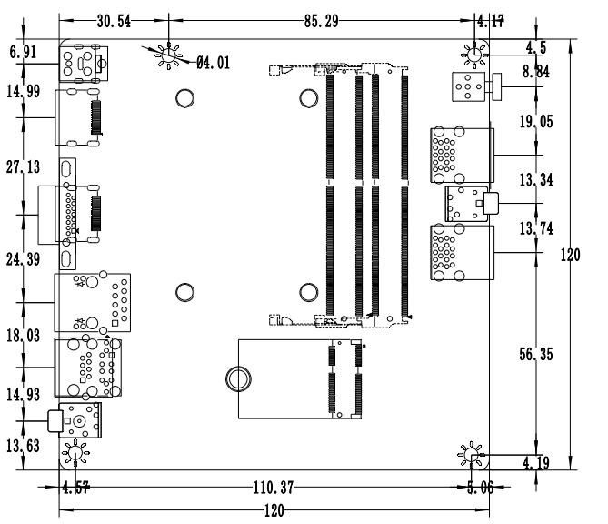
――――――――――――――――――――――――――――――――――――――――――――――――――――――
VGA+single network↓
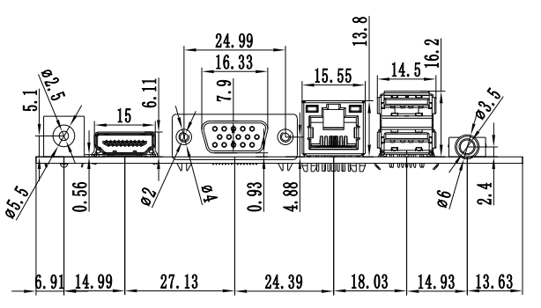
――――――――――――――――――――――――――――――――――――――――――――――――――――――
VGA+dual network↓
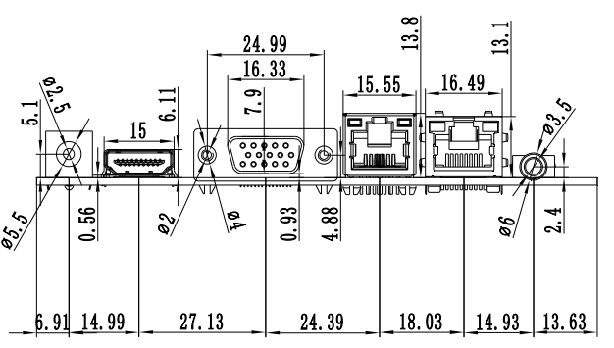
――――――――――――――――――――――――――――――――――――――――――――――――――――――
Dual HDMI®+single network↓
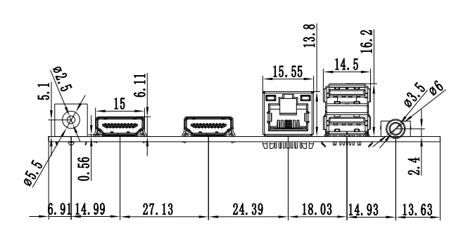
――――――――――――――――――――――――――――――――――――――――――――――――――――――
Dual HDMI®+dual network↓



