
ELSKY NANO19 Specification
――――――――――――――――――――――――――――――――――――――――――――――――――――――
PC size
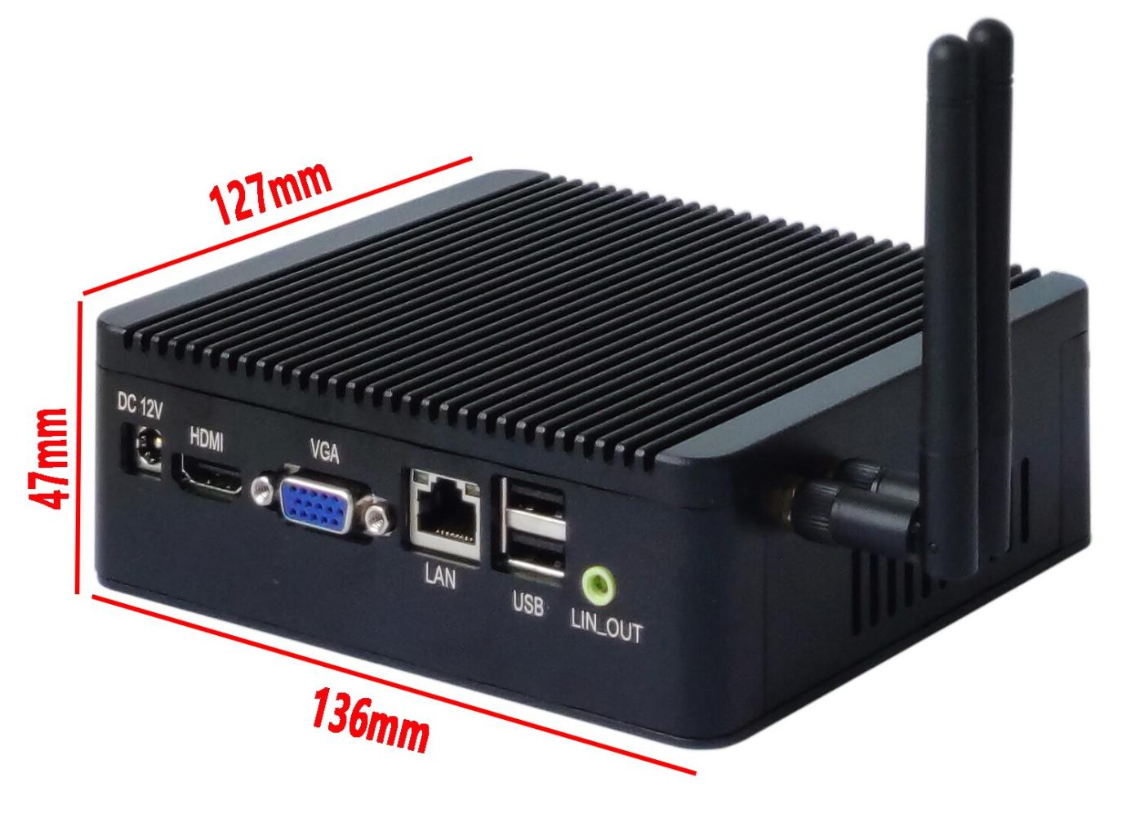
――――――――――――――――――――――――――――――――――――――――――――――――――――――
Single network interface diagram
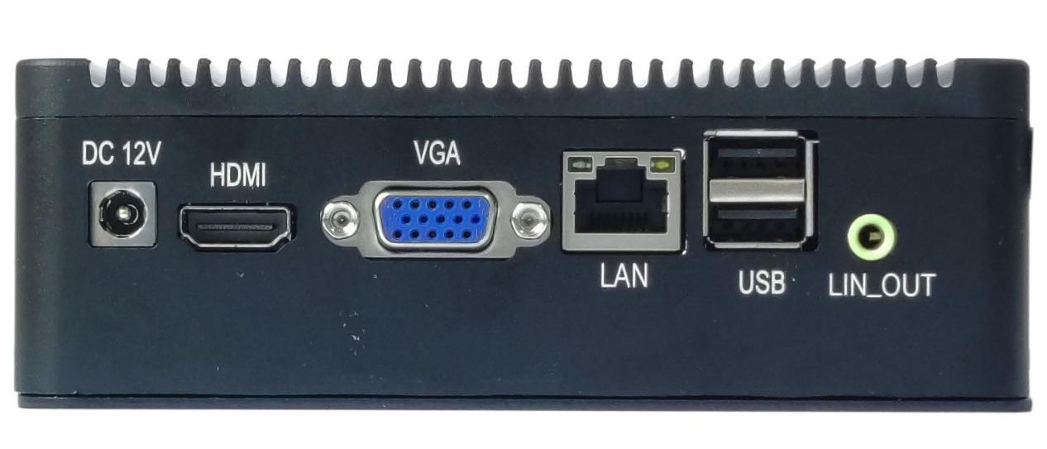
――――――――――――――――――――――――――――――――――――――――――――――――――――――
――――――――――――――――――――――――――――――――――――――――――――――――――――――
Dual network interface diagram
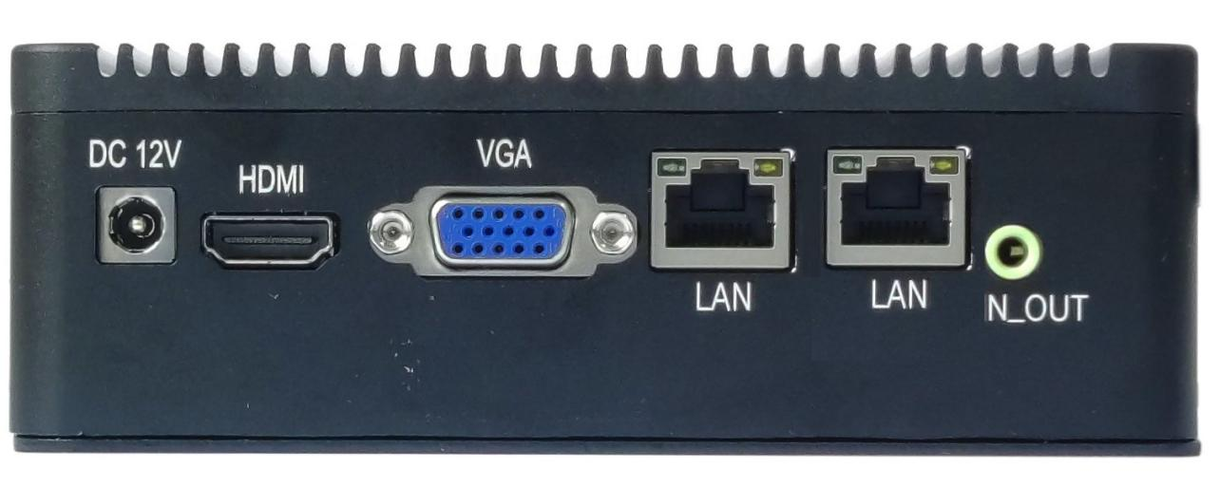
――――――――――――――――――――――――――――――――――――――――――――――――――――――

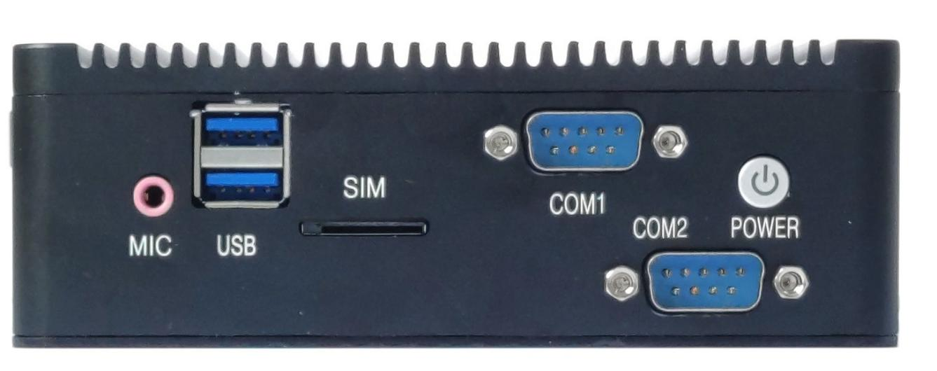
――――――――――――――――――――――――――――――――――――――――――――――――――――――
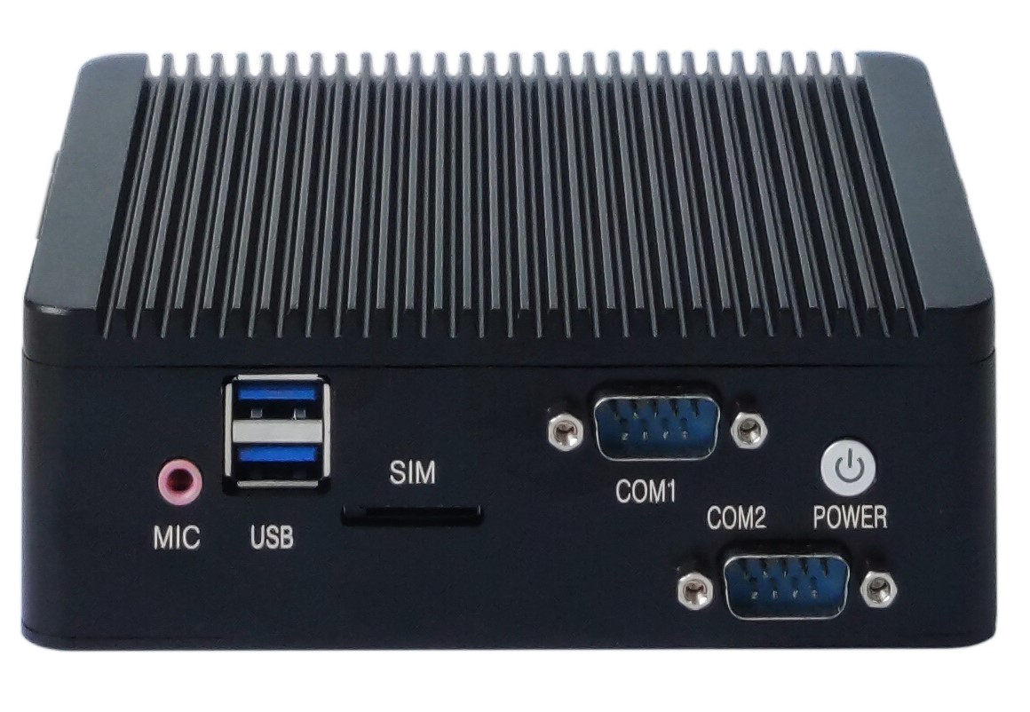
――――――――――――――――――――――――――――――――――――――――――――――――――――――
The pictures are for reference only, please refer to the actual product!
Product model ordering options:
PC model | CPU | 4K | LAN | COM | USB2.0 | USB3.0 | SSD | Memory | Power
NANO19 | J1800  J1900  J2900  Optional | / | 1 | 2 | 3 | 1 | 1*MSATA  1*SATA2.0 | 1*NB-DDR3  MAX 8GB | +12V
NANO19 | J1800  J1900  J2900  Optional | / | 2 | 2 | 1 | 1 | 1*MSATA  1*SATA2.0 | 1*NB-DDR3  MAX 8GB | +12V

Important Tips:
- The PC power supply only supports 12V, and the full load is about 30W. It is recommended to use a 12V4A or above power supply;
- PC VGA, HDMI support single display, dual display copy, dual display expansion, single display under DOS;
- The blue USB port on the PC has USB 3.0 at the bottom and USB 2.0 at the top . The black USB port is USB 2.0.
- The PC MSATA interface defaults to coexisting SATA signals and USB signals, and supports MSATA hard disks or WiFi modules with USB signals by default;
SATA signal can be changed to PCIE signal, and after the change, it can support PCIE signal WiFi module;
- The PC Mini-PCIE interface defaults to coexisting PCIE signals and USB signals, and supports WiFi/3G/4G/Bluetooth WiFi modules by default;
- All USB ports on the PC are S-type (no power after shutdown) and cannot be changed to A-type (power after shutdown);
- The mainboard COM port supports RS232 by default; COM2 can select RS232/RS422/RS485, which is controlled by JP9/JP10/JP11 jumper caps;
- The ninth pin of the motherboard COM1/2 can be set to 5V/12V through JCOM1/2, the default is 0V;
- The PC supports 100M and 1000M network cards; single and dual network ports are optional; POE power supply cannot be changed;

Product Specifications
PC model | NANO19
PC size | 136 mm ( L ) *1 27 mm ( W ) * 47 mm ( H )
CPU Processor | Intel® Processor Celeron J1800, Celeron J1900, Pentium J2900
Memory support | 1*DDR3 SODIMM memory slot, supports 1600MHz memory, low voltage 1.35V, maximum support 8GB
Power supply | 1*DC_IN | Supports 12V voltage, the inner diameter of the DC head is 2.5MM  The motherboard consumes about 30W when fully loaded. It is recommended to use a 12V4A or higher power supply
Display functions | Intel HD Graphics graphics controller , supports single display, dual display copy, dual display expansion, single display under DOS
Display functions | 1*HDMI 1.4 interface | Support resolution 1920*1080@60HZ
Display functions | 1*VGA DB15 interface | Support resolution 1920*1080@60HZ
Network Features | 1/2*RJ45 LAN interface | Realtek 8105E 100M and 8111 F 1000M network cards are optional, supporting network wake-up and PXE diskless boot functions
Network Features | 1*Mini-PCIE interface | Support WIFI/3G/4G/Bluetooth WiFi module
Hard disk function | 1*MSATA interface | Support MSATA disk, support SATA 2.0
Hard disk function | 1*SATA1 interface | Standard SATA2.0 hard disk interface
Hard disk function | 1*SATA_PWR1 pin | Hard disk power supply pin, can take 5V, 12V power. (4Pin, 1*4Pin, 2.54mm)
Sound Features | 1*LIN_OUT interface | Support audio output (green)
Sound Features | 1*MIC_IN interface | Support microphone input (red)
USB Function | 1*USB3.0 interface | Rear standard USB3.0 interface
USB Function | 3*USB2.0 interface | Rear standard USB2.0 interface
Switch function | 1* POWER button | Switch button
Other I/O | 1*SIM_CARD slot | Support SIM card, SIM card is required when using 3G/4G
Operating Environment | Working temperature: -20℃~60℃;  Working humidity: 5%~95% relative humidity, no condensation
BIOS | AMI BIOS, supports power-on, scheduled power-on, remote power on and off, and intelligent device identification
Watch Dog | Watchdog programming, support hardware reset function (256 levels, 0~255 seconds)
Operating system | Support Windows 10, Windows 8, Windows7, Linux, etc.

CPU Information
CPU Specifications | CPU Brand | CPU Model | Frequency | Turbo | CPU power consumption (W)
 | Intel Celeron | J1800 | Dual core 2.41G | 2.58G | 10W
 | Intel Celeron | J1900 | Quad-core 1.99G | 2.41G | 10W
 | Intel Pentium | J2900 | Quad-core 2.41G | 2.66G | 10W

