
ELSKY NANO4E V1.1 User manual
――――――――――――――――――――――――――――――――――――――――――――――――――――――
Motherboard schematic diagram↓
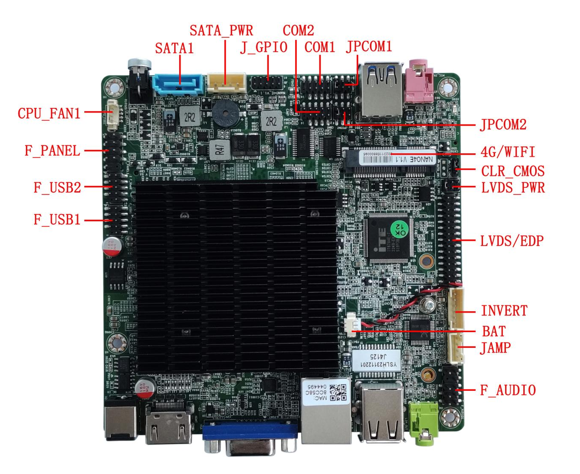
――――――――――――――――――――――――――――――――――――――――――――――――――――――
Schematic diagram of motherboard interface↓

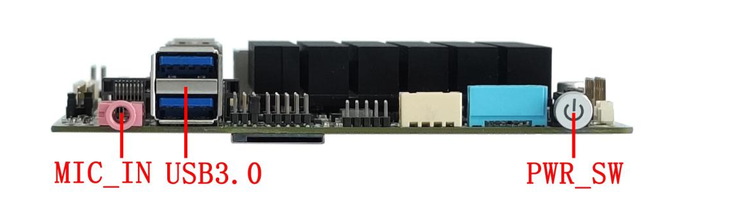
――――――――――――――――――――――――――――――――――――――――――――――――――――――
――――――――――――――――――――――――――――――――――――――――――――――――――――――
Schematic diagram of the back of the motherboard
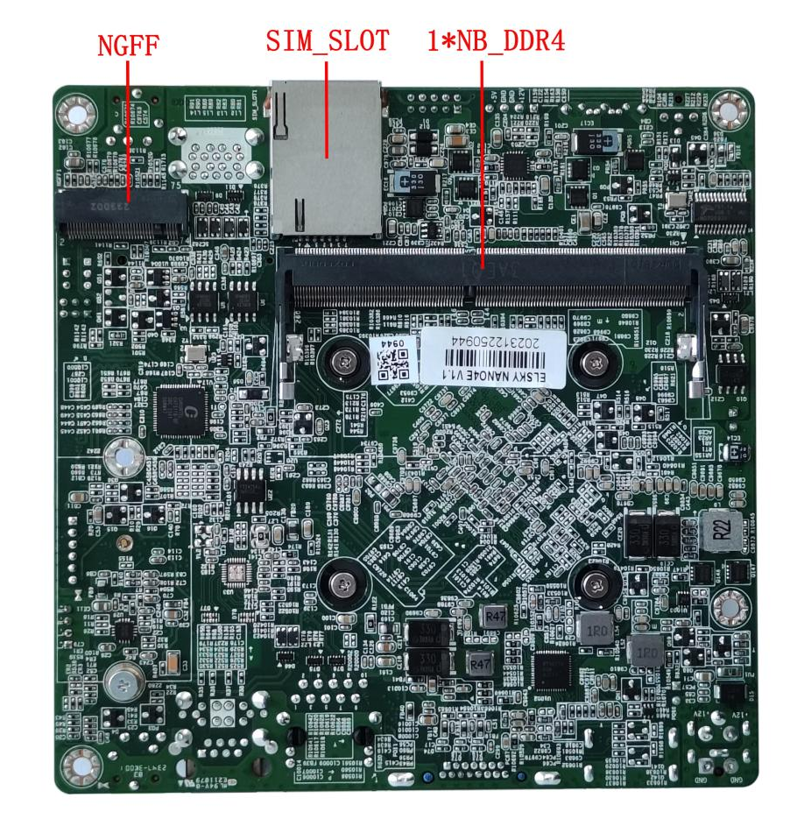
――――――――――――――――――――――――――――――――――――――――――――――――――――――
Schematic diagram of dual network interface↓

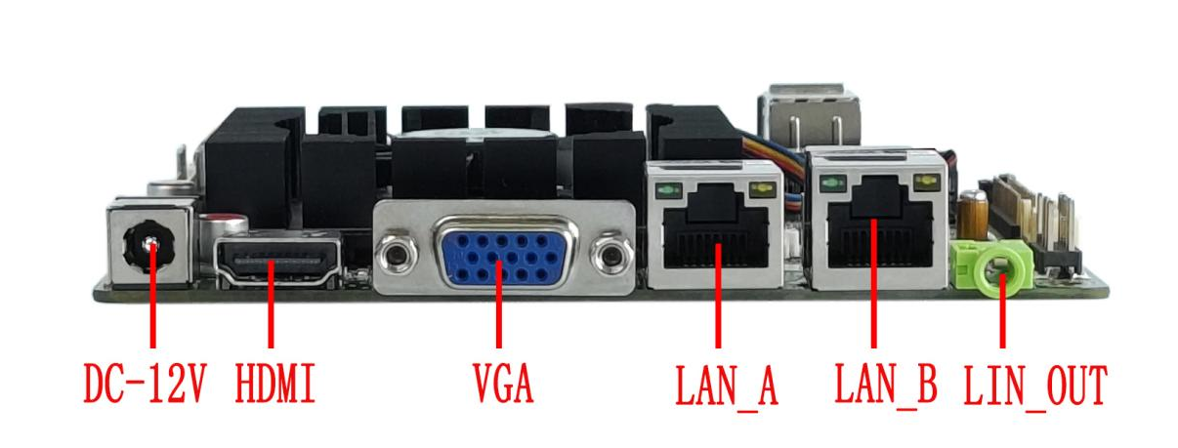
――――――――――――――――――――――――――――――――――――――――――――――――――――――
Single network interface schematic diagram↓

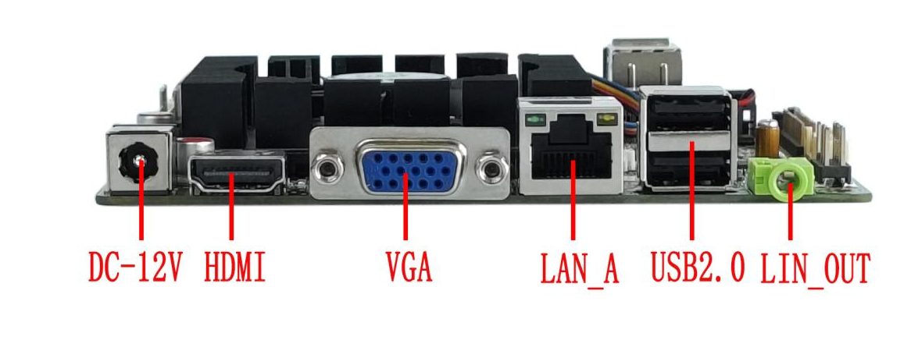
――――――――――――――――――――――――――――――――――――――――――――――――――――――

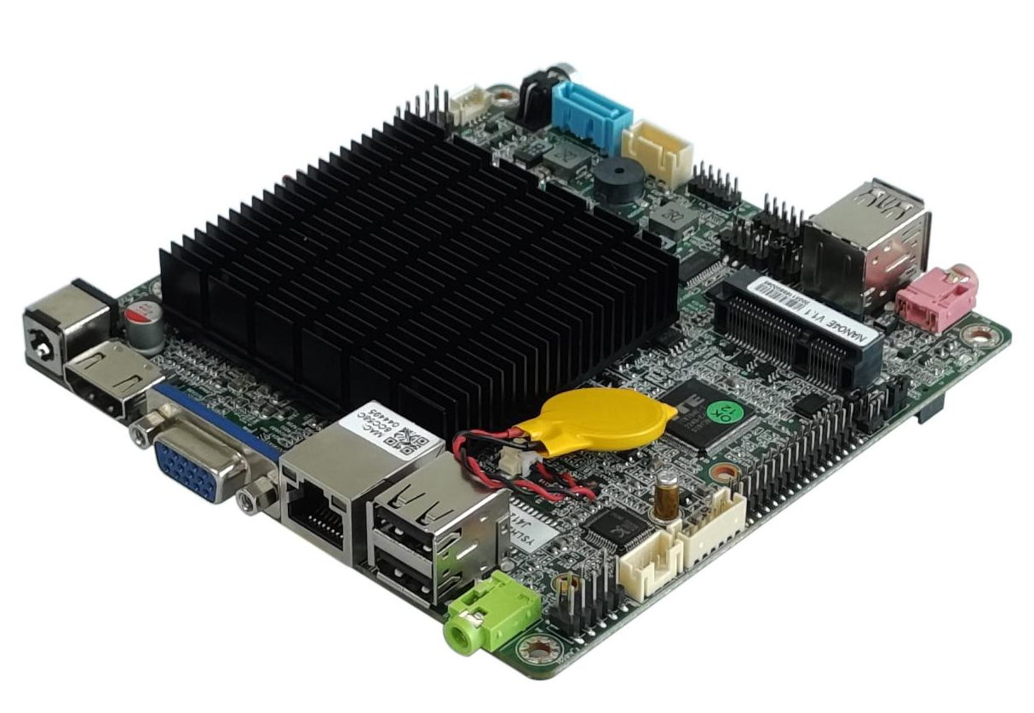

――――――――――――――――――――――――――――――――――――――――――――――――――――――
DC_TX power socket/with fan heat sink
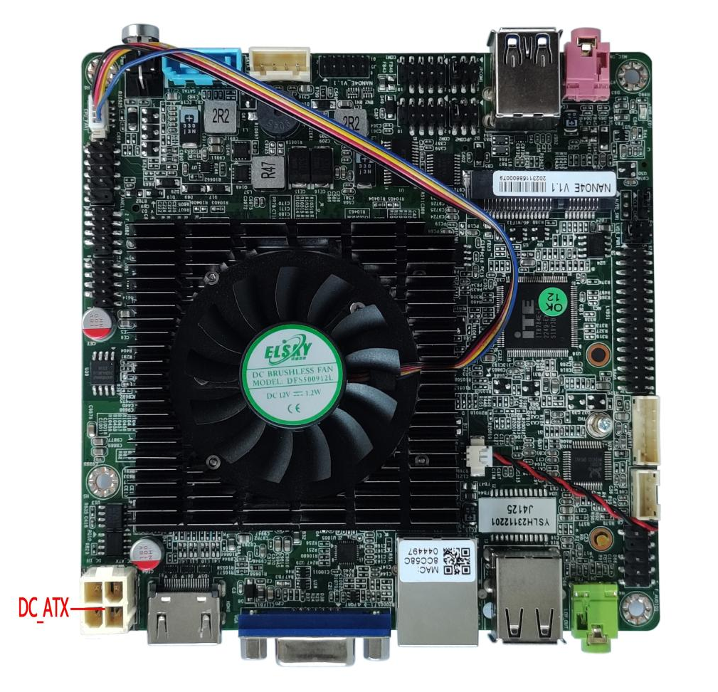
――――――――――――――――――――――――――――――――――――――――――――――――――――――
The motherboard image is for reference only, please refer to the actual product!
Product Model Ordering Optional：
Motherboard model | CPU | 4K | COM | LAN | USB2.0 | USB3.0 | SSD | Memory | Power
NANO4E | Support Intel Gemini Lake Refresh J and N series CPU  （as：J4125） | Support | 2C | 1LAN | 6*USB2.0 | 2*USB3.0 | 1*M.2  1*SATA 3.0 | 1*NB-DDR4  MAX 16G | +12V
 |  |  |  | 2LAN | 4*USB2.0 | 2 | 1*M.2  1*SATA 3.0 | 1*NB-DDR4  MAX 16G | +12V
Single network motherboard defaults to 8*USB; Dual network motherboard defaults to 6*USB
Important Note：
Power supply interface：
The DC interface specification of the motherboard is 5.5 * 2.5, and one 4pin ATX power interface can be modified;
The motherboard only supports 12V power supply, with a full load of about 30W. It is recommended to use a 12V4A or higher power supply;
Display interface：
1. The motherboard VGA, HDM, LVDS/EDP support single display, dual display/triple display replication, dual display/triple display expansion, and single display under DOS;
2. The motherboard's LVDS pins support LVDS by default, but can be changed to support EDP. Shared pins are used, and EDP uses EDP-B screen cables (20 pin backlight separate independent screen cables). EDP does not support 4K;
3. The motherboard HDMI interface supports HDMI 1.4 and 4K resolution of 4096/3840* 2160@30Hz ；
Mini-PCIE：
The Mini PCIe motherboard supports the coexistence of PCIe and USB signals by default, with USB being an independent signal; Default support for WiFi/4G/Bluetooth modules; PCIE signal cannot be changed to SATA signal;
M.2:
The motherboard NGFF supports Key-M interface M.2 2280 hard drive, optional M.2 2242 hard drive; Default support for NVME (PCIE) protocol, hardware can be changed to support SATA protocol;
M. Choose between the PCIE signal of 2 and the PCIE signal of LAN-B. By default, M.2 has a PCIE signal and LAN-B has no signal;
After the motherboard is converted to dual network, the M.2 interface only supports SATA protocol and does not support NVME (PCIE) protocol;
USB interface：
1. Single network motherboard supports 8 * USB (2 * USB 3.0, 6 * USB 2.0);
2. The USB interface of the motherboard defaults to S power (not charged after shutdown), but can be changed to A power (charged after shutdown); The built-in USB plug defaults to A power and can be changed to S power;
COM：
1. The motherboard supports 2COM, among which COM1 can optionally support RS232/RS422/RS485, set through BIOS, 1 * RS422 or 1 * RS485;
2. The JPCOM1/2 pins on the motherboard control the voltage of pin 9 of COM1/2 to 0V/5V/12V, with a default of 0V;
Network card：
1. Single network: default Realtek 8111H Gigabit Ethernet card or Realtek 8106E 100Mbps Ethernet card;
2. Dual network: Realtek 8111H+Realtek 8111H Gigabit Ethernet card; Or Realtek 8106E+Realtek 8106E 100Mbps network card;
3. After the motherboard is converted to dual network, the M.2 interface only supports SATA protocol and does not support NVME (PCIE) protocol;
4. POE power supply cannot be changed;
Sound card：
The motherboard supports Realtek ALC 897/662 sound card by default, and the built-in F_AUDIO pin is available. The USB sound card cannot be changed;

The following CPU information is for reference only. Please consult sales for specific requirements!
CPU brand | CPU model | main frequency | Turbo | CPU Power consumption（W） | The full load power consumption of the entire board is about
Intel Celeron | J4025 | Dual core 2.00G | 2.90G | 10W | 30W
Intel Celeron | J4125 | Quad core 2.00G | 2.70G | 10W | 30W
Intel Celeron | N4020 | Dual core 1.10G | 2.80G | 6W | 30W
Intel Celeron | N4120 | Quad core  1.10G | 2.60G | 6W | 30W
Intel Pentium | J5040 | Quad core  2.00G | 3.20G | 10W | 30W
Intel Pentium | N5030 | Quad core  1.10G | 3.10G | 6W | 30W

Statement

Except for the accessories listed with the product configuration, the content contained in this manual does not represent our company's commitment. Our company reserves the right to make changes to this manual without further notice.
We are not responsible for any direct, indirect, intentional or unintentional damage or hidden dangers caused by improper installation or use.
Before ordering the product, please inquire with the distributor in detail about whether the product performance meets your needs.
The content of this manual is protected by copyright, and all rights reserved. Without permission, it may not be copied in any mechanical, electronic, or other way.
The final interpretation of this manual belongs to SHENZHEN ELSKY TECHNOLOGY CO.,LTD.

The above ordering information is for reference only. For specific inquiries, please contact our business at 0755-82260150
Motherboard driver download https://pan.baidu.com/s/1ie7qi5NutS53ipPecRSYtw
Access password cbn5

BIOS function buttons
BIOS function buttons | Function Description
Press Delete when starting up | Enter the BIOS function interface
Press F11 to power on | Select the startup option, or choose to enter the BIOS function interface
← → | Move the left and right arrows to select an item
↑ ↓ | Move the up and down arrows to select an item
Enter | Select the project and enter the submenu
+/- | Change the selection or add or subtract numerical values
F1 | Display relevant help content
F9 | Restore factory settings
F10 | Save Changes and Exit
Esc | exit

Chapter 1: Product Specifications
Motherboard model | NANO4E
Motherboard size | 120mm（L）*120mm（W）*24mm（H）
CPU processor | Intel ® Processor: Celeron J4025/J4125/N4020/N4120, Pentium J5040/N5030
Memory support | 1*NB-DDR4 SODIMM memory slot, supports single channel 2400MHz memory, low voltage 1.2V, maximum support 16GB
Power supply | 1*DC_IN | Supports 12V voltage, with a DC head inner diameter of 2.5mm  The full load power consumption of the motherboard is about 30W. Suggest using a 12V/4A or higher power supply
Power supply | 1*DC_ATX(optional)
Power supply | DC-IN and DC_TX are two options, and the motherboard supports DC-IN by default
Display function | Intel ® Ultra HD graphics card 600 graphics controller, supporting single display, dual display/triple display copying, dual display/triple display expansion, single display under DOS
Display function | 1*HDMI 1.4 interface | Supports 4K resolution of 4096/3840* 2160@30Hz
Display function | 1*VGA DB15 interface | Support resolution 1920 * 1080@60Hz
Display function | 1*LVDS/EDP Pin | Support resolution 1920 * 1080@60Hz （30Pin，2*15Pin，2.0mm）
Display function | 1*LVDS_PWR1 Pin | LVDS/EDP working voltage control pin （6Pin，2*3Pin，2.0mm）
Display function | The motherboard has a choice between LVDS and EDP. LVDS is supported by default, but EDP can be changed to use EDP-B screen cable
Network function | 1/2*RJ45 LAN interface | Default support for single gigabit network card, optional 100Mbps network card, supports network wake-up and PXE diskless boot function  (Gigabit: single network Realtek 8111H, dual network Realtek 8111H+Realtek 8111H)  (100Mbps: single network Realtek 8106E, dual network Realtek 8106E+Realtek 8106E)
Network function | 1*Mini-PCIE interface | Support WIFI/4G/GPS/Bluetooth modules, etc
Hard disk function | 1*NGFF(M.2) interface | Support Key-M interface M.2 2280/2422 hard drive; Default NVME (PCIE) protocol, SATA protocol can be changed
Hard disk function | Choose between the PCIE signal of NGFF interface and the PCIE signal of LAN-B. The dual network motherboard only supports SATA protocol
Hard disk function | 1*SATA1 interface | Standard SATA 3.0 hard drive interface, maximum transfer speed of 6.0 Gbps
Hard disk function | 1*SATA_PWR1 Pin | The hard drive power supply pin can be powered with 5V or 12V. （4Pin，1*4Pin，2.54mm）
Sound function | Integrated Realtek ALC 897/662 HD digital audio decoder, 6-channel high fidelity audio controller
Sound function | 1*LIN_OUT interface | Supports audio output (green)
Sound function | 1*MIC_IN interface | Supports microphone input (red)
Sound function | 1*JAMP Pin | The amplifier supports dual channel output with 8 ohms and 5 watts speakers （4Pin，1*4Pin，2.0mm）
Sound function | 1*F_AUDIO Pin | Standard audio pin （9Pin，2*5Pin，2.54mm）
USB function | 2*USB3.0 interface | Rear standard USB 3.0 interface, maximum transmission bandwidth of 5.0Gbps
USB function | 2*USB2.0 interface(optional) | Rear standard USB 2.0 interface, with a maximum transmission bandwidth of 480Mbps
USB function | 1*F_USB1 Pin | Front USB 2.0 pins, one set with 2 * USB 2.0 （9Pin，2*5Pin，2.0mm）
USB function | 1*F_USB2 Pin | Front USB 2.0 pins, one set with 2 * USB 2.0 （9Pin，2*5Pin，2.0mm）
SWITCH | 1*F_PANEL Pin | Switch, power light, hard disk light, restart pin （9Pin，2*5Pin，2.54mm）
SWITCH | 1*PWR_SW button | switch button
Other I/O | 1*COM1 Pin | Serial port, optional support for RS232/RS422/RS485（9Pin，2*5Pin，2.0mm）
Other I/O | 1*COM2 Pin | Serial port, only supports RS232 （9Pin，2*5Pin，2.0mm）
Other I/O | 1*JPCOM1/2 Pin | Control COM1/2 pin 9 voltage 0V/5V/12V optional （6Pin，2*3Pin，2.0mm）
Other I/O | 1*SIM_CARD Card Slot | Supports SIM card, SIM card is required when using 3G/4G
Other I/O | 1*CLR_CMOS Pin | Motherboard reset and discharge pins （3Pin，1*3Pin，2.0mm）
Other I/O | 1*CPU_FAN Pin | CPU fan pin, supports temperature control （4Pin，1*4Pin，1.25mm）
Other I/O | 1*GPIO Pin | Standard GPIO pins （10Pin，2*5Pin，2.0mm）
Operating environment | Working temperature: -10 ℃~60 ℃;  Working humidity: 5%~95% relative humidity, no condensation
BIOS | AMI BIOS， Support power on, timed power on, and intelligent recognition of remote power on/off devices
Watch Dog | Watchdog programming, supports hardware reset function (256 levels, 0-255 seconds)
Operating system | Support Windows 11，Windows 10，Linux,etc

1.1 Motherboard size
――――――――――――――――――――――――――――――――――――――――――――――――――――――



