ELSKY QM3600 V1.3 Specification
―――――――――――――――――――――――――――――――――――――――――――
6C motherboard picture↓
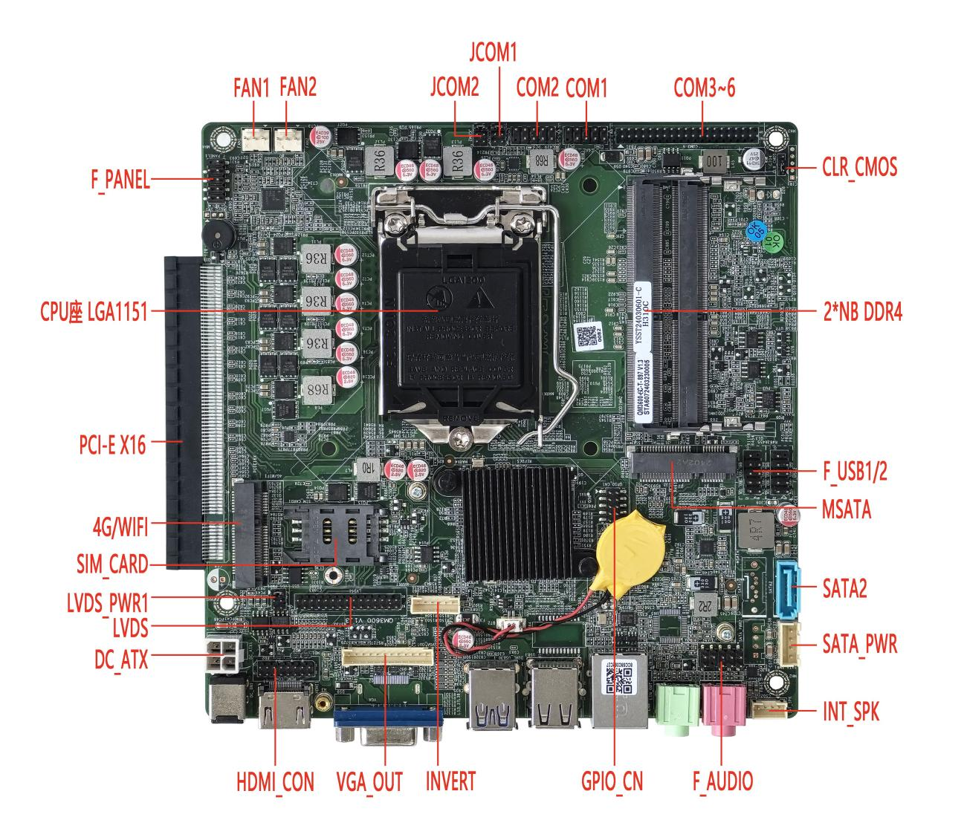
―――――――――――――――――――――――――――――――――――――――――――
HDMI+VGA+Single LAN port picture↓（default）
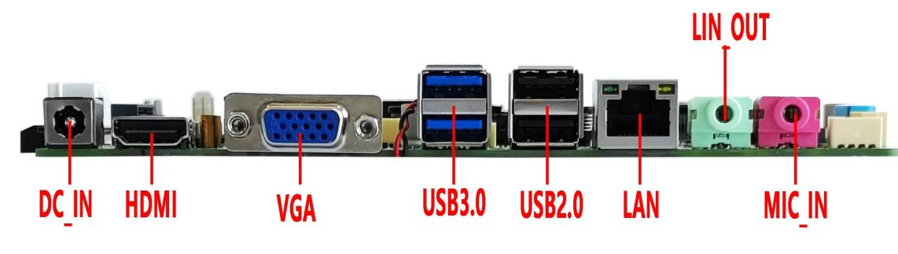
―――――――――――――――――――――――――――――――――――――――――――
HDMI+VGA dual LAN port picture↓
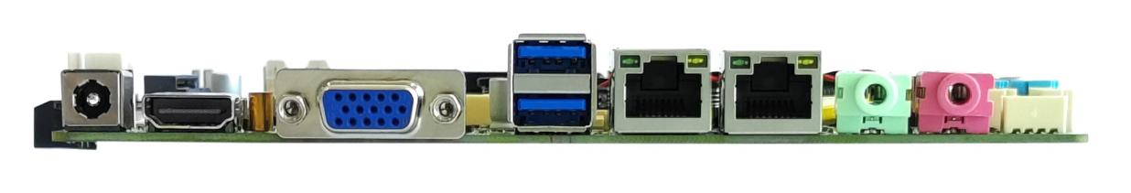
―――――――――――――――――――――――――――――――――――――――――――
DP+HDMI dual LAN port picture↓
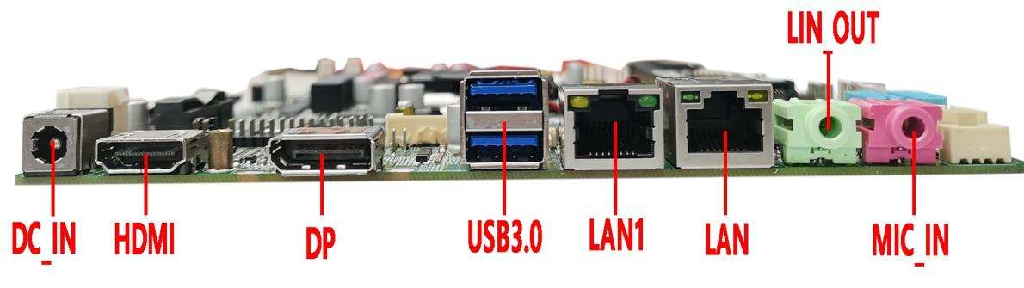
―――――――――――――――――――――――――――――――――――――――――――
DP interface+115X Schematic picture of double-pipe radiator↓

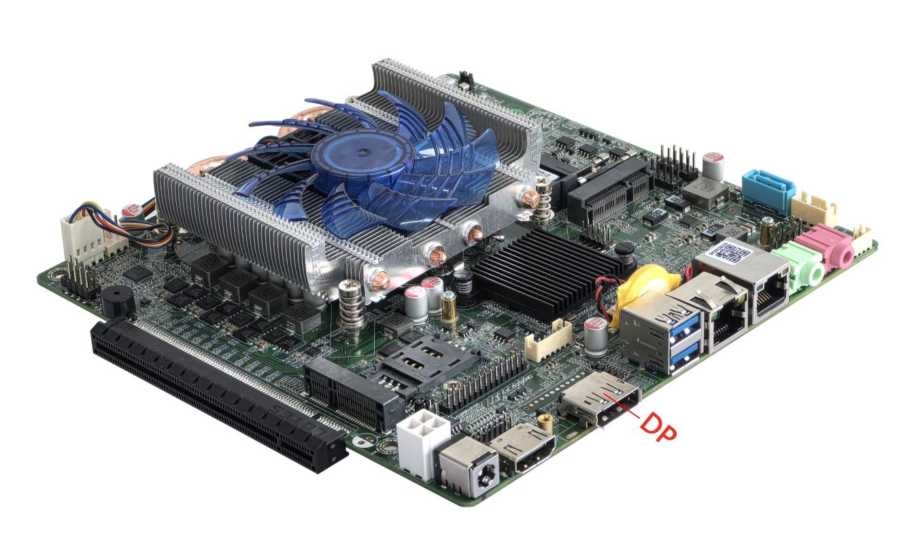
――――――――――――――――――――――――――――――――――――――――――
2C Without PCIE slot + embedded heat sink picture↓
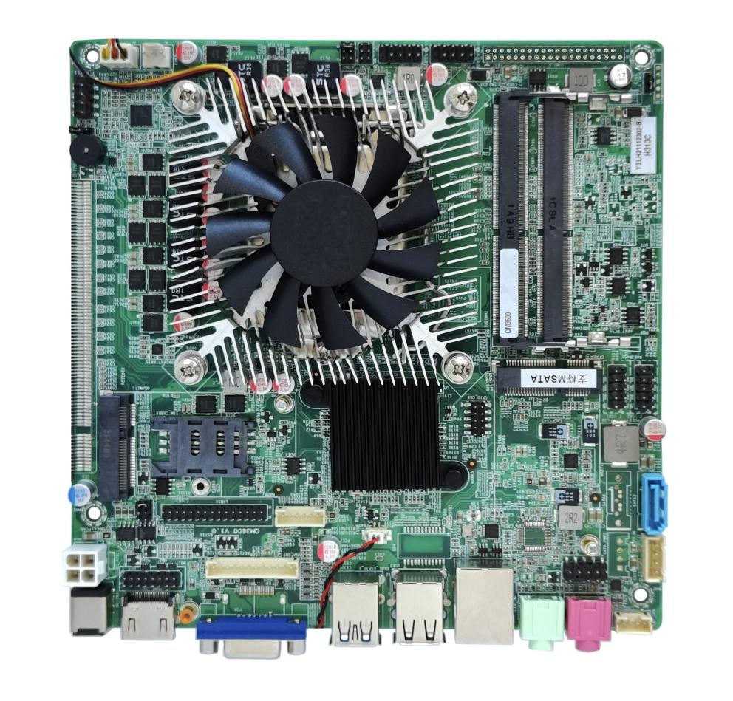
―――――――――――――――――――――――――――――――――――――――――――
The back sight picture of the Motherboard↓
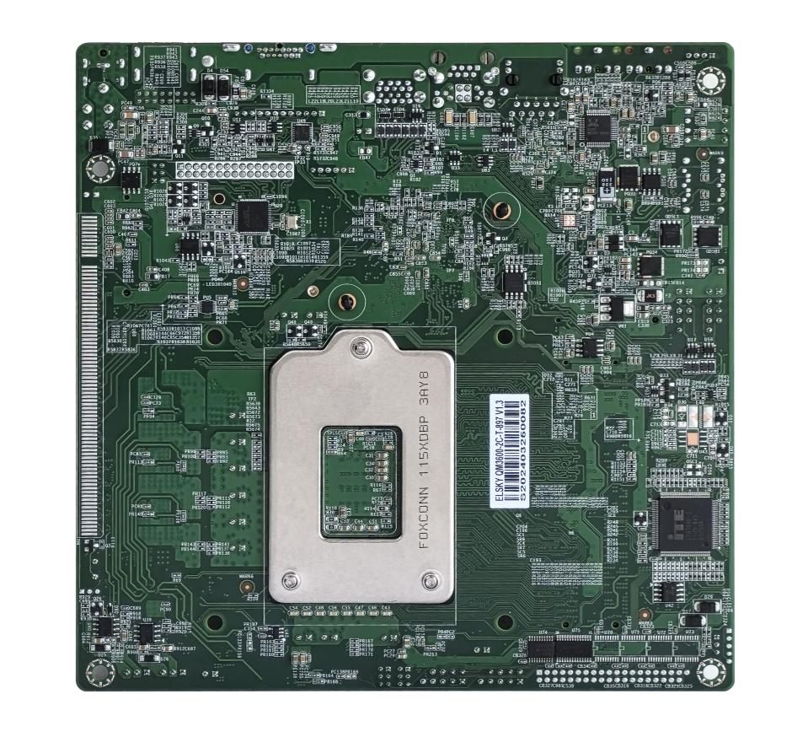
―――――――――――――――――――――――――――――――――――――――――――
The above picture is for reference only, please refer to the actual object！
Product Model Ordering Options：
Motherboard module | CPU | 4K | COM | LAN | USB2.0 | USB3.0 | SSD | Memory | Power
QM3600 | Support Intel 6th/7th/8th/9th generation LGA1151 Core i3, i5, i7, i9 independent CPU | support | 2/6 | 1 | 6 | 2 | 1*MSATA  1*SATA | 2*NB-DDR4  MAX 64G | +12V/19V
QM3600-2L |  | support | 2/6 | 2 | 4 | 2 | 1*MSATA  1*SATA | 2*NB-DDR4  MAX 64G | +12V/19V
The motherboard can be equipped with a PCI-E X16 interface, which can be connected to an external graphics card
Important remind：
Power supply interface：
The motherboard DC interface specification is 5.5*2.5, supporting a 4Pin ATX power interface;
The motherboard power supply supports 12V or 19V; the full load power consumption is about 90W, and it is recommended to use a power supply of 12V/10A or 19V/6A or above;
CPU:
The motherboard supports Intel 6th/7th/8th/9th generation LGA1151 Core i3, i5, i7, i9 independent CPU;
Display interface：
1. The motherboard supports HDMI, VGA/DP, LVDS/EDP pins to support single display, dual display copy, dual display expansion, and single display under DOS;
2. The motherboard supports VGA and DP, VGA is supported by default, and DP can be changed to support DP;
3. The motherboard supports LVDS and EDP pins, and the pins are shared. LVDS is supported by default, and EDP can be changed to support EDP. EDP uses EDP-B 20Pin backlight to separate independent screen lines;
4. The motherboard supports 1 PCIE X16 interface. After connecting to an independent graphics card, the motherboard display interface (VGA/DP/HDMI/LVDS/EDP) has no signal output;
5. The motherboard HDMI supports 4K resolution 4096/3840*2160@30Hz;
6. The motherboard DP supports 4K resolution 4096/3840*2160@60Hz;
7. The motherboard LVDS and EDP support resolution 1920*1080@60Hz;
Mini-PCIE：
The motherboard MSATA port defaults to coexisting SATA signals and USB signals, and supports MSATA disks by default. Its USB signal and USB sound card signal are selected from one to the other; when the motherboard is a USB sound card, MSATA has no USB signal; SATA signal cannot be changed to PCIE signal;
The motherboard Mini-PCIE port defaults to coexisting PCIE signals and USB signals, and supports WiFi/4G/Bluetooth modules by default. The USB signal is an independent signal;
USB interface：
1. The motherboard supports 8 USB by default (2*USB3.0, 6*USB2.0);
2. All USB interfaces and pins on the motherboard default to S power (no power when turned off), and the built-in USB pins can be changed to A power (powered when turned off);
COM port：
The motherboard supports 2/6*COM ports, of which COM1 supports RS232/RS422/RS485. Through BIOS settings, other COM ports only support RS232.
The motherboard COM1/2 can be set to output 0V/5V/12V on the ninth pin through JCOM1/2/jumper caps, and the default is 0V.
All serial ports can be changed to support TTL hardware.
Network Card：
Single network: supports Realtek 8111H Gigabit network card by default; optional support for domestic Yutaiwei YT6801 Gigabit network card;
Dual network: supports Realtek 8111H+Realtek 8111H Gigabit network card or domestic Yutaiwei YT6801+Yutaiwei YT6801 Gigabit network card;
PoE power supply cannot be changed;
Sound card：
The motherboard defaults to Realtek ALC897 sound card, and the F_AUDIO built-in pin is available. It can be changed to support Cmedia HS_100B USB sound card. After the change, the F_AUDIO built-in pin is unavailable, and there is no USB signal on the MSATA interface after the change

Illustrate

Except for the accessories listed with the product, the content contained in this manual does not represent the company's commitment. The company reserves the right to change this manual without prior notice.
We are not responsible for any direct, indirect, intentional or unintentional damage and hidden dangers caused by improper installation and use.
Before ordering a product, please ask the dealer for details about whether the product performance meets your needs.
The contents of this manual are protected by copyright and may not be reproduced mechanically, electronically or by any other means without permission.
The final interpretation right of this manual belongs to SHENZHEN ELSKY TECHNOLOGY CO.,LTD.

The above ordering information is for reference only. Please contact us for details.
Motherboard driver download https://pan.baidu.com/s/1ie7qi5NutS53ipPecRSYtw
Access password cbn5

BIOS Function key
BIOS Function key | Function description
Power on Delete | The BIOS function screen is displayed
Power on F11 | Select the boot option or access the BIOS function screen
← → | Move the left and right arrows to select an entry
↑ ↓ | Move the up and down arrows to select the entry
Enter | Select the item and go to the sub-menu
+/- | Change the selection, or add or subtract values
F1 | The help content is displayed
F9 | factory data reset
F10 | Save the changes and exit
Esc | quit

The following CPU information is for reference only. Please contact sales for specific requirements！
CPU | CPU brand | CPU module | Dominant Frequency | Turbo | CPU power consumption (W) | CPU full load power consumption (W)
6th gen I3 | Intel Core | 6100 | Dual Core 3.7G |  | 65 | 90
6th gen I3 | Intel Core | 6300 | Dual Core 3.8G |  | 65 | 90
6th gen I3 | Intel Core | 6320 | Dual Core 3.9G |  | 65 | 90
6th gen I5 | Intel Core | 6400 | Quad Core 2.7G | 3.3G | 65 | 90
6th gen I5 | Intel Core | 6500 | Quad Core 3.2G | 3.6G | 65 | 90
6th gen I5 | Intel Core | 6600 | Quad Core 3.3G | 3.9G | 65 | 90
6th gen I7 | Intel Core | 6700 | Quad Core 3.4G | 4.0G | 65 | 90
7th gen I3 | Intel Core | 7100 | Dual Core 3.9G |  | 65 | 90
7th gen I3 | Intel Core | 7300 | Dual Core 4.0G |  | 65 | 90
7th gen I3 | Intel Core | 7320 | Dual Core 4.1G |  | 65 | 90
7th gen I5 | Intel Core | 7400 | Quad Core 3.0G | 3.5G | 65 | 90
7th gen I5 | Intel Core | 7500 | Quad Core 3.4G | 3.8G | 65 | 90
7th gen I5 | Intel Core | 7600 | Quad Core 3.5G | 4.,1G | 65 | 90
7th gen I7 | Intel Core | 7700 | Quad Core 3.6G | 4.2G | 65 | 90
8th gen I3 | Intel Core | 8100 | Quad Core 3.6G |  | 65 | 90
8th gen I3 | Intel Core | 8300 | Quad Core 3.7G |  | 65 | 90
8th gen I5 | Intel Core | 8400 | Six cores 2.8G | 4.0G | 65 | 90
8th gen I5 | Intel Core | 8500 | Six cores 3.0G | 4.1G | 65 | 90
8th gen I5 | Intel Core | 8600 | Six cores 3.2G | 4.3G | 65 | 90
8th gen I7 | Intel Core | 8700 | Six cores 3.2G | 4.6G | 65 | 90
9th gen I3 | Intel Core | 9100 | Quad Core 3.6G | 4.2G | 65 | 90
9th gen I3 | Intel Core | 9300 | Quad Core 3.7G | 4.2G | 65 | 90
9th gen I5 | Intel Core | 9400 | Six cores 2.9G | 4.1G | 65 | 90
9th gen I5 | Intel Core | 9500 | Six cores 3.0G | 4.4G | 65 | 90
9th gen I5 | Intel Core | 9600 | Six cores 3.1G | 4.6G | 65 | 90
9th gen I7 | Intel Core | 9700 | Octa-core 3.0G | 4.7G | 65 | 90
9th gen I9 | Intel Core | 9900 | Octa-core 3.1G | 5.0G | 65 | 90

Production Specification
Size | 170mm（L）*170mm（W）*22mm（H）  (The thickness of the embedded radiator is 30mm, and the thickness of the 115X double-tube radiator is 42mm)
CPU | Support Intel 6th/7th/8th/9th generation LGA1151 Core i3, i5, i7, i9 independent CPU
Chipset | Intel H310C Chipset
Power supply | 1*DC_IN | The inner diameter of the DC head is 2.5MM, The supporting 12V/19V motherboard has a full load power consumption of about 90W. It is recommended to use a 12V/10A or 19V/6A power supply or above
Power supply | 1*4Pin DC-ATX
Memory | 2*SODIMM slots | NB-DDR4 memory, supports 2133/2400/2666MHz memory, maximum support 64G
Network function | 1/2*LAN interface | Single network: default support Realtek 8111H Gigabit network port;  Optional support Yutaiwei YT6801 Gigabit network card;  Dual network: support Realtek 8111H + Realtek 8111H Gigabit network card;  Optional support Yutaiwei YT6801 + Yutaiwei YT6801 Gigabit network card;  Support network wake-up, PXE function
Network function | 1*MINI_PCIE interface | PCIE3.0 signal, support WIFI/4G/Bluetooth module
Display function | Graphics | Intel HD Graphics 530/630 super core graphics card, supports single display, dual display copy, dual display expansion, single display under DOS
Display function | 1*HDMI 1.4 interface | Support 4K resolution 4096/3840*2160@30Hz
Display function | 1*HDMI_CON pin | Support resolution 4096/3840*2160@30Hz （16Pin，2*8Pin，2.0mm）
Display function | 1*VGA DB15 interface | Support resolution 1920*1080@60Hz
Display function | 1*VGA_OUT pin | Support resolution 1920*1080@60Hz （12Pin，1*12Pin，2.0mm）
Display function | 1*DP interface (optional) | Support 4K resolution 4096/3840*2160@60Hz
Display function | VGA and DP are two choices, the default signal is VGA, and the signal can be changed to DP
Display function | 1*LVDS pin  (EDP optional) | Support resolution 1920*1080@60Hz (30Pin, 2*15Pin, 2.0mm)
Display function | LVDS and EDP share the same pin, the default is LVDS signal, can be changed to EDP signal, use EDP-B screen cable
Display function | 1*LVDS_PWR pin | LVDS/EDP voltage control pin (6Pin, 2*3Pin, 2.0mm)
Display function | 1*INVERT pin | LVDS/EDP backlight switch control pin (6Pin, 1*6Pin, 2.0mm)
USB function | 2*USB3.0 interface | Rear standard USB3.0 interface
USB function | 2*USB2.0 interface | Rear standard USB2.0 interface
USB function | 1*F_USB2 pin | Front USB2.0 pin, one set has 2*USB2.0 (9Pin, 2*5Pin, 2.54mm)
USB function | 1*F_USB3 pin | Front USB2.0 pin, one set has 2*USB2.0 (9Pin, 2*5Pin, 2.54mm)
Sound function | Integrated Realtek ALC897 HD digital audio decoder, 6-channel high-fidelity audio controller;  Can be changed to support Cmedia HS_100B USB sound card;
Sound function | 1*LINE_OUT interface | Support audio output (green)
Sound function | 1*MIC_IN interface | Support microphone input (red)
Sound function | 1*F_AUDIO pin | Standard audio pin, when the motherboard is a USB sound card, the pin is not available (9Pin, 2*5Pin, 2.54mm)
Sound function | 1*INT_SPK pin | The amplifier supports 8 ohm 5 watt speaker dual channel output  (4Pin, 1*4Pin, 2.0mm)
Hard disk function | 1*MSATA pin | Support MINI_SATA disk, support MSATA 3.0
Hard disk function | 1*SATA1 interface（optional） | Standard SATA hard disk interface, supports SATA 3.0 (no interface by default, can be changed to an independent signal)
Hard disk function | 1*SATA2interface | Standard SATA hard disk interface, supports SATA 3.0
Hard disk function | 1*SATA_PWR1 pin | Hard disk power supply pin, can take power 5V, 12V (4Pin, 1*4Pin, 2.54mm)
Hard disk function | 1*SATA_PWR2 pin（optional） | Hard disk power supply pin, can take power 5V, 12V (4Pin, 1*4Pin, 2.54mm)
Switch function | 1*F_PANEL pin | Switch, power light, hard disk light, restart pin (9Pin, 2*5Pin, 2.54mm)
Other I/O | 1*COM1 pin | Serial port, support RS232/RS422/RS485 optional (9Pin, 2*5Pin, 2.54mm)
Other I/O | 1*COM2 pin | Serial port, only supports RS232 (9Pin, 2*5Pin, 2.54mm)
Other I/O | COM3~COM6 pin | Serial port, support standard RS232; (39Pin, 2*20Pin, 2.0mm)
Other I/O | All serial ports can support TTL hardware
Other I/O | 1*JCOM1 pin | Control COM1 pin 9 voltage 0V/5V/12V optional (6Pin, 2*3Pin, 2.0mm)
Other I/O | 1*JCOM2 pin | Control COM2 pin 9 voltage 0V/5V/12V optional (6Pin, 2*3Pin, 2.0mm)
Other I/O | 1*SIM_CARD slot | Support SIM card, SIM card is required when using 4G
Other I/O | 1*FAN1 pin | CPU fan pin, supports temperature control (3Pin, 1*3Pin, 2.54mm)
Other I/O | 1*FAN2 pin | System fan pin, full speed does not support temperature control  (3Pin, 1*3Pin, 2.54mm)
Other I/O | 1*CLR_CMOS pin | Motherboard reset and discharge pin (3Pin, 1*3Pin, 2.0mm)
Other I/O | 1*GPIO_CN pin | GPIO control pin (9Pin, 2*5Pin, 2.0mm)
Operating environment | Working temperature: -10℃~60℃;  Working humidity: 5%~95% relative humidity, no condensation
BIOS | AMI BIOS, supports power-on, scheduled power-on, remote power on and off, and intelligent device identification
Watch Dog | Watchdog programming (256 levels, 0~255 seconds)
Operating system | Support Windows 11，Windows 10，Windows 7，Linux etc

1.1 Motherboard size
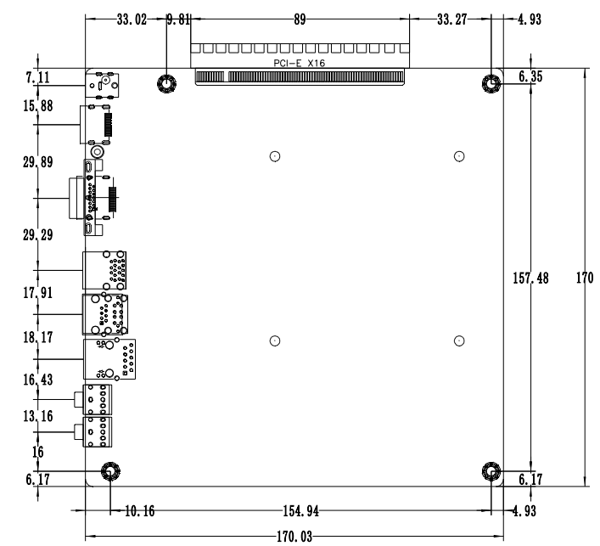
―――――――――――――――――――――――――――――――――――――――――――

VGA+single LAN↓
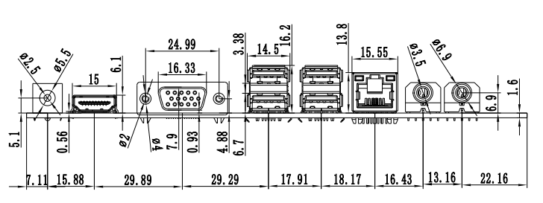
―――――――――――――――――――――――――――――――――――――――――――
VGA+Dual LAN↓
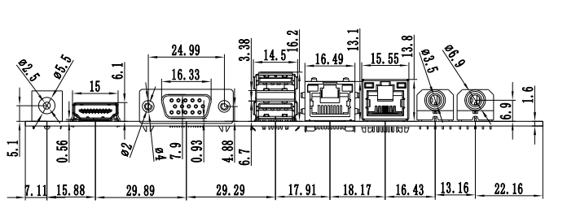
―――――――――――――――――――――――――――――――――――――――――――DP+Single LAN↓
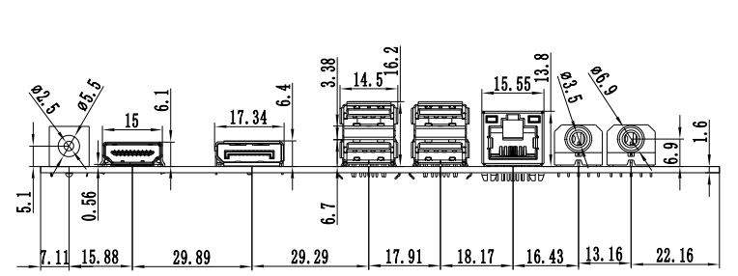
―――――――――――――――――――――――――――――――――――――――――――
DP+Dual LAN↓
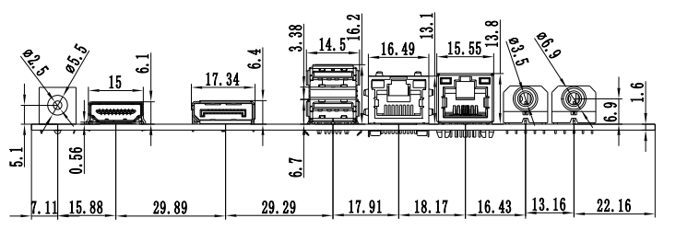
―――――――――――――――――――――――――――――――――――――――――――

Motherboard pin definition and description

2.0 The first pin identification method
Method 1：Look at the screen mark next to the pin on the front of the motherboard, which will be represented by or or 1 ；
Method 2：Look at the back pad of the motherboard, the square pad is the first pin ；
Distinguish the first pin when inserting the device and connecting cable; otherwise, the motherboard and device will be damaged.

2.1 VGA Pin definition
item：VGA_OUT （1*12Pin，2.0mm）
pin | definition | pin | definition
1 | GND | 2 | VSYNC
3 | HSYNC | 4 | GND
5 | RED | 6 | GND
7 | GRN | 8 | GND
9 | BLUE | 10 | GND
11 | DDC_DATA | 12 | DDC_CLK
Pin number diagram
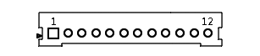
Note: The VGA_H pin signal is the same as the rear VGA port and only supports dual-display copying.

2.2 HDMI Pin definition
item：HDMI_CON （2*8Pin，2.0mm） |  |  |  | Pin number diagram
pin | definition | pin | definition | 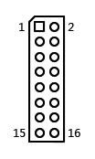
1 | HDMI_TXD2P | 2 | HDMI_TXD1P
3 | HDMI_TXD2N | 4 | HDMI_TXD1N
5 | GND | 6 | GND
7 | HDMI_TXD0P | 8 | HDMI_TXC0P
9 | HDMI_TXD0N | 10 | HDMI_TXC0N
11 | GND | 12 | HDMI_5V
13 | HDMI_CLK | 14 | HDMI_5V
15 | HDMI_DATA | 16 | HDMI_HPD
Note: When plugging in the HDMI cable, the first pin of the cable must correspond to the first pin of the motherboard. If it is plugged in reverse or in the wrong position, there will be no display.

2.3 LVDS Pin definition
item：LVDS （2*15Pin，2.0mm） |  |  |  | Pin number diagram
pin | definition | pin | definition | 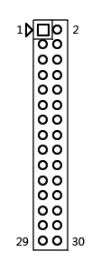
1 | VCC | 2 | VCC
3 | VCC | 4 | GND
5 | GND | 6 | GND
7 | ADO0- | 8 | ADO0+
9 | ADO1- | 10 | ADO1+
11 | ADO2- | 12 | ADO2+
13 | GND | 14 | GND
15 | ACLK- | 16 | ACLK+
17 | ADO3- | 18 | ADO3+
19 | BDO0- | 20 | BDO0+
21 | BDO1- | 22 | BDO1+
23 | BDO2- | 24 | BDO2+
25 | GND | 26 | GND
27 | BCLK- | 28 | BCLK+
29 | BDO3- | 30 | BDO3+
Note: When plugging in the screen cable, the first pin of the screen cable must correspond to the first pin of the motherboard. If it is plugged in reverse or in the wrong position, there is a risk of burning the screen and motherboard!

2.3.1 LVDS backlight power supply definition

item：INVERT （1*6Pin，2.0mm） |  | Pin number diagram
pin | definition | 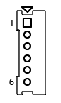
1 | +12V
2 | +12V
3 | ON/OFF（Backlight switch）
4 | ADJ（Backlight brightness adjustment）
5 | GND
6 | GND

2.3.2 LVDS Working voltage

item：LVDS_PWR （2*3Pin，2.0mm） |  | Pin number diagram
pin | definition | 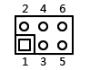
1-2 Short Circuit | +3.3V
3-4 Short Circuit | +5V
5-6 Short Circuit | +12V

Note: Screens of different sizes require different operating voltages. The motherboard provides three screen operating voltages: 3.3V, 5V, and 12V. Please set the corresponding value of LVDS_PWR according to the required operating voltage of the screen, otherwise there will be a risk of burning the screen and motherboard!

2.4 EDP Pin definition
Note: EDP and LVDS share the same pins, use EDP-B type screen cable, and separate the 20Pin screen cable and backlight;
item：LVDS/EDP（2*15Pin，2.0mm） |  |  |  | Pin number diagram
pin | definition | pin | definition
1 | VCC | 2 | VCC
3 | VCC | 4 | HPD
5 | GND | 6 | GND
7 | TX0N | 8 | TX0P
9 | TX1N | 10 | TX1P
11 | NC | 12 | NC
13 | GND | 14 | GND
15 | AUX- | 16 | AUX+
17 | GND- | 18 | GND
19 | NC | 20 | NC
21Pin~30Pin signal is empty
Note: When plugging in the screen cable, the first pin of the screen cable must correspond to the first pin of the motherboard. If it is plugged in reverse or in the wrong position, there is a risk of burning the screen and the motherboard！

2.5 GPIO_CN Pin definition
item：GPIO_CN （2*5Pin，2.0mm） |  |  |  | Pin number diagram
pin | definition | pin | definition | 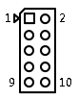
1 | GPIO_IN0 | 2 | GPIO_OUT0
3 | GPIO_IN1 | 4 | GPIO_OUT1
5 | GPIO_IN2 | 6 | GPIO_OUT2
7 | GPIO_IN3 | 8 | GPIO_OUT3
9 | +3.3V | 10 | GND
GPIO_IN and GPIO_OUT can be freely changed/interchanged as needed.

2.6 USB Pin definition
item：F_USB1/2 （2*5Pin，2.54mm） |  |  |  | Pin number diagram
pin | definition | pin | definition | 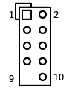
1 | VCC+5V | 2 | VCC+5V
3 | DATA0- | 4 | DATA1-
5 | DATA0+ | 6 | DATA1+
7 | GND | 8 | GND
9 | NC | 10 | GND

2.7 Fan interface definition
item：FAN1 （1*3Pin，2.54mm） |  |  | item：FAN2 （1*3Pin，2.54mm） |  | Pin number diagram
pin | definition | pin |  | definition | 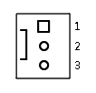
1 | GND | 1 |  | GND
2 | CTL（Temperature control） | 2 |  | +12V
3 | TAC（Fan speed detection） | 3 |  | TAC（Fan speed detection）

2.8 Serial port (COM) function and pin definition

The motherboard supports standard RS232 6COM motherboard, COM1 can optionally support RS485 and RS422, through BIOS settings;
The 9th pin of COM1/2 can be changed through the JCOM1/JCOM2 jumper settings, and the 9th pin can be selected to output +5V or +12V voltage

item：JCOM1 （2*3Pin，2.0mm） |  |  | item：JCOM2 （2*3Pin，2.0mm） |  | Pin number diagram
pin | COM1 pin 9 is charged |  | pin | COM2 pin 9 is charged |  | 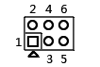
1-2 Short Circuit | +5V |  | 1-2 Short Circuit | +5V
3-4 Short Circuit | +12V |  | 3-4 Short Circuit | +12V
5-6 Short Circuit | uncharged（default） |  | 5-6 Short Circuit | uncharged（default）

2.8.1 COM1/2 Pin definition
item：COM1/2（2*5Pin，2.54mm） |  |  |  | Pin number diagram
pin | definition | pin | definition | 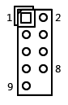
1 | DCD | 2 | RXD
3 | TXD | 4 | DTR
5 | GND | 6 | DSR
7 | RTS | 8 | CTS
9 | RI | 10 | NC

2.8.2 COM3~6 Pin definition
item：COM3~6 （2*20Pin，2.0mm） |  |  |  | Pin number diagram
pin | definition | pin | definition | 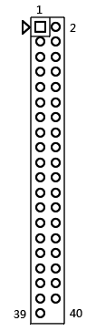
1 | COM3_DCD | 2 | COM3_RXD
3 | COM3_TXD | 4 | COM3_DTR
5 | GND | 6 | COM3_DSR
7 | COM3_RTS | 8 | COM3_CTS
9 | COM3-RI | 10 | NC
11 | COM4_DCD | 12 | COM4_RXD
13 | COM4_TXD | 14 | COM4_DTR
15 | GND | 16 | COM4_DSR
17 | COM4_RTS | 18 | COM4_CTS
19 | COM4-RI | 20 | NC
21 | COM5_DCD | 22 | COM5_RXD
23 | COM5_TXD | 24 | COM5_DTR
25 | GND | 26 | COM5_DSR
27 | COM5_RTS | 28 | COM5_CTS
29 | COM5-RI | 30 | NC
31 | COM6_DCD | 32 | COM6_RXD
33 | COM6_TXD | 34 | COM6_DTR
35 | GND | 36 | COM6_DSR
37 | COM6_RTS | 38 | COM6_CTS
39 | COM6-RI | 40 | NC

2.8.3 RS422/RS485 definition of COM1
item：COM1 （2*5Pin，2.54mm）
signal | Pin definition
RS485 | 1（S485-) | 2（S485+）
RS422 | 1（TXD-） | 2（TXD+)
RS422 | 3（RXD+） | 4（RXD-）

2.9 Audio interface and pin definition
item：F_AUDIO （2*5Pin，2.54mm） |  |  |  | Pin number diagram
pin | definition | pin | definition | 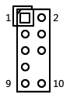
1 | MIC-L | 2 | GND
3 | MIC-R | 4 | NC
5 | LINE OUT-R | 6 | MIC_JD
7 | FAUDIO_JD | 8 | NC
9 | LINE OUT-L | 10 | LINE_JD
When the motherboard is a USB sound card, the F_AUDIO pin is unavailable, but it is available when it is a Realtek sound card.

2.10 Speaker (amplifier) ​​pin definition
item：INT_SPK （1*4Pin，2.0mm） |  | Pin number diagram
pin | definition | 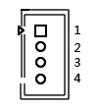
1 | L+
2 | L-
3 | R-
4 | R+

2.11 Hard disk interface and definition
1 SATA3.0 hard disk interface, 1 MSATA hard disk interface
item：SATA2 |  |  | item：SATA_PWR1 （1*4Pin，2.54mm） |  | Pin number diagram
pin | definition |  | pin | definition | 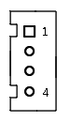
1 | GND |  | 1 | 12V
2 | SATA_TXP |  | 2 | GND
3 | SATA_TXN |  | 3 | GND
4 | GND |  | 4 | 5V
5 | SATA_RXN
6 | SATA_RXP
7 | GND
Note: Pin 1 of the SATA_PWR hard disk power supply interface is 12V output, and pin 4 is 5V output. When using, you must use the power cord provided by our company to avoid burning the hard disk.

2.12 Power and switch pin definitions
The motherboard provides a 2.5 standard DC head (DC_IN); a 4-pin ATX power interface, defined as：
item：ATX （2*2Pin，4.2mm） |  | Pin number diagram
pin | definition | 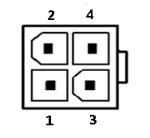
1 | GND
2 | GND
3 | +12V
4 | +12V

Switch pin definition：
item：F_PANEL （2*5Pin，2.54mm） |  |  |  |  |  | Pin number diagram
pin | definition |  | pin | definition
1 | HDLED+ | Hard disk light | 2 | PWRLED+ | Power supply light
3 | HDLED- | Hard disk light | 4 | GND | Power supply light
5 | RST | restart | 6 | P_SW IN | switch
7 | GND | restart | 8 | GND | switch
9 | NC |  | 10
(1) Hard disk indicator light (pins 1 and 3, HDD LED, pin 1 is the positive pole of the LED) When the hard disk is performing read and write operations, the indicator light will flash, indicating that the hard disk is running;
(2) Power indicator light (pins 2 and 4, Power LED, pin 2 is the positive pole of the LED) When the motherboard is powered on, the power indicator light is on; when the motherboard is powered off, the power indicator light is off;
(3) Reset button (pins 5 and 7, Reset Button) When the system fails and cannot continue to work, resetting can make the system start working again;
(4) Power switch control (pins 6 and 8, Power Button) These two pins are connected to the bounce switch on the front panel of the chassis, which can be used to turn on or off the computer

2.13 Motherboard discharge reset and battery

CMOS is powered by the button battery on the motherboard. Clearing CMOS will clear the previous BIOS settings and set them to the original factory settings.

The steps are as follows:
(1) Turn off the computer and disconnect the power supply;
(2) Jump the "CLR_CMOS" pin jumper to short the 2-3 pins for 5-6 seconds, and then jump back to the 1-2 pins;
(3) Press the "Delete" key on the keyboard to enter the BIOS interface;
(4) Enter the BIOS interface and press the "F9" key - "Enter" key to reload the optimal default value;
(5) Press F10 to save and exit the settings.

CMOS pin definition:
item：CLR_CMOS （1*3Pin，2.0mm）
pin | definition | 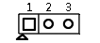
1-2 Short Circuit | Default normal boot
2-3 Short Circuit | Clear CMOS content and restore BIOS to factory settings
Note: Do not clear CMOS when the computer is powered on to avoid damaging the motherboard.
After power failure, re-insert the button battery to reset the motherboard. Button battery specification: 3V CR2032
Note: Please make sure that the positive pole of the battery is facing upwards; Please make sure that the battery voltage is sufficient to be 2.8V~3V; When replacing batteries, please use batteries of the same model or type and recommended by the manufacturer. If the battery is replaced improperly, there is a risk of explosion!

