
ELSKY QM9400/QM9500 V2.x Manual
――――――――――――――――――――――――――――――――――――――――――――――――――――――
No GPIO motherboard picture
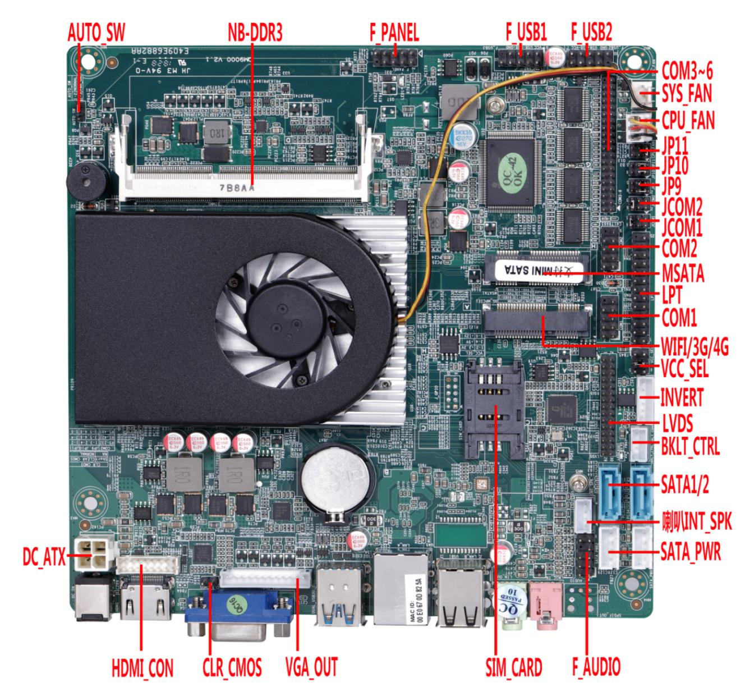
――――――――――――――――――――――――――――――――――――――――――――――――――――――

――――――――――――――――――――――――――――――――――――――――――――――――――――――
Single network port image (default)
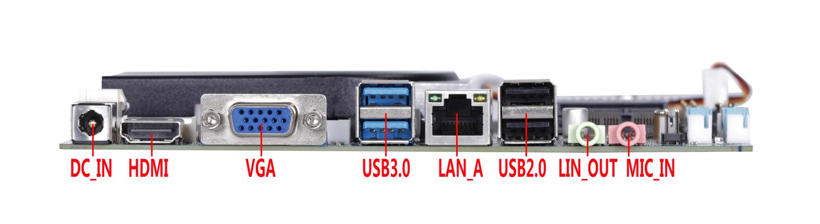
――――――――――――――――――――――――――――――――――――――――――――――――――――――
Picture of motherboard with GPIO
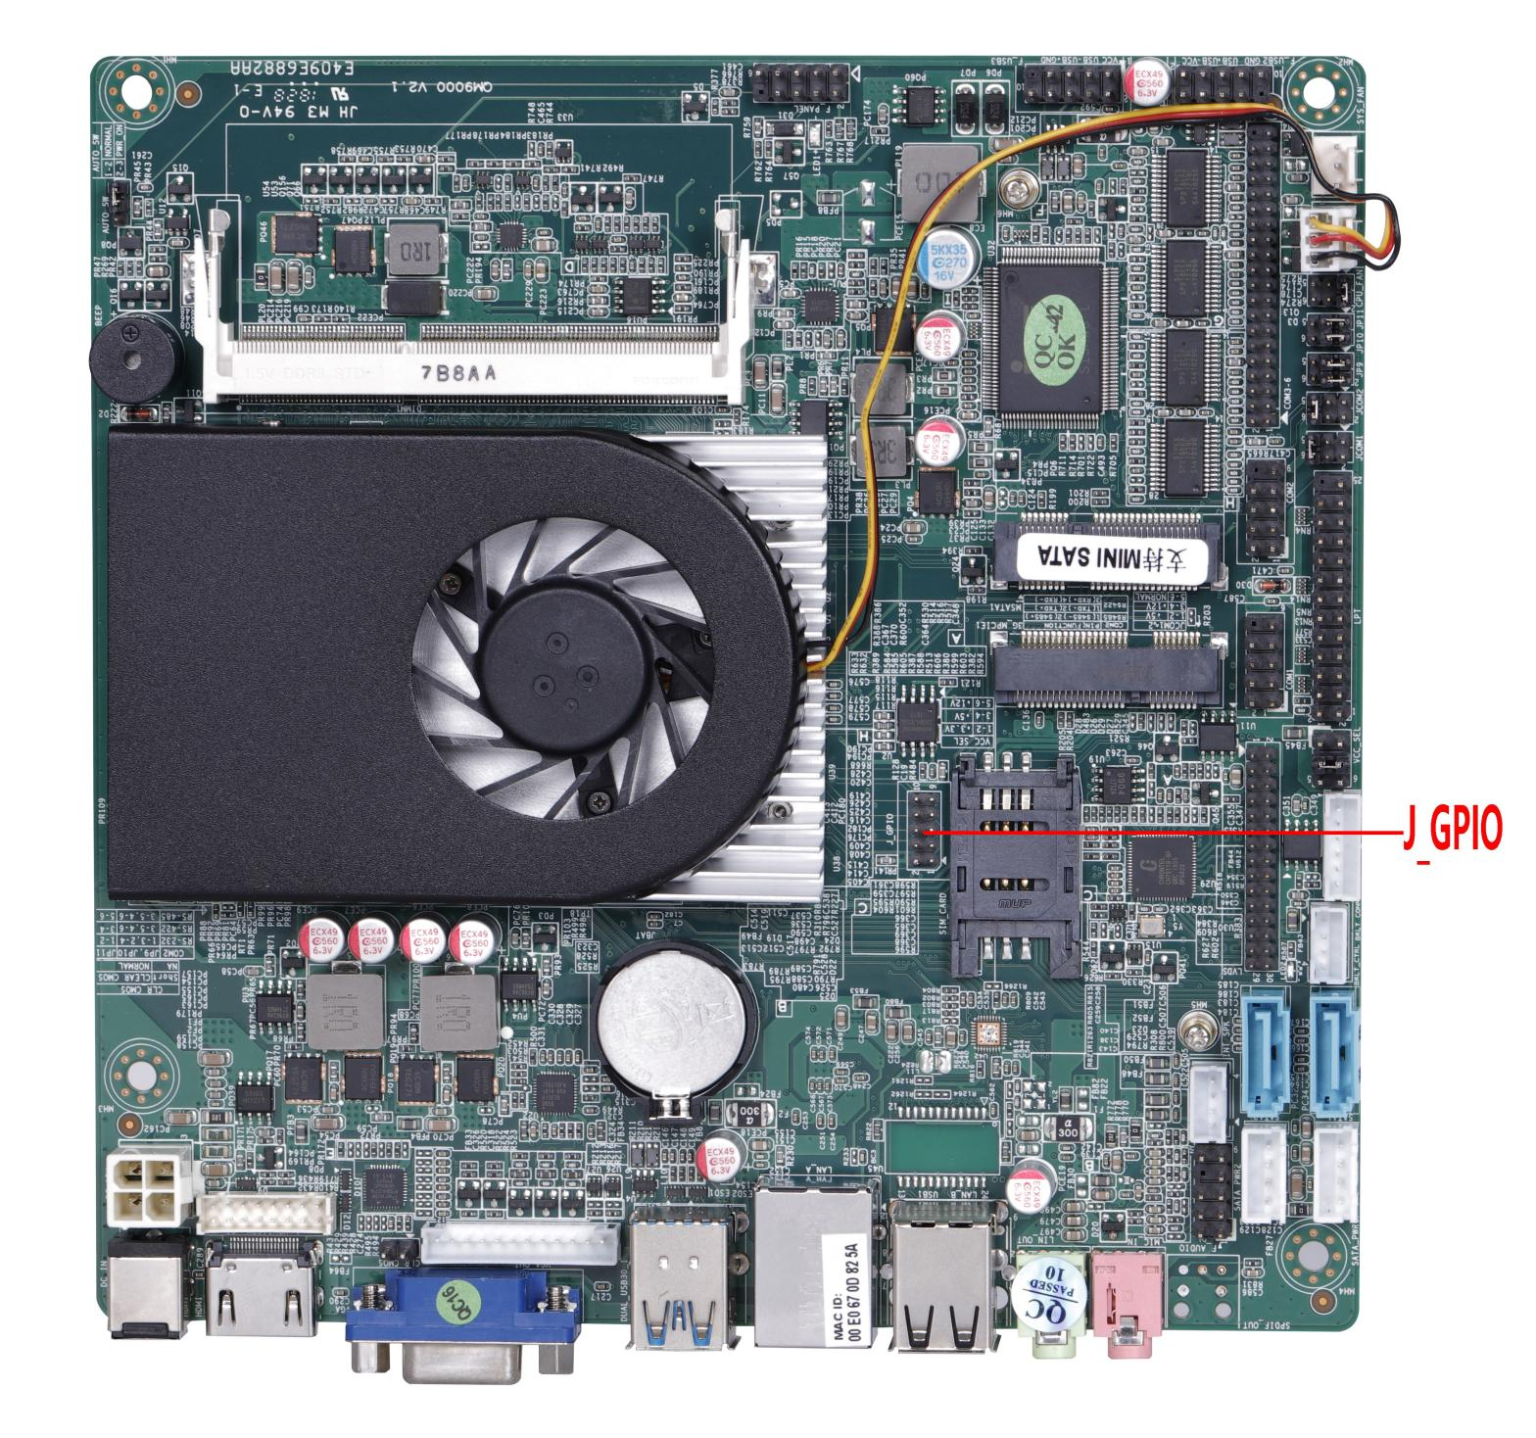
――――――――――――――――――――――――――――――――――――――――――――――――――――――

――――――――――――――――――――――――――――――――――――――――――――――――――――――
Dual network port pictures
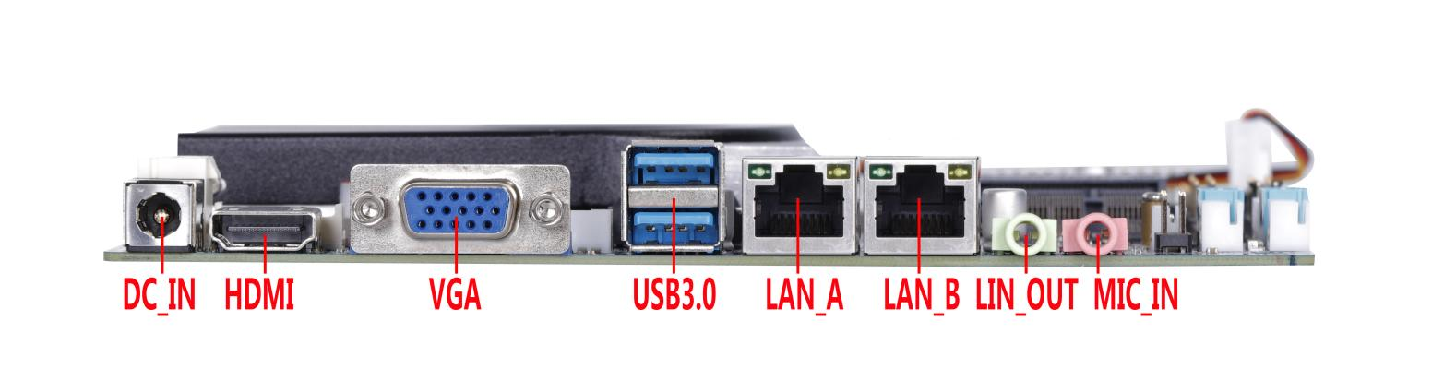
――――――――――――――――――――――――――――――――――――――――――――――――――――――
2C motherboard picture
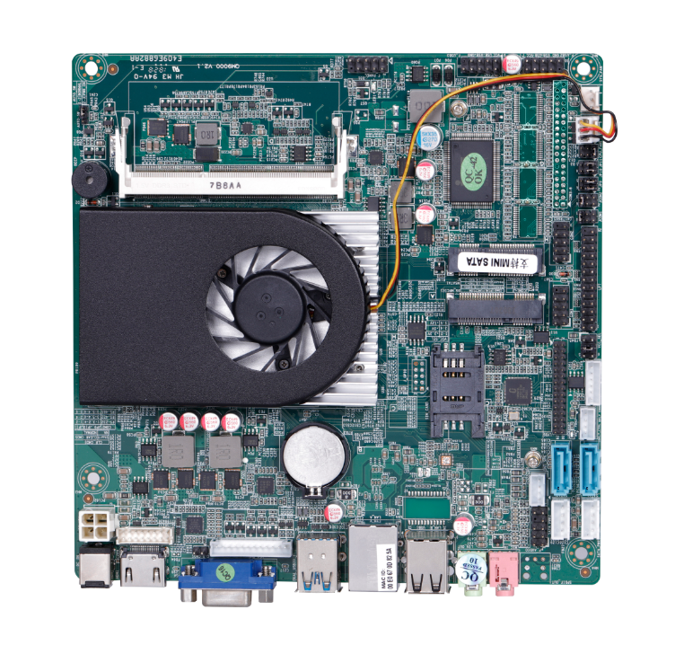
The motherboard picture is for reference only, please refer to the actual product!

Product model ordering options:
Motherboard model | CPU | 4K | LAN | COM | USB | SSD | Memory | Power
QM9400-2C | Haswell-U 4th Generation | support | 1 | 2 | 8 | 1*MSATA  2*SATA 3.0 | 1*NB DDR3  8GB MAX | The 2C motherboard only supports 12V;  6C motherboard supports 12V/19V
QM9400-2L2C | Haswell-U 4th Generation | support | 2 | 2 | 6 | 1*MSATA  2*SATA 3.0 | 1*NB DDR3  8GB MAX
QM9400-6C | Haswell-U 4th Generation | support | 1 | 6 | 8 | 1*MSATA  2*SATA 3.0 | 1*NB DDR3  8GB MAX
QM9400-2L6C | Haswell-U 4th Generation | support | 2 | 6 | 6 | 1*MSATA  2*SATA 3.0 | 1*NB DDR3  8GB MAX
QM9500-2C | Broadwell-U 5th Generation | support | 1 | 2 | 8 | 1*MSATA  2*SATA 3.0 | 1*NB DDR3  8GB MAX
QM9500-2L2C | Broadwell-U 5th Generation | support | 2 | 2 | 6 | 1*MSATA  2*SATA 3.0 | 1*NB DDR3  8GB MAX
QM9500-6C | Broadwell-U 5th Generation | support | 1 | 6 | 8 | 1*MSATA  2*SATA 3.0 | 1*NB DDR3  8GB MAX
QM9500-2L6C | Broadwell-U 5th Generation | support | 2 | 6 | 6 | 1*MSATA  2*SATA 3.0 | 1*NB DDR3  8GB MAX

Important Tips:
- 2C motherboard only supports 12V; 6C motherboard supports 12V/19V;
- The motherboard does not have GPIO pins by default. If you need to use them, you need to change the board and declare it in advance;
- The motherboard VGA, HDMI, and LVDS support single display, dual display/triple display copy, dual display/triple display expansion, and single display under DOS;
- The motherboard HDMI interface supports 4K resolution 4096/3840*2160@30Hz; Windows 10 system is required to run 4K video;
- The motherboard supports 2*COM and 6*COM optional, and supports RS232 by default;
- Motherboard COM2 supports RS232/422/485 optional, through JP9/JP10/JP11 jumper settings;
- The 9th pin of COM1/2 on the Motherboard can be set to 0V/5V/12V through JCOM1/2;
- The motherboard Mini-PCIE supports PCIE signals and USB signals by default.
- MSATA supports SATA signal and USB signal by default, and supports dual WIFI by default;
- The motherboard supports single Gigabit network card by default, and can optionally support dual Gigabit network cards;

Illustrate

Except for the accessories listed with the product, the contents of this manual do not represent the company's commitment. The company reserves the right to change this manual without further notice.
We are not responsible for any direct, indirect, intentional or unintentional damages and hidden dangers caused by improper installation or use.
Before ordering a product, please consult your dealer to learn in detail whether the product performance meets your needs.
The contents of this manual are protected by copyright. All rights reserved. No reproduction in mechanical, electronic or other ways is allowed without permission.
The final right of interpretation of this manual belongs to SHENZHEN ELSKY TECHNOLOGY CO.,LTD.

The above ordering information is for reference only. For details, please consult the sales department at 0755-82260150
Motherboard driver download https://pan.baidu.com/s/1ie7qi5NutS53ipPecRSYtw
Access password cbn5

The following CPU information is for reference only. Please consult sales for specific needs!
CPU Specifications | CPU Brand | CPU Model | Frequency | Turbo | CPU power consumption (W)
4th Generation I3 | Intel  Core | 4005U | Dual-core 1.7G |  | 15
4th Generation I3 | Intel  Core | 4010U | Dual-core 1.7G |  | 15
4th Generation I3 | Intel  Core | 4025U | Dual core 1.9G |  | 15
4th Generation I3 | Intel  Core | 4030U | Dual core 1.9G |  | 15
4th Generation I3 | Intel  Core | 4100U | Dual core 1.8G |  | 15
4th generation I5 | Intel  Core | 4200U | Dual core 1.6G | 2.6G | 15
4th generation I5 | Intel  Core | 4210U | Dual-core 1.7G | 2.7G | 15
4th generation I5 | Intel  Core | 4250U | Dual core 1.3G | 2.6G | 15
4th generation I5 | Intel  Core | 4278U | Dual core 2.6G | 3.1G | 28
4th generation I5 | Intel  Core | 4300U | Dual core 1.9G | 2.9G | 15
4th generation I5 | Intel  Core | 4308U | Dual core 2.8G | 3.3G | 28
4th generation I5 | Intel  Core | 4310U | Dual-core 2.0G | 3.0G | 15
4th Generation I7 | Intel  Core | 4500U | Dual core 1.8G | 3.0G | 15
4th Generation I7 | Intel  Core | 4510U | Dual-core 2.0G | 3.1G | 15
4th Generation I7 | Intel  Core | 4550U | Dual-core 1.5G | 3.0G | 15
4th Generation I7 | Intel  Core | 4558U | Dual core 2.8G | 3.3G | 15
4th Generation I7 | Intel  Core | 4578U | Dual-core 3.0G | 3.5G | 28
4th Generation I7 | Intel  Core | 4600U | Dual core 2.1G | 3.3G | 15
4th Generation I7 | Intel  Core | 4650U | Dual-core 1.7G | 3.0G | 15
5th Generation I3 | Intel  Core | 5005U | Dual-core 2.0G |  | 15
5th Generation I3 | Intel  Core | 5010U | Dual core 2.1G |  | 15
5th Generation I3 | Intel  Core | 5015U | Dual core 2.1G |  | 15
5th Generation I3 | Intel  Core | 5020U | Dual core 2.2G |  | 15
5th Generation I5 | Intel  Core | 5200U | Dual core 2.2G | 2.7G | 15
5th Generation I5 | Intel  Core | 5250U | Dual core 1.6G | 2.7G | 15
5th Generation I5 | Intel  Core | 5257U | Dual-core 2.7G | 3.1G | 15
5th Generation I5 | Intel  Core | 5287U | Dual-core 2.9G | 3.3G | 28
5th Generation I5 | Intel  Core | 5300U | Dual core 2.3G | 2.9G | 15
5th Generation I5 | Intel  Core | 5350U | Dual core 1.8G | 2.9G | 15
5th Generation I7 | Intel  Core | 5500U | Dual-core 2.4G | 3.0G | 15
5th Generation I7 | Intel  Core | 5550U | Dual-core 2.0G | 3.0G | 15
5th Generation I7 | Intel  Core | 5557U | Dual-core 3.1G | 3.4G | 28
5th Generation I7 | Intel  Core | 5600U | Dual core 2.6G | 3.2G | 15
5th Generation I7 | Intel  Core | 5650U | Dual core 2.2G | 3.1G | 15

Chapter 1. Product Specifications
Motherboard size | 170mm(L)*170mm(W)*20mm(H)
CPU Processor | QM9400 supports 4 generations of CPU: I3-4010U, I5-4200U, I7-4500U, etc.
CPU Processor | QM9500 supports 5 generations of CPU: I3-5010U, I5-5200U, I7-5500U, etc.
Chipset | Haswell-U, Broadwell-U Express Chipset
Memory support | 1*DDR3 SODIMM memory slot, supports 1600MHz memory , low voltage 1.35V , maximum support 8GB
Power supply | 1*DC_IN | Supports 12V/19V voltage, the inner diameter of the DC head is 2.5MM  Motherboard power consumption: about 30W. It is recommended to use a 12V5A or higher power supply
Power supply | 1*DC_ATX
Display functions | 4th generation integrated Intel® HD 4400 graphics controller , supports single display, dual display / triple display copy, dual display / triple display expansion, single display under DOS
Display functions | 5th generation integrated Intel® HD 5500 graphics controller , supports single display, dual display / triple display copy, dual display / triple display expansion, single display in DOS
Display functions | 1*VGA DB15 interface | Support resolution 1920*1080@60HZ
Display functions | 1*VGA_OUT pin | Support resolution 1920*1080@60HZ (12Pin, 1*12Pin, 2.0mm)
Display functions | 1*HDMI 1.4 interface | Support resolution 4096/3840*2160@30HZ
Display functions | 1*HDMI_CON pin | Support resolution 4096/3840*2160@30HZ (16Pin, 2*8Pin, 2.0mm)
Display functions | 1*LVDS pin | Support resolution 1920*1080@60HZ (30Pin, 2*15Pin, 2.0mm)
Display functions | 1*VCC_SEL pin | LVDS voltage control pin (6Pin, 2*3Pin, 2.0mm)
Display functions | 1*INVERT pin | LVDS backlight switch control pin (6Pin, 1*6Pin, 2.0mm)
Display functions | 1*BKLT_CTRL pin | LVDS backlight brightness adjustment pin (4Pin, 1*4Pin, 2.0mm)
Network Features | 1*RJ45 LAN interface | RTL8111 F Gigabit network card chip , supports network wake-up and PXE diskless boot functions .
Network Features | 1*Mini-PCIE interface | Support WIFI/3G/4G
Hard disk function | 1*MSATA interface | Support MSATA disk
Hard disk function | 2*SATA interface | Standard SATA3.0 hard disk interface, maximum transmission speed 6.0 Gbps
Hard disk function | 2*SATA_PWR pin | Hard disk power supply pin, can take 5V, 12V power. (4Pin, 1*4Pin, 2.54mm)
Sound Features | Integrated Realtek ALC662 HD digital audio decoder , 6-channel high-fidelity audio controller
Sound Features | 1*LIN_OUT interface | Support audio output (green)
Sound Features | 1*MIC_IN interface | Support microphone input (red)
Sound Features | 1*INT_SPK pin | The amplifier supports 8 ohm 5 watt speaker dual channel output  (4Pin, 1*4Pin, 2.0mm)
Sound Features | 1*F_AUDIO pin | Standard audio pin (9Pin, 2*5Pin, 2.54mm)
USB Function | 2*USB3.0 interface | Rear standard USB3.0 interface
USB Function | 2*USB2.0 interface | Rear standard USB2.0 interface
USB Function | 1*F_USB2 pin | Front USB2.0 pin, one set has 2*USB2.0 (9Pin, 2*5Pin, 2.54mm)
USB Function | 1*F_USB3 pin | Front USB2.0 pin, one set has 2*USB2.0 (9Pin, 2*5Pin, 2.54mm)
Switch function | 1*F_PANEL pin | Switch, power light, hard disk light, restart pin (9Pin, 2*5Pin, 2.54mm)
Switch function | 1*AUTO_SW pin | Hardware control power-on pin (3Pin, 1*3Pin, 2.0mm)
Other I/O | 1*COM1 pin | Serial port, only supports RS232 (9Pin, 2*5Pin, 2.54mm)
Other I/O | 1*COM2 pin | Serial port, COM2 supports RS232/RS422/RS485 optional  (9Pin, 2*5Pin, 2.54mm)
Other I/O | 1*JCOM1 pin | Control COM1 pin 9 voltage 0V/5V/12V optional (6Pin, 2*3Pin, 2.0mm)
Other I/O | 1*JCOM2 pin | Control COM2 pin 9 voltage 0V/5V/12V optional (6Pin, 2*3Pin, 2.0mm)
Other I/O | JP9/JP10/JP11 pin | COM2 supports RS422 and RS485 signal jumper settings  (6Pin, 2*3Pin, 2.0mm)
Other I/O | COM3~COM6 pins | Serial port, supports standard RS232; (39Pin, 2*20Pin, 2.0mm)
Other I/O | 1*MINI_PCIE interface | Support WIFI/3G/4G/GPS/Bluetooth modules, etc.
Other I/O | 1*SIM_CARD slot | Support SIM card, SIM card is required when using 3G/4G
Other I/O | 1*CLR_CMOS pin | Motherboard reset and discharge pin (2Pin, 1*2Pin, 2.54mm)
Other I/O | 1*J_GPIO pin (optional) | GPIO control pins (10Pin, 2*5Pin, 2. 0 mm)
Other I/O | 1*SYS_FAN pin | System fan pin, full speed, does not support temperature control  (3Pin, 1*3Pin, 2.54mm)
Other I/O | 1*CPU_FAN pin | CPU fan pin, supports temperature control (3Pin, 1*3Pin, 2.54mm)
Operating Environment | Working temperature: -20℃~60℃;  Working humidity: 5%~95% relative humidity, no condensation
BIOS | AMI BIOS, supports power-on, scheduled power-on, remote power on and off, and intelligent device identification
Watch Dog | Watchdog programming, support hardware reset function (256 levels, 0~255 seconds)
Operating system | Supports Windows 10, Windows 8, Windows 7, Linux, etc.

1.1 Motherboard Dimensions
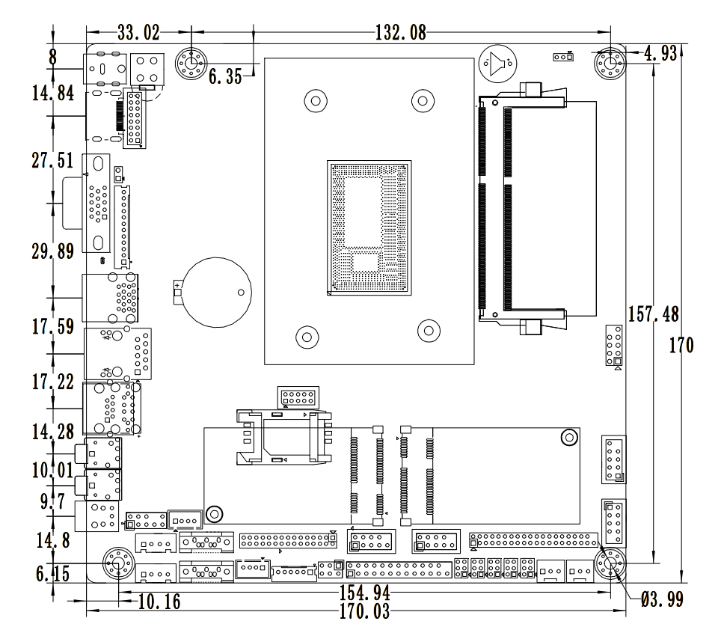
Single mesh size↓
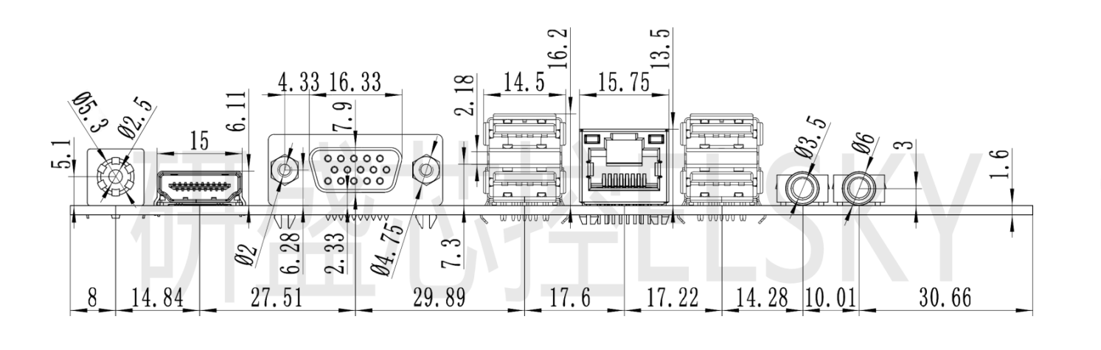

――――――――――――――――――――――――――――――――――――――――――――――――――――――

Double mesh size↓



